Abboskhon Sobirov, id 20202037  
  
  
This was a really interesting assignment with a few challenges. Particularly, rounding up the data of vaccinated people and removing decimal points from population thereafter:  
  
The first, I got to do on my own.   
  
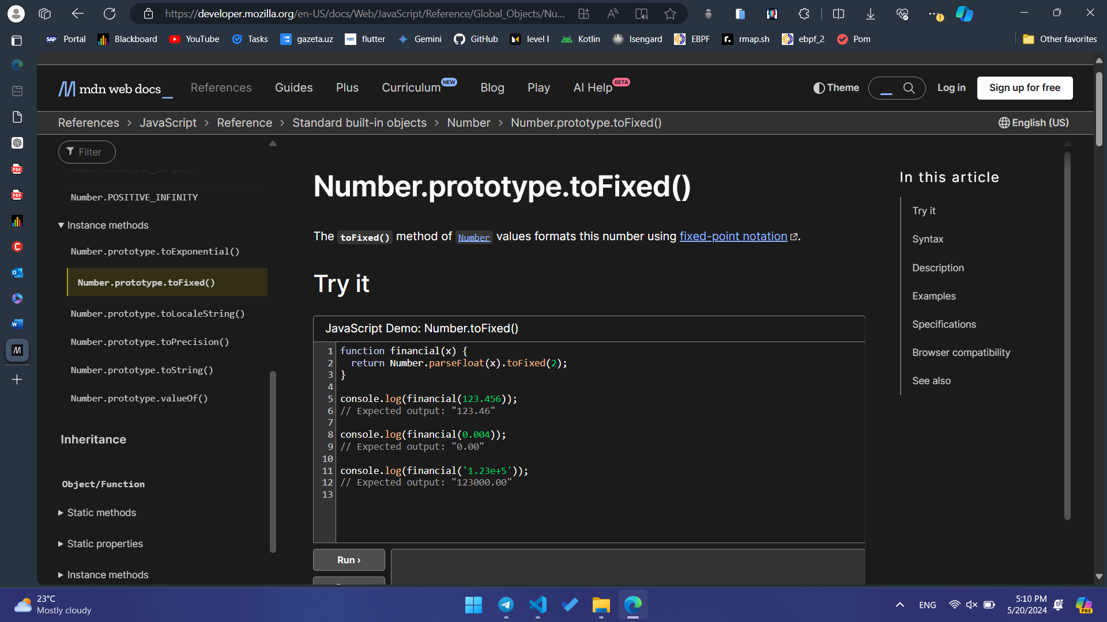  
As well as toLocaleString where it fixes the number and makes it more readable:  
  
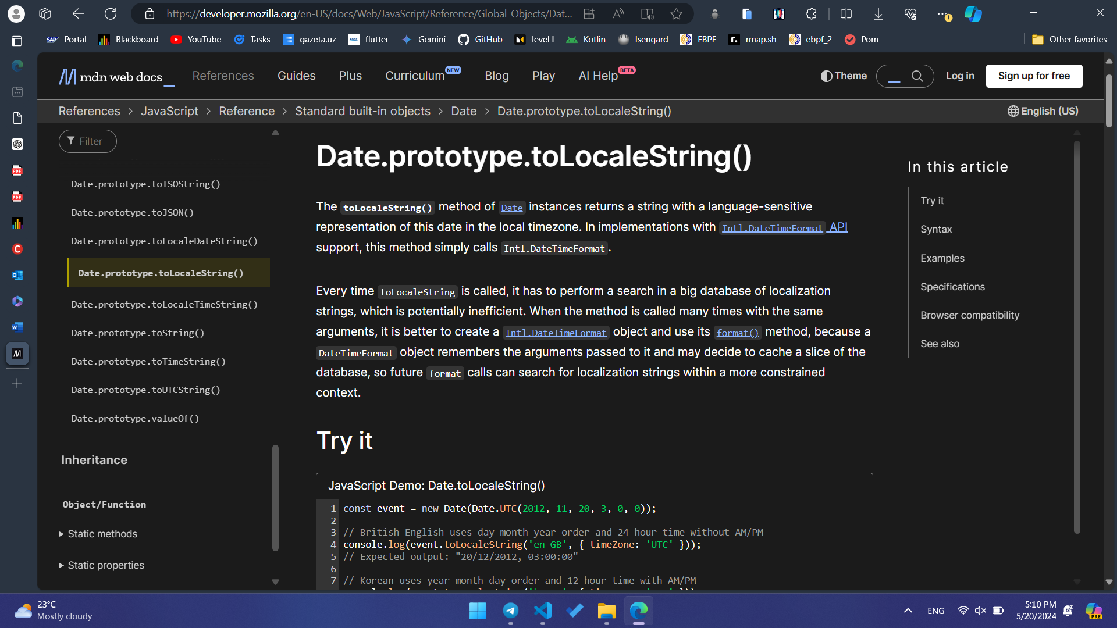

When it comes to integrating chatGPT, I used it extensively to implement Zoom part:   
  
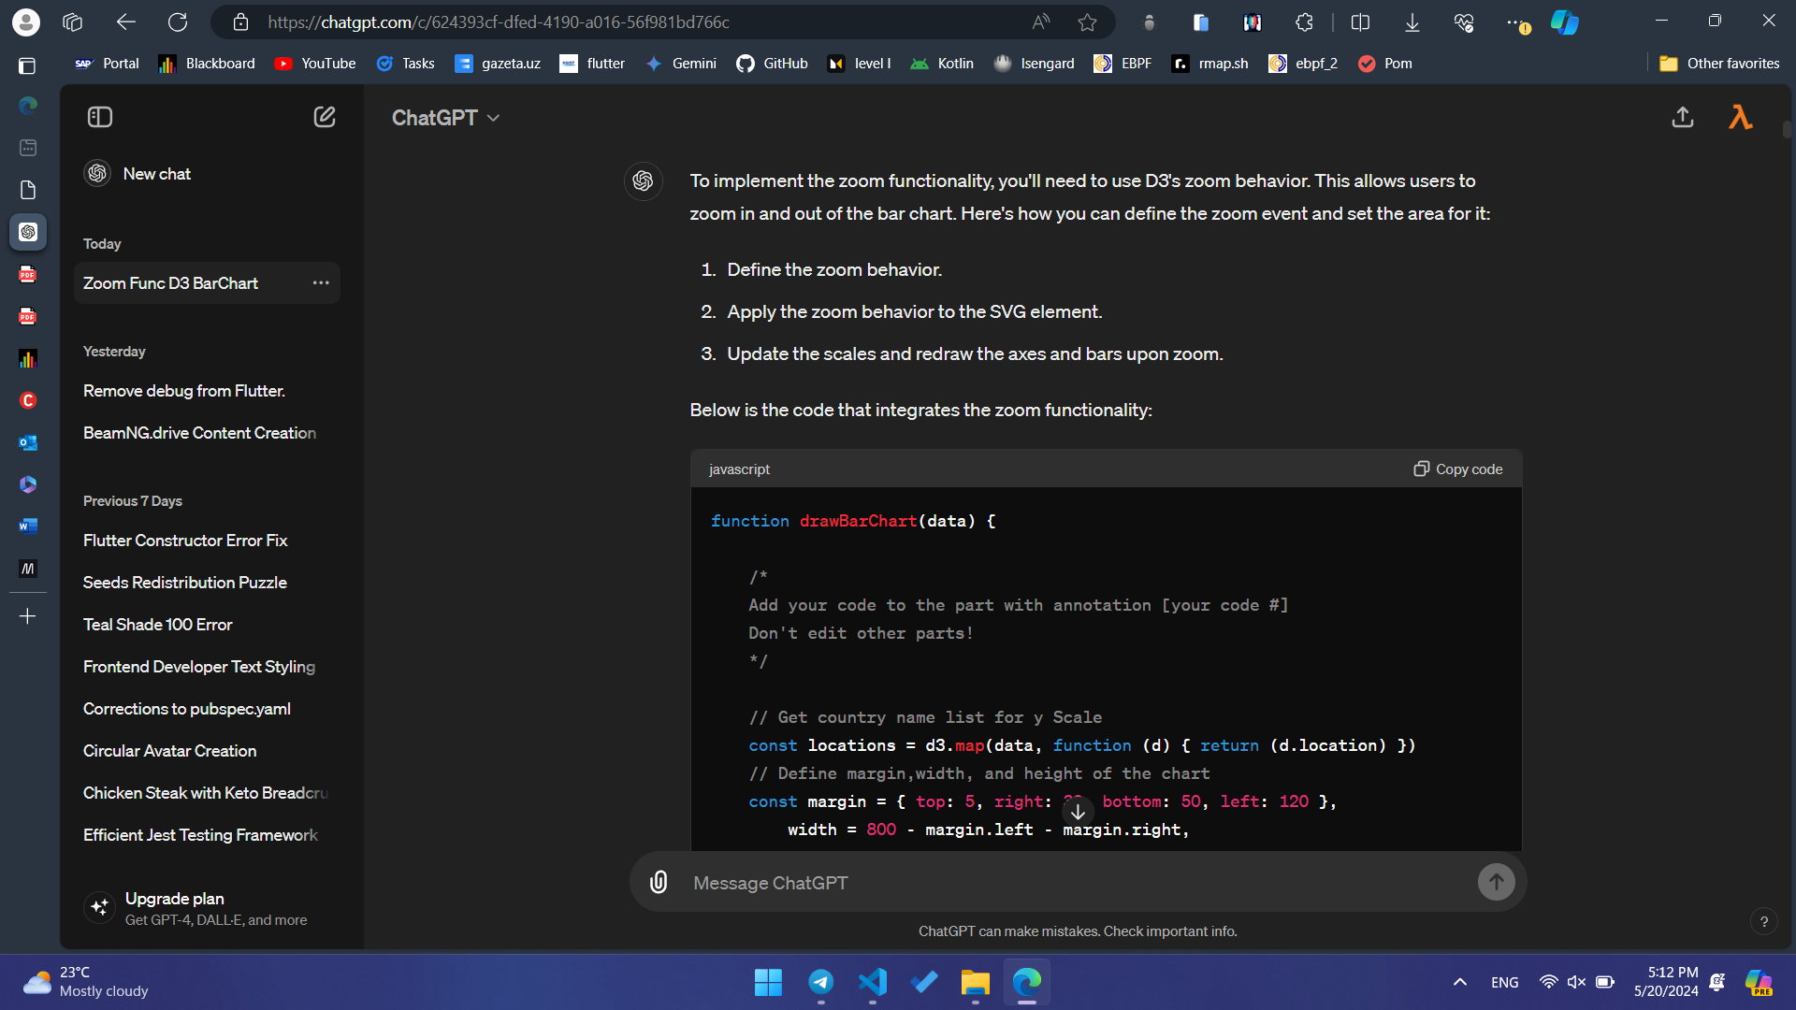  
Also the color of the bar part:  
  
