



CONSUL Administration
GuideVersion 0.15

Index of contents

0. Introduction to the CONSUL Administration guide

1. Administrator interface

1.1 Polls
1.2. Collaborative legislation
1.3. Participatory budgets
1.4. Messages to users
1.5. Site content
1.6 Voting booths
1.7 Signature sheets
1.8. Moderation
1.9 Profiles
1.10. Configuration

2. Moderator interface

3. Valuation interface

4. Management interface

5. Poll officers interface

5.1. Validate document and vote
5.2. Total recount and results

0. Introduction to the CONSUL Administration guide

CONSUL has different independent interfaces from which can be managed everything that happens in the platform easily. These interfaces are the following: Administration, Moderation, Valuation, Management, and Polling officers.

Administrators can access all of them, and additionally assign permissions to other users to access any of them, and thus be able to collaborate with the management of the processes in a decentralized and secure manner.

In the following sections we will explain the use of each of the interfaces.
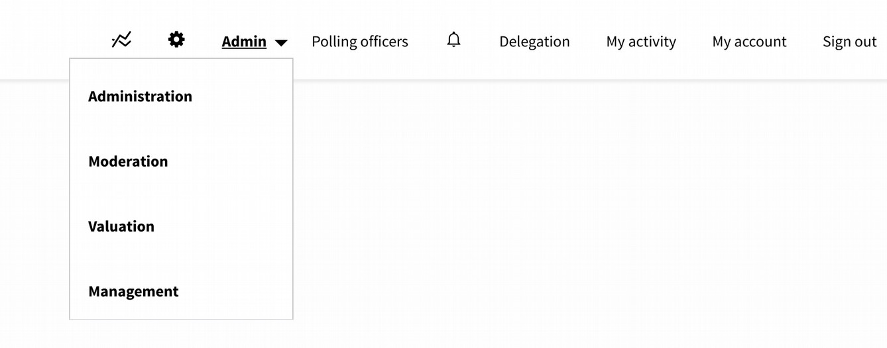
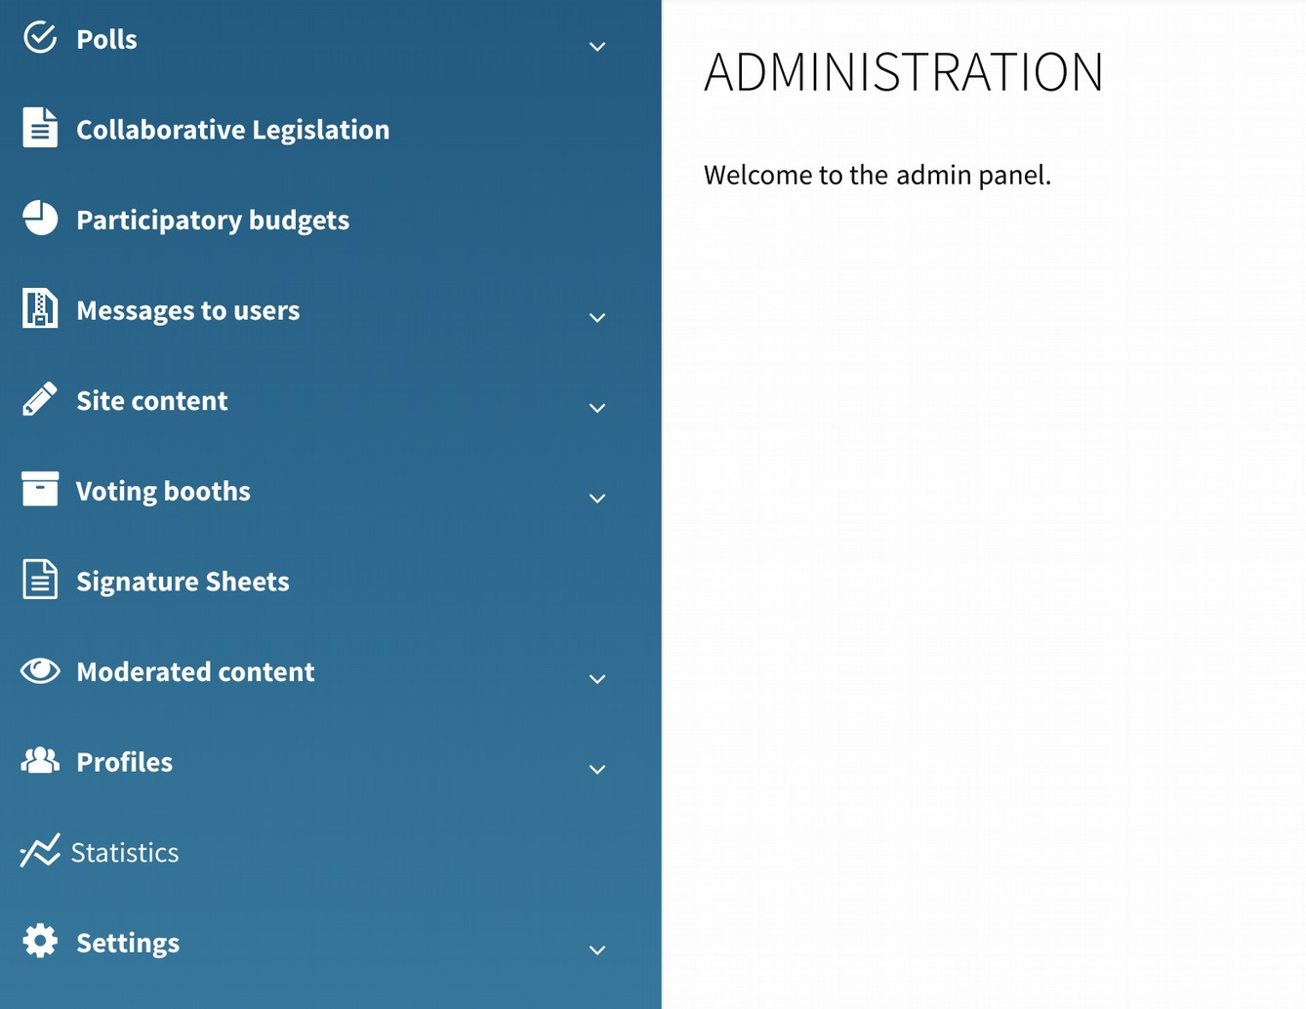
1. Administrator interface

1.1 Polls

Section to manage the voting processes. Each poll may contain several questions, may be configured to be voted by everybody or only by the residents of an area, and may have some specific voting booths to vote it. Different polls with different configurations may run simultaneously.

- Polls. List of polls. The "Create poll" button allows the initial definition of the poll. "Name", "Summary" and "Description" will be the public information presented on the poll web page (each poll has its own web page, listed all of them in the voting section of the platform). Voting online will be possible between the "Start date" and the "End date". An "Image" can be uploaded, and will be shown in the list of polls in the voting section. The checkbox "restricted by geozone" allows restricting the users who can vote on the poll to a specific area.
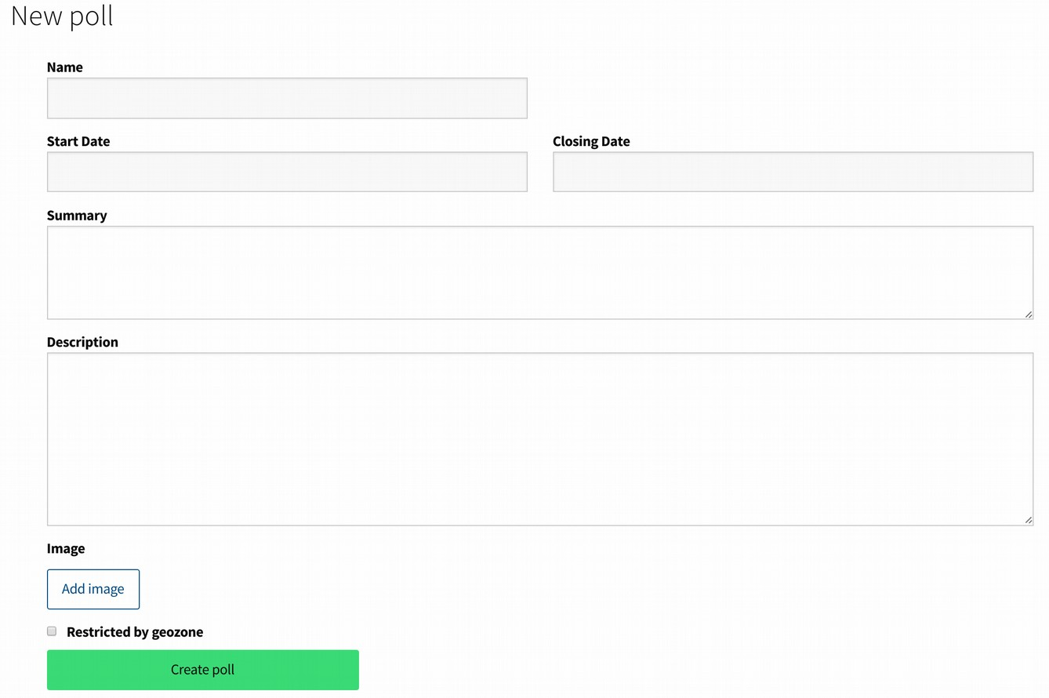
- Polls questions. List of all the questions of all polls. The button "Create question" allows creating a new question for any poll. In the first form is only needed the question and selecting the poll where it will be included. In the following form can be added the possible answers with the "Add answer" button. Each answer can include a description, images, documents and videos. All this information will be shown in the poll web page, below all answers. To upload material click in the "images list", "documents list" or "videos list" links on the right side once the answer has been created.
This section also includes a tab named "Successful proposals". There are listed the proposals that reached the required threshold of supports. The "Create question" button allows to create a voting of the proposal and include it in a poll.
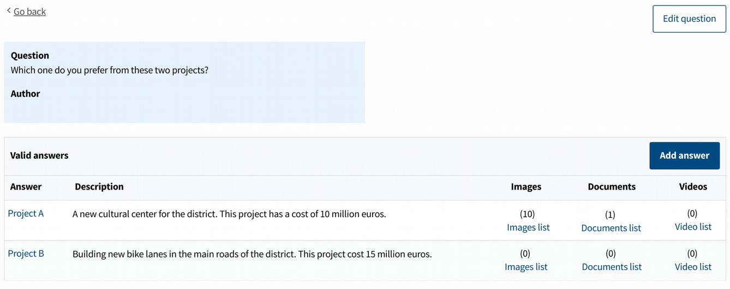

- If you want to enable ballot boxes in addition to digital voting, this can be configured through the menu "Voting booths", that will be introduced later.

Once a poll has been defined through these previous sections (and through the “Vooting booths” menu if this is the case), the poll can be accessed in the "polls" section. Clicking in the poll can be seen the questions, booth, officers, recounting and results (these last two options once the poll has started).

In the recounting and result section can be found links to see the partial results for each booth. Notice that the recounting section differentiate between two types of recounting: the recounts (made by the officers) and the votes (registered automatically by the platform). This comparison helps checking that the process was done correctly. Once the poll has finished, is the results section are found two checkboxes to do public the results and the statistics of the voting. Those results will be shown in the public voting page.

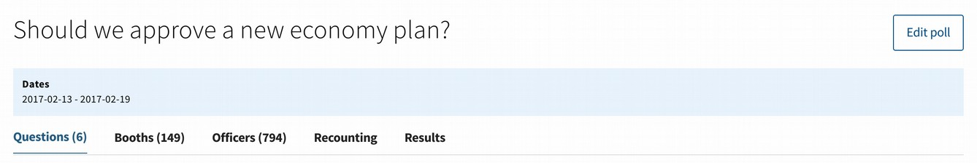

1.2. Collaborative legislation

In this section are managed the processes of collaborative legislation. The basic process allow three different phases, and in each one can be decided which ones are used. The phases are: debate, proposals and drafting. The debate phase allows to open several questions. The users can give open answers to the questions, and rate other's users answers. The proposals phase allows to the users to write proposals on the issue, and support other users proposals. The drafting phase allows to publish a text. Users can select any part of the text, make comments to it, and rate other comments.

Clicking "Create new process" can be defined which phases will be active (click in the "enabled" checkbox of each phase), the start and end dates of each phase, the information that will be shown in the web page of the process (title, summary for the list of processes, basic description and additional information), and additional documents that can be uploaded when required to that same page as additional information.
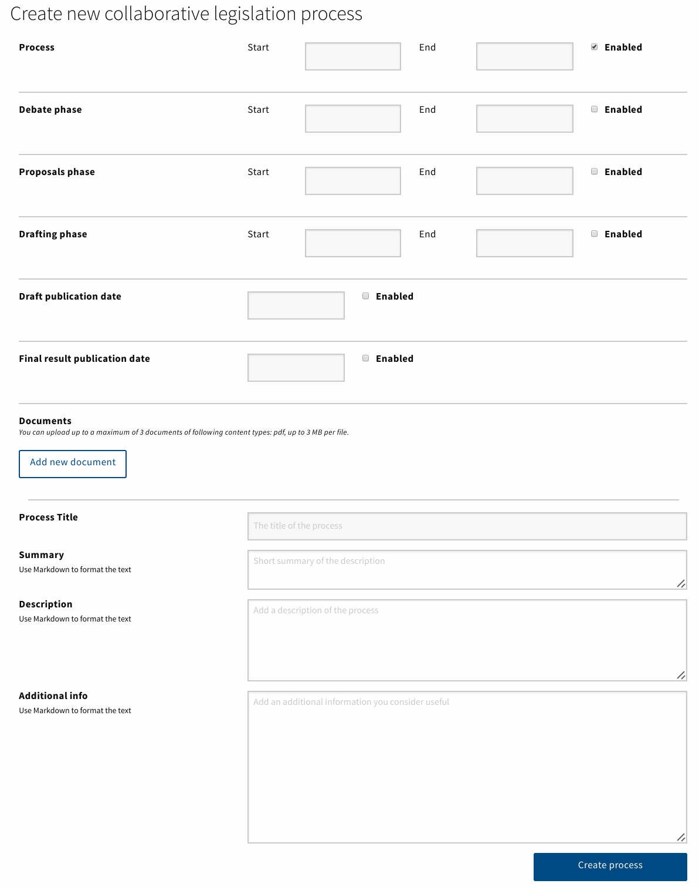
Once created the process, clicking on it can be seen different tabs to define each phase:
- Information. Basic information defining the process.
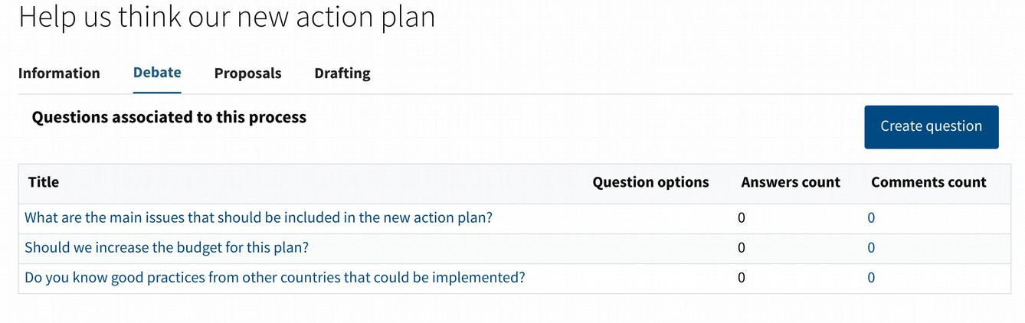
- Debate. The button "create question" allows to add new questions to the phase. It is possible to define closed answers to the question, but it is optional. By default the answers are open.

- Proposals. The "categories" field define which categories will be suggested to the user when creating a new proposal. The categories will be listed during the process, in order to filter the proposals with those categories.
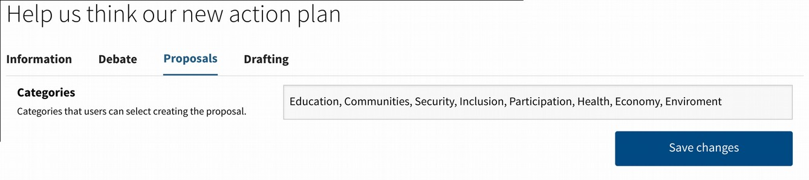

- Drafting. The drafting phase allows to have a first version of the text, and then modify it and publish new versions. To start the process click on the "Create version" button. In the upper part can be written the title of the text and there is an optional field to write a summary of changes with respect to the last version. The status option select between "draft" (the text will not be public, only administrators can preview it) and "published". Once the process has finished, the "Final version" checkbox allows to publish the final text where comments will not be allowed.
The link "Launch text editor" can be used to upload the text. When clicking on it, the window will be split in two parts. The left part is used to introduce the text, and the right part will show how will it look in the web page. In order to add styles to the text (as: bold letters, italic, etc.) "markdown" format should be used. It may seem very different to traditional text editors, but is easier than what it seems. When having the text ready (or part of it) click in the "close text editor" and then in the "create version" button.

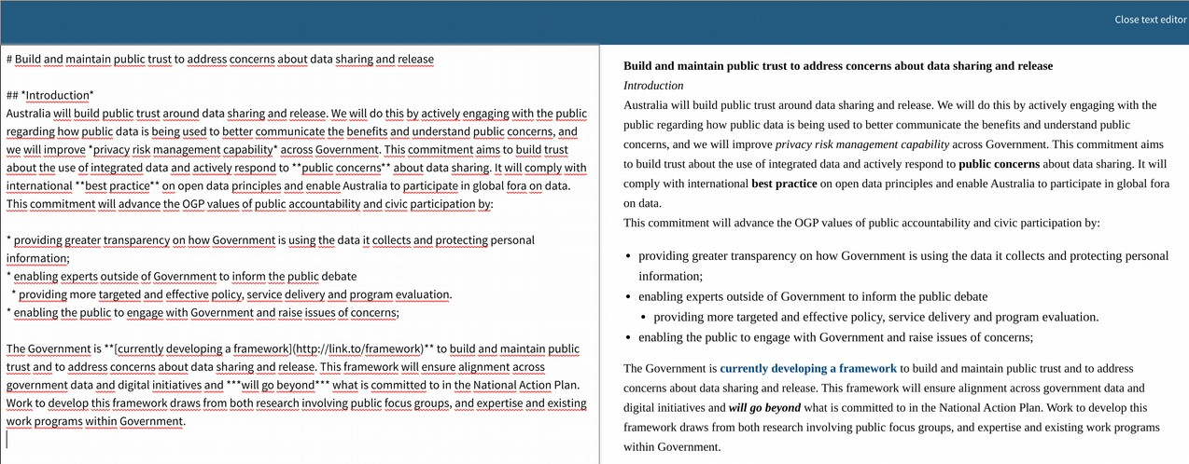

1.3. Participatory budgets

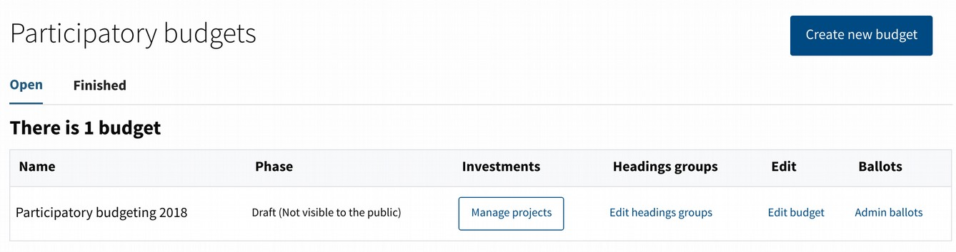
Through participatory budgeting the users can decide together how to spend a budget.

The process may include the optional following phases: "Information", to publish the basic information on the process before the participation phases start. "Accepting projects", users can write projects for spending the budget. "Reviewing projects", all projects are published and new ones can not be added, so it can be detected mistakes in the existing projects. "Selecting projects", user can support the projects they like to prioritize them. "Valuating projects", administrators and valuators can select if the projects are feasible or not, and the cost for each one. "Publishing projects prices", the feasible projects selected for the voting phase are published, but still the voting is closed, users can check if the information and valuation has been done correctly. "Voting projects" where the selected projects are voted. "Reviewing voting", in order to check the results. "Finished budgets", to present the final results once the process has finished.

The projects are categorized within "groups", and "headings" for each group. Each user can support and vote projects from each group, but only from some limited amount of headings of each group (one by default). As an example, in the participatory budgeting of a city, one of the groups could be "Projects for the whole city", and other group could be "Projects for a specific district". And then inside the second group would be one heading for each district. All users would vote the projects for the city, and projects of one district of their choice.

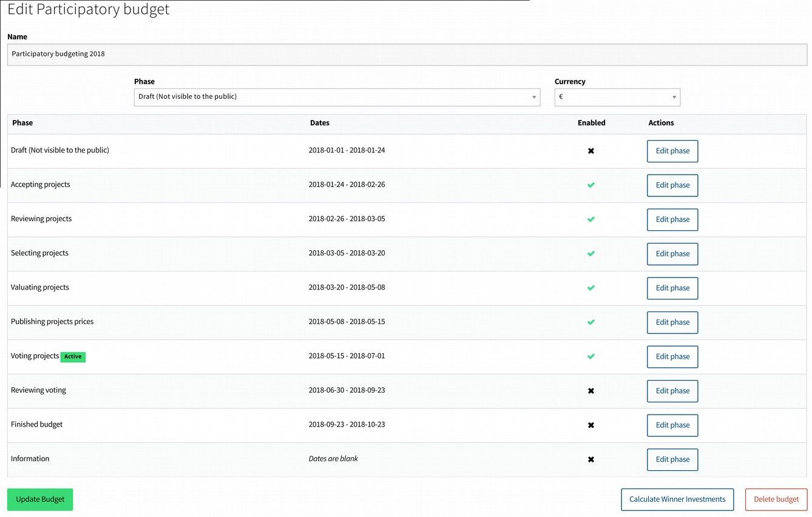
Click on "Create new budget" to define the name of the process, the currency, and select the initial phase. In the following window, clicking in "Add new group" new groups may be defined.

For each group can be added as many headings as wanted. The heading is defined by the name, the amount of money, and optionally the population (if the heading corresponds to an area). The max number of headings that can be selected to support or vote can be defined for each group independently with the "Edit group" button.
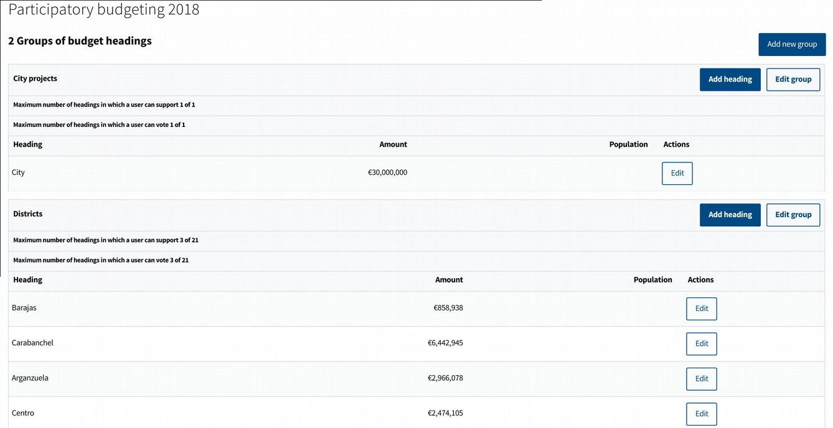
The main section contains two tabs: "open" and "finished" budgets. The "Edit budget" link allows to define which phases will be active, and the start and end date for each phase. In each budget the link "manage projects" show us the list of projects created by the users:

The list of projects include the following fields: "ID", "Title", "Supports" (of the 'selecting projects' phase), "Administrator" (the projects can be assigned to administrators, to check they are properly evaluated, and have a general overview over some headings or groups), "Valuator" (users with the valuator role will see their assigned projects through their valuation interface, where they can evaluate them), "Valuation Group" (valuators can be organized in groups), "Scope of operation" (heading of the project), "Feasibility" (undecided by default, and then feasible or unfeasible once evaluated), "Show to valuators" (valuators will see only their assigned projects marked with this checkbox, in order to prioritize which ones have to evaluated), "Val. Fin." (describing if the valuation has been marked as finished), "Selected" (feasible projects with finished valuation can be marked as selected; those will be the projects shown in the final voting phase).

The projects can be filtered according to the following tabs: All, Without assigned admin (no administrator assigned), Without assigned valuator (no valuator assigned), Under valuation (projects with valuator assigned), Valuation finished, Winners.
Other filters can be found in the top part: Administrator, Valuator, Headings, Tags (tags set by the administrators, not by the users). Also "advanced filters" that allow filtering by:
Feasible, Selected, Undecided or Unfeasible projects, or the minimum amount of supports to be shown in the list, and a search field to search by ID or word. All those filters and tabs can be combined to produce very specific searches.

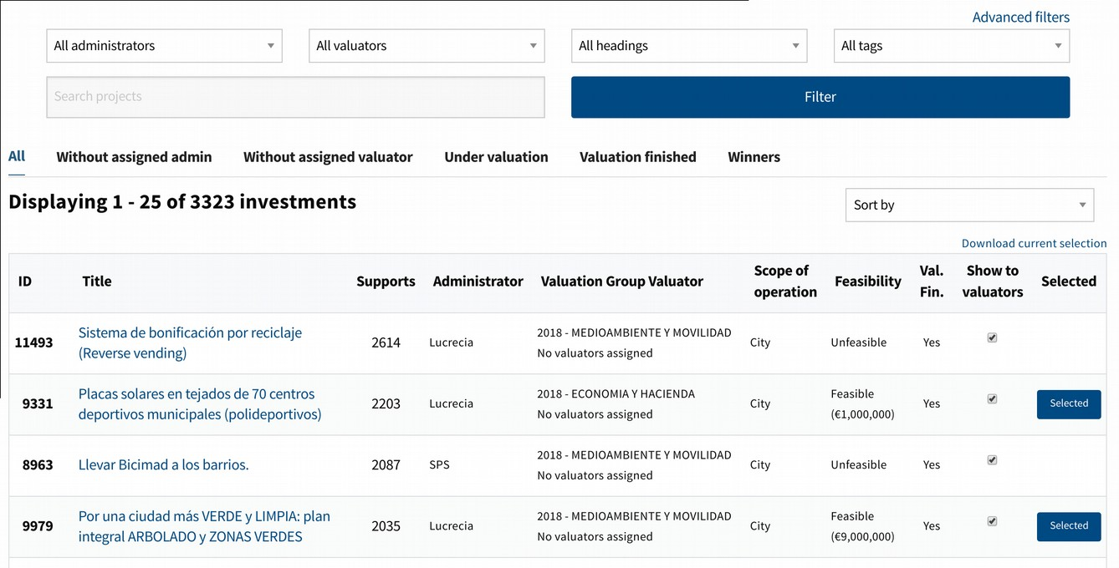
The link "download current selection" allows downloading the projects shown in the bottom table in a csv file.

Clicking in the title of a project a new page show us the information of the project. First the public information of the project. Then the "Classification" section where the administrator and valuators assigned and the tags are shown, and can be edited with the link "Edit classification".

It is important to keep in mind that you should not change the classification of which heading or group a proposal belongs to during the support or voting phase. The possibility of supporting or voting on a proposal depends on the heading in which it is classified. Therefore, someone who could be voting on a proposal in a heading may not be able to vote the same proposal in another heading. Therefore, if the classification of a proposal is changed, the supports or votes that it has at that moment will be eliminated. Although this will be alert to the administrator, it must be taken into account during the management of the process.

The following section is the "Dossier", where the feasibility and price are shown and edited. When editing the report of a project, will be displayed the same interface that "evaluators" users see through the “evaluation interface”, that will be explained later. It will be explained in more detail in that section, but it is important here to bear in mind that if a project is declared unfeasible and the project report is finalized, the report of unfeasibility will be public on the project website, and it will be sent at that moment an email to the author with that report.

The next section is the "Valuation comments"; those comments between the administrators and the valuators are not public. Are used for internal discussion on the projects. And finally the "Milestones" section.

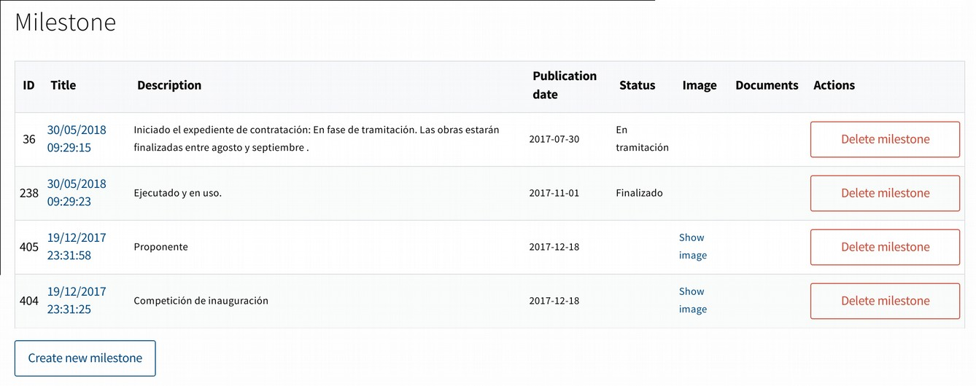
The Milestones section is used to publish the evolution of the finally selected project once the participatory process has finished. A timeline will be published in the public page of the project with all milestones. Clicking in "Create new milestone" the following information can be added: status (to categorize the projects, for example: "studying the project, contracting, building, finished"; the possible status can be defined in the bottom link), description of the milestone, date of publication of the milestone, images and documents to show in the milestone. The date and a status or a description are the only mandatory fields.
1.4. Messages to users

This section manage the communication with the users. The following possibilities are available:

- Newsletters. Newsletters are e-mails sent to the users. For each one it can be defined the content of the email, and which users will receive it. Click on "New newsletter" to define the subject, the email that will appear as sending it, the content and the recipients (the users that will receive it). Once created can be "Previewed" and then sent with the "Send" button of the preview page.
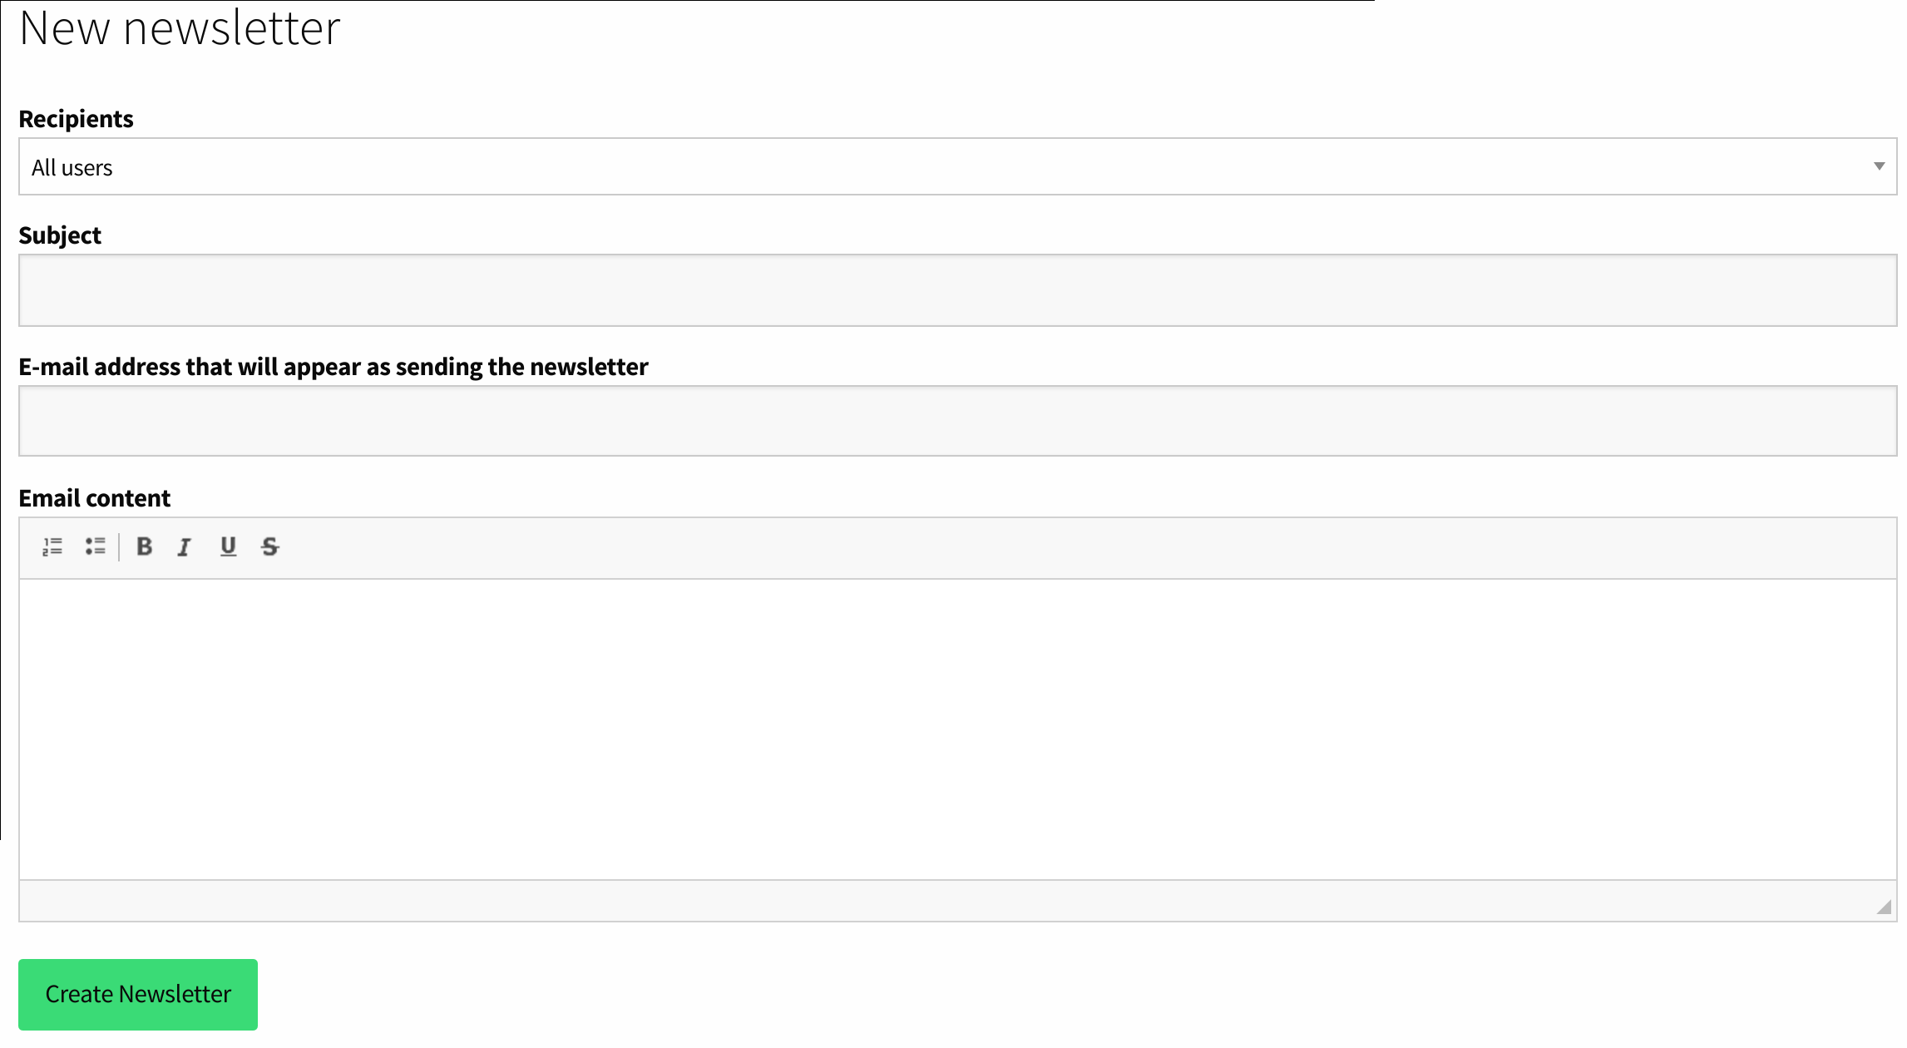
- Notifications. Notifications are internal messages that appear in the notifications dashboard for the users (the bell on the top right of the screen). It can be defined the recipients, title and text (as in the previous section), and also a link. When clicking the notification the link will be open.
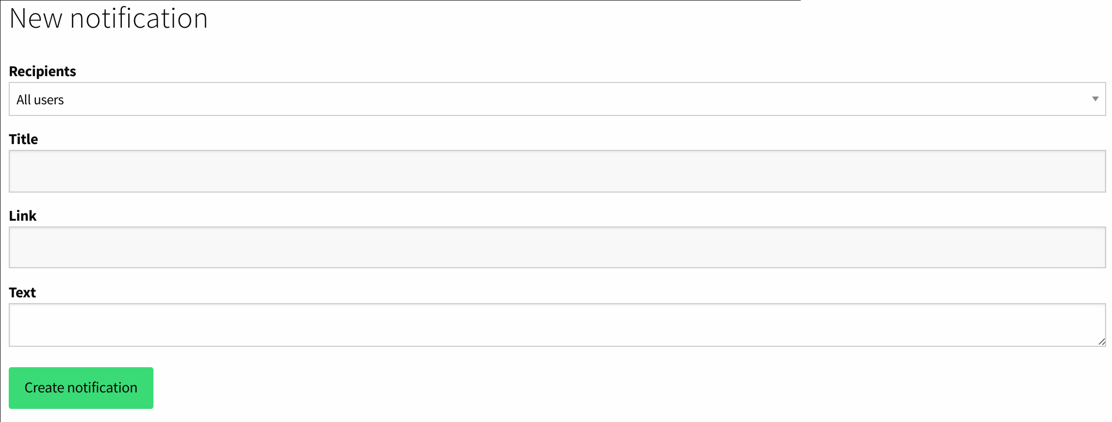
- System emails. In this section can be found all the internal emails that the system send to the users. For example emails sent to the user when signing-up, when verifying the account, etc. An important special kind of system email is the "Proposal Notification Digest". The authors of the proposals can write proposal notifications that appear in the web page of their proposal. Those notifications are sent to all users supporting the proposal through this digest. Here the digest can be previewed, to check the content to avoid spam, and send when decided.
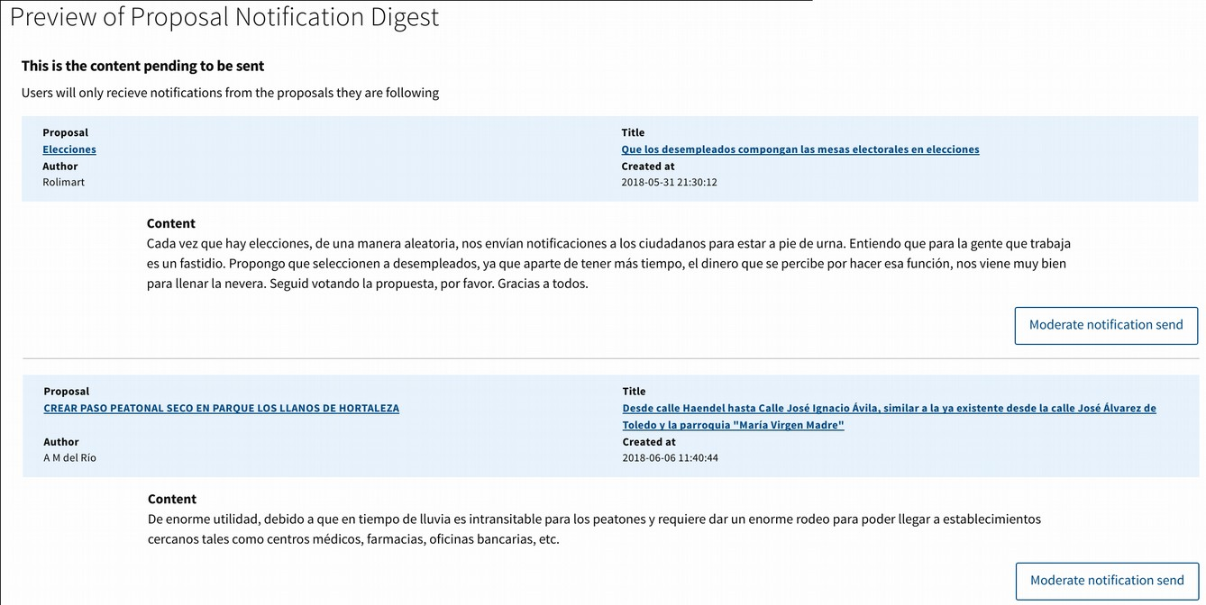
- Emails download. The last option allows to select a group of users and download their emails in a csv file, to use it in an external communication system.

1.5. Site content

- Homepage. In this section you can configure what is shown on the initial screen of the platform when you enter it.

The first menu allows you to define the "Header" by clicking the "Create header" button. This is a first band that appears just below the menu bar, and allows to give the most visibility to what seems most relevant. The band can be configured with a title that will appear in a large font, a small description, an additional image, and a link that will be accessed by pressing the button that will appear in the band.

The next element to configure is the "Cards". These cards are rectangles of smaller size than the band of the header, and located below, which will allow to highlight other processes or relevant links, although less than the header. Several cards can be created with the "Create card" button, and will be placed one after the other. The cards are defined in the same way with title, description, image and link.
Then we can activate four different elements, with the "Enable" buttons: Proposals, Debates, Processes and Recommendations. Proposals will show us the proposals that appear in the top of the “Proposals” section of the platform. Debates are the same, but referring to the “Debates” general section of the platform. Processes will activate a format similar to the previous Cards, but with the content of the last processes that are active in the "Processes" or "Collaborative Legislation" section of the platform. In these three cases we can select the number of elements that will be displayed with respect to each one. The last option "Recommendations" activates a module at the bottom of the page, which will only be seen when one is logged in as a user on the platform. When this is the case, it will show three debates and three recommended proposals for our user, depending on the debates and proposals that we have previously supported. This automatic recommendation system selects the labels of the debates and proposals that we have supported and looks for other elements with the same labels. If we enter with our user in the Debates or Proposals section, in the upper part of the debates or proposals we find different filters to order the elements: "More active / Highest rated / New / Recommended". This last filter is the same one that is used to show recommended elements in the initial page.

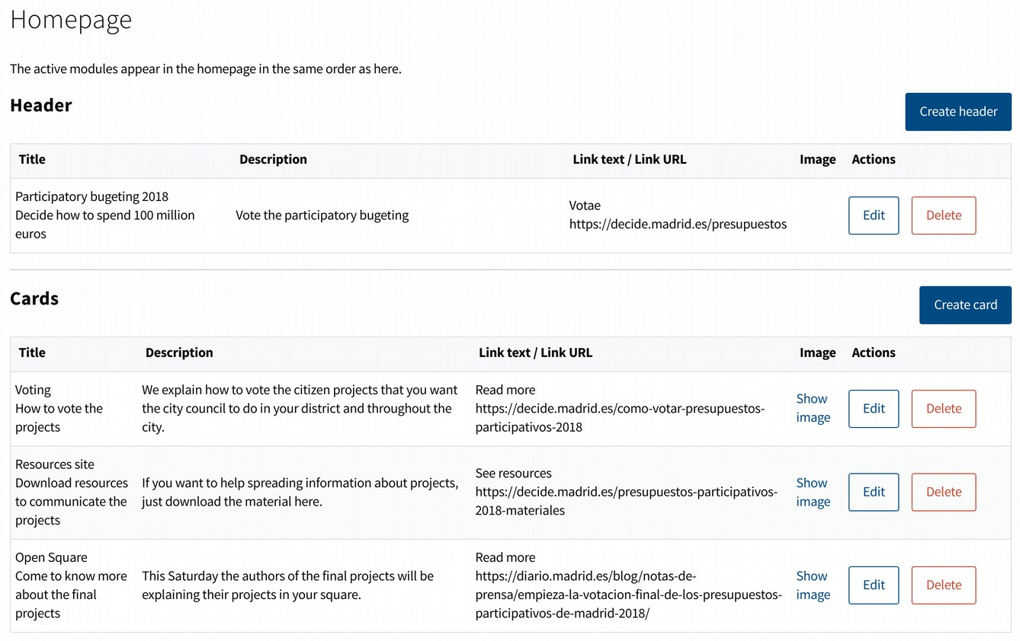
- Custom pages. In this subsection can be created information pages for the users. Click in the "Create new page" button to define it. The page includes a title, subtitle and text. The language of the page can be defined, and also the "slug" (the url that will be shown in the web browser). The status can be chosen between "draft" (while we are creating it) and "published" (visible to the users). And two additional options can be selected: showing it in the "help" section of the platform, and including a "print" button on it to make easier for the users to print it.

- Custom banners. This section allows you to configure banners that will be displayed at the top of the Debates and Proposals sections of the platform. They will allow to highlight other processes or links that seem especially relevant.
By clicking on the "Create a banner" button we can fill in the following information:
Style. The style of fonts and colors of the banner.
Image. The background image of the banner.
Post started and ended at. The banner will be displayed automatically during the selected period.
Title and description The text that will be displayed on the banner.
Link. The URL to which you will direct us when you click on the banner.
The banners are saved and can be reused later.

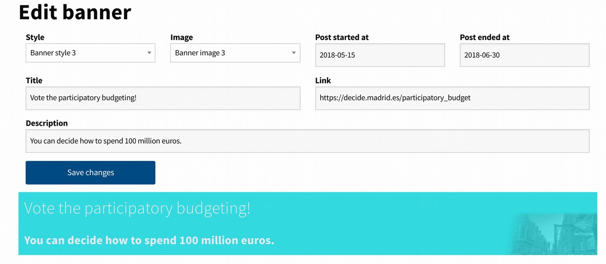
1.6 Voting booths

This section allows you to enable offline voting polls for both "Voting" and "Participatory Budgeting" processes. The booths are managed through the “Polling officers” interface to ensure that no person can vote twice in the ballot box and on the digital platform. It also allows monitoring of the evolution of voting in ballot boxes in a decentralized manner.

To be able to use the voting booths we must first define the voting. This will be done in the "Voting" menu or in the "Participatory Budgeting" menu (in the "Manage booths" button) depending on the case. Once the voting has been created, you can define the polls, poll officers and assign the corresponding shifts.

- Poll officers. List of users with the role of "officers". This users are allowed during a voting to access to the officers interface (that will be explained later), where is managed the voting in physical booths. These officers check that people vote correctly, that nobody votes twice, and check the results of the physical booth. To assign the role of "officer" search the user in the top field, and then click in the button next to the user name.

- Booths location. Booths can be given a name, and their location, in order to manage them easily. Click "Add booth" to define a new booth and its location. The "booth kind" option differentiates between a "physical booth" where people vote in a ballot box, and a "digital booth" where people vote directly in a tablet or computer. The first one implies a manual process of counting the votes and checking the results by the officers.
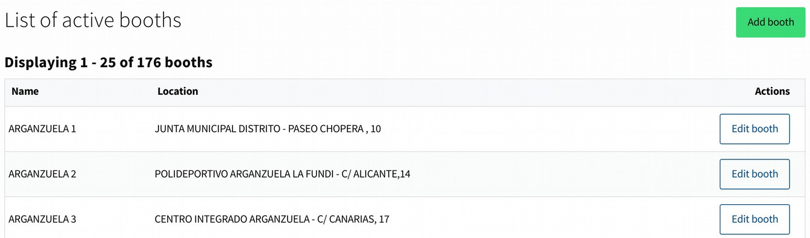
- Booths assignments. The platform controls which ballot boxes are used for each active poll and which officers are in each ballot box. The "manage assignments" button allows to select which ballot boxes will be used for each poll, by clicking the "assign booth" next to the selected booth.
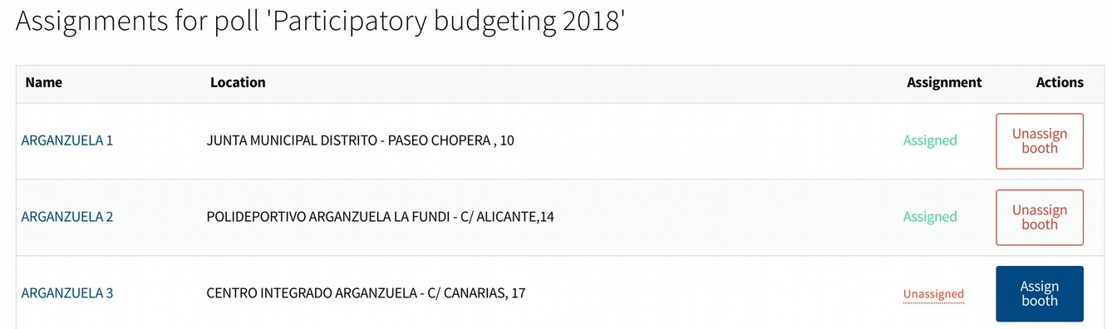
- Manage shifts. Clicking in "Manage shifts" for each active ballot box officers can be searched. The "Edit shifts" button right to each officer allows to add a shift for that officer in the ballot box. Shifts can be defined as "Collect votes" for the days the poll is open, and "Scrutiny" for the days following the poll. This two tasks allow different options for the officer in the "officer interface" during the voting process. Several shifts can be assigned to each officer.
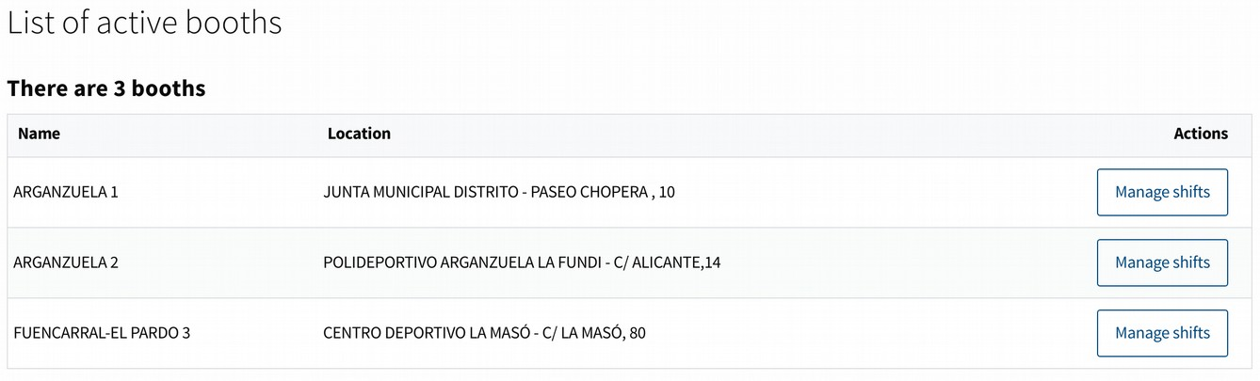

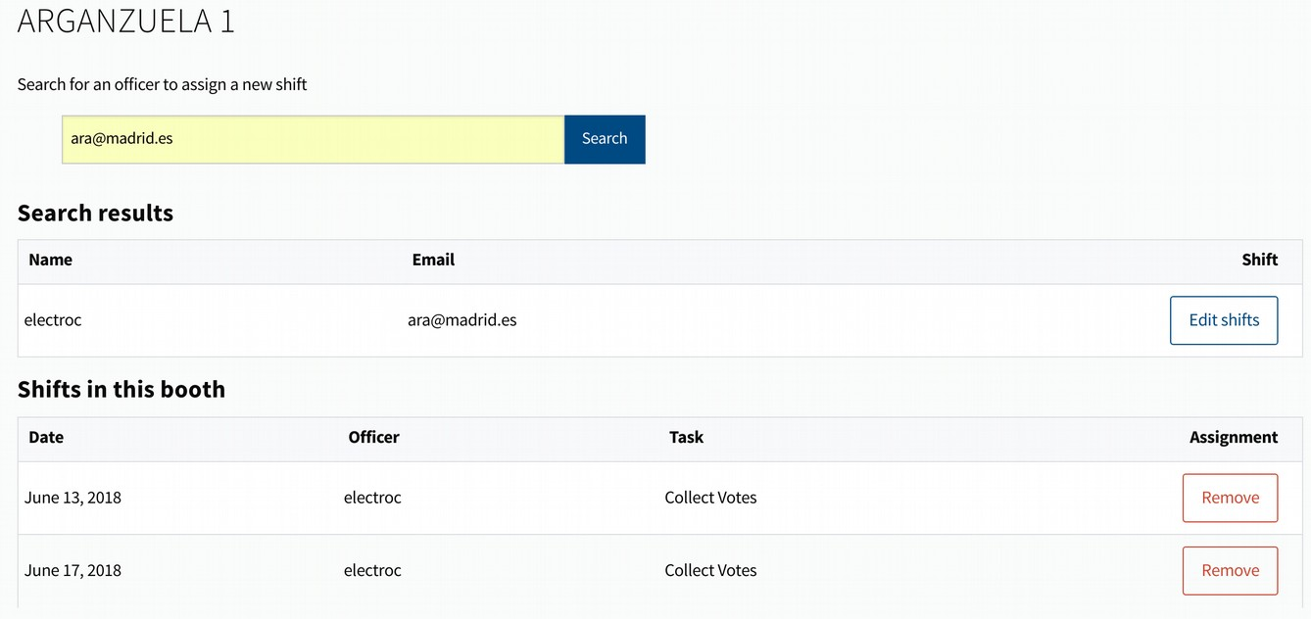

1.7 Signature sheets

If it is allowed to support proposals or participatory budget projects by signing a traditional signature sheet, that part of the process may be managed here. This section allows to upload the signatures so it can be checked if the citizens are allowed to support the proposal/project, and not having duplicate or unverified signatures. To upload new signatures click on "new signature sheet". Select if it is a proposal or a participatory budget project, add the ID of it (it is shown in the web page of the proposal/project), and then add the citizen document numbers separated by commas. When clicking in "Create signature sheet" the system will verify each signature, and add the valid supports to the proposal/project. Take into account that the verification system is slow. You may come back later to the signature sheet web page to check its result. All the signature sheets will be shown in the section, with a link to each one showing all the information and the result after creating it, for any additional verification.
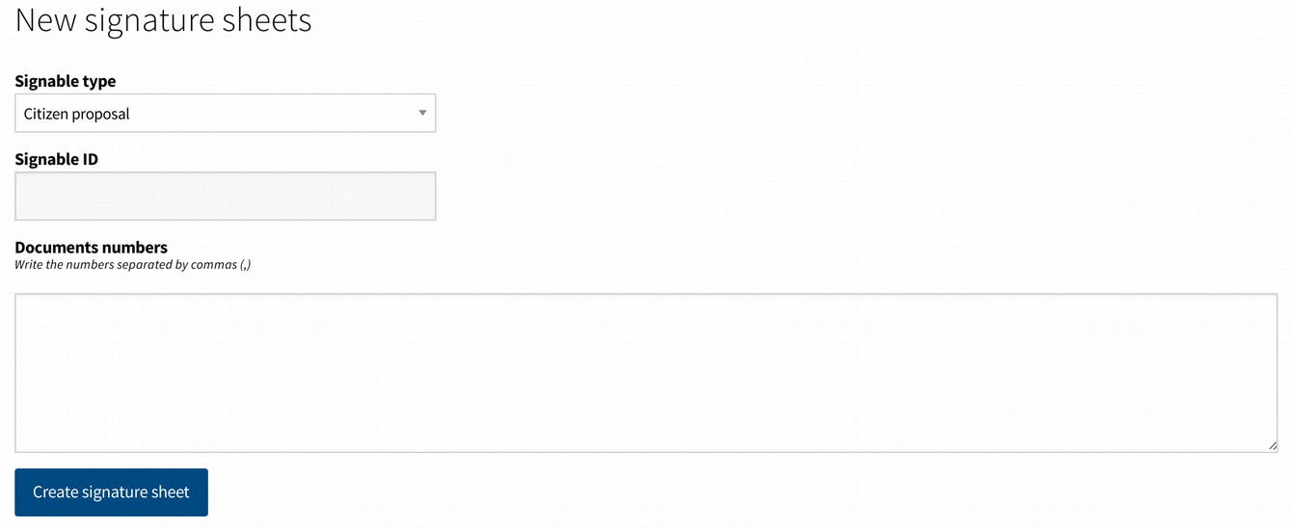

1.8. Moderation

Moderation of the platform is done from the moderation interface, which we will explain later. However, this section allows you to follow up the moderatio activities. It shows all the content moderated by moderators or administrators of the platform, as well as the activity of the moderators to verify that it is being done correctly. All moderation activities are kept in a log and can be verified by other administrators. The subsections 'hidden proposals', 'hidden debates','hidden comments' and ‘hidden proposal notifications’ work in the same way. Each show the list of moderated content, with buttons "restore" and "confirm moderation" next to each content. The first one undo the moderation action, making the content public again. The second one confirm that the moderation was properly done and move the content to the "confirmed" tab. The confirmation action does not change anything publicly, is just useful for internal purposes of review of moderation.
The subsection 'blocked users' shows all users that have been blocked in the platform. In the same way, the block action can be undone or confirmed.
The subsection 'activity of the moderators' contains a log of each moderation action carried out and the date and author who made it, to ensure that it is carried out correctly.

1.9 Profiles

Users can have additional roles, allowing them to use special interfaces or functionalities of the platform. To mark a user with a role enter in the proper subsection, search the user in the top field by name or email and then click in the "add" button next to the user name. To revoke a role, search the user in the same search field and click the button "delete" next to the user name.

The following roles are available:
- Administrators. Those users can access to the administrator interface and the rest of the interfaces (manager, moderator, valuator, etc). As seen all the processes and configurations of the platform are managed through the administrator interface. Double check who administer the platform.

- Organisations. When signing-up to the platform, it can be chosen to create an organisation user instead of a normal one. By default those users, when verified, are highlighted with a small banner of "organisation" next to their user name in the content they create. They may create debates, proposals or comments, but they can not support or vote in the processes. The organisation users created will appear in this section. Administrators can chose to "verify" or "reject" each user. Pending or rejected users have the same functionalities, but will no show the "organisation" banner in the content created. The top tabs organize the users depending if they have been already verified or not ("pending", "all", "verified", "rejected").

- Officials. Those users are highlighted with a small banner next to their user name in the content they create. The content is also shown with a different style to highlight it. Different levels of "officials" can be defined in the configuration section, and the text that appear in each banner type. The specific level for the user can be changed or removed by the "edit official" button next to the user name. As an example in a city the top level official could be the mayor, the next level the councillors, etc.

- Moderators. Users with this role can access to the moderator interface, where are listed all the content of the platform flagged as 'inapropriate' by the users. They have the options to hide or confirm the content and block the users.

- Valuators. This role allows the access to the valuation interface for the participatory budgets. Through this interface they see the proposals that are assigned by the administrators for each specific valuator, and can fill the valuation dossiers.

In addition to defining individual valuators, these can be organized into groups. This is especially useful since generic groups can be defined according to the topics or responsibilities, and then add or eliminate evaluators in the group as necessary. It allows a more flexible control of the evaluation during this phase, as well as several people working in the same set of proposals. To access this possibility, in the upper right part you can find the "Valuators Groups" button.
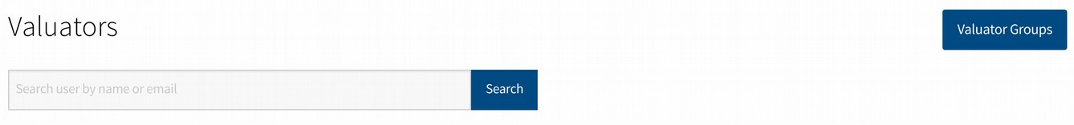
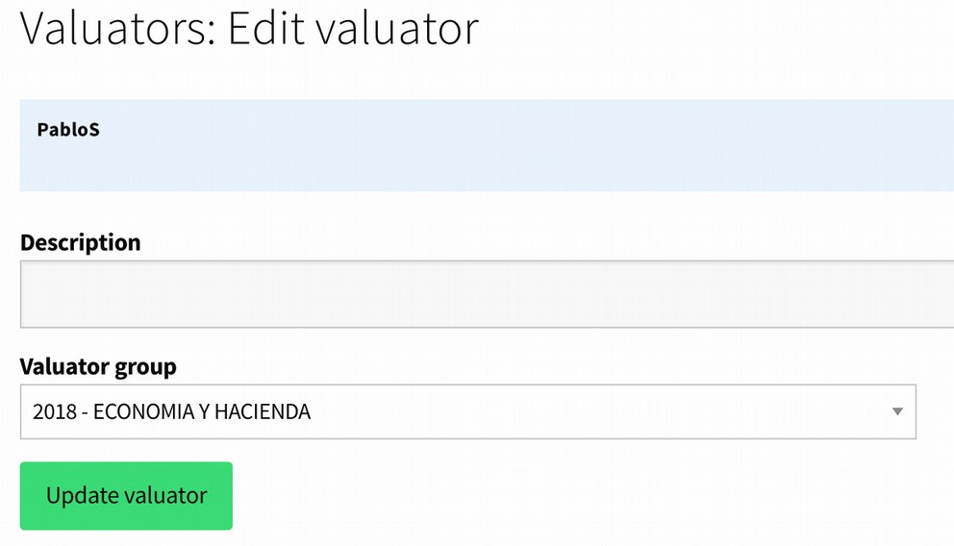
Once inside, the "Create Evaluator Group" button allows you to define a new group. When creating a group it will be shown in the list on that page and by clicking on it we can see the evaluators that are part of it in case there is one assigned. To assign evaluators to a group we will do it from the initial page of "evaluators". When registering an evaluator (or clicking on it and then on the 'Edit' button of your tab) we will see a selector titled 'Evaluators' group' where we can select if we want to assign a group. This can be changed at any time.

If a project of participatory budgets is assigned to a group of evaluators, all the evaluators that at that moment are defined as part of the group will have access to it.

- Managers. Those users have the permission to access the managers interface. In this interface managers can create and verify users accounts, and perform tasks for the users are creating or supporting proposals, etc. The common use of this role is for public workers in the institution office, to help the citizens to interact with the participation processes.

- Users. All registered users of the platform can be found here with their user information and a link to their user page.

1.10. Configuration

From this section it can be defined the general configuration options of the platform, which do not affect the configuration of each specific participation process. These other configurations are adjusted from the sections of each of the processes.

- Global settings. This is the main configuration section. It is divided into the following tabs: Configuration settings, Features, Banner styles, Banner images, Map configuration.
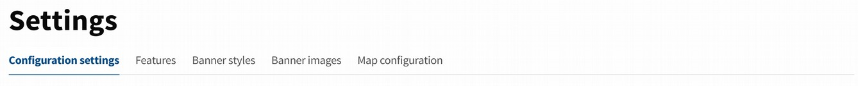
- Configuration settings. Here are found various parameters of the platform.

- Features. By clicking on the "enable / disable" buttons, sections of each participation process (Debates, Proposals, Processes (Collaborative Legislation), Participatory Budgeting) or some specific functionality (such as Facebook or Twitter login, Communities in the proposals, Recommendations, Geolocaion, etc.) will appear or disappear from the platform.

- Banner styles and images. To configure the menu options "Site content" → "Manage banners"

- Map configuration. If the geolocation is activated in the Features section and the latitude and longitude and zoom is correctly defined in the section "Global settings" it will be shown a map in this section, which will be the one shown by default in the proposals and projects of participatory budgets to set the proposals.

- Proposal topics. When a user creates a proposal, some default labels are suggested for his proposal. These categories will also be shown in the sidebar of the proposals section. In this section you can define these labels by typing them in the upper field and clicking on the "Create topic" button

- Manage geozones. When creating proposals from the general section of Proposals, they can be categorized as belonging to a specific geographical area. To define the geographical areas click on the button "Create geozone" and add the name and coordinates (the other fields are not necessary). The coordinates refer to the coordinates in the image that we define in the installation of the platform (see the installation manual), it does not refer to geographical coordinates of latitude and longitude.

- Custom images. Here we will include basic images of the platform, such as the logo that will appear on it in the upper bar.

- Custom content blocks. This option allows us to define HTML blocks that will be embedded in the header or footer of the platform on all pages.

2. Moderator interface
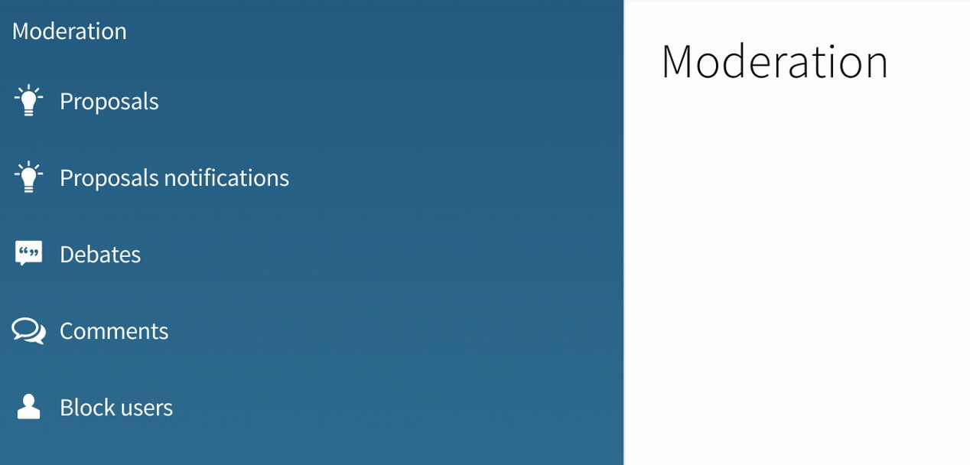

Moderators and administrators can access to this interface. Here are listed all the content of the platform flagged as 'inapropriate' by the users. Moderators have the options to hide or confirm the content and block the users.

When a user marks in a Proposal / Debate / Comment the option to "report as inappropriate", will appear in this list. For each element will be shown the title, date, number of complaints (how many different users have marked the option to report) and the text of the Proposal / Debate / Comment will appear.
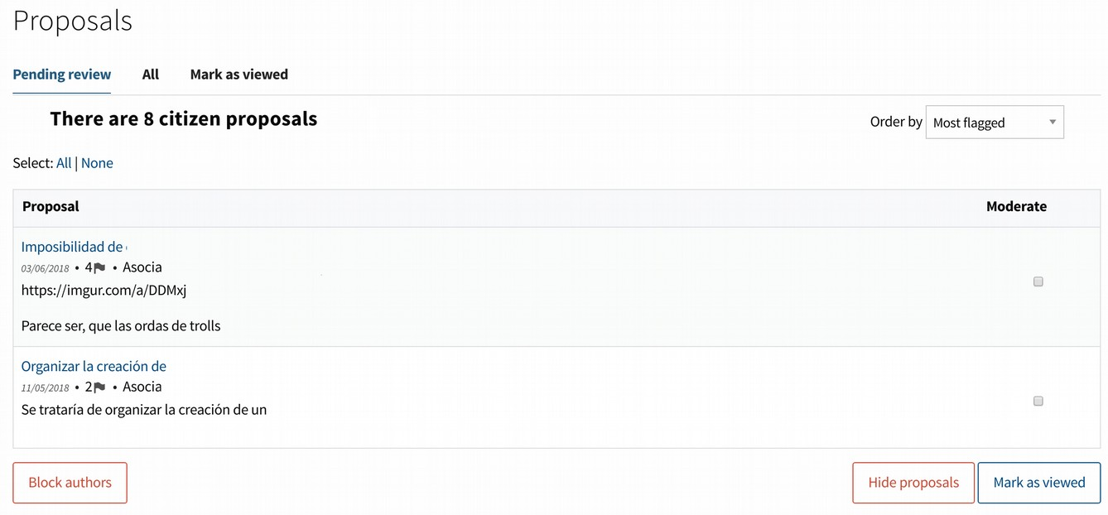

To the right of each item appears a box that we can mark to select several ones from the list. Once one or more are selected, we find three buttons at the bottom of the page to perform actions on them:

Hide: will hide those elements in the platform.
Block authors: will cause the author of that element to stop being able to access the web, and also to hide in the platform all the Proposals / Debates / Comments of that user.
Mark as viewed: used when we consider that these elements should not be moderated, that their content is correct, and thus they should stop being shown in this list of inappropriate elements.

To facilitate the management, above we find a filter with the sections:

Pending: Proposals / Discussions / Comments on which has not yet been pressed "hide", "block" or "mark as viewed", and therefore should still be checked
All: showing all the Proposals / Discussions / Comments on the web, and not just those marked as inappropriate.
Marked as viewed: those that some moderator has marked as viewed and therefore seem correct.

It is advisable to check the "pending" section regularly.

Block users
The search form allows us to find any user by entering their username or email, and block it once found. By blocking it, the user will not be able to access the web again, and all their Proposals / Discussions / Comments will be hidden and will no longer be visible on the web.

3. Valuation interface
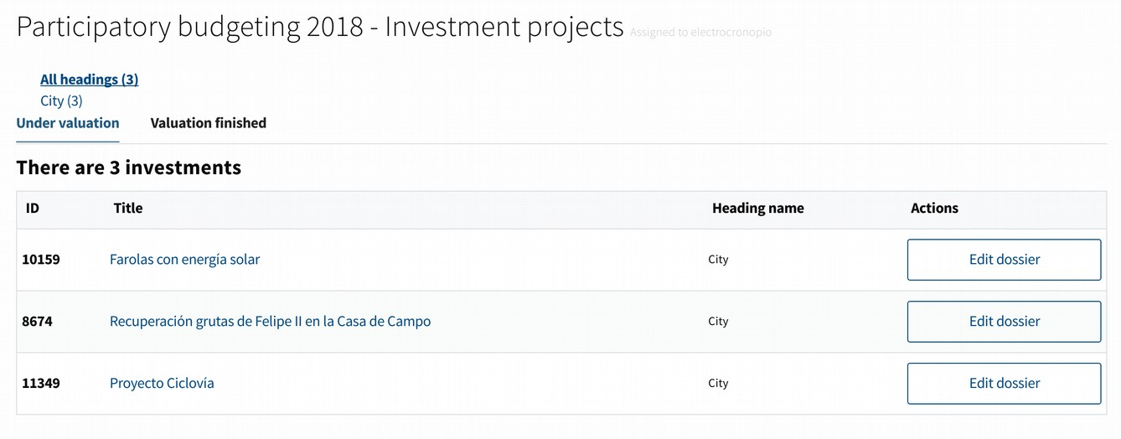
Valuators and administrators can access to this interface for the valuation of projects of the participatory budgeting processes. Through the administration interface the projects are assigned to different valuators or groups of valuators. Each valuator can see in this interface only the projects assigned for him, and fill the valuation dossier of each project. Thus the valuation can be done in a decentralized way, simplifying the work for each valuator.

In order to be shown here, the projects should be assigned to the valuator, and also marked the checkbox "show to valuator" in the administrator interface. Thus the administrators may ration the work that has been done by each valuator in different time periods, and not show all the projects from the beginning, if that is useful.

When accessing the interface is shown the current participatory budget process ongoing, and an "evaluate" button to start the valuation of projects. In the next window in the top is shown the number of projects for each heading, and then two tabs to organize the projects: "Under valuation" and "Valuation finished"

Clicking in each project can be seen the public information of the project, the administrators and valuators assigned, the current state of the valuation dossier and a space for internal comments between the valuators and the administrators. This comment section is not public, is used only for internal debate and clarification between the people in charge of the valuation of the project.

Clicking in the "Edit dossier" link the valuation dossier form is shown. First has to be selected the feasibility of the project: pending (by default), feasible or not feasible.

When clicking in "feasible" the following fields are to be filled:
- Price (mandatory). The price of the project will be shown during the final voting phase, and used to calculate how many projects can vote each user.
- Price explanation (optional). If this field is filled, the explanation will be shown in the project page. This field can be used to explain how the price was calculated, or how the project can be executed.
- Cost during the first year (optional, not public). This field is only used for internal purposes. Will not be published at any time.
- Time scope (optional, not public). This field is only used for internal purposes. Will not be published at any time.
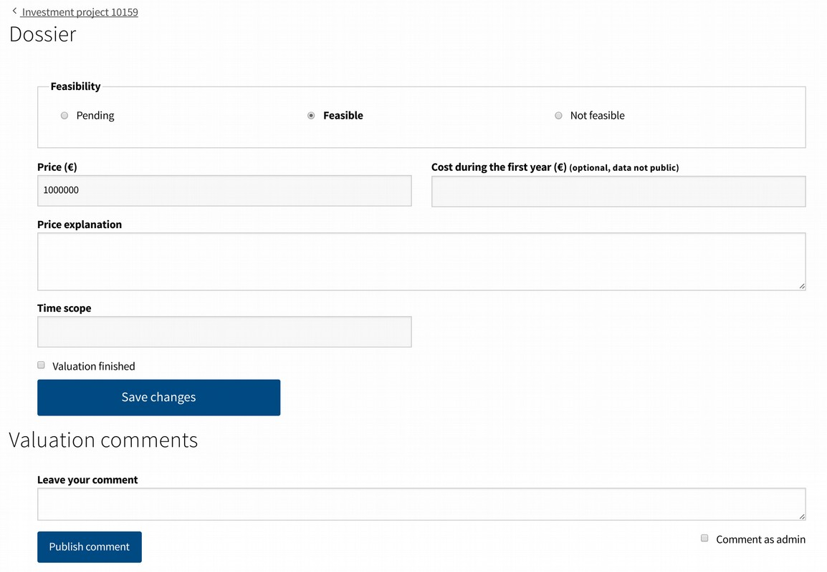

When clicking the "not feasible" option the only field required is the following:
- Feasibility explanation (mandatory). Here it is explained why the project was declared infeasible.

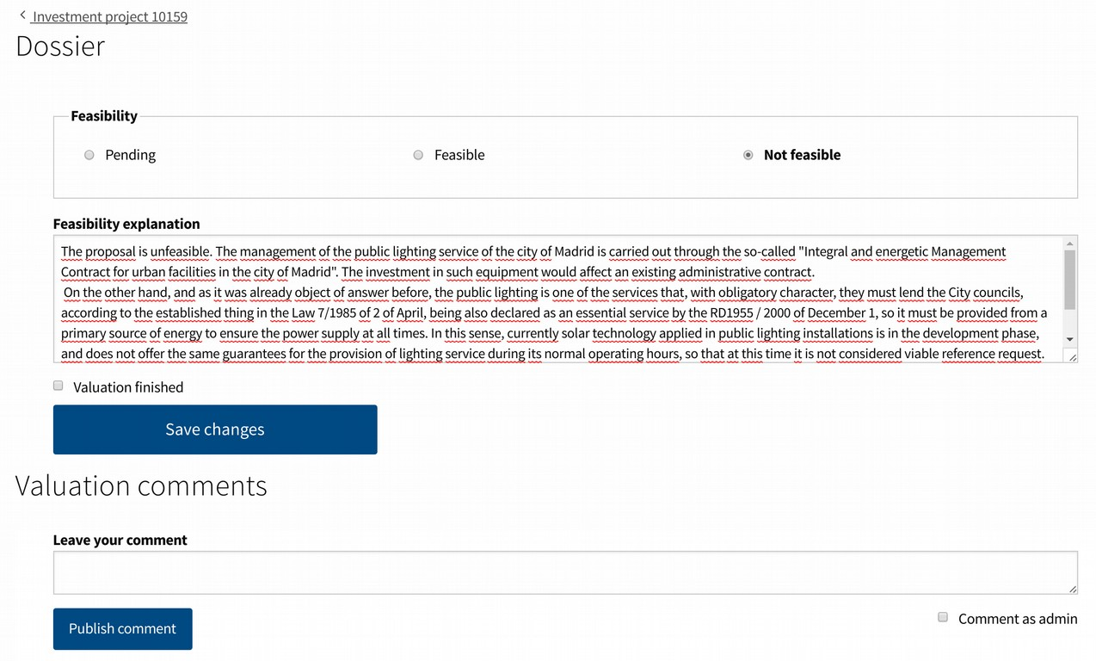
When the dossier is marked as "Valuation finished" and the changes saved, the project will appear in the 'unfeasible projects' list publicly, and the feasibility explanation published in the project page. Also a email will be sent to the author of the project, with the feasibility explanation. Take into account that this mail is sent and the explanation published in the platform at the same moment the valuation is set as finished and the changes saved.

When clicking in the "valuation finished" checkbox and in the "save changes" button, the dossier will be closed. The valuator will not be allowed to do any further change (except if an administrator undo that checkbox).

If the "save changes" button is clicked without marking the "valuation finished" checkbox, the information of the fields will be saved, to keep working on them at another time.

4. Management interface
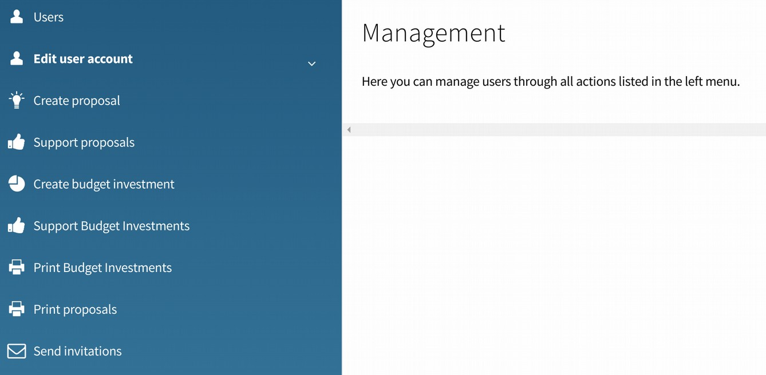
Managers and administrators can access to this interface. Here managers can create and verify users accounts, and perform tasks for the users are creating or supporting proposals, etc. The common use of this role is for public workers in the institution office, to help the citizens to interact with the participation process.

The following options are available:
- Users. The managers can create or verify user accounts through this option. All the other options require first to access through this section, to select the user whose actions will be performed.

- Edit user account. This option allows to reset the password of an user by two ways: via email (this is the most common way, the user will receive an email with a link to reset the password), manually (in case the user has no access to his email, a random password can be generated, or typed by the own user through this interface)

- Create proposal. Here is shown the form to create a proposal. When created, it will appear in the platform as created by the user.

- Support proposal. A search field is shown in the top of the page to search a proposal. Once found if clicking in the "support" button next to it, the proposal will register a support coming from the user. The final voting of proposals or participatory budgets projects, being a much more delicate process, is not managed from this interface. To manage this process, in the administration interface there is the ‘Voting booths’ option.

- Create budget investment. Here is shown the form to create a project for the current participatory budgeting process, if the 'accepting projects' phase is open. When created, it will appear in the platform as created by the user.
- Support budget investment. A search field is shown in the top of the page to search a project for the current participatory budgeting process, if the 'supporting projects' phase is open. Once found if clicking in the "support" button next to it, the project will register a support coming from the user.

- Print proposals. This section facilitates to print part of the list of the proposals.

- Print budget investment. This section facilitates to print part of the list of the investment budgets.

- Send invitations. The field can be filled with a list of emails separated by commas. When clicking in the "send invitations" button an email will be sent to each email address
inviting the person so sign up in the platform.

5. Poll officers interface

The poll officers can access this interface during a general voting or the final voting of the participatory budgets. This interface is used by those in charge of the ballot boxes, to verify that the person who wants to vote can do so, and in case they vote to confirm the vote so that they can not vote a second time in other booth or through the digital platform.
It also allows to enter the results of the vote once it has finished.

Clicking on "Polling officers". This screen will appear:

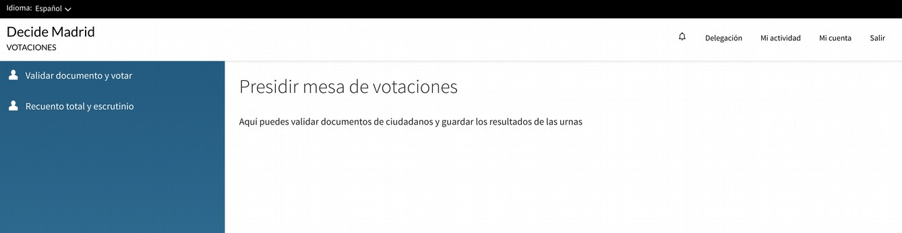
On our left we find a menu with two options (we will explain each one in a separate section)

1. Validate document and vote
2. Total recount and results

5.1. Validate document and vote

In this section we introduce the voter identity document and manage the vote.

VOTER IDENTITY:

In first place will be shown the form to enter the voter data. The type of document, the document number and the year of birth:

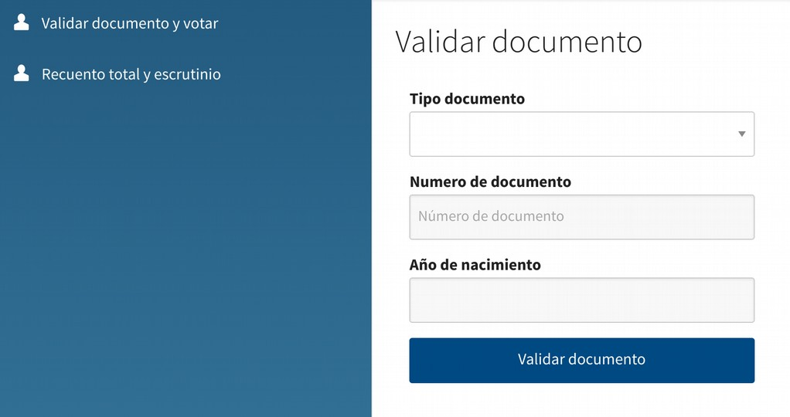

Different types of documents can be selected:
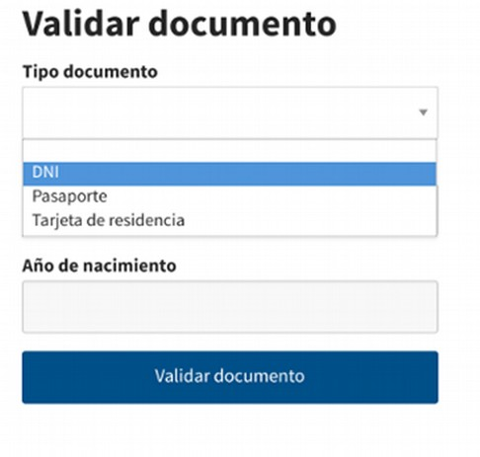

We select the type of document and enter the requested data:

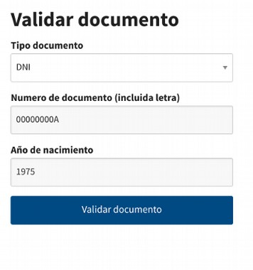
And then click on the "Validate document" button.

In case the person is not in the user verification register with that document, or is less than the age set as the minimum voting age, or the information is not correct, it will show us the message "This document could not be verified".

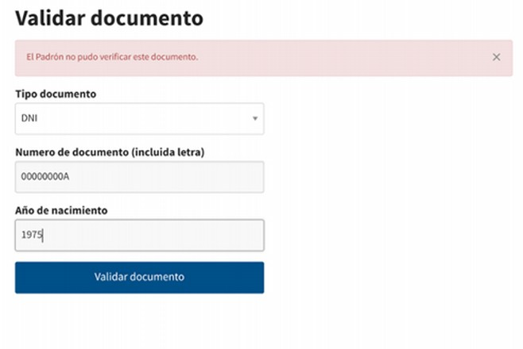
In case everything is correct, it will take us to the following screen:

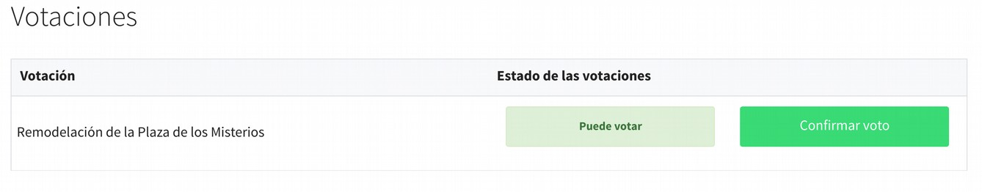
It will show the list of active votings in our voting booth indicating with a message "You can vote" in case the voter is able to vote, or a message "You have already participated in this voting" in case the voter had already voted on the internet or at another voting booth.

In case the vote is possible, the voter will be informed, who will proceed to introduce the ballot envelopes into the ballot box.

Once the corresponding envelope has been introduced, the Poll officer will mark the "Confirm vote" button.

The voting button will change to a message "Vote correctly entered".

If the voter tried to vote again at this table (or if he had voted online) the following message would appear to prevent the vote:
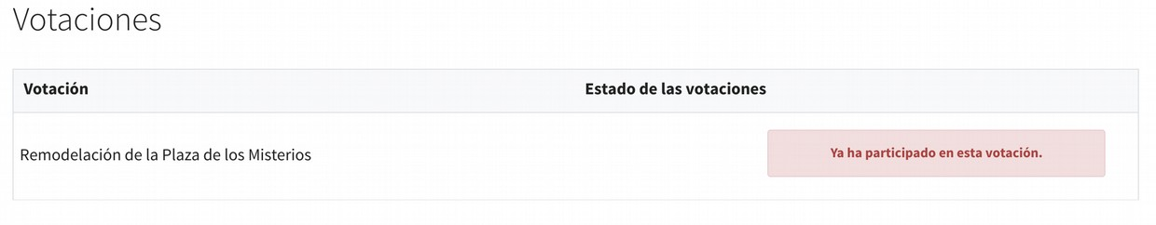
Once this process is completed, click again on the side menu "Validate document and vote" to pass to the next voter.

5.2. Total recount and results

This last section will be used only on the voting scrutiny.

By clicking on the menu "Final recount and results" on the left we will see the following screen:

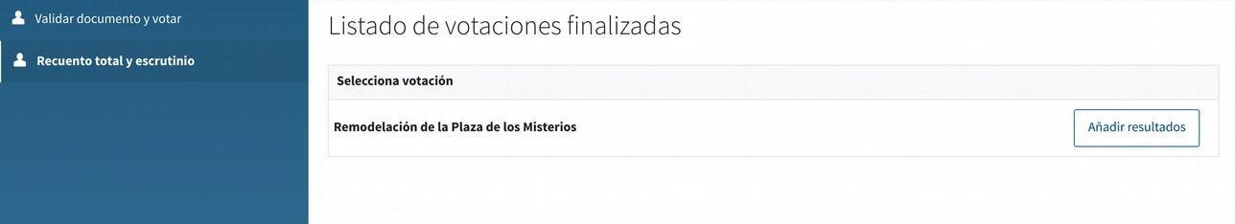
In the central part we will see the finalized votigs in which we can perform the final recount and add the results. Clicking on the button "Add results" of the voting chosen will take us to the following screen:

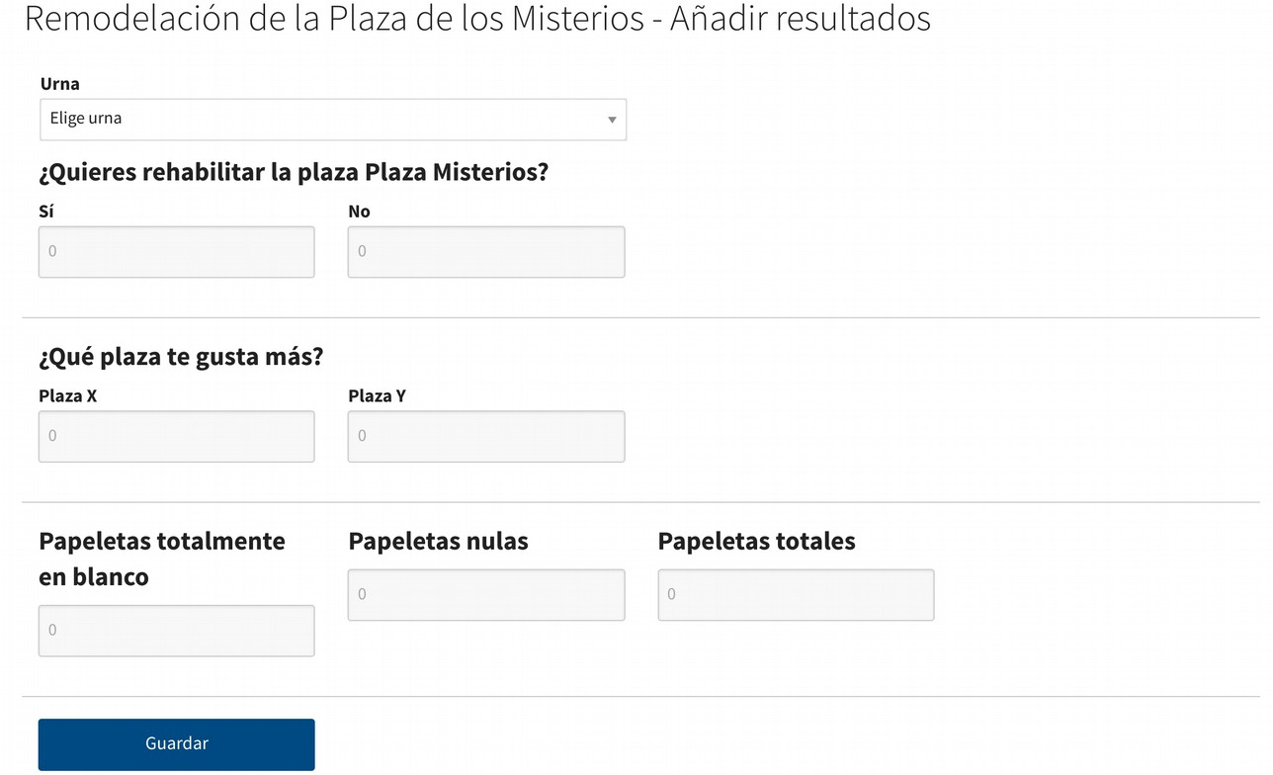

In the first drop-down we will choose the booth corresponding to the scrutiny we have made, and then fill in the requested fields.

When you click on the "Save" button, the blank page will load again, but in the lower part we will see a link with the results entered:
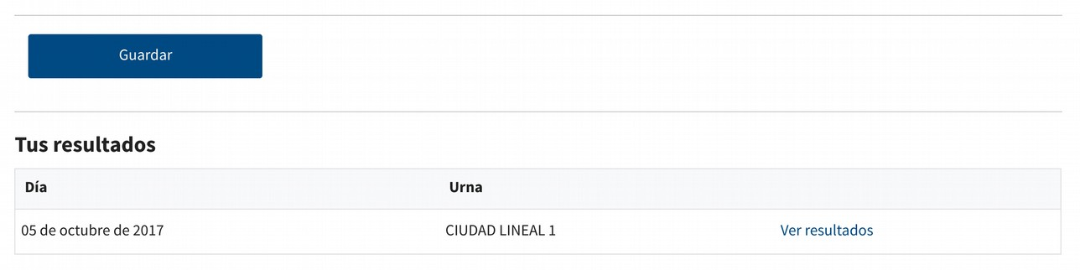

If we click on the link "See results" we can make sure that we have correctly entered them:
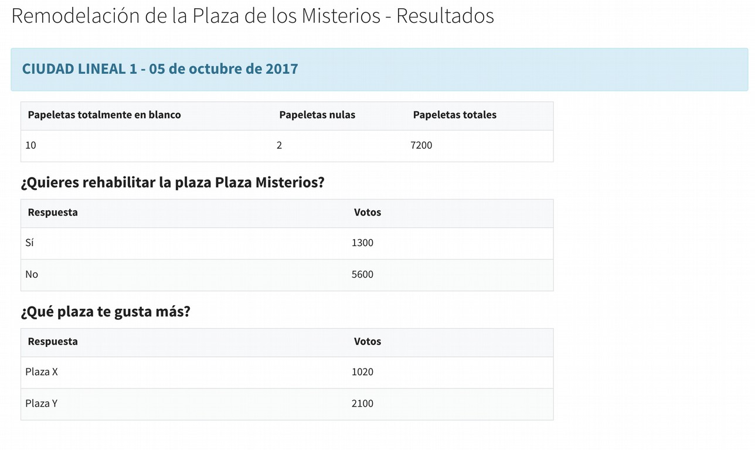

If we want to reintroduce the result, for having made an error when entering it, we just have to repeat the process. The new result will overwrite the previous one.

