

CONSUL
Communication guide

Index of contents

0. Introduction to the CONSUL communication guide.

1. Actions prior to the public launch of the participation platform.

1.1. Design and identity of the platform.
1.2. Contents of the participation website.
1.3. Creation of communication channels: social networks and blog.

2. Daily communication.

2.1. Use of social networks

2.1.1. Creation of content for social networks.
2.1.2. Facebook.
2.1.3. Twitter
2.1.4. Instagram
2.1.5. Youtube.

2.2. Media.
2.3. Blog.
2.4. Newsletters.

3. Dissemination and communication campaigns.

3.1. Preparation of the campaign.

3. 1. 1. Previous analysis
3. 1. 2. Work teams.

3.2. Types of campaign.

3. 2. 1. Outdoor campaign.
3. 2. 2. Advertising campaign.

4. Metrics and Indicators.

4.1. Indicators for the web page.
4.2. Indicators for social networks.
4.3. Indicators for advertising campaigns.

0. Introduction to the CONSUL communication guide.

This communication guide is a tool to accompany the launch of citizen participation platforms created from the open source software CONSUL and the processes of direct democracy that are started linked to them.

The document is oriented to the generic and basic aspects to communicate the project and the participatory processes. Based on this guide, each institution can expand and deepen according to the priorities and resources it allocates to communication.

The implementation of the participation must be accompanied by actions to inform the public: to explain the possibilities to be involved in the direct decision making and to show how you can use the web.

CONSUL is a tool that helps make big decisions among all people. The processes that are developed in the platform transform our streets, neighborhoods, cities, regions and countries. They also enable the creation of environments of coexistence, a better quality of life and more transparency in public decision-making.

A basic ingredient so that all this happens is that the platform is used and people participate in it. From a simple idea that a citizen shapes, the policies of a city, region or country can be modified.

1. Actions prior to the public launch of the participation platform.

Before addressing specific actions regarding the platform and the processes that are carried out in it, it is convenient to carry out an analysis of the context in which we are going to communicate these new channels of direct democracy.

We can ask ourselves the following questions: Do the people of my city, region, country or environment participate? Are there associations and groups mobilized around us? In the day to day of the institution, does citizens claim to participate in direct decision making?

The analysis of the participation environment can arise from data from a survey, academic studies, trends observed in the society, the analysis of suggestions and claims received, etc.

From there, a basic strategy can be developed to know the positioning of the institution with respect to the environment in which it is going to communicate.

1.1. Name, design and identity of the platform.

The CONSUL platform has standard design and content that would allow a launch with few adjustments. However, the institutions that have already installed the software choose to adapt the platform to their own corporate identity.

There are a series of steps to be taken into account prior to the launch, which require the coordination of the communication, development and design team, whether the teams are internal or external to the institution.

Name of the platform

CONSUL is the name of the software on which the participation platform is based. But for the public users we must look for a name that is easily understandable and descriptive, such as, for example, Zamora Participates, Buenos Aires Choose or Decide Madrid. Each institution is free to adopt the name that best suits its needs. The chosen name is the brand and serves as the basis to create the identity and all kinds of content.

Graphic design and identity

Parallel to the installation of the participation software, the creation of an own design that helps to identify the platform can be proposed. The institutions that have installed CONSUL generally opt for a different graphic design that allows distinguishing the participation project from the generic institutional corporate image.

From this new design, it is advisable to create a corporate identity manual that will govern the web, the image on social networks, the dissemination of digital and paper content, etc.

Practical tip: an option that can help consolidate the communication of the platform is to create an own graphic line (typography, color palette, etc.) so that the participation project is easily identifiable. That line can evolve and improve, but always under a graphic coherence.

In this section it is necessary to make a reference to the importance of having a page adapted to mobile navigation, since currently, Internet traffic through mobile phones exceeds web browsing on a personal computer. This is clear from the data of 2017 released by Akamai, a company that manages between 15 and 30% of global web traffic.

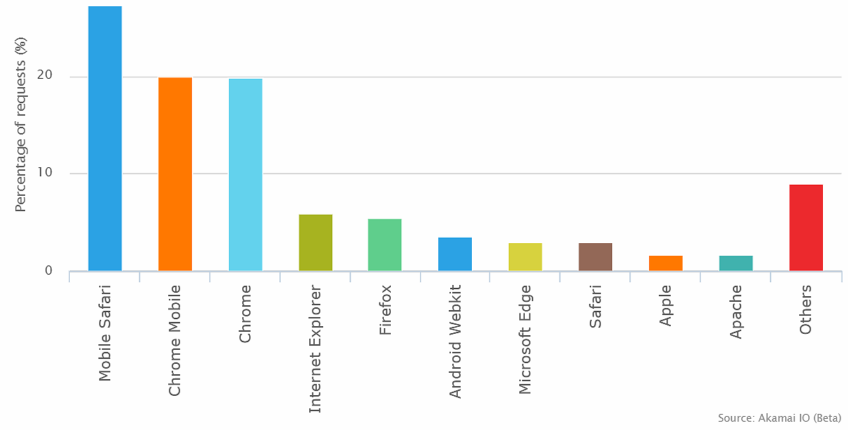

The websites created with CONSUL are responsive, that is, they are displayed correctly on all types of devices. However, when thinking about the future dissemination of content both in networks, blogs, and in institutional advertising, we must keep in mind that more and more people will participate in the page through their mobile phones.

1.2. Contents of the participation website.

The web is the main communication window of the project, since it is the final destination of the users and where they will carry out actions of direct decision making.

The communication team should contribute to the creation of a coherent and common vocabulary that defines participation. Also to translate the administrative language into understandable phrases and to explain how to participate from a didactic and simple point of view. The web language has its particularities, is far from a press release and has to be understandable, attractive and clear to the user.

CONSUL includes a standard content that summarizes the participatory tools of the platform: debates, proposals, participatory budgets, voting and processes. It is up to each institution to choose which tools to use and how to name them.

On the other hand, in web pages there are contents that are not visible to people but to search engines, which is known as metadata. There are writing guidelines that serve to position themselves in search engines and, therefore, be easy to find by users. Therefore, it is recommended to have the collaboration of a SEO specialist. In this section, however, some basic recommendations are offered for the start-up.

Some steps to follow to create the contents of the platform are:

- Name: decide on the tools of direct democracy that will be used and their denomination. The names must be easily identifiable, that is, terms that any user can find.

- Introduction to the processes : as a recommendation to guide users and improve search optimization of the page (improve SEO) we recommend including an introductory description of about 280 words about what is and what each participatory tool is for on foot of page (not in the upper part so as not to lose the users who visit each section).

- Metadata of the page: each page and section of our website must include in the code the title (title), a description (metadescription) and some keywords (keywords).

A tool that can help us find the words that most users look for, and therefore, that can position themselves better is Google Trends. It allows you to narrow the search by country, time interval, category and by type of search.

The title is the first thing searchers read and appears in the browser tab, so it has to be brief and very descriptive, about 60-70 characters. Example: Participatory budgeting 2018 - Las Palmas de Gran Canaria

The description must be a brief introduction of a maximum of 156 characters of what that page is and, if possible, include a call to action. Example: Submit your projects to the 2018 participatory budgeting of Las Palmas City Council. Decide on how to spend the municipal budget.

The keywords, although not essential, to be included must be descriptive of the content of the page.

Example: City of Las Palmas de Gran Canaria, participatory budgeting, municipal budget, Las Palmas, Las Palmas de Gran Canaria.

- User help page: create a help page with frequently asked questions of each of the sections of the web explaining in detail what it is and how the process works (example of help menu y example of frequently asked questions )

- Technical problems page: create a page to solve the most recurrent technical doubts of users (example).

Besides, you can also create useful content for users within each section, to help understand each process. That is, a kind of brief guide that explains how to create a project for participatory budgeting, for example.

Practical advice: at the time of writing the contents of the participation website, keep in mind who you are addressing. So you can create more understandable texts in terms of language and structure and adapt to those less familiar with direct democracy.

1.3. Creation of communication channels: social networks and blog.

Parallel to the creation of the participation website, once we have the name of the project, it is advisable to have a presence in social networks, because they will bring great benefits to the project: visibility, positioning, reputation and a better service to the citizens.

According to We are social data for 2018, there are 3.196 million users of active social networks in the world, 13% more than last year. And the number of users over 65 has increased by 20% in the last 12 months. The presence in social networks, therefore, is not so much an option as almost an obligation.

It is essential that citizens know the platform, and therefore, apart from sending a note or organizing a press conference, it is convenient to have communication channels of their own and differentiated from the main channels of the institution. From the very beginning we are going to broadcast highly specialized contents that require the action and involvement of the citizens.

In the event that it is not possible to have our own and differentiated communication channels, we will broadcast our content through the main channels of the institution, so coordination with those responsible for the management of social networks will be essential.

When creating profiles on social networks we will take into account the following steps:

- Goals

The strategy mentioned in point 1 (the analysis of the context in which we are communicating direct democracy) will allow us to define what we intend to achieve with our presence in the networks. We can have different orientations that do not have to be exclusive: dissemination of information and news about the processes of participation, training and dissemination of how these processes are carried out on the web, having a channel for answering the users and to solve doubts and problems, etc.

- Audience

Who do we want to address? Do we want to use social networks to focus our communication on young people? Do we want to reach, on the contrary, the entire spectrum of the population? Identifying our potential public (the population to which we direct direct democracy channels) and our target audience (to which we want to direct our strategy), will facilitate optimizing and profiting our presence in social networks.

- Choice of social networking platforms

We must decide on what platforms we want and can be. It is a common mistake to think that we should be in all or the best known, since we will not be able to focus our efforts on the communities we want to reach.

We will analyze, therefore, the wide spectrum of available platforms and locate where most of our target audience is present. Do we want to specifically target young people and are mostly on Instagram? Do we want to reach the entire population spectrum?

In this case, we can see which platforms dominate the market and where the largest number of users is concentrated: Facebook (2,167 million users), YouTube (1,500 million users), WhatsApp (1,300 million), Instagram (800 million) and Twitter (330 million), in this order.

In addition, depending on our available resources, we can decide which platforms we can feed. How many people make up the communication team? What profiles do they have? The ideal would be to have at least one person dedicated entirely to social networks. If this is not possible, using more networks will be more limited.

Once decided the platforms on which we are going to be, and with a graphic identity, we must try to create a specific identity for the social profiles, which will be composed of: a cover image, an avatar and a description of the profile.

Another recommendation before opening the page to the public is to open a blog of the project, since it will be one more window to be able to attract citizens and promote the culture of direct democracy. This guide offers details about what content you can include and more keys.

2. Daily communication.

2.1. Use of social networks

Social networks are the most immediate and accessible channels that the institution can offer the public. In recent years its growing use makes it essential to be there to bring public service information, establish a conversation with citizens and be a mean of solving doubts.

In the field of direct democracy, social networks help to announce the processes of direct decision making that are opened, to explain the tools of participation and how to use them. To create user communities around these networks, useful and attractive content must be added frequently.

It is advisable to alternate the announcement of institutional news (such as the beginning of a process or its results) with didactic content and external information on participation of the platform itself or of other parts of the world.

Practical advice: in order to make content attractive, it is necessary to resort to the use of audiovisual material, images, GIF, videos, etc. Sometimes it is difficult to find photos that illustrate what we want to communicate. You can create templates that combine the use of photos, flat colors, texts, quotes, icons, etc., that follow the graphic line of our corporate image and that identify and distinguish us in social networks. Inspiring tools in this sense are Canva, Pablo, Genially or Piktochart, among others.

Practical advice: in order to make content attractive, it is necessary to resort to the use of audiovisual material, images, GIF, videos, etc. Sometimes it is difficult to find photos that illustrate what we want to communicate. You can create templates that combine the use of photos, flat colors, texts, quotes, icons, etc., that follow the graphic line of our corporate image and that identify and distinguish us in social networks. Inspiring tools in this sense are Canva, Pablo, Genially o Piktochart, among others.

It is also advisable to address the comments and requests of users. Among the constructive criticisms that we receive, we will surely find clues about what information they are claiming, such as knowing the execution status of a participatory budgeting project, or knowing when certain processes begin and end.

In order to give consistency to our communication in social networks, it is advisable to establish a style guide that defines the editorial line, the tone of the communications, the way of communicating with the users, questions of style, how it will be animated and interacted, as well as the protocol of action, before any negative comment or error that we can commit, to face an online crisis.

Practical advice: for the day to day it is very useful to create an editorial calendar that allows you to plan weekly the messages and the topics that you want to communicate, the types of content and through which channels it is more appropriate to distribute them.

Practical advice: for the day to day it is very useful to create an editorial calendar that allows you to plan weekly the messages and the topics that you want to communicate, the types of content and through which channels it is more appropriate to distribute them.

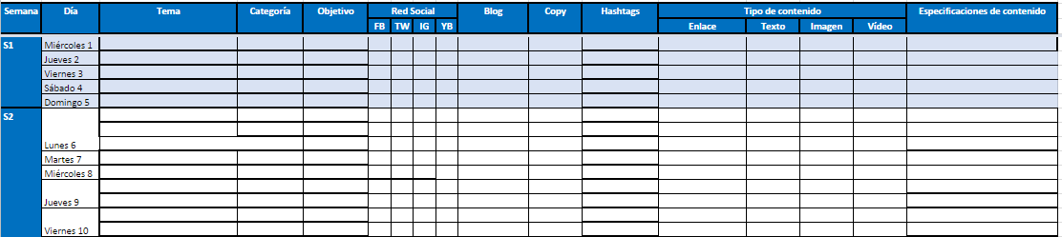

2.1.1. Creating content for social networks

In social networks we will face the task of creating, distributing and managing useful and relevant content for our audience with the aim of attracting it to our community on the participation website.

Some tips for developing relevant content:

- Write short, simple and direct messages.
- Take care of the spelling and grammar.
- Create attractive titles that attract attention and convey the main idea.
- Enrich the content with audiovisual pieces: audio, images, videos, infographics, photographs, graphics, etc.
- Expand the information with links.
- Give advice, tutorials and practical guides on the use of the participation features of the website.
- Collect lists of resources.
- Explain platform functionalities or participation mechanisms.
- Create content related with current issues: news about the platform, news about the participation processes, etc.
- Create stories: you can search for the stories behind the participation, such as who are the people making proposals, how they have come to get support, what participation they have had in the execution of the projects, etc.
- Make calls to action to invite to participate in the platform.
- Show the human side.
- Adapt to the narrative of each platform.

2.1.2. Facebook

A Facebook page is the most appropriate formula to be present in this network. It can be managed from the computer and mobile phones. Facebook has the apps: Page manager (for the activity related to content) and Facebook Messenger (to interact with users).

When creating a Facebook page we have to provide as much information as possible, both in the information section and in the "Your history" section; incorporate the corporate image of the web both in the profile image and on the cover and organize the tabs of the menu, eliminating those that are not going to be used.

The type of communication that can be carried out on Facebook is more relaxed; It allows us to explain widely what we want to transmit and it is quite versatile in terms of the use of audiovisual material.

Some guidelines for using Facebook:

- Characteristics of a suitable post: regarding the length of the text, it is convenient to be direct and use brief headlines and include a single URL. In any case, despite having to lengthen, you have to facilitate reading so leave a line break between paragraphs and write the sentences with the subject-verb-predicate structure. It is also advisable to finish the publication with a call to action, with a question or asking the opinion of the user.

It is highly recommended that each post be accompanied by an image, a GIF or a video (it is better to upload the videos directly to Facebook than linking them from an external platform), to make the communication more colorful and attractive.

Facebook offers several resources to present images, from uploading a single photo to creating albums, sequences, presentation as a video or a canvas or combination of images and videos.

More information about the images and videos on Facebook.

- How many post publish: various theories and practices exist about how much or how often to publish on Facebook. What is certain is that if we have a recurring presence, we are more likely to appear on the users' wall. On the other hand, the change of algorithm in Facebook has led to the need to invest in paid advertising to expand the reach of our content. Otherwise, our organic scope will be very limited.

- When to publish the post: depending on the metrics we will know the best times to publish and our content will have more impact among our users.

- Post programming: Facebook allows you to leave post programmed from a page, a functionality that personal profiles do not have, and can be modified at any time. It is also possible to leave programmed contents from external applications.

2.1.3. Twitter

Twitter is the social network of immediacy, the rate of publication is constant, less paused than Facebook. It allows a type of immediate, open communication and sometimes allows to solve doubts about the processes in a more direct way. You can also create networks of users interested in being part of the decision making of your city or region.

When opening an account on Twitter we have to include a brief description that identifies our project, the URL, location and incorporate the corporate image of the web both in the profile image and on the cover.

Some guidelines for using Twitter:

- Characteristics of a suitable post: since 2017 Twitter has increased the number of characters in the posts to 280. However, it is not necessary to exhaust those characters. Therefore, it is advisable to write short texts, with line breaks between sentences and follow the subject-verb-predicate structure. When we have a lot of content to communicate we can resort to the modality of publication in "threads", building a story.

We can categorize our own information with the use of hashtags (labels) that have a differentiating element (for example, the name of our city or region, the initials).

It is also advisable that each post be accompanied by an image, a GIF or a video.

More information about the images and videos on Twitter.

- How many tweets to publish: the Twitter features allow many publications per day. To let us know and maintain the growth of followers, the key is to offer a lot of content.

- When to publish the post: the metrics will reveal the best times to publish and have more impact.

- Programming tweets:: Twitter has a basic tool for programming content, Twitter Media Studio. You can upload multimedia material (in the case of videos add many details) and program it. However, it is possible to leave content programmed from external applications, such as Tweetdeck (owned by Twitter, does not have a mobile app), Hootsuite, etc.

2.1.4. Instagram

Instagram, the social network dedicated to image and video, is one of the services that is growing the most in recent months and is in third position in the list of networks with the most users, behind Facebook and YouTube.

Some reasons to assess if the citizen participation project should have an Instagram account are:

- Citizen participation processes generate news linked to images that can be communicated on Instagram. For example, photographs of completed projects of participatory budgets, voting and counting processes, face-to-face meetings related to processes, etc.

- The Instagram Stories functionality (stories that last published 24 hours) allows you to connect with young audiences and create different narratives around participation, since full screen images are used in which you can superimpose labels, stickers, emojis, etc.

- The use of hashtags (tags) on Instagram is intensive, so you can better position the news that we offer within the niche of topics such as #participation #citizenparticipation #open government #opengov, among others.

Some guidelines for using Instagram:

- Characteristics of a suitable post: to create optimal post, first of all you must have images and / or videos of the highest quality; have a novel story to tell, also through the text that allows contextualizing the image; Geotag the photo in the place where the hashtag has been taken and used, related to the issue of the publication.

In addition, Instagram has some versatility in the use of images. Apart from a flat photograph, you can create a gallery with photos or with photos and videos; a composition of several photos in the same publication or use Boomerang, an application to create short videos (as a GIF).

More information about Instagram images and videos

- How many post to publish?: Sometimes, the frequency of publication is marked by having good photos or news to tell. A minimum of update can be between once or twice a week. It is convenient to observe the metrics to assess the behavior of our followers before a possible increase in the frequency of publication.

- When to publish the post?: the metrics will reveal the best times to publish and have more impact.

2.1.5. YouTube

At one time or another it may be necessary to open a channel on YouTube, since video is the most consumed content on the network. If we have equipment to create videos, it is convenient to support the processes that are started and show how the participation of our platform works through short pieces that do not exceed one minute or one and a half minutes.

When opening the channel, it is important to include a description, the URL of the website and the corporate image of the project in the profile image and on the cover page.

- Video features: every time a video is uploaded to YouTube, the owner must be very careful (short, direct, descriptive); the description (summarizes the video in a paragraph and includes the URL of the page or process), in addition to descriptive labels. You have to select a good thumbnail image or cut one to make the video attractive at first glance. Also add subtitles so that the video is accessible to all citizens.

More information about videos on YouTube.

- Create playlists: from the first moment, it is advisable to organize the content in lists. Video tutorials of participation, videos of each process that we open, etc. can be published correctly categorized to facilitate its dissemination.

2.2. Media.

Another of the pillars of the dissemination of our direct democracy platform is the media. It is an institutional responsibility to make known through written press (online and on paper), radio and television the main milestones of participation to reach the maximum possible public.

In this section we break down some guidelines to know when and how to count on the means of communication to spread the news of participation.

Calls and press releases

When and why organize a press conference? In the processes of direct democracy linked to CONSUL there are certain milestones in which the press can be called for a press conference and / or send communications.

It can be a traditional press conference, in dependencies of the institution prepared for that purpose, but you can also think about an alternative location, which for some reason is linked to the process. All media press conferences must be accompanied by the delivery of a press release, images, voice cuts and / or video pieces. All this material also serves to spread the news in our own social networks.

Below, the communication milestones of the different processes that can be communicated are broken down.

Citizens' proposals and votings

- Announcement of the process: moment in which a proposal has reached the necessary supports and the voting is called. Explain the date of the voting and the participation mechanisms (example press release).

- Beginning of the consultation: on the same day that the possibility of voting opens, it is necessary to provide the maximum possible new information, such as voting start and end dates, if there are polling places (indicate hours), when it will be possible to offer the results, etc. (example of press release).

- Counting of votes: if there have been ballot boxes, it is convenient to carry out a voting count open to the citizens and also to the press. It is a good time to have a balance of the course of the consultation (example press release).

- Communication of results: once the participation of online and face-to-face voting is known (if there is one) and what the citizens have decided (example of a press release).

- Follow-up of the results: if the citizens' proposal is approved and incorporated into the municipal policies, the most important moments must be communicated (example of a post and another example).

Participatory budgeting

- Announcement of the beginning of the process: the amount of the budget allocated to citizen projects is explained; dates of the phases; participation mechanisms, etc. It is advisable to coincide with the day in which you can start presenting projects so that, if the citizen receives the information, they can participate immediately (example press release).

- End of the presentation of projects: at this moment you can provide the total number of projects submitted by citizens and offer data by type of projects, by scope of action, etc. (example of press release).

- Beginning of the support phase: the population must be informed that it can start supporting projects to prioritize for the review and evaluation phase (example press release).

- End of the support phase: once the support phase is closed, you can count how many people have participated, total number of supports, information on the next phase of evaluation of projects and other information of interest (example press release) .

- Beginning of the voting: the last phase of the process has enough importance to organize a call with media. In it we must explain the voting mechanisms, if there are polling places, when it will be possible to offer the results, etc. (example of press release).

- Communication of results: once the voting is completed and the total participation data and the list of winning projects are available, an act in which the proposers are present can be organized. Each institution, depending on its possibilities, can use the most appropriate formula (example of event and press release).

- Follow-up of the projects: from the approval of the municipal budgets of the following year, the citizen projects approved in the participatory budgets begin to be carried out. Once finalized, it is essential to communicate both to the proponents and to the population in general that the institution complies with the citizens' decision. It is the way to demonstrate the complete process.

Some examples:

- Example of press release.
- Example of tweet
- Example of post on Facebook.
- Example post on Instagram.
- video example.

Processes

- Announcement of the beginning of a public consultation prior to drafting a municipal ordinance, plans, regulations and guidelines or processes to receive contributions and opinions on municipal actions (example press release).

- Announcement of the results of previous public consultations (example press release).

- Monitoring of citizen contributions to the regulations: comments and contributions made by the participants in the resulting regulations can be communicated.

Citizen consultations

- Announcement of a public consultation: if the institution calls a vote to ask a question that it is raised by the citizens, it is advisable to organize a press conference (example press release).

- Start of the consultation: the same day that the possibility of voting begins, it is time to call the press. It is necessary to provide the maximum possible new information, as if there are voting points in person and schedules, when it will be possible to offer the results, etc. (example of press release).

- Voting count: if there has been a face-to-face vote, it is advisable to carry out a voting count open to the public and also to the press. It is a good time to evaluate the course of the consultation (example press release).

- Communication of results: once the participation of online and face-to-face voting is known (if there is one) and what the citizens have decided (example of press release).

2.3. Blog.

Another way to get to the citizens, to promote the project, place it on the Internet and to have a content repository different to the institutional press releases, is to open a blog on the participation website.

One of its main advantages (especially compared to our channels on social networks whose content is more ephemeral) is that it will allow us to create a historical archive with all the information and news about our direct democracy platform and participation processes.

Before creating it, you should think about a publishing strategy that answers the following questions:

- Do we have human resources to maintain it? The team should have between one and two people who can write.
- Do we have information to communicate through the blog? A priori you have to think about what topics would fit in the blog.
- What publication periodicity can we maintain? If we have a blog we would have to publish a post at least once a week or once every two weeks. For less frequency it is not worth having a blog and maybe it is better to resort to press releases and communication through social networks.

The blog can be created from an existing publishing platform. The development staff can recommend which is the best content management system and how to incorporate it into our website.

The image must be the same as the participation project, but if the institution already has a network of blogs, you can open a specific space that is linked from our website.

Regarding the issues that address from the blog, you can address issues such as:

- Participation tutorials: tutorial example in blog.
- Color chronicle of a voting day or counting of votes: post example.
- Timeless themes of direct democracy or citizen participation that would not be offered in a press release: post example.
- Follow-up of citizen proposals or projects of participatory budgets that are not offered in a press release but are likely to communicate: post example.

2.4. Newsletters.

When the citizen participation platform is on the internet and users start signing up, you can contemplate the possibility of sending newsletters to disseminate news.

It is a very effective resource to encourage participation in the processes of direct democracy, but which should not be abused so as not to saturate the people registered.

It is advisable to use the newsletters for key moments of the processes of citizen proposals, participatory budgets or legislative processes. To keep the population informed of other minor milestones we already have press releases and social networks.

The reading time of users on the Internet is very short, so, in view of the writing of the newsletters:

- The subject of the mail has to be short, direct and attractive.
- The body of the email should be as short a description as possible and include a call to action, such as "present your project" or "vote now".
- Include a single URL: if we include a single address we will have more possibilities to focus the clicks on the desired URL. If we attach several, it is more likely that the attention is dispersed.
- Include images: the newsletter will be more attractive to recipients if it includes any images. It also fulfills the function of contextualizing and transmitting more information at a single glance, so we must ensure that the photo is related to the content.

3. Dissemination and communication campaigns.

The dissemination of the platform and the implementation of processes of direct democracy, besides the communicative actions explained above, can be accompanied by dissemination and institutional publicity campaigns.

Each organization has its formula and methodology to create and carry out these campaigns, either with an internal team that designs them or must resort to contracting services.

Before making the campaign you have to take a series of steps. This section includes some guidelines to implement this type of public service communication and thus multiply and strengthen the knowledge and impact of direct democracy processes.

3.1. Preparation of the campaign.

3. 1. 1. Previous analysis

In order to carry out a campaign it is necessary to carry out a previous internal work before defining in detail the tasks to be developed.

Main objective of the campaign

First of all, we must ask ourselves the following question: What objective do I want to achieve with the campaign? Possible answers can be:

- Publicize the participation platform.
- Getting people to register on the web.
- That the citizens carry out a certain action, such as supporting or voting in a process.

Previous planning

Secondly, it is necessary to elaborate a plan for internal use that includes the type of campaign that we would like to carry out in order to know its magnitude. We must include the resources we have, that is, budget available for creativity, impressions, reservation of spaces, logistics, advertising, human resources, deadlines, processing times, etc. besides a list of the materials that we will need.

Working draft

It is highly recommended to prepare a draft of work to deliver to the teams that will develop the campaign and that include:

- General description of the process and reason for carrying out the campaign.

- Brief context through actions and data from previous processes, participation statistics, data from our platform, etc.

- Details about the campaign: main objective, secondary objectives, calls to action, target audience we want to address and duration.

- Materials that will be needed and / or being offered, with an approximate indication of the number of pieces and delivery dates. In this section you must include the graphic identity manual of the institution (including logos and application rules).

Depending on whether or not we have creative staff, we must also contemplate delivering the main message of the campaign and secondary messages, as well as basic information that must appear.

Calls to action

If we are clear that the campaign is linked to a participatory process in our platform, there are very defined actions that must be carried out by the participants: these are the calls to action of the different phases of the campaigns.

In participatory budgeting, calls to action are: present a spending project; support projects and vote projects.

In the citizen proposals: present a citizen proposal.

In a citizen voting: vote on citizen proposals or vote on the proposals of the institution.

3. 1. 2. Work teams.

Whether you have an internal or external team, the profiles with which you have to count in order to carry out a campaign are the following:

- Design: team that includes creativity profiles and designers. The first steps are to create the main message, the key information that will be disseminated and the graphic line that will be implemented.

This team is responsible for developing the main image, and, from there, to create the materials that will be printed, in digital, merchandising, material for institutional advertising, etc.

- Video: Video is necessary if we want to make a campaign on television, YouTube, other video platforms or social networks. According to data collected by Business Insider in 2017 more than 6,000 million video impressions were recorded (in direct and programmatic channels) and visualizations have increased from 26.7% in 2015 to 58.2% in 2017.

To create ads, it is necessary to have a video equipment (recording, editing, postproduction, etc.). For the digital environment we have to think about adaptations of advertising to online formats (in the next section more specifications are included) and it is advisable to have several pieces to prove which one works best.

- Advertising: for the insertion of advertising it is necessary to hire a media agency that is responsible for buying offline/online advertising, plan and monitor the campaigns.

The agency must receive materials from the creative and design team; must coordinate with the social network team to launch the payed campaigns and with the development team to implement tracking pixels on the platform (it is a transparent image of 1x1 px, which is included in the source code of the page for measure the activity within the web).

- Web development and design: the team that develops and design the layout of the participation platform must collaborate with the advertising team, both to implement the tracking pixels, and to make specific changes in the design or usability of the website with the aim of optimizing campaigns

- Social networks: a team that during the campaign disseminates specific content that encourages participation and that provides public service information to citizens about the processes of direct democracy.

Tasks that can be done in coordination with designers are:

- Images with the graphic line of the campaign for the covers of social networks.

- Definition of the key messages that will be launched during the campaign.

- Creation of materials that invite the call to action (GIF, animations).

- Creation of narratives around the participation process: stories and photo galleries for Instagram, threads for Twitter with images, help kits for the participants, etc.

- Project coordinator: the human deployment needed to develop a campaign requires a person who defines needs and deadlines, which contextualizes the work to be developed; connect some teams with others; follow the delivery deadlines; the evolution of the advertising campaign; perform an evaluation once the campaign is finished, etc.

3.2. Types of campaign.

To establish the type of campaign we are going to develop are key factors: the scope of the public to which we are going (local, regional or state), age and their habits; the annual planning of the processes of direct democracy and the budget that is available.

Also the means that we are going to use to develop the campaign. As a guidance, the following data is included in the Survey of the General Hearinf ogf the Media (from AIMC) from February to November 2017, with penetration through Spain.

This analysis reflects the readers per day of the newspapers; readers per week of supplements; readers by period of publication of the magazines; listeners per day on radio; spectators per television day; supports seen per week outdoors; Viewers per week in movies and Internet users per day.

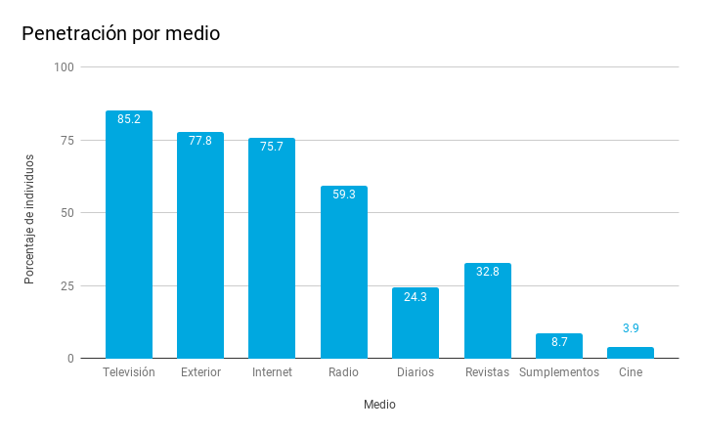
3. 2. 1. Outdoor campaign

"Outdoor" refers to the presence of campaigns in urban furniture such as canopies, columns, digital screens, banners, signage in buildings or diptychs and triptychs, mainly.

An institutional campaign should contemplate at least having this line, given the high penetration of the external environment. In this sense, take advantage of the supports that the institution has and, if not, evaluate the elements of the furniture of the city that can adjust to our need for impact.

Below are some supports for an outdoor campaign with a short introduction to the material that requires:

- Canopies, columns: these protections, usually made of glass and metal, can be found at bus stops or are maps of the city, among others.

Requirements: you have to reserve routes for our campaign and print posters (you have to be careful with the support measures and ensure that designer and printer work with those same measures). The posters have to be delivered with enough time to ensure their placement, you have to print more than needed, since they can be broken while they are placed. You also have to foresee the cost of installing and removing.

- Canopies and digital screens: this type of supports are gaining weight in streets, buildings, shopping centers, etc. They are very colorful and their production is simpler. Keep in mind that your design can not be loaded with too many messages, but be very specific and highlight the URL where you can expand the information.

Requirements: reservation of routes and creation of videos (MP4 or the type of file indicated to us) with the image of the animated campaign and having the measures indicated by those responsible for the respective digital media.

- Buses: public buses are another colorful support in which we can insert our campaign. The production of the material and installation is expensive, but it can impact a multitude of citizens.

Requirements: vinyl production with the exact measurements of each vehicle. You have to foresee the cost of installing and removing.

- Banners: they are found in the streetlights and poles of the cities.

Requirements: reservation of circuits; Banner printing with a design that can be read and easily identified from the ground. You have to foresee the cost of installing and removing.

- Posters in institutional buildings: in the dependencies of the institutions posters of the campaigns that are underway are usually hung. It is a good way to impact the public that goes to offices, cultural centers, libraries, etc.

Requirements: printing in the size that best suits (50x70 cm can be considered a standard size) and distribution of posters.

- Diptychs and triptychs: this simple support serves to complete the information of the participation process that we are disseminating. While the signage has to have as little text as possible, the diptychs and triptychs allow to develop more information and go into details.

Requirements: printing in the most convenient size and distribution of the diptychs / triptychs.

3. 2. 2. Advertising campaign

The insertion of institutional advertising reinforces and amplifies the impact of a campaign of a participation process. Each institution has its budget and policy regarding advertising campaigns, the execution of which is usually carried out by a media agency.

Before going into details, it should be emphasized that each medium has characteristics that are directly related to the type of consumption, and advertising must be adapted to each medium to ensure that the effectiveness of the campaign is optimal.

For example, the highest percentage of content consumption in social networks is done from the mobile, without wifi and with a 5-second attention window, so you have to make sure that the impact is adapted to each support.

Outdoor advertising, radio and television are passive media, while digital is a medium where the consumer is active and in which the relevance of the content must be ensured in order not to be intrusive.

To design or order a campaign is a great advantage to have training or experience in advertising. Although if you do not have, in this section are explained, in broad strokes, the types of advertising that can be used, the needs that should be covered by the side of the institution and some basic recommendations.

Before ordering the campaign

Some questions that the institution has to contemplate before entering to develop the campaign are:

- Define the target audience to which the campaign is directed: who we are targeting, both demographically (age ranges, sex, socioeconomic class, geographical distribution), and qualitatively (interests or affinity with specific contents such as the environment, cinema, urban planning, travel , etc). This will help us determine the size of the campaign and the distribution of the weight by type of media.

- Define the main and secondary objective of the campaign to mark strategies: what we want to achieve (records, votes, presentation of proposals, etc.). It is a decision that the institution has to make.

- Offline, online advertising? Although it will depend on the study of the target audience and their consumption of media, an ideal scenario is the combination of both types of advertising if you have a sufficient budget. It must be emphasized that our participation platform is digital, so online advertising is a "natural" format for our objectives. We seek that users click on our page and participate, and it is easier to get if they come from a digital environment.

- Materials needed according to the objective of the campaign: depending on the main objective of the campaign we will need some materials or others. There are no clear guidelines to know what works best.

In the experience of Decide Madrid, the use of videos has served to publicize the platform (branding), while the images and GIFs have better supported calls to action for users to make direct decisions from online advertising.

During and at the end of the campaign

It is important that during the course of the campaign there are partial follow-up reports to be able to decide the optimal strategy at all times.

If it is detected that there are better results with one strategy than with another and we are in time to turn resources into something that works, we must be able to redirect the campaign and in this way, in addition to increasing the impact among the public, optimize the advertising investment .

Likewise, it is essential to have a complete report of final results. Each advertising experience serves to learn in the face of a future campaign.

Some metrics that should be taken into account in the final analysis are:

- The reach of the announcements (to how much public we have reached).

- The number of visits to our website through advertising.

- Conversions (is the fulfillment of the action we were looking for, such as completing a vote).

- The CTR (the clicks that a link obtains with respect to its number of impressions).

- The CPC (how much each action / click has cost depending on the investment).

- The CPV (cost for video playback), etc.

Practical tip: regarding metrics we can detect what works best in terms of creativities, media, etc. If any of the advertising actions has not worked at all, it may not be the best way to get users hooked.

As for new formats, if we do a test with little investment with any format or medium and we see that it has given good results, we can expand investment in the future.

Television advertising

Television is the most viewed medium today and the most expensive type of advertising to produce and when buying spaces. Before investing in television advertising you have to assess aspects such as how much it costs to create an advertisement; in what chains and when to insert them (cost of the time slot, audience, etc).

Advertising in digital media

The proliferation of digital media has gone up in the last two decades, as well as advertising investment in them. These media are a way to approach potential participants through banners that are shown when the participatory process is underway.

The cost will depend on the rates of each media depending on the position of the ads within the pages and the duration of their insertion, among others.

Advertising on social networks

Advertising on social networks is a relatively simple way to reach a broad audience and requires less production effort. It is important to have accounts with a broad base of followers, to get more impact with the campaign. However, if this is not the case, we can resort to launching the campaign from the main accounts of the institution, which may have been open for a longer time.

As for the investment to be made, it will depend on the results the institution wants to achieve. Based on these objectives, the agency will guide the investment that has to be made.

In what social networks should we advertise? To know what works best, each institution should be planned based on experience and data collected in previous campaign reports.

- Facebook: since the algorithm change at the end of 2017, Facebook prioritizes the organic publications of family and friends with respect to brands, institutions, etc. It seems that the way the company sets to achieve visibility is to use the promoted publications, that is, advertising.

The main features of the ads on this platform are that it allows you to segment by location, age, sex, language and interests; they allow adding user behaviors (for example, if they follow our page) and marking the objectives we want to achieve, among others.

If images are used to advertise on Facebook, we must ensure that they have the least possible text, since excessive text penalizes. You can check the density with this tool offered by the platform itself. If video is used, it does not have to exceed 30 seconds in length.

More information: Facebooks page and Messenger ads

- YouTube and video platforms: for the Google platform and others, there are formats such as pre-roll (very short video before a video is played) or mid-roll (very short video when playing a video), among others . You can also insert clickable banners into third-party videos.

Regarding the duration of the videos, they must have a minimum of 12 seconds and a maximum of 30, and it must be taken into account that you can decide to omit the advertisement after 5 seconds of playback.

More information: ad page on YouTube

- Instagram: this network, allows you to use images and videos. The most recommended format for images is the square (1080x1080 px) and you can not include more than 20% of the text in the image.

The videos, best in square format, should not exceed 30 seconds in length. In both cases it is advisable to include a call to action.

More information: Instagram ads page

- Twitter: on Twitter you can promote campaigns with the objectives of getting more visits to the web; conversions; to get followers; interaction (increase retweets, create brand awareness or generate interest) and promotion of mobile apps (downloads and interaction).

This network allows you to segment the public by demographic data, by keywords that include users in tweets, by users who follow certain accounts and people interested in certain topics.

More information: Twitter ads page.

SEM Advertising

The SEM (Search Engine Marketing), is the promotion of a web page with payment ads in search engines like Google or Bing. The users look for a specific term and among the results it appears highlighted, in the superior part, publicity related to that search term.

We must consider this type of ads, because if we have an outdoor campaign and media appearances, it is likely that searches will increase. In issues such as direct democracy or citizen participation there may be less competition when positioning in this type of advertising.

Paper advertising

Advertising in the paper press (newspapers, magazines and Sunday papers) is one of the traditional formats in advertising. The publications offer insertions that vary in price depending on the position, size, dissemination of the medium, etc.

From higher to lower cost, there is full-page or double-page advertising, which is the one that has the greatest impact on readers; Stripps, which are the horizontal ads that are located at the bottom of the page and modules, which are the blocks into which a page is divided.

To obtain the materials we have to indicate exact measures to the design team and have the support of the media agency, who will advise us on how we can optimize this announcement.

Radio advertising

The radio is still a medium whose penetration is very high, so we should consider including the dissemination of advertising spots within our campaign. The media agency can present a plan in which it is necessary to take into account the duration of the campaign and, therefore, the density of emission of ads, the geographic scope and which time slots are the most recommended to reach the maximum possible public .

Of the writing of ads and the locution must be commissioned professionals, that either are in the own organization or it is necessary to include it between our requests if we resort to the contracting of services.

4. Metrics and Indicators

To ensure the greatest success of the project, it is necessary to carry out an analytical follow-up that allows us to make decisions based on objective data and not on intuitions.

This way we will know the results of our strategies on the website, in social networks or with advertising campaigns and the effectiveness of the management of our followers' communities. If we measure from the first moment, we will know the impact of the actions that we carry out and we will be able to improve.

When to measure? It depends on the resources we have; if we have software that, in an automated way, measures our networks and our website, we can monitor more constantly, for example, weekly. If we have to resort to the native analytical tools in each social network we may have to space the obtaining of results each month. In any case, it is advisable to have the help of an expert in digital analytics, who will help us understand what is happening and how we can improve.

Why measure? Do we know what percentage of users come from each of our efforts (from our activity in social networks, advertising or the media)? Do we know how our newsletter works? How much time are users on the web and what percentage of visits participate in the processes?

To answer these and more questions and be able to apply corrective measures, it is advisable to follow these steps:

Para contestar a estas y más preguntas y ser capaces de aplicar medidas correctoras, es recomendable seguir estos pasos:

- Define objectives: the first step is to define the objectives of each media, always aligned with the overall strategy of the project. What do we want to achieve? Depending on the strategy we have set, we will define some objectives or others. The objectives always have to be concrete, measurable and achievable. For example: Increase web participation by 10% compared to the previous year; Achieve a response rate to citizen consultations 15% higher than the previous year; Increase by 5% compared to the previous period visits to social network channels; Get 10% more records on the website compared to the previous year, etc.
- Define metrics and indicators (KPIs): Once the objectives are defined and goals are set, we have to think how we can measure them. It is advisable to define indicators that measure the objectives. For example: bounce rate on the web (quality indicator); scope of our content on social networks (volume indicator); impressions (volume indicator); CTR (quality indicator); etc. In summary, you have to use different indicators (volume, quality, etc.) to describe a problem well.
- Periodically perform an analysis of the data: after the data collection an analysis work is carried out with which it is intended to solve specific problems detected. For example, the analysis seeks to answer questions such as, why do visits go down from mobile devices? There are many options to analyze data: compare periods and trends; segment the data (age, sex, geographic location, etc.); compare variations of a metric for a set of values; perform combinations of metrics, etc.

Below are some examples of indicators to measure the activity of the website, social media channels and advertising campaigns:

4.1. Indicators for the web page.

Indicator | What does it measure
Visits | No. of times that users enter the web.
Visits from social networks | Number of user visits from social media platforms.
Visits from email marketing campaigns | Number of visits from users from email marketing campaigns.
Bounce rate | Percentage of visits that only see a page of the web.
Citizen proposals consulted | No. of pages of proposals visited.
Participatory budgeting projects consulted | No. of pages of participatory budget projects visited.
Registrations | Percentage of users who sign up on the web.
Voters | Number of users who voted at least one participatory budget project.
Citizen proposals created | Number of users that created at least one citizen proposal.

4.2. Indicators for social networks

Indicator | What does it measure
Audience or Community size | Total number of followers of all social network channels.
Scope | Number of users who have seen our publications on social networks.
Impressions | Number of times that users saw the tweets posted on Twitter or the images published on Instagram.
Frequency | Number of pieces (posts, tweets, images, tec.) Published on social media channels.
Traffic to the web | Measure the activity on the web of participation of users who come from social networks: unique users, page views, time of permanence, bounce rate, etc., who have accessed the website of participation from social channels
Influence | Influence index (eg Klout)
Engagement | Measure the degree to which users interact with each of our social network profiles (number of comments, number of retweets, number of likes, number of favorites, etc.)

4.3. Indicators for advertising campaigns.

Indicator | What does it measure
Scope of the announcements | To how much public we have arrived.
Visits | No. visits to the participation platform through advertising.
CPV | Cost of the campaigns divided by the total of the visits obtained.
Advertising impressions | Number of ad impressions served.
Clicks on advertising | No. of clicks that are made on the ads.
CTR | Number of clicks that a link obtains with respect to the number of impressions.
CPM | Cost per thousand impressions.
Conversions | Number of actions that we were looking for (eg: finishing a vote)
CPC | Cost of each action / click based on the investment.



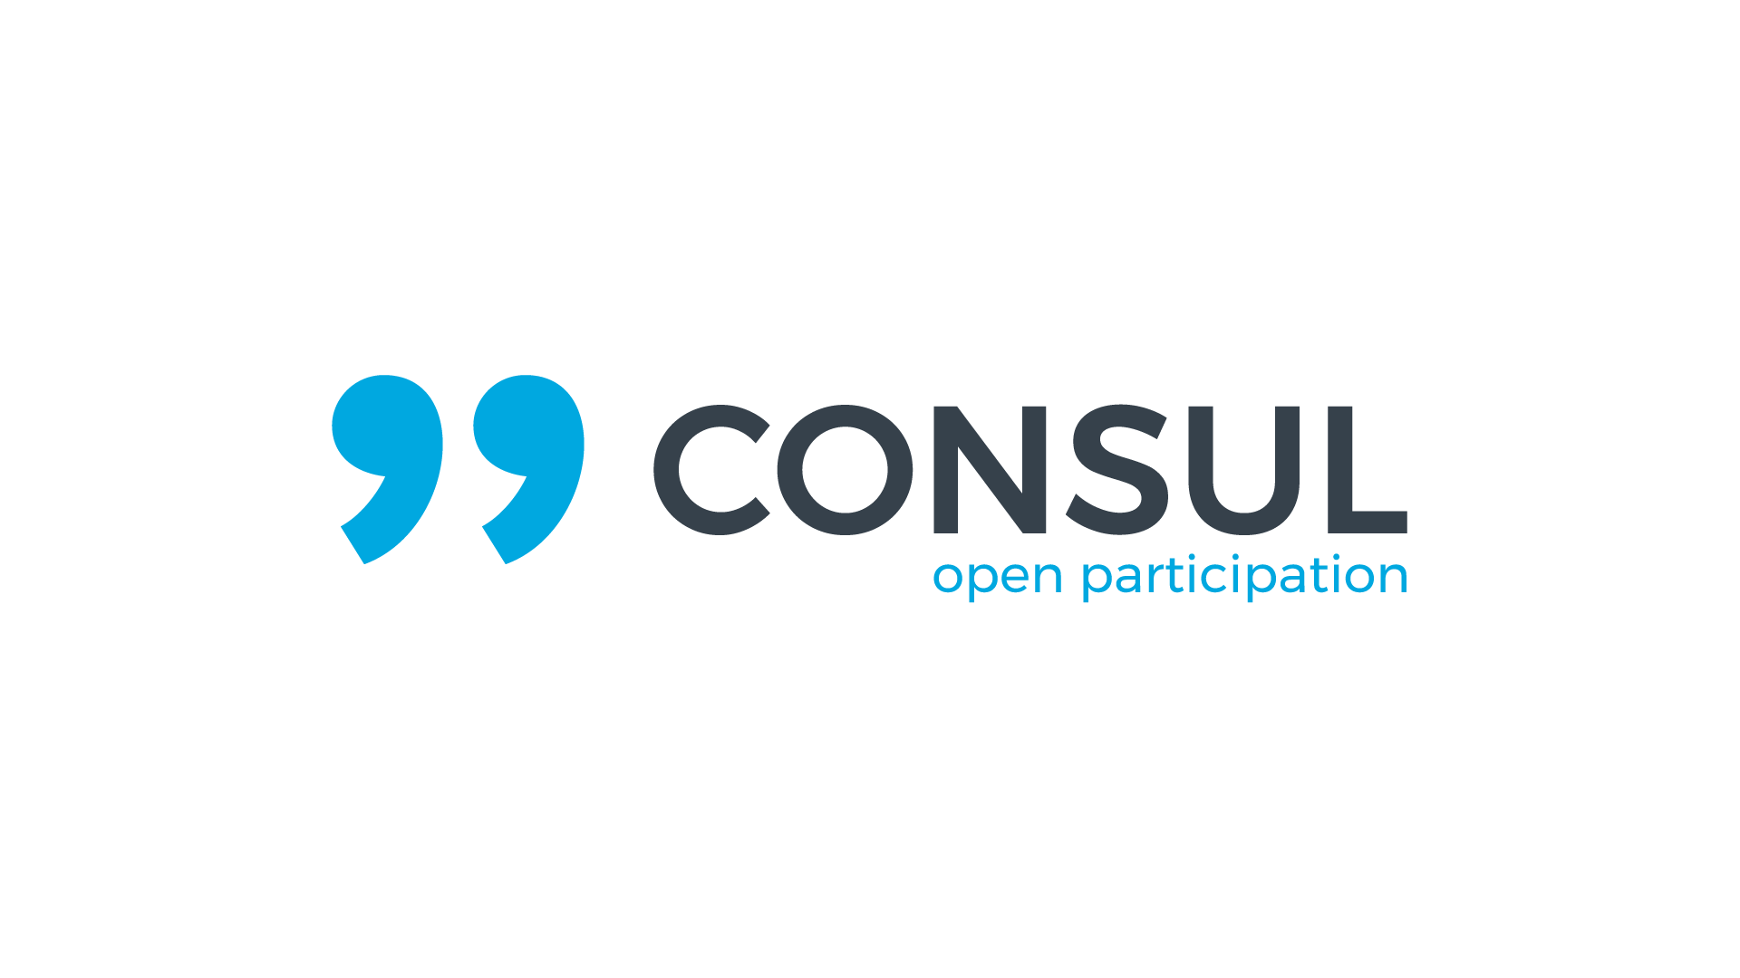

Citizen Participation, Transparency and Open Government Department
City of Madrid

Institutional Extension Unit
Phone: +34 915883084
Email: extension.institucional@madrid.es

More information in:

consulproject.org | github.com/consul/consul

2018 CC-BY-SA 4.0
This work is under a Creative Commons Attribution-ShareAlike 4.0 International license.

