1. Vendor first instruction: The first is to run the windows command prompt as an administrator. Use that to navigate to and run the msi file to install 7
Output to follow this instruction:
The installer is unable to start the 7 installer installation process and display the message underneath.
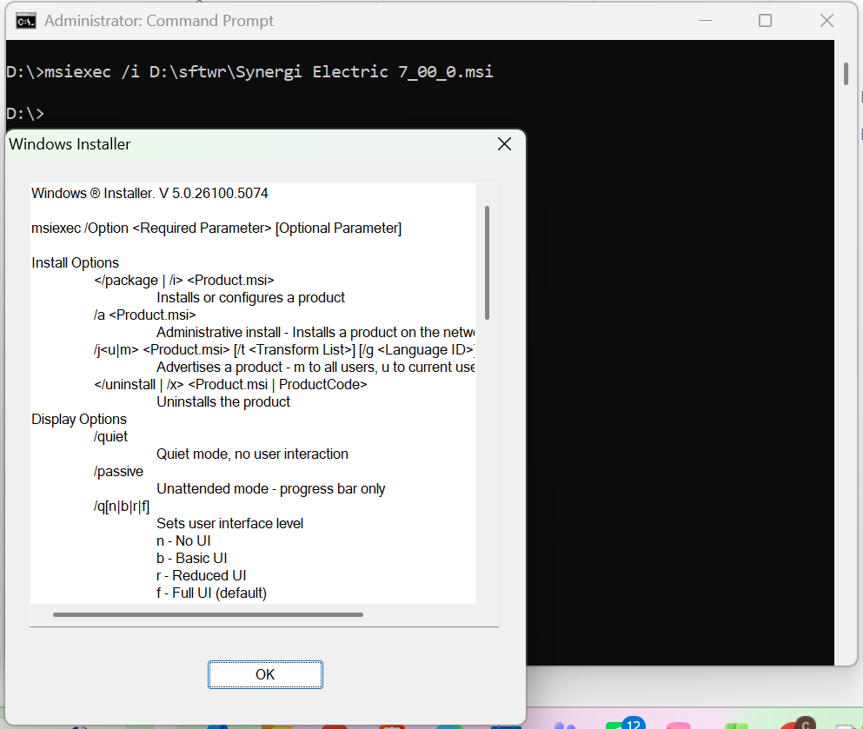

2. Vendor second instruction: If that does not work there may be a Windows driver that is not installed. That can be found here, https://support.microsoft.com/en-us/topic/ms15-074-vulnerability-in-windows-installer-service-could-allow-elevation-of-privilege-july-14-2015-f8098b21-9ab7-a0a6-bddb-a287351f4665

Output to follow this instruction:
As per this instruction I created a new key with name RemappedElevatedProxiesPolicy and set its value 1.
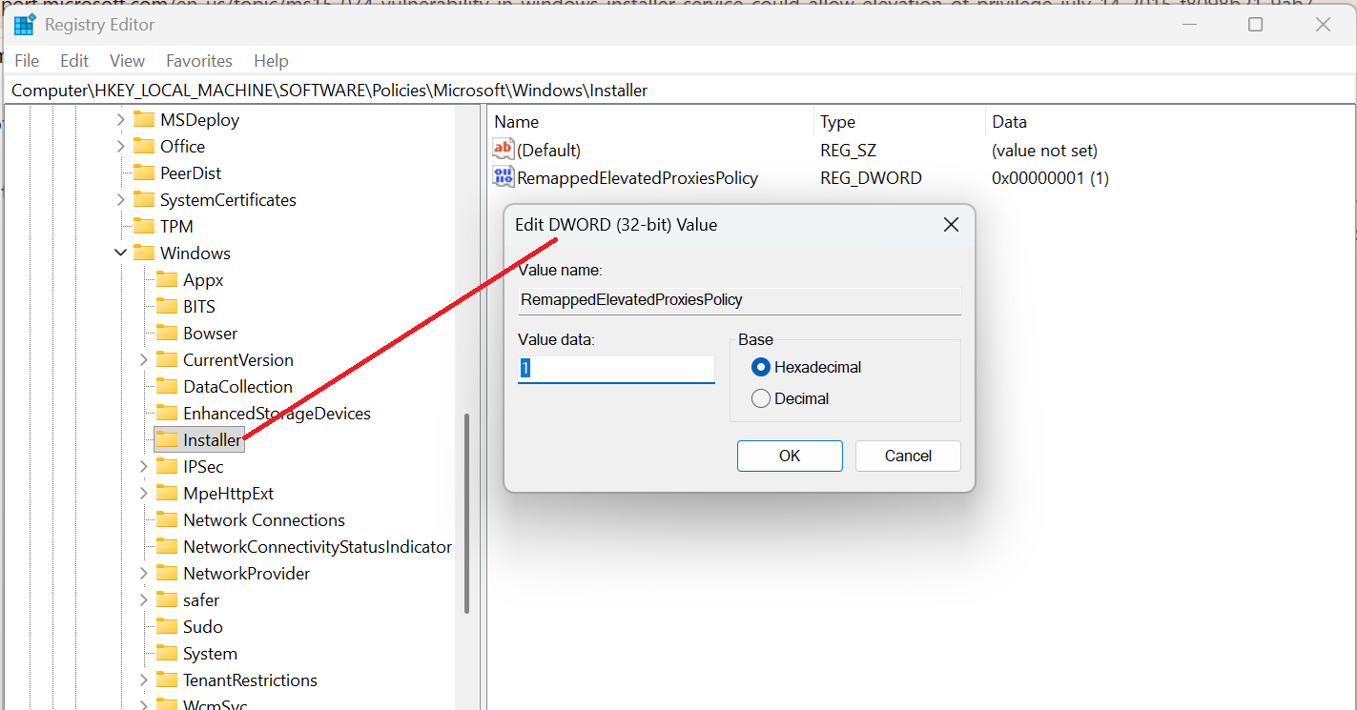

After this change i again did try to run the 7 installer but still i got the error underneath show in picture
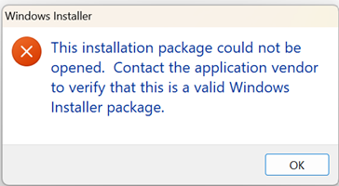
Furthermore, I tried to run the 7 installer on three different PC's (Two systems have windows 10 and one system have windows 11) but I am unable to install the 7 installer and get the error every time.
It is requested to guide us to install your 7 installer successfully.

