© Ericsson AB 2007

User Guide – GOHST
Abstract
This document describes how to use in IO BC project GOHST test tool.
Contents
1 Revision History 3
2 Introduction 4
2.1 Prerequisites 4
2.2 Related Documents 5
2.3 User Interface Conventions 5
2.4 Typographic Conventions 5
3 GOHST 7
3.1 General 7
3.2 Installation 8
3.3 Start-up 8
3.4 Commands 10
3.5 Options 11
3.6 Examples 14
3.6.1 General 14
3.6.2 Send file 15
3.6.3 Generate and send files 16
3.6.4 Generate and send blocks from a single CP 17
3.6.5 Generate and send blocks from multiple CP 17
3.6.6 Send directory 18
3.6.7 Generate and send directories 19
3.6.8 To execute GOHST in multisession 20
3.6.9 Using gohsthelp 21
3.7 Log file 21
3.8 Clear 23
4 Glossary 24
4.1 Acronyms and Abbreviations 24
4.2 Definitions 24

Revision History

Rev | Date | Prepared | Description
PA1 | 2001-08-13 | QABMSOL | First draft
PA2 | 2001-08-20 | QABMSOL | Updates
PA3 | 2001-08-23 | QABMSOL | Product number added, updates
PA4 | 2001-08-31 | QABMSOL | Installation instruction added
PA5 | 2001-09-25 | QABMSOL | Updated. Command file added. Limits on options added.
PA6 | 2001-10-15 | QABMSOL | Updated. Command clear. GOHST detects on which disc it is executed and sets default paths depending on disc.
PA7 | 2001-10-31 | QABMSOL | Destination ->Transfer queue
A | 2003-04-09 | QABBJOF | Updated with new option for the new block transfer (DBO) in GOH2.0 and GOH2.1. GOHST R5A
PC1 | 2007-04-10 | QMICSAL | Update after Internal Ispection

Introduction

Prerequisites
The user of this test tool should be:
- Familiar with command line interface environments
- Familiar with Generic Output Handler (GOH) environment
Necessary preparations:
- Define destination and destination set using Common Destination Handling (CDH) server; ex:
- Use these samples commands to send files via FTP server:
  - cdhdef –a xxx.xxx.xxx.xxx –t FTPV2 –u user –p DEST1 → This command creates a destination DEST1 that sends files via FTP on the server with xxx.xxx.xxx.xxx IP address, username user
  - cdhdsdef DEST1 DESTSET1 → This command creates a destination set DESTSET1
- Use these samples commands to send blocks via RPC server:
  - cdhdef –a xxx.xxx.xxx.xxx –t BGWRPC DEST1 → This command creates a destination DEST1 that sends blocks via RPC on the server with xxx.xxx.xxx.xxx IP address
  - cdhdsdef DEST1 DESTSET1 → This command creates a destination set DESTSET1
- GOHST transfer queue must be defined in AP File Processing server for file transfer; ex:
- Use this sample command to create a file TQ:
  - afpdef GOHSTDEST1 DESTSET1 → This command define a file transfer queue GOHSTDEST1 and assign it the DESTSET1 destination set. The names of TQ must be GOHSTDESTn where n is a digit (1, 2, …) .
- GOHST transfer queue must be defined in Direct Block Output (DBO) server.
- Use this sample command to create a block TQ:
  - dbodef GOHSTDEST1 DESTSET1 → This command define a block transfer queue GOHSTDEST1 and assign it the DESTSET1 destination set. The names of TQ must be GOHSTDESTn where n is a digit (1, 2, …) .
NOTE: Refers to relative manual pages.

Related Documents
-

User Interface Conventions
GOHST is a simple command line interface program. This user guide only uses one user interface convention. The prompt is represented in bold font.
Examples:
GOHST>
GOHSTHELP>

Typographic Conventions
Commands and options used in GOHST are in this user guide represented with italic Courier New font (11pt).
Example:
To define two transfer queues enter def –d 2.
========================================================
To visualise that more options can be used than those shown in example the patter +… is used.
Example:
GOHST> def –p c:\gohst2 +…
========================================================
Filenames, directories and paths are represented with Courier New font (11pt).
Example:
Log file log.txt contain information about performed actions.
NOTE: Do not manipulate the gohst_rescue directory. The directory will automatically be removed if GOHST is terminated correctly.
========================================================
The words “enter” and “type” are used in the following way:
- “Enter” means “Type the command/option shown and end your input with return”.
- “Type” means “Type exactly what is shown and, nothing else”.
========================================================
Words within < > means that the user should submit some value.
Example:
def –p <path> means that the user types for example def –p c:\my_folder.
========================================================
Sentence within square brackets ([ ]) is a description of the printout that will be displayed at this place.
[ Description of the command ]
========================================================
Figure texts are written with italic Arial (8 pt).
Example:
Figure 1: Text describing figure 1.

GOHST

General
The GOHST test tool is a simulator with following features:
- Generate data with a known content
- Build files or blocks with the generated data
- Report files or blocks to GOH
- Files and blocks have numeric id’s to simplify handling of generated/reported files/blocks
- Generate/report directories containing a defined number of files
GOHST is a test tool for GOH and uses the Output Handler Interface – Application Programmers Interface (OHI-API) according to figure 1 below.
GOHST
RPC
DBO Server
CDH Server
AFP Server
Remote System
OHI-API (dll)
FTP
Block
based
File
based

Figure 1: Brief overview of the GOHST environment.
The main changes of the applIication GOHST in BC version are:
- GOHST can be executed in more sessions at the same time.
- Every session of GOHST simulates one CP with an assigned CP Name

Installation
At the moment GOHST has no install wizard. Simply just copy the GOHST binary into desired local directory. Set system path to find required libraries.
NOTE: Do not execute GOHST binary directly from cleacase. At start-up phase GOHST detects on which disc it is executed upon and use this in default paths. If executed in clearcase (Z:) GOHST does not have the authority to write on disc. It is important that GOHST has right authorities irrespective of which disc it is executed from.

Start-up
GOHST is started by calling the gohst.exe binary from the command line.
The GOHST application take the CP Name argument; ex.: “c:\> gohst –cp CP0001”. However this application can start also without any argument.
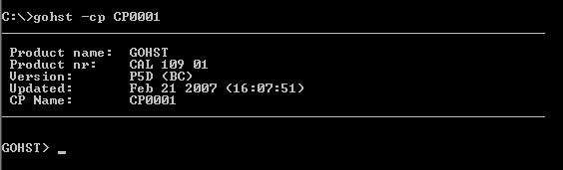
Figure 2: The prompt of GOHST application when they passed a CP Name.
If CPName is not passed the customer will be informed and he will be asked to.
It is possible to continue inserting now the CP Name or to continue working without a CP Name to simulate.
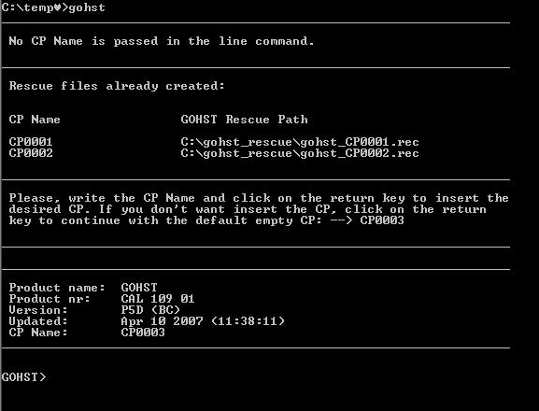
Figure 3: The prompt of GOHST application when they not passed a CP Name.
At start up information about the current GOHST version is displayed according to figure 2. Information about product name, product number, version, latest build and CP Name are shown.
________________________________________

Product name: GOHST
Product nr: CAL 109 01
Version: P5D (BC)
Updated: Feb 16 2007 (15:42:05)
________________________________________

The same information as shown at start-up may also be viewed during a GOHST session by using the version command. The command will present a pop-up box containing the same information as in figure 2 (see you figure 4).
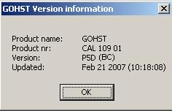
Figure 4: Information pop-up.

If the additional information shown in figure 5 is retrieved at start-up it indicates that the previous GOHST session, on the selected CP Name, was incorrectly terminated.
________________________________________

Product name: GOHST
Product nr: CAL 109 01
Version: P5D (BC)
Updated: Feb 16 2007 (15:42:05)
________________________________________

INFO: Gohst session not terminated correctly last
time. Restoring previous gohst session.
(Enter "list" to check status)

If a new gohst session is wanted enter "exit"
and restart gohst.

GOHST>

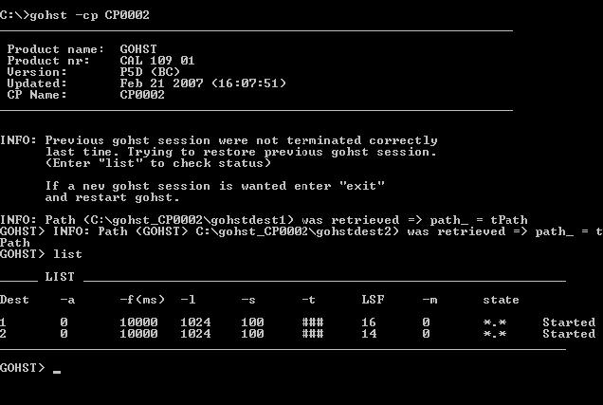

Figure 5: The prompt of GOHST.
At this point GOHST tries to resume previous GOHST session with the option that where defined and the same states. If a “new” GOHST session is desired for this CP Name the user must enter exit and then restart GOHST with the same CP Name.

Commands
This part describes the different commands that are used in GOHST.
Command: Description:
block Used to generate and report blocks instead of files.
clear To delete all generated GOHST directory including all sub directories and sub files.
def This command alone defines one transfer queue with default values. To define more than one transfer queue use option –d (see below) option. The def command is also used to change values of options described in 3.6. All changes on options are preceded by the def command.
dir This command is used to send an already existing directory. For further information about how to use the command see example 3.6.6.

exit End the current GOHST session.
file This command is used to send an already existing file. For further information of hoe to use the command see example 3.6.2
help Shows commands that can be used with GOHST.
list Lists values of specified options for defined transfer queues. To view extended information use option list –l.
NOTE: This additional option should not be mixed up with the –l option used together with def command (see below).
pause Pauses the file generation. Can be combined with option –x (see below) to pause file generation of a specific transfer queue.
start Starts defined task.
stop Stops defined task
version Display GOHST version information in a pop-up box.
To show these commands in GOHST enter help at the prompt:
GOHST> help

Options
The following options can be used together with the GOHST command def. For example def –f 1000 –pl C:\logfiles which changes the frequency from default value 10000 to 1000 and the path to the log file from C:\gohst to C:\logfiles for defined transfer queue.

Option: Description:
-a Defines the amount of files that are generated in each directory.
Default value: 0 files.
Limits: 0 <= a <= 10000
GOHST> def –a 5 +…
Definition above defines that in each generated directory there will be 5 files generated.
-b Defines number of simulated CP in block transfer data.
Default value: 1 simulate CP.
Limits: 0 > b <= 5
GOHST> def –b 3 +…
Definition above defines 3 simulate CP in block transfer data.
-d Defines number of GOHST transfer queues.
Default value: 1 transfer queue.
Limits: 0 < d < =100
GOHST> def –d 3 +…
Definition above defines 3 GOHST transfer queues.
-e Information in the event in case of failure.
Default value: EventText.
GOHST> def –e “SendDirFailure” +…
Definition above defines a new event text.
-f Defines the file-, directory- or block generation frequency.
Default value: 10000 ms.
Limits: 0 <= f <= 864000 (24h)
GOHST> def –f 1000 +…
Definition above defines a file will be generated each second (in case of sending files).
-l Defines the record length, i.e. the size of the data blocks.
Default value: 1024.
Limits: 1024. 2048, 4096, 8192, 16384,
32768, 49152 or 65536
GOHST> def –l 4096 +…
Definition above defines record length 4096.
-m Defines a mask.
Default value: *.*
GOHST> def –m *.exe +…
Definition above defines a mask selecting all files ending with file extension *.txt.
-k Defines the StreamID for block transfer wich is the identification that is sent to the BGw or RPC server. Without using this option, the identification that is sent by GOH to the BGW or rpcServer is: “APCLUSTERNAME_TQ_DESTINATIONSET”.
GOHST> def –k TESTSTREAMID + …
Definition above defines the StreamID that is used in the block transfer.
Note: Use this option only if is not defined the CP Name otherwise this option overwrite the CP Name

-p Defines the path where generated files, directories and blocks are stored.
Default value: C:\gohst.
GOHST> def –p D:\myDir +…
Definition above redefines GOHST default path to D:\myDir.

-s Defines the amount of records in one file.
Default value: 100 records.
Limits: 0 <= s <= 50000
GOHST> def –s 1 +…
Definition above defines that each file will contain 1 record.
-t Defines the transmission type, i.e. ascii or binary.
Default value: binary (b).
GOHST> def –t a +…
Definition above defines that selected files will be sent using transfer type ascii.
-x Specifies a specific transfer queue.
Default value: 0 (All transfer queues).
Limits: Number of defined transfer queues.
GOHST> def –x 2 +…
Definition above defines following options will effect GOHST transfer queue two.
-z Specifies the size of the maximum transaction length.
Default value: 2000 KByte (All transfer queues).
GOHST> def –z 3000
Definition above defines the maximum transaction length to 3000 KByte.

To show these options in GOHST enter def at the gohsthelp prompt.
GOHSTHELP> def
See 3.7.7 for more detailed information about gohsthelp.

Examples

General
Examples described below (3.6.2 – 3.6.7) are when one GOHST transfer queue is defined. The transfer queues are named GOHSTDEST1, GOHSTDEST2 and so forth (according to prerequisites 2.1).
NOTE: The transfer queue names are defined in GOHST and can not be changed.
NOTE: The following examples can be executed with the assigned simulated CP Name or without the assigned simulated CP Name.

GOHST make the disc that it is installed on it default disc. This is used for default path in GOHST. That is if the GOHST binary is installed at C: and the default path value not is changed with -p option the directory structure showed in figure 4 is created. The directory gohst_rescue seen in figure 4 is used to store temporary data during GOHST sessions. The user of GOHST should not manipulate this directory.

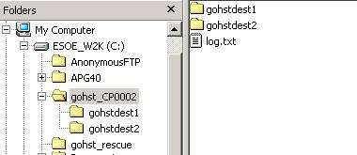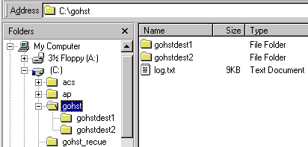

Figure 6: Default directory structure for a simulate cp named CP0002.
If several transfer queues are defined in AFP the def -d <nrOfDest> command must be used to define corresponding number of transfer queues in GOHST. To perform commands or options on a specific transfer queue use –x <destNr> option to make changes/actions. For example:
GOHST> def –d 5
GOHST> def –x 3 –f 10
Example above defines five transfer queues and changes the frequency value of transfer queue three.
If several transfer queues are defined and user not uses –x <destNr> option changes will be performed on all defined transfer queues.

Send file
This example shows how to send a specified file.
NOTE: The file to send is already an existing file.
- Define the path where the generated files will be stored (if other than default is c:\GOHST_CPName desired) by using command def –p <path>.
GOHST> def +…
Additional parameter may in this case be for example –t (transfer type), if the file will be sent using binary- or ascii mode.
- To enable send file mode the command file is used together with the complete path to the file that will be sent.
GOHST> file <file>
- Start sending of the file with command start.
GOHST> start
The file will be copied from the source directory specified in step 2 into transfer queue directory (specified by –p option) before being sent.
- Stop this mode with command stop.
GOHST> stop
NOTE: The command pause can not be used when sending an already existing file.

Generate and send files
This example shows how to generate files that will be sent.
- Define the path where the created files are being stored (if other than default is c:\gohst_CPName desired) by using command def –p <path>.
- Set options for transfer queue if other than default values are desired. Use command list (list –l) to see defined values. The make desired changes with the def command, for example:
GOHST> def –f 10 –l 2048 +…
Files will be generated continuously until stopped by user. The rate of generation is configurable by using option –f <rate> (default value is 10000ms).
- Start generation of files with command start.
GOHST> start
- Stop generation of files with command stop.
GOHST> stop
If a break in file generation is desired use the command pause, which pauses the file generation. During a paused session option like for example –f may be changed. To resume file generation enter start.

Generate and send blocks from a single CP
Generate and send blocks works almost in the same way as for creating and sending files (3.6.3)
Billing gateway RPC (BGWRPC): All blocks will be sent to one file at the receiver. Default RPC protocol used by GOHST.
- Initiate block mode with command block. Just entering block will create
and send blocks with default values, i.e. record length 1024 using BGWRPC.
GOHST> block
Start block generation and sending with command start.
GOHST> start
- Stop generation of files with command stop.
GOHST> stop
As for file generation a break in block generation can be done using the command pause, which pauses the block generation.

Generate and send blocks from multiple CP
To simulate sending blocks from more CP, -b option must be used indicate how many CPs will be simulated. The supported protocol is BGWRPC.
Billing gateway RPC (BGWRPC): All blocks will be sent to one file at the receiver. Default RPC protocol used by GOHST.
- Indicate how many CP they are to be simulated with the option –b
GOHST> def –b 3
The previous command similate 3 CP
- Initiate block mode with command block. Just entering block will create
and send blocks with default values, i.e. record length 1024 using BGWRPC.
GOHST> block
Start block generation and sending with command start.
GOHST> start
10 blocks will be sent for every CP in a cyclical way
- Stop generation of files with command stop.
GOHST> stop
As for file generation a break in block generation can be done using the command pause, which pauses the block generation.

Send directory
This example shows how to send an already existing directory.
NOTE: No files or directories are generated at this mode. Files and directories to send are already existing.
Specified directory structure (specified in step 2) is first copied into the GOHST directory (specified in step 1) before it is being sent.
- Define the path where ‘directory to be sent’ will be copied into (if excluded default C:\gohst_CPName is used).
GOHST> def –p C:\sendDir +…
Additional options can be for example mask (-m) or transfer type (-t).
GOHST> def –m *.txt –t a +…
Above definition means that all files (in specified directory) ending with the file extension .txt are sent using transfer mode ascii. All other files not matched by mask are sent using opposite transfer mode (i.e. binary).
- Define the path to the directory that will be sent using the dir <referenceDir> command.
GOHST> dir C:\refDirectory
NOTE: No default path is defined.
- Enter command start. This will start copying specified directory including files and subdirectories from reference directory to GOHST directory (specified in step 1) and then sending directory to the receiver.
GOHST> start
- To end sending enter command stop. If sending is stopped action 2 must be done before starting again.
NOTE: The command pause can not be used when sending an already existing directory.

Generate and send directories
This example shows how generate directories containing a number of files (configurable) and sending these to a receiver.
- Define a path where to store created directories (default is C:\gohst_CPName).
GOHST> def –p C:\myDir
- Define how many files that will be created in each directory with the -a <nrOfFiles> option (default is 0).
GOHST> def –a 5 +…
This will create subdirectories in ‘myDir’ where the first directory named temp0001 contains five files (0001-0005), the second directory named temp0002 five more files (0006-0010) and so forth.
Step 1 and step 2 can be performed in one step.
GOHST> def –p C:\myDir –a 5 +…
Directories and files will be created continuously until stopped by user. The rate of generation is configurable by using option –f <rate> (default value is 10000ms).
- Use command dir (without any options) to indicate that directories will be created and sent.
GOHST> dir
- Sending of the created directories is initiated with the start command in the same manner as in previous examples.
GOHST> start
- Use stop command to end the process of creating and sending directories.
GOHST> stop
To make a break in creation and sending of directories the pause command can be used.

Figure 5 shows how a directory structure might look like (default paths are being used). Under gohstdest1 temporary directories temp0001-temp0010 are generated. These directories contain five files each in numeric order starting with file CP1_0001 – CP1_0005 in temp0001, CP1_0006 – CP1_0010 in temp0002 and so forth.

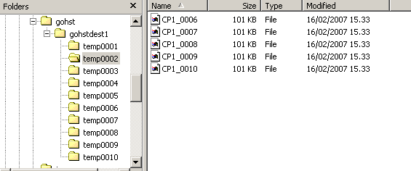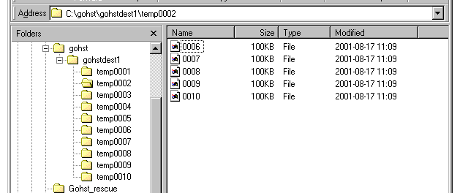

Figure 5: Example of directory structure after generate and send directories.

To execute GOHST in multisession
It is possible to execute more session of GOHST and, for any session, is possible to assign a different CP Name to simulate.
It is possible to execute the previous samples with the multisession case.

Using gohsthelp
All commands and options available for GOHST can be viewed during runtime in gohsthelp. There are also some examples of the most common tasks performed by GOHST.
To start gohsthelp just enter help at the prompt.
GOHST> help
[ A menu is presented containing commands on which help are available. The GOHST prompt is changed to gohsthelp prompt. ]
To get information about a GOHST command or option, enter the command that help is desired for (listed in help menu).
GOHSTHELP> <Command that help is desired for>
[ Description of the command ]
GOHSTHELP> end
The gohsthelp is terminated by entering end at the gohsthelp prompt. This will end the GOHST help and present the regular GOHST prompt again.

Log file
Operations performed with GOHST are written down to a log file named log.txt. This file is stored in C:\gohst_CPName\ (default value). If desired the log path can be changed with def –lp <log path> command. If several GOHST transfer queues are defined all transfer queues uses the same log file.
GOHST> def –lp C:\my_log_path
The log file contains the following information:
- Date (in format YYYY-MM-DD)
- Time (in format HH:MM:SS)
- GOHST transfer queue (gohstdest1, gohstdest2 and so forth)
- Command/action with options
- Error messages (if any error occurs)
Figure 6 shows an example of how a part of the log file might look like.
2001-08-17 13:49:59 GOHSTDEST01 def
2001-08-17 13:50:04 GOHSTDEST01 def -a 3
2001-08-17 13:50:06 GOHSTDEST01 dir
2001-08-17 13:50:08 GOHSTDEST01 start
2001-08-17 13:50:08 GOHSTDEST01 Sending directory temp 0001
2001-08-17 13:50:09 GOHSTDEST01 Sending directory temp 0002
2001-08-17 13:50:11 GOHSTDEST01 Sending directory temp 0003
2001-08-17 13:50:11 GOHSTDEST01 pause
2001-08-17 13:50:20 GOHSTDEST01 start
2001-08-17 13:50:20 GOHSTDEST01 Sending directory temp 0004
2001-08-17 13:50:21 GOHSTDEST01 Sending directory temp 0005
2001-08-17 13:50:22 GOHSTDEST01 Sending directory temp 0006
2001-08-17 13:50:23 GOHSTDEST01 Sending directory temp 0007
2001-08-17 13:50:24 GOHSTDEST01 stop
2001-08-17 13:51:45 GOHSTDEST01 def
2001-08-17 13:51:54 GOHSTDEST01 def -f 4
2001-08-17 13:52:45 GOHSTDEST01 start
2001-08-17 13:52:45 GOHSTDEST01 Sending file CP1_0001
2001-08-17 13:52:45 GOHSTDEST01 Sending file CP1_0002
2001-08-17 13:52:45 GOHSTDEST01 Sending file CP1_0003
2001-08-17 13:52:45 GOHSTDEST01 Sending file CP1_0004
2001-08-17 13:52:45 GOHSTDEST01 Sending file CP1_0005
2001-08-17 13:52:45 GOHSTDEST01 Sending file CP1_0006
2001-08-17 13:52:45 GOHSTDEST01 Sending file CP1_0007
2001-08-17 13:52:45 GOHSTDEST01 Sending file CP1_0008
2001-08-17 13:52:46 GOHSTDEST01 Sending file CP1_0009
2001-08-17 13:52:46 GOHSTDEST01 pause
2001-08-17 13:52:53 GOHSTDEST01 start
2001-08-17 13:52:53 GOHSTDEST01 Sending file 0010
2001-08-17 13:52:53 GOHSTDEST01 Sending file 0011
2001-08-17 13:52:53 GOHSTDEST01 Sending file 0012
2001-08-17 13:53:53 GOHSTDEST01 stop

Figure 7: Example of a log file.

Clear
After generating files or directories these can be deleted from ghost by using command clear. This command will delete all generated GOHST directory including all sub directories and sub files.
GOHST> clear
NOTE: Clear must be performed before exit in GOHST.

Glossary

Acronyms and Abbreviations
AFP AP File Processing
AP Adjunct Processor
API Application Programmers Interface
BGW Billing Gate Way
CDH Common Destination Handling
DBO Direct Block Output
GOH Generic Output Handler
OHI Output Handler Interface
RPC Remote Procedure Calls

Definitions
transfer queue Indicate GOHST sessions. Normally (with default values) a GOHST session contain one transfer queue, but together with –d option several transfer queues can be handled in on GOHST session. The expression transfer queue was in previous versions of GOH named destination.
file Number of records, with a known patter, which is treated as a single file.
GOHST The test tool described in this user guide.
receiver Remote system that receives files and/or directories sent by GOHST.
record Known pattern with length 1024, 2048, 4096, 8192, 16384 bytes.

