Usage instructions for the DDP macro.

1. Request access to DDP DB
2. Install ODBC 32 bit - <http://dev.mysql.com/downloads/connector/odbc/>
3. 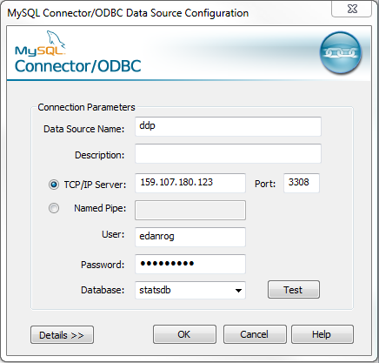Configure a new ODBC connection.
   1. Start –> Control Panel –> Administrative Tools -> Data Sources (ODBC)
   2. Select MySQL ODBC Unicode Driver -> Finish  
      If the driver is not listed, switch to the 32bit version of Data Sources (ODBC). This is located under C:\Windows\SysWOW64\odbcad32.exe. Run this as administrator and continue (you may see more drivers listed than pictured below)

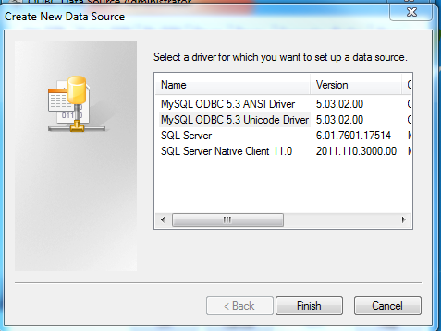

* 1. Configure as follows (using your Username & Password, all other fields as shown)

1. Open the workbook “DDP DB Check”. When opening for the first time grant any permissions requested.
2. Enter any queries to be used on the sheet “sql”. Each query goes in Column B and must have an associated ID in Column A. Any variables to be used should start with a dollar sign (these will be replaced with the corresponding values entered at step 6). Do not place blank rows between any entries; any rows after a blank row will be ignored.
3. Enter the configuration fields for each query on the “configuration” sheet (one query per row):
   1. Query ID of the query to use, in Column A. This must match one of the query ID’s on the “sql” sheet.
   2. Series Name in column E. This is the name of the graph series, as it appears on the graph legend. It is also the name of the sheet on which the query results will be stored. This must be unique or errors will occur.
   3. Variables in column C. This is a list of variables to use in the query. Each entry in the cell must be in the format $<variable name>=(<variable value>). <variable name> must match a variable in the associated query. <variable value> is the value that will replace the variable name in the query.
   4. Graph Name in column D. This is the graph to draw the results to. Multiple queries can share the same graph.
4. Run the Macro by clicking the “generate graphs” button. All existing worksheets and graphs are cleared, new ones are generated, and the workbook browses to the “graphs” sheet