Executive summary
!!! Remove this text box !!!
NOTE!!
The text in [brackets] or blue are placeholders or giving instructions about the contents of the chapter, and it is meant to be removed or replaced.
THIS IS A TEMPLATE WITH DOCUMENT NUMBER LMF-10:001012
To create your own report with a new document number, click Templafy, Documents and then Update document. Change document type from Template to Report. Update Document Title, Date, and Prepared By fields according to your situation. Store the new document in EriDoc (or other document library) and use the document library tool to assign a new unique number and revision for your report. The report shall be classified as Ericsson Confidential with restricted access.
!!! Remove this text box !!!
Assessment target: [Product] [Release]
Assessment period: [yyyy-mm-dd] – [yyyy-mm-dd]
Security Risk and Privacy Impact Assessment was performed in workshops on [add dates]. The workshops were led by [add role] and the product was presented by [add roles]. Workshop participants are listed in 1.1.
Security level is [Choose, refer to Appendix C].
Privacy level is [Choose, refer to Appendix C].
The table below summarizes the number of residual risks:
SUMMARY | Risks | with privacy impact
Very High
High | 1 | 1
Medium | 2
Low | 1
Total | 4 | 1

Highest risks are related to:
- [Summarize here 3-5 highest risks]
Most important treatment actions and recommendations to lower the risks are:
- [Summarize here 3-5 top priority actions]

Contents
1 General information 5
1.1 Participants 5
1.2 Distribution 5
1.3 Scope 5
1.3.1 Included 5
1.3.2 Excluded 5
1.4 Overview 5
1.5 Additional remarks 5
2 RA and PIA activities and their outcomes 6
2.1 Data flow diagrams 6
2.2 Assets 6
2.2.1 Security assets 6
2.2.2 Personal data 6
2.3 Threat agents 7
2.4 Existing security and privacy controls 7
2.5 Security and privacy assumptions 7
2.6 Threat modeling 7
2.7 Risks from security and privacy requirements 7
2.7.1 Generic security requirements 8
2.7.2 Generic privacy requirements 10
2.8 Risks from 3PP and FOSS 11
2.8.1 Risks related to data protection agreements with 3PP 11
2.9 Risks related to misuse of personal data 11
2.9.1 Product risks for misuse of personal data 11
2.9.2 Features under misuse threat 12
2.10 Identified need for additional assurance activities 13
3 Advanced level risk assessment 14
3.1 Additional threat modeling 14
3.2 Assess risk in real deployment contexts 14
3.3 Assess risks in relation to past security incidents 14
3.4 Quantitative risk analysis 14
3.5 Use external security experts 14
4 Privacy impact assessment activities for aaS 15
4.1 Legal overview 15
4.2 Processor record of data processing 15
4.3 Agreements and contracts 16
4.4 Data flow diagram 17
5 Risks 19
5.1 Summary 19
5.2 Feature 1 19
5.3 Area 2 21
5.4 Privacy risks 21
5.5 Convert old risk table 22
6 References 23
7 Change history 24
Appendix A Asset security classification 25
Appendix B Risk evaluation guideline 26
Appendix C Security and privacy posture 27

General information

Participants
[Name, role]
[Name, role]

Distribution
Receiver: [Name, role]
FYI: PSIRT

Scope
[Define the scope of RA/PIA here. For re-assessments, describe the changes since previous assessment at high level.]

Included
[If relevant to detail what’s included.]

Excluded
[If relevant to detail what’s excluded.]

Overview
[Describe here the product or solution in general. You may include descriptions and diagrams from design documents and other relevant documents.]

Additional remarks
[Add here any additional remarks.]

RA and PIA activities and their outcomes
Risk assessment and privacy impact assessment are fundamental security assurance practices, as they bring holistic understanding of products’ or solutions’ security and privacy threats, highlights the necessity of implementing certain security functionality (BSRs and product specific) and helps the scoping of other security assurance activities where they are needed the most.
This risk assessment has been done following the Risk Assessment and Privacy Impact Assessment Instruction [1]. This report is the evidence and the outcome of the performed assessments and treatment activities.

Data flow diagrams
[Attach here the up-to-date data flow diagrams of the product or solution. If they take more than one or two pages, place them in appendix.]

Assets

Security assets
[Identify the assets and define their security classification. See [1] for examples.]
Classification levels are N/A, Low (L), Medium (M), High (H) and Very High (VH). Security classification is used in estimating the threat impact related to assets. See Appendix A for the definitions.
 | Security classification
Asset | Confidentiality | Integrity | Availability
[asset2]
[asset2]

Personal data
[Fill in the Personal Data Classification Instruction template [4]. This template will also yield the Privacy Technical Index (PTI) of the product and/or feature. The PTI is an indication of the sensitivity level of the product and must be reported to Sensitive Business before PRT.
Copy the relevant content here including the PTI value.]

Threat agents
[Identify here the relevant threat agents. See [1] for examples.]
The relevant threat agents and their potential motives in product’s context are identified as follows:
Threat agent | Motive
[agent1]
[agent2]

Existing security and privacy controls
[Describe here the existing controls in the product or solution.]

Security and privacy assumptions
[Identify the security and privacy features, capabilities and controls needed from the environment where the product or solution is operating. Features, capabilities and controls may be technical, operational or organizational in nature. Ensure that these are documented in the Customer Product Information (CPI), Security User Guide, Privacy User Guide and Service Integration (SI) project documentation as appropriate.
If assumptions change, check if earlier identified and treated risks need to be reopened.]

Threat modeling
[Describe here the threat modeling done using the STRIDE (for security) and LINDDUN or TRIM (for privacy) methodologies. For example, you can document the threats component by component, or category by category. Resulting risks are captured in chapter 5.]

Risks from security and privacy requirements
[Fill in the security [2] and privacy requirements [3] applicability tables below. By default, all requirements should be considered Applicable. Any statement of Not Applicable shall be justified. For each Not Compliant and Partially Compliant requirement, create a risk and evaluate it or refer to already identified risk. Mark the risk ID in the table referring to risks in chapter 5.
Options for Status: Fully Compliant, Partially Compliant, Not Compliant, Not Applicable.]

Generic security requirements
Requirement | Status | Justification | Risk ID
Risk management
105 65-0164/00115 Base_risk_001_m
Risk Assessment Report
Hardening
105 65-0164/00324 Base_hard_001_m
Ability to Identify All Listening Services
105 65-0164/00119 Base_hard_002_m rev C
Ability to Disable Any and All Services and Protocols
105 65-0164/00325 Base_hard_003_m
Ability to Control Service Bindings for Listening Services
105 65-0164/00326 Base_hard_004_m
Ability to Disable Processing of Packets Utilizing IP Options
105 65-0164/00327 Base_hard_006_m
Ability to Disable Any User Account
105 65-0164/00120 Base_hard_010_m Rev B
Product Hardening Documentation
105 65-0164/00121 Base_hard_013_m
Vulnerability Analysis Report
105 65-0164/00346 Base_hard_019_m
Security Test Report for external communication
105 65-0164/00252 Base_hard_018_m
Provide Security User Guide
105 65-0164/00502 Base_hard_023_m
Secure coding report
105 65-0164/00503 Base_hard_024_m
FOSS and other 3PP included in product
105 65-0164/00347 Base_hard_020_m
Undocumented features
105 65-0164/00076 Base_hard_014_m rev B
Malware Prevention
105 65-0164/00348 Base_hard_021_m
Software Signing
105 65-0164/00349 Base_hard_022_m
Web application security
105 65-0164/00504 Base_hard_025_m
Secure default values of parameters
Access Control
105 65-0164/00308 Base_acc_001_m
Ability to assign O&M user IDs and passwords
105 65-0164/00235 Base_acc_002_m Rev B
Enforce replacement of passwords
105 65-0164/00309 Base_acc_003_m
Provide for selection of strong passwords
105 65-0164/00310 Base_acc_004_m
Password protection
105 65-0164/00311 Base_acc_005_m
Support password aging
Base_acc_006_m
Prevent unauthorized change of user's password
105 65-0164/00314 Base_acc_008_m
Ability to give information from previous login
105 65-0164/00250 Base_acc_022_m
Legal warning at login
Base_acc_009_m
Ability to protect against password cracking
Base_acc_010_m
Support inactivity timer for user account
Base_acc_011_m
Support inactivity timer for login session
105 65-0164/00319 Base_acc_012_m
Support network element (NE) authentication
105 65-0164/00350 Base_acc_024_m
'Superuser' account disabled
105 65-0164/00320 Base_acc_015_m
Ability for centralized authentication
105 65-0164/00321 Base_acc_017_m
Support local O&M user authentication
105 65-0164/00243 Base_acc_018_m Rev B
Server side authentication
105 65-0164/00244 Base_acc_020_m Rev B
Support O&M user authorization
105 65-0164/00251 Base_acc_023_m
Ability to retrieve centrally maintained authorization information
Security event logging
105 65-0164/00322 Base_log_002_m
Log for Security Events
105 65-0164/00254 Base_log_004_m Rev B
Configuration of security events to be logged
105 65-0164/00260 Base_log_023_m
Full Personal Accountability
105 65-0164/00080 Base_log_011_m rev B
Ability to Log Locally
105 65-0164/00323 Base_log_013_m
Transmission of Log Records to Remote Server
105 65-0164/00257 Base_log_017_m Rev B
Safe storage of local log files
105 65-0164/00258 Base_log_021_m
Syslog format for the security event log
105 65-0164/00259 Base_log_022_m
Detect modifications to the security event log
Traffic protection
105 65-0164/00261 Base_sec_002_m
Traffic separation
105 65-0164/00262 Base_sec_003_m
Confidentiality and integrity protection of O&M traffic
105 65-0164/00265 Base_sec_017_m
Confidentiality and integrity protection of control plane traffic
105 65-0164/00351 Base_sec_018_m
Confidentiality and integrity protection of data storage traffic
105 65-0164/00122 Base_sec_010_m rev. C
Strong encryption
105 65-0164/00269 Base_sec_014_m Rev B
Secure key management
105 65-0164/00501 Base_sec_023_m
Secure key creation
105 65-0164/00352 Base_sec_019_m
Support of trustworthy environment
Data protection
105 65-0164/00354 Base_data_001_m
Data protection
Packet filtering
105 65-0164/00270 Base_filter_001_m
Ability to Filter Traffic
105 65-0164/00305 Base_filter_004_m
Ability to Log Filter Actions
105 65-0164/00306 Base_filter_007_m
Ability to Filter on Any Protocol Header Fields
105 65-0164/00307 Base_filter_008_m
Ability to Filter Inbound and Outbound

Generic privacy requirements
Requirement | Status | Justification | Risk ID
105 65-0164/00355 Privacy Impact Assessment report
105 65-0164/00356 Privacy User Guide
105 65-0164/00546 Notice to Subscribers
105 65-0164/00547 Notice to System Users and Administrators
105 65-0164/00358 Consent
105 65-0164/00359 Choices
105 65-164/00512 Personal Data Exporting
105 65-164/00513 Personal Data Importing
105 65-0164/00525 Restriction of Processing
105 65-0164/00360 Voluntary Personal Data Collection
105 65-0164/00361 Personal Data Quality
105 65-0164/00362 Personal Data Retention
105 65-0164/00363 Personal Data Identification
105 65-0164/00364 Personal Data Classification
105 65-0164/00365 Configurable Personal Data Classification
105 65-0164/00366 Personal Data Protection Agreement
105 65-0164/00367 Access Rights for Privacy
105 65-0164/00544 Confidentiality and Integrity of Personal Data at rest
105 65-0164/00545 Confidentiality and Integrity of Personal Data in transit
105 65-0164/00566 Confidentiality and Integrity of Personal Data in use
105 65-0164/00369 Logging for privacy

Risks from 3PP and FOSS
[List here the used 3PP and FOSS components. Create risks for vulnerable and non-patched components.]

Risks related to data protection agreements with 3PP
[Identify here any 3PP that process personal data on behalf of Ericsson. If such an arrangement is in place, ensure that also data protection agreement is in place. Create risks if a data protection agreement is not in place or is insufficient.]

Risks related to misuse of personal data
[This chapter applies only if PTI (Privacy Technical Index) reaches 180 or above.]

Product risks for misuse of personal data
[This section should analyze the likelihood for misuse of personal data impacting individual’s privacy. This should cover the worst case scenario where the product is used in a non-intended way impacting individual’s privacy.
I.e. this should cover situations where:
- Operator is addressed by illegal actions
- When exposed to intrusive authority requests to reveal personal information
The analysis should consider aspects as: product placement in a network, data availability and easiness to extract and present such data.
The risk of misuse should be presented as very high, high, medium, or low risk.]

Features under misuse threat
[This information must be sent to mailbox Sensitive Business (sensitive.business.mailbox@ericsson.com) before PRT or Technical Function Ready For Contract (or before being made available for offering)
Use Subscriber Data Classification evaluation sheet to determine the individual Feature/Value package/component PTI. The process is the same independent on solution, node, feature or value pack being evaluated.
Each line reports one Commercial feature/Value Package/Component. The mapping from misuse threats into commercial feature is reported on the same line. For each feature/value package, there might be several misuse threats.
Use Commercial Feature or Price Object as the Feature Name/Value Package/Component, since this information is used within sales process. If the misuse threat is part of the core functionality, and there is no commercial feature for that, then one can use “Basic Feature” as the Commercial Feature name.
Fill-in the following table]
Feature/Value package name (or Object) and number | Related License Key (FAT, CXC…) Number | Basic or Optional | Intended Use | Nature of sensitiveness | Misuse Threats | Feature/Value Package PTI  (Use Subscriber Data Classification sheet per Feature/Value Package to determine figure)
Subscriber Trace (for troubleshooting)  FAJ 121 xxx, or FAJ 801 xxx, or FAZ 101 xxx, or  INF 901 xxx … | FAT  xxx xx | B/O | For troubleshooting only and only by authorized administrators | The log of subscriber trace reveals subscriber’s MSISDN and current location. | The subscriber’s location information is used for surveillance | Numeric value from evaluation
Feature xyz)  FAJ 121 xxx, or FAJ 801 xxx, or FAZ 101 xxx, or  INF 901 xxx … | CXC xxx xx | B/O | For troubleshooting only and only by authorized administrators | The log of subscriber trace reveals subscriber’s MSISDN and current location. | The subscriber’s location information is used for surveillance | Numeric value from evaluation
Feature 123  FAJ 121 xxx, or FAJ 801 xxx, or FAZ 101 xxx, or  INF 901 xxx … | CXC xxx xx | B/O | For troubleshooting only and only by authorized administrators | The log of subscriber trace reveals subscriber’s MSISDN and current location. | The subscriber’s location information is used for surveillance | Numeric value from evaluation

Identified need for additional assurance activities
Based on the risk assessment the following additional (advanced or tailored) assurance activities should be done.
- [Mention here and add a reference to backlog item]

Advanced level risk assessment
[If you performed any advanced level activities, capture their outcomes here. Otherwise this chapter can be deleted.]

Additional threat modeling
[If you performed advanced level threat modeling methodologies in addition to the basic threat modeling, describe here the methodologies and the results.]

Assess risk in real deployment contexts
[If you used a real deployment context in assessing risks, describe here briefly the contexts and refer to particular risks identified. Be mindful about the confidentiality aspects.]

Assess risks in relation to past security incidents
[If you studied past security incidents and their root cause analyses when assessing risks, mention here briefly the cases and refer to particular risks identified. Be mindful about the confidentiality aspects.]

Quantitative risk analysis
[If you performed quantitative risk analysis and describe the results here.]

Use external security experts
[If you used external security experts in addition to inhouse risk assessment, describe here the activities and results.]

Privacy impact assessment activities for aaS
[Delete the chapter if not relevant.]

Legal overview
[Analyze the relevant legislation that concern the aaS solution. This is not limited to only data protection legislation like GDPR but should also consider other legislation such as telecom or other specific field in scope.
The legal analysis should be done together with representatives from GF Legal.]

Processor record of data processing
[Indicate who is the data controller and the contact information (the customer). Example:
Data Controller:
Volvo Car Sverige AB
405 31 Göteborg
Sweden
+46 31 59 00 00
Indicate what is the main Ericsson entity responsible for the data processing (usually the Ericsson country organization who signed the customer contract). Example:
Data Processor:
Ericsson AB
Torshamnsgatan 21
164 83 Stockholm
Sweden
+46 10 719 00 00
Describe the contractual relationships of the aaS, including the name of the companies involved (including the 3rd party companies), their role in the data processing (controller, processor, sub-processor) and the contractual relationship between them. Follow the example picture below to draw your own:
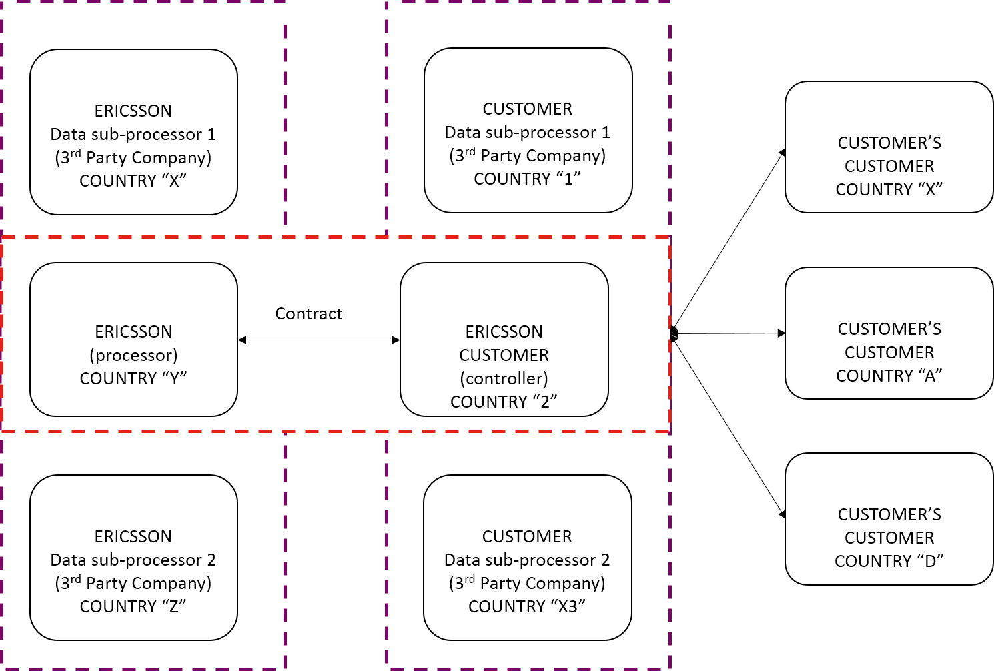
- Data Controller and purpose of data processing
  - Ericsson customer [company name on contract] is the data controller, based in country 2. Customer’s purpose of data processing is e.g. to provide telco services to their subscribers.
  - Ericsson customer has two data sub-processors: data sub-processor 1 in country 1 and data sub-processor 2 in country X3. The purpose of data processing for customer’s data sub-processor 1 is e.g. troubleshooting.
- Data Processor and purpose of data processing
- In this aaS offering, [e.g. Ericsson India] is the data processor. The purpose of the data processing is e.g. to provide billing services.
- Ericsson has two sub-processors: data sub-processor 1 in country X and data sub-processor 2 in country Z. The purpose of data processing for Ericsson’s data sub-processor 1 is e.g. customer support.]

Agreements and contracts
[This section should contain a mapping of all existing legal contracts between the parties identified above, that are within Ericsson influence. This chapter should list:
- Status of Record of Processing in OneTrust [5]
- Data Processing Agreements
Ericsson should sign Data Processing and sub-processing Agreements (DPA) with any involved suppliers.
Example: Sub-Processing Agreement with Ericsson supplier signed/not signed
- Data Transfer Agreements (DTA)
Any transfer of Personal Data outside of the EU requires a legal basis. The legal basis depends on the parties involved in data transfer.
- Data Transfer Agreement containing the Standard Contractual Clause
- Processor Binding Corporate Rules (only within Ericsson Group)
- Privacy Shield (only transfers to US)
- Other, e.g. explicit consent from subscriber
Sub-Processor Name | Record in OneTrust? | DPA signed? | DTA signed?
Sub-processor1 | Y/N | Y/N | Y/N

Any “No” answer should be handled as a potential risk and included in chapter 5.]

Data flow diagram
[Describe which applications store the personal data listed in the data classification, including the country(s) of the storage and the country(s) from where the data will be accessed from. Follow the example picture below to draw your own:
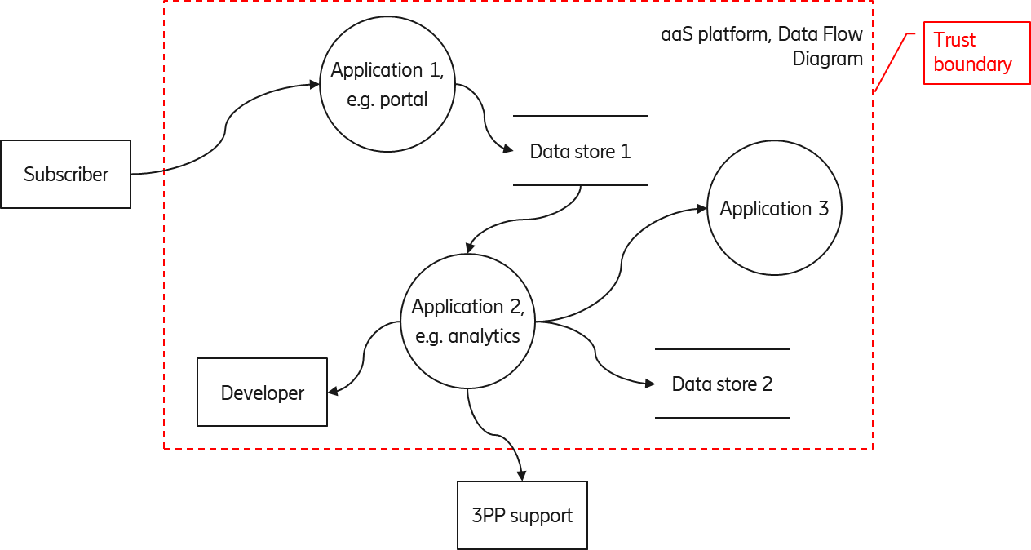

Application number in the picture | Application name in the picture | Description of data stored | Data stored by Ericsson in | Data accessed by Ericsson from
1 | Application 1 | First Name, Last Name User ID, password, login details, Email address, Event Monitoring Browsing/Connection history, URL, originating IP | Sweden | Sweden  UK  India
2 | Application 2 | User ID, Login details, Email address, Event Monitoring | Sweden, India | Sweden
3 | Application 3 | Etc.. | Etc.. | Etc..

According to the Privacy pre-sales activities guideline [6], the CU who owns the customer contract has a requirement to provide a record of the data processing for the aaS in the OneTrust tool [5], in accordance to GDPR article 30.]

Risks
This chapter lists all relevant risks identified during Security Risk Assessment and Privacy Impact Assessment. Each risk should be treated to one of the four states (Accept, Avoid, Transfer, Mitigate). There should be no open risks at the time of GA release. Residual risk is the risk after treatment actions, e.g. mitigation. See Appendix B for risk level definitions.
[The PDU or SI project is advised to manage risks separately in a risk management tool or spreadsheet from where risks and the summary data are exported to the report. Three alternatives are provided for managing the risks
- Jira project reference implementation
- Excel template
- This RA report template (for legacy reasons)
When using a separate tool, merge the exported data to below.]

Summary
Risks are summarized in table below.
Risks identified
ID | Title | Inherent risk | Status | Residual risk
ProductX-5 | Risk title five (PI) | 3-High | TRANSFER | 3-High
ProductX-1 | Risk title one | 2-Medium | OPEN | 2-Medium
ProductX-2 | Risk title two | 4-Very High | MITIGATE | 2-Medium
ProductX-3 | Risk title three | 1-Low | ACCEPT | 1-Low
ProductX-4 | Risk title four (PI) | 4-Very High | AVOID | 0-None

Feature 1
[Pick a unique identifier scheme for risks, e.g. product name and sequence number.
For evaluation vector, the risk rating calculator that is provided in [1] can be used.]
ProductX-1 | Risk title one |  |  |  | OPEN
Risk evaluation | Probability | Impact | PI | Inherent risk | Residual risk
Risk evaluation | 2-Unlikely | 3-Major | N | 2-Medium | Not changed
Evaluation vector | E.g. (SL:1/MO:6/OP:1/SZ:3/EX:3/AW:6/AV:3/ID:3/LC:6/LI:6/LA:3/PV:0/NC:0/FD:6/RD:3/)
Asset / target
Threats
Vulnerabilities
Existing controls
Recommendations
Actions taken
Comments

ProductX-2 | Risk title two |  |  |  | MITIGATE
Risk evaluation | Probability | Impact | PI | Inherent risk | Residual risk
Risk evaluation | 4-Almost certain | 3-Major | N | 4-Very High | 2-Medium
Evaluation vector
Asset / target
Threats
Vulnerabilities
Existing controls
Recommendations
Actions taken
Comments

ProductX-3 | Risk title three |  |  |  | ACCEPT
Risk evaluation | Probability | Impact | PI | Inherent risk | Residual risk
Risk evaluation | 2-Unlikely | 1-Negligible | N | 1-Low | Not changed
Evaluation vector
Asset / target
Threats
Vulnerabilities
Existing controls
Recommendations
Actions taken
Comments

Area 2
ProductX-4 | Risk title four |  |  |  | AVOID
Risk evaluation | Probability | Impact | PI | Inherent risk | Residual risk
Risk evaluation | 3-Likely | 4-Severe | Y | 4-Very High | 0-None
Evaluation vector
Asset / target
Threats
Vulnerabilities
Existing controls
Recommendations
Actions taken
Comments

Privacy risks
ProductX-5 | Risk title five |  |  |  | TRANSFER
Risk evaluation | Probability | Impact | PI | Inherent risk | Residual risk
Risk evaluation | 2-Unlikely | 4-Severe | Y | 3-High | 3-High
Evaluation vector
Asset / target
Threats
Vulnerabilities
Existing controls
Recommendations
Actions taken
Comments

Convert old risk table
[You can import risk tables from document created with the old RA report templates by pasting the risk tables below and running the macro convert_old_risk_tables (from View -> Macros).
Set the risk status to one of Avoid, Accept, Mitigate, Transfer and define the Residual risk, as these are new fields.
Be aware that the macro assumes that the old risk tables have text “Risk Evaluation” in first column and the second row (case sensitive), and that the risk evaluation parameters are like in the old RA template format.
Example of old table format below.]
Product-R17A- | Security risk 1 with no Privacy Impact
Risk Evaluation | Prob. | 2 | Impact | 1 | PI | N | Rating | Low
Asset / target
Threat(s)
Vulnerability(ies)
Existing controls
Recommendations

References
- Risk Assessment and Privacy Impact Assessment Instruction, LME-07:000887 Uen
- Generic Baseline Security for Ericsson Products, EAB-04:000820 Uen
- Generic Privacy Requirements for Products, LMF-14:001052 Uen
- Personal Data Classification Instruction for Products, LMF-14:001078 Uen
- OneTrust tool
- Privacy pre-sales activities, LME-18:000497 Uen

Change history
Revision | Date | Author | Modification
A

- Asset security classification
Identified assets are given security classification in terms of the traditional three security objectives: confidentiality, integrity and availability. The classifications are defined as follows
Security classification | Description
N/A | Loss of confidentiality, integrity or availability is expected to have  no adverse effect on the asset or the organization operating it.
Low (L) | Loss of confidentiality, integrity or availability is expected to have negligible adverse effect on the asset or the organization operating it.
Medium (M) | Loss of confidentiality, integrity or availability is expected to have minor adverse effect on the asset or the organization operating it.
High (H) | Loss of confidentiality, integrity or availability is expected to have major adverse effect on the asset or the organization operating it.
Very High (VH) | Loss of confidentiality, integrity or availability is expected to have severe adverse effect on the asset or the organization operating it.

Refer to [1] for more information.

- Risk evaluation guideline
Risk evaluation is done by calculating the probability and impact of a threat from several contributing factors. Refer to [1] for more information on how calculation is done. Resulting probability and impact levels are placed on the risk matrix (Figure 1) to find the resulting risk level.
Figure 1 Risk matrix
Impact
Probability
Negligible
Major
Minor
Rare
Almost
certain
Likely
Unlikely
M
M
L
L
H
M
L
L
VH
H
M
M
VH
H
H
VH
Severe
The risk levels are used in prioritizing risks and highlighting the unacceptable risks.
Risk level descriptions
- VH stands for Very High risk which has severe impact and is likely to occur. Risk is unacceptable and immediate actions must be taken.
- H stands for High risk which has either unlikely but severe impact or likely but less than severe impact. Risk is unacceptable and actions should be taken in short term.
- M stands for Medium risk. These are unlikely but have major impact or likely but have only minor or negligible impact. Risks should be addressed, but they can also be accepted.
- L stands for Low risk. They are unlikely and have only minor or negligible impact. Risks are recommended to be addressed, if feasible, but may otherwise be accepted.
- Security and privacy posture
The overall security and privacy posture on product or solution level is a combination of risks, evidence and other observations.
Privacy posture can be equal to or weaker than that of security; the privacy posture statement is used also as the overall risk posture statement for the product.
Posture levels are
- Defective
- Insufficient
- Reasonable
- Systematic
- Excellent
Refer to [TBD] for definitions of the posture levels.

