

**INTERIM REPORT**

**By**

**CAPSTONE-CV1 Proj-Group2**

Table of Contents

Background: 3

Data 3

Summary of Pre-processing, EDA and Findings 4

Findings: 4

CSV Files 4

DATA SET - Training 5

DATA SET - Testing 5

Pre-processing 6

Merging Dataframe and remove duplicates 6

Print random images from merged dataframe along with its class 7

Data balancing 7

Encoding 7

EDA 8

Understand Target and Class 8

Insights on coordinates 9

Correlations 9

Visualization of images with coordinates 10

Analysis Summary and Next Step 10

Milestone – 1 Basic CNN 11

Train Test and Validation split 11

Convert to tensor 11

Basic CNN Model 11

Architecture 11

Trainable Parameters 12

Accuracy and Loss 12

Accuracy and Recall using dedicated 13

Summary and Next step: 13

# Background:

Pneumonia is a Health Condition which is caused by Infection that inflames air sacs in one or both **lungs**, which may fill with fluid. With pneumonia, the air sacs may fill with fluid or pus. The infection can be life-threatening to anyone, but particularly to infants, children and people over 65. This project is aims to create a Model using Computer Vision algorithms to detect a visual signal for pneumonia from medical images given as input. The algorithm should provide marker for Lung opacities on the Xray images. The infection in lungs can be in more than one location and algorithm should detect and provide marker for all the inflammation.

# Data

Following files are shared for this project,

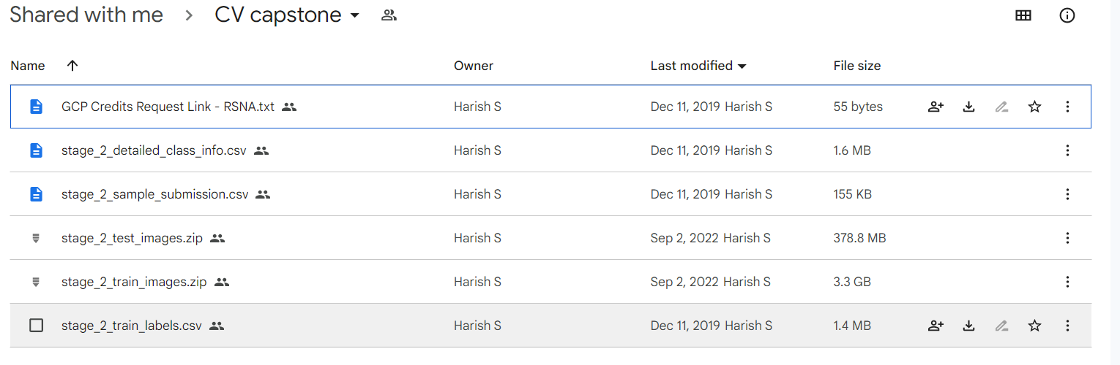

1. GCP Credits Request Link - RSNA.txt: The credit file which we don’t need to process in the project. It is to give credit to the author of this data.
2. stage_2_detailed_class_info.csv: CSV file having patientid and corresponding class of the disease.
3. stage_2_sample_submission.csv: CSV file which has patientid and predictionstring which is a constant value shown for example. This file may not be required any processing.
4. stage_2_test_images.zip: Zip file containing test images of type DICOM.
5. stage_2_train_images.zip: Zip file containing list of DICOM images which we can use for model training
6. stage_2_train_labels.csv: The CSV File having patientid, coordinates(x, y, width, height) and Target. The target is 0 if there are no coordinates. The Target is 1 if there is a coordinates available.

# Summary of Pre-processing, EDA and Findings

# Findings:

# CSV Files

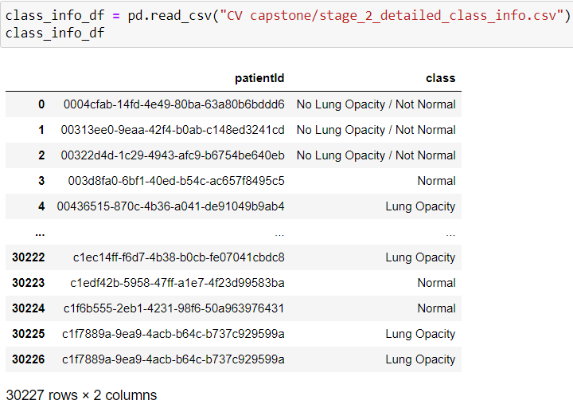The class info CSV has 30227 records with two column such as patented and class. There are three classes. They are,

1. No Lung Opacity/Not Normal
2. Normal
3. Lung Opacity

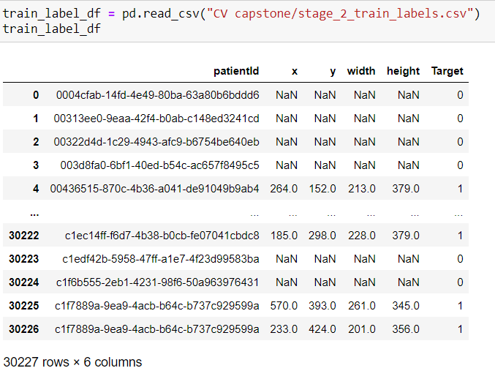

The train label CSV has 30227 records with four coordinate column such as (x, y, width and height) and we have Target Feature and its distribution is,

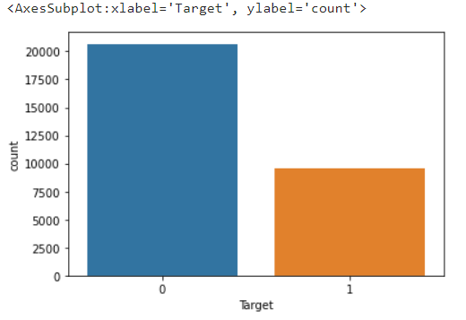

# DATA SET - Training

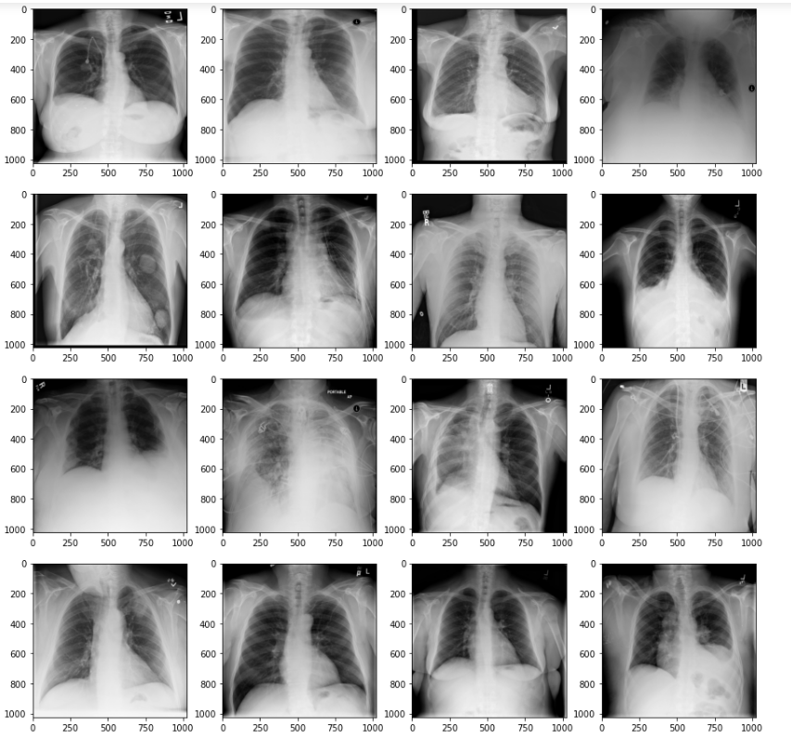Randomly picked images zipped inside stage_2_train_images.zip file. These are DCM images which needs special library such as [pydicom](https://pydicom.github.io/) to process. We should install them as it won’t come by default. The images can be read and displayed like below,

img = dicom.dcmread(img.dcm)

plt.imshow(img)

**NOTE**: We have 26684 image and individual files are named as patiendid.<dcm>. We will need to pre-process these files as we have more label and class info from CSV, hence remove duplicate if any.

# DATA SET - Testing

* We have got 3K images and there is no label and class information details available as they are pure test image set.

# Pre-processing

We can load images into pandas dataframe for further processing. While loading we can create attribute of the images such as patentienid, image width, height, filename, path and the actual content after resizing images to 32 * 32.

Following line of code can help get the image dataframe.

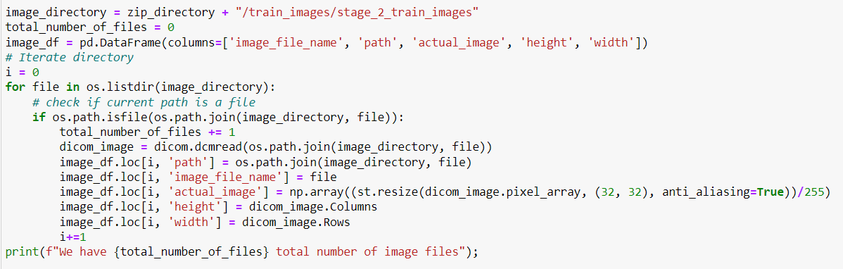

# Merging Dataframe and remove duplicates

We can merge image, class and label dataframe to remove duplicate using patientid as common column. After successfully merged three dataframe we are getting 26684 records of image data which will something like below,

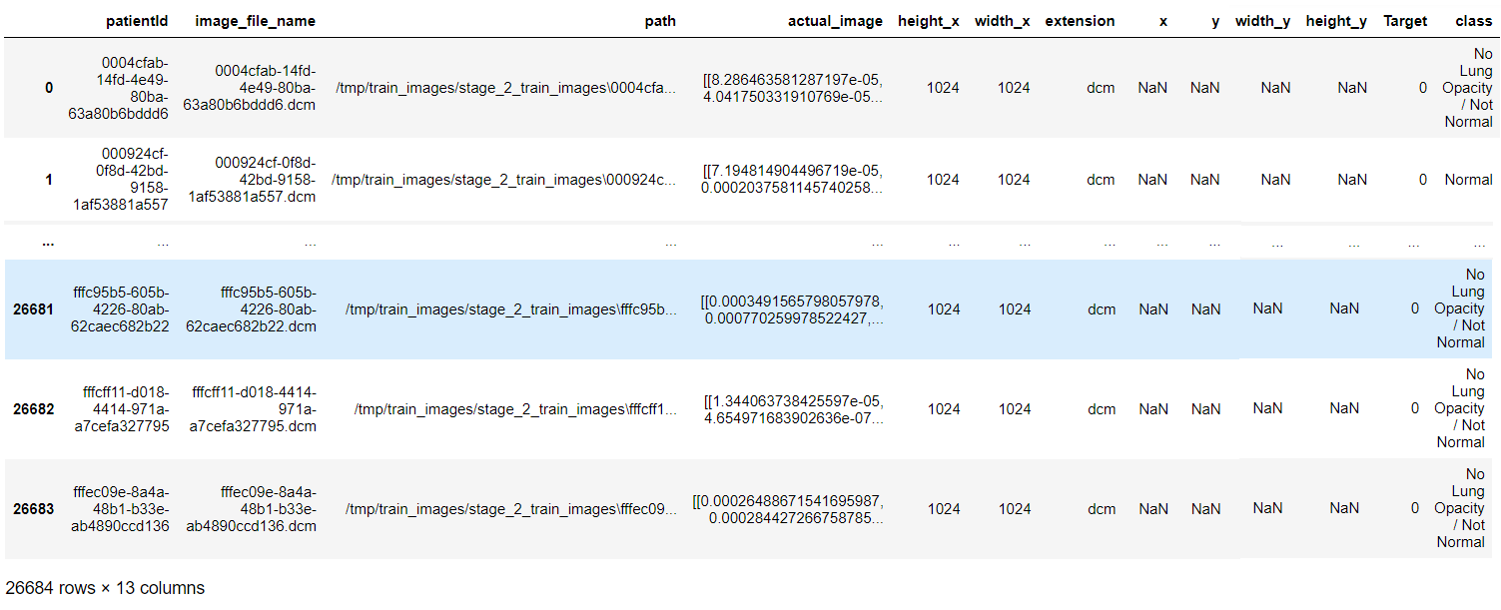

# Print random images from merged dataframe along with its class

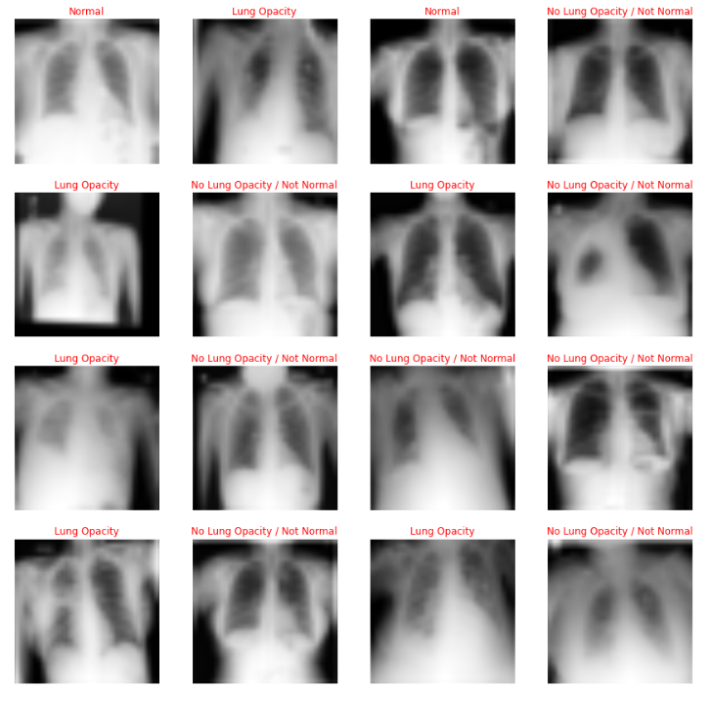

# Data balancing

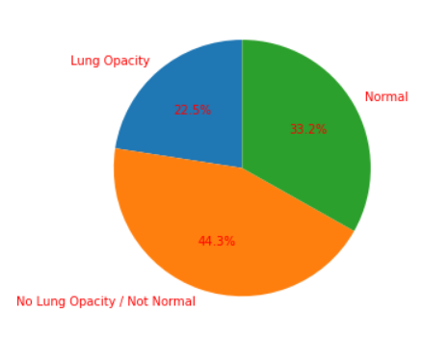The class is not perfectly balanced there is a slight imbalance. We will address this data unbalancing in the second part of this project

# Encoding

The machine learning or deep learning algorithm requires numbers hence we should convert the class into numbers. We can use LabelEncoder from sklearn preprocessing library like below,

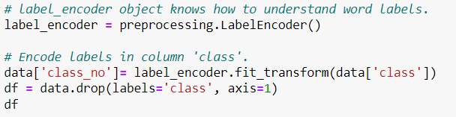

# EDA

The dataframe that we have after preprocessing and ready to do EDA. The Target and class_no is a category type

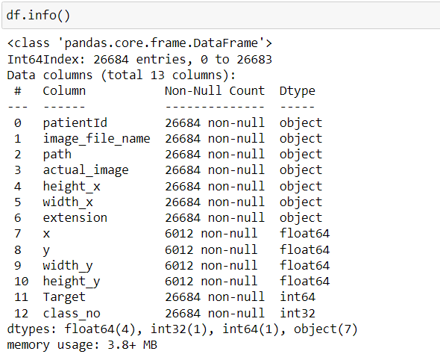

# Understand Target and Class

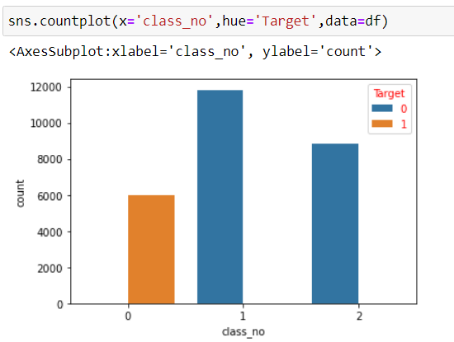

There are 6k records having target as 1 remaining records are set to zero. The zero is nothing but “Lung Opacity” class.

# Insights on coordinates

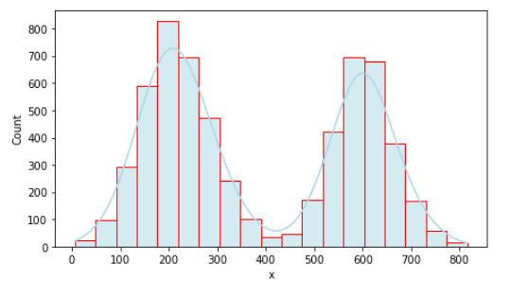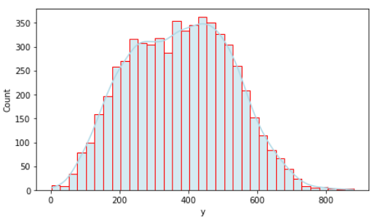

Y is range from 0 to 800 with some extremes. It has lot of records value range from 5o to 450

X is range from 0 to 800. There are lot of values are range from 150 to 300 and 550 to 700. We have less count on other ranges

Height_y is right skewed where we have lot of records having value greater than 200

Width_y range from 50 to 400 with few extremes on both side.

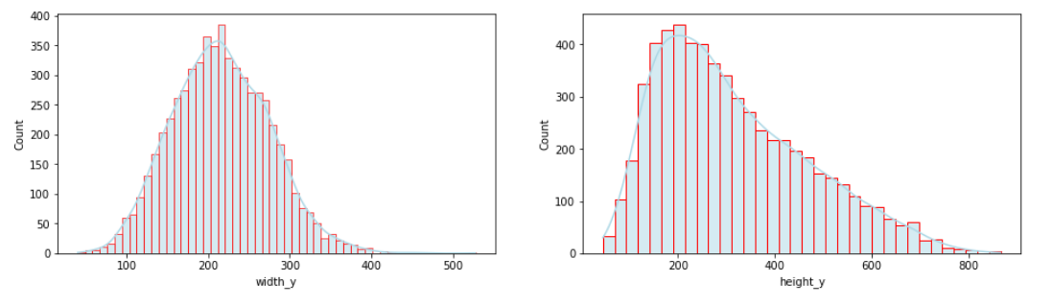

# Correlations

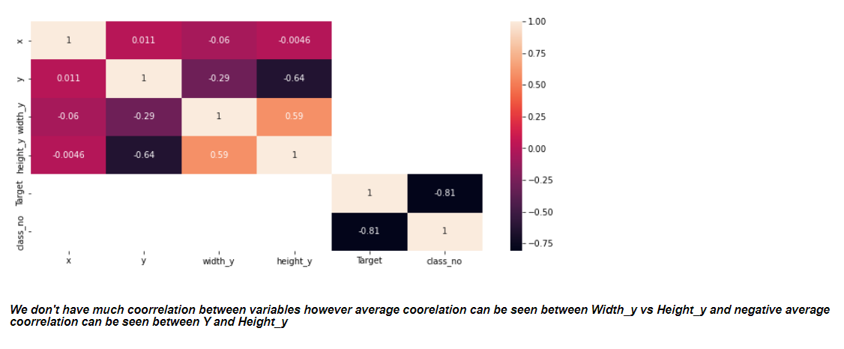

# Visualization of images with coordinates

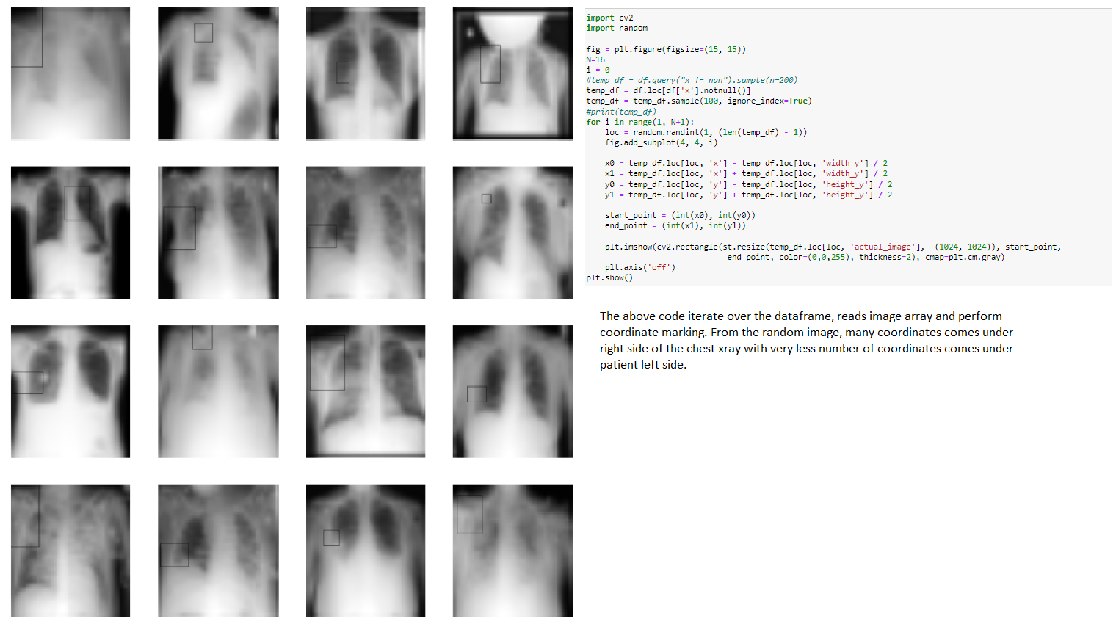

# Analysis Summary and Next Step

We have merged training images with class and training label CSV file. The Analysis suggest that we have 26684 images with 6K records having coordinates and remaining with out coordinates. Since we have images, we should CNN algorithm. We have three classes hence we should use Softmax in the output layer. We will build basic classification model in the first milestone, perform testing and then we will apply down sampling, image augmentation to adjust class balancing, additionally we will use transfer learning technique, Faster RCNN and Mask RCNN in the next phase.

# Milestone – 1 Basic CNN

# Train Test and Validation split

In order for us to evaluate the model more accurately we will have train, test and validation split. This practise is more nuance. In order to do this split we use following function,

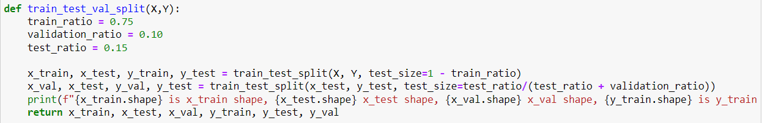

We have our X stored in Dataframe as ‘actual_image’ and Y as “class_no”. Take them out appropriately and split them up.

# Convert to tensor

The CNN models will take image of size (N,width,height,RGB). We need to convert our actual_image array to tensor and following function can help you achieve that.

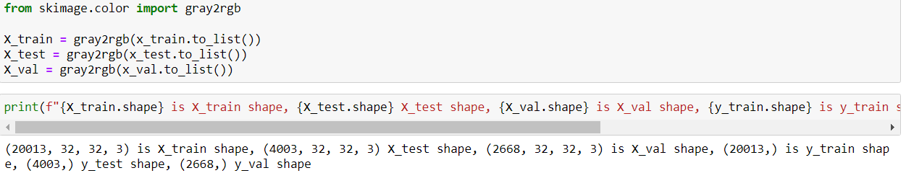

# Basic CNN Model

# Architecture

3 Conv Layer, 3 Batch Normalization, 2 Dense, 1 Flatten and Output layer with softmax.

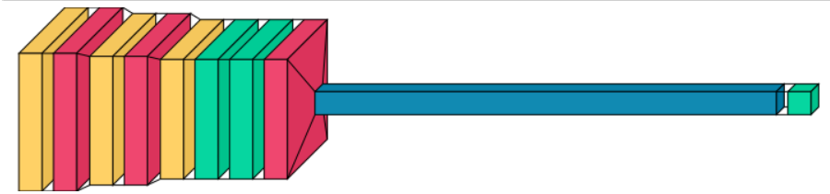

# Trainable Parameters

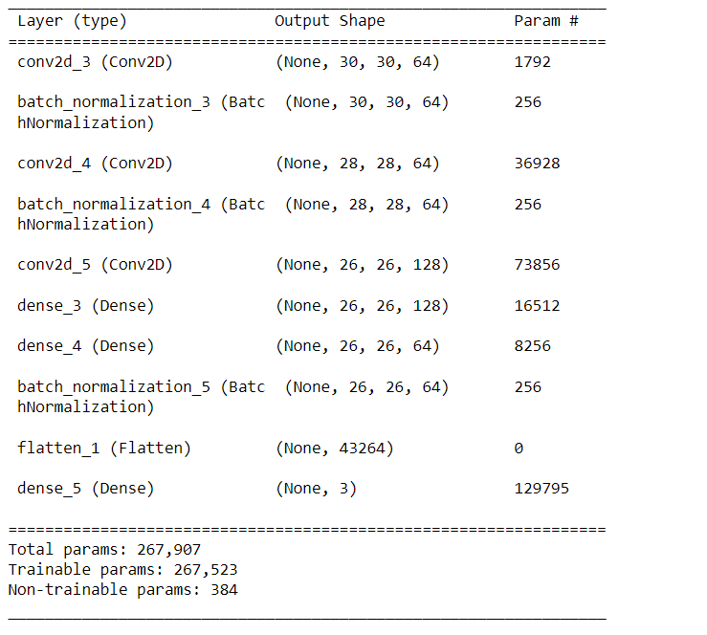

# Accuracy and Loss

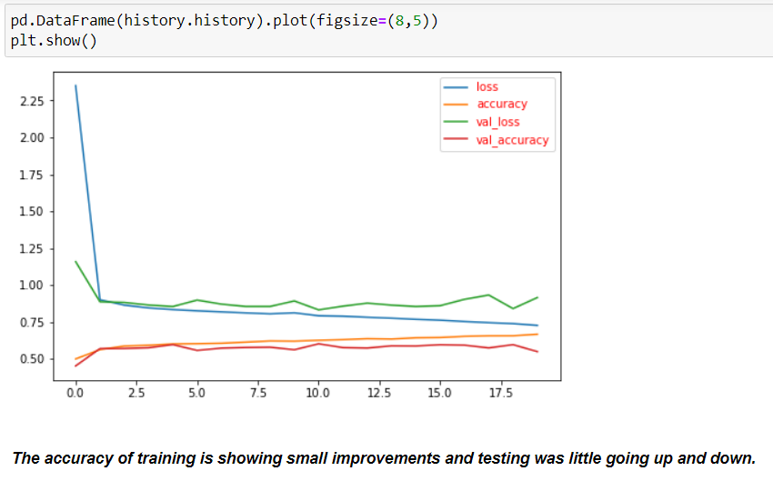

# Accuracy and Recall using dedicated

We have a validation data available with use which we can use to run against the model to accurately understand the accuracy, recall and precision. We can do this using following code,

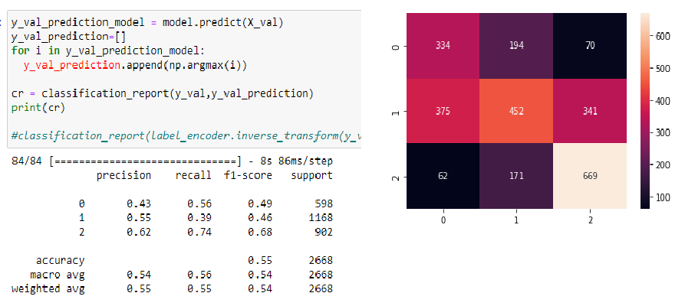

We can also get actual classification vs predicted classification like below which shows lot of images are misclassified to different class (Red color)

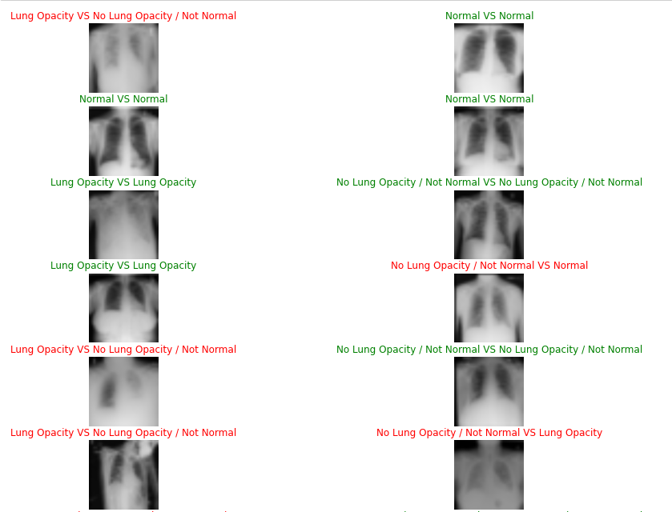

# Summary and Next step:

The basic model we have got to do classification is giving low recall on predicting lung opacity and for normal class as low as well. We will be doing further optimization for this model like Image Augmentation, Parameter tunning such updating learning rate, trying with Adam Optimizer, transfer learning optimization and trying with more convolution layer, etc in the second phase. Later we will implement Object detection using Faster RCNN and Mask RCNN, etc.