1. Install Java using MSI Installer <https://github.com/ojdkbuild/ojdkbuild/releases/download/java-1.8.0-openjdk-1.8.0.332-1.b09-x86/java-1.8.0-openjdk-1.8.0.332-1.b09.ojdkbuild.windows.x86.msi>

# Install Chrome Driver using following link. Please check your chrome browser version before installing

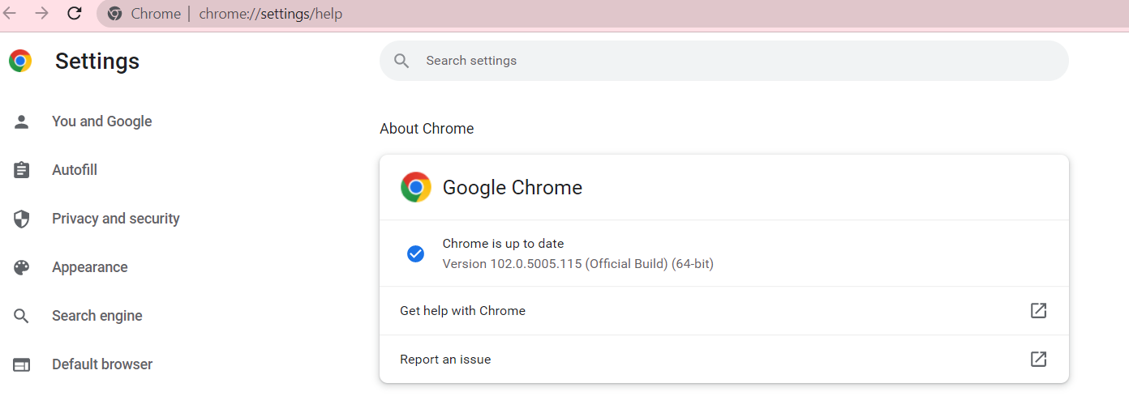



# <https://chromedriver.chromium.org/downloads>

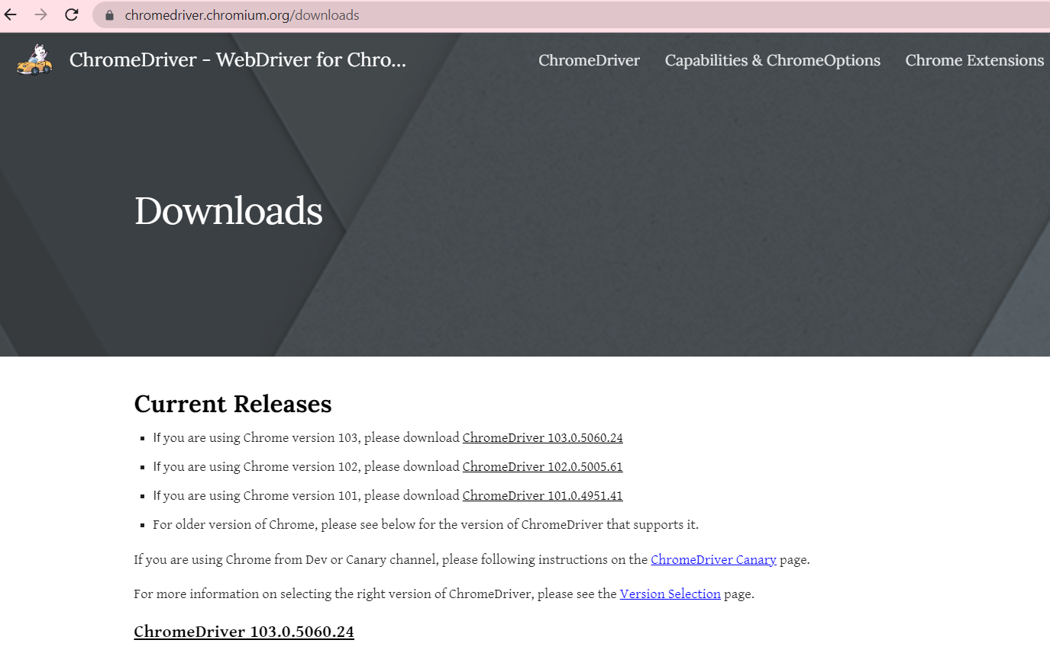



1. Verify Java installation – Type command prompt and open command Prompt

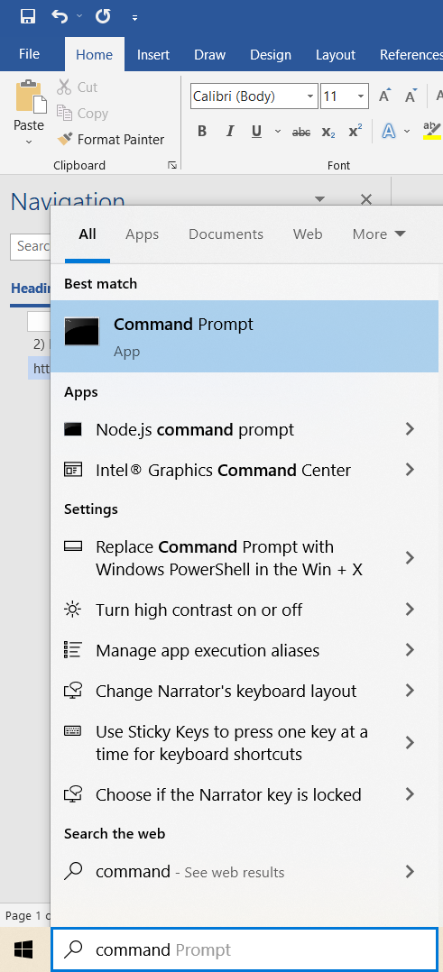

1. In the new Command prompt type java -version command make sure you are getting o/p like the one shown below,

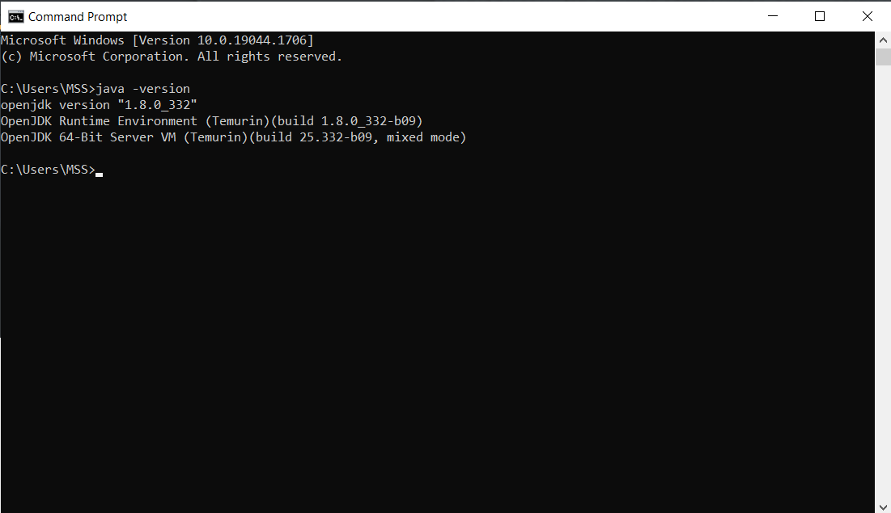

1. If the above command is working as expected we need to run the application.
2. Download slapps.jar from <https://drive.google.com/file/d/1W_if8KP8Zr0YxV7zVlj1iJEVKZUWJMyA/view?usp=sharing>
3. Find out location where the slapps.jar is downloaded. Copy the directory location and go to command prompt and type following command,

* cd <location-copied>

1. Now run following command,

* Java -jar slapps.jar

1. Proxy support is not added yet – Press simply cancel on the dialog window

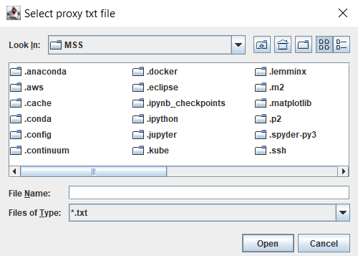

1. In the “Select ChromeDriver Exe file” Dialog select the chromedriver.exe installed as part of Step – 2

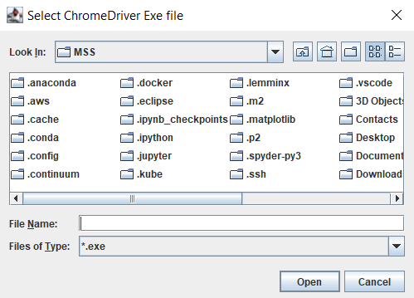

1. Third Dialog is to select the CSV file.

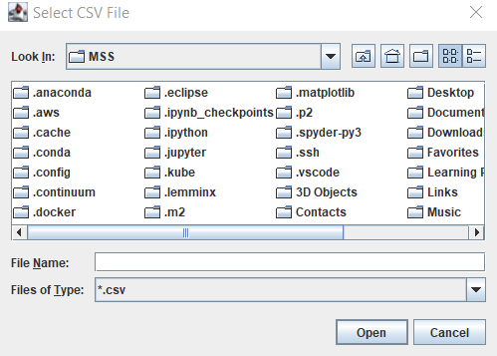

Following format is supported. It Is same as what you gave.

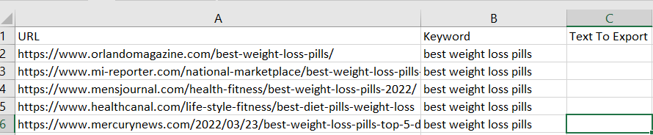

1. Try to run for different URL and review the Text to Export column. If your environment is up and running – we can focus on Rule Engine and Proxy implementation in the application.

# UPDATE as of June 15th:

1. The application can be started with arguments given in the command line. It is useful to test few sites quickly and get the output command line. Use following command,

* java -jar slapps.jar “<keyword>” “<url-1>” “<url-2>” “<url-3>”

1. Rule engine has been added with Href and Li attribute filter. If there is a Href on the paragraph – it will selected as result. If there is a LI tag in the result of paragraph – it will be ignore from the final list. If none of the rule matched – all the paragraph scraped will be returned
2. Code to disable push notification is added
3. Partial code is added for Proxy and it is not enabled yet.
4. Latest app is uploaded at Download slapps.jar from <https://drive.google.com/file/d/1W_if8KP8Zr0YxV7zVlj1iJEVKZUWJMyA/view?usp=sharing>

# UPDATE as of June 16th:

1. Constructing test URL from the given URL and found only 351 URL’s are legitimate.
2. Support for Proxy address (IP and Port number) is added.
3. Ran tests for 351 URL – Yet to analyse the result and fix issues.
4. Latest slapps.jar is uploaded into drive. Refer here <https://drive.google.com/file/d/1W_if8KP8Zr0YxV7zVlj1iJEVKZUWJMyA/view?usp=sharing>