Chapter 3
METHODOLOGY
3.1 Agile Scrum Methodology in the Project
Agile Scrum is an iterative project management framework that structures work into time-boxed sprints typically spanning two to four weeks to deliver incremental value, accommodate evolving requirements, and prioritize stakeholder input. Within public consultation initiatives, this approach facilitates adaptable design, enables responsive action to community needs, and ensures ongoing alignment with policy objectives, effectively addressing the dynamic character of public engagement and the diversity of stakeholder expectations..

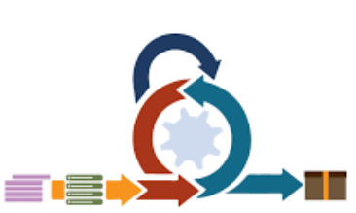
Figure no. 1 Agile Scrum Framework
3.2 Roles and Responsibilities
Each role in the project team carries significant responsibilities that directly influence the success and overall performance of the capstone project. The table below outlines the key duties assigned to each team member:
Name | Role | Responsibilities
Ms. Richelyn Villasor | Research Adviser | A research adviser (also called a supervisor or mentor) guides and supports researchers throughout their project lifecycle, ensuring work is rigorous, ethical, and aligned with academic or organizational goals. Their responsibilities span technical, professional, and developmental domains
Ms. Richelyn Villasor | Product Owner | Represents the LGU’s interests (typically a designated staff member). They are responsible for defining and prioritizing key system features—such as public submission handling, concern categorization, and tracking functionalities—within the Product Backlog
Mr.Ombina, julius | Project Manager | A Project Manager (PM) is accountable for planning, executing, and closing projects to deliver agreed-upon goals on time, within budget, and to the required quality standard. Their role integrates leadership, coordination, and strategic oversight across all project phases
Ms. Richelyn Villasor | Developer/Lead Programmer | Combines technical expertise with leadership to oversee software development projects, ensuring solutions are high-quality, scalable, and aligned with organizational goals. Their role spans coding, team management, architecture design, and stakeholder collaboration
Ms. Richelyn Villasor | QA Tester | A QA (Quality Assurance) Tester ensures software, systems, or products meet defined quality standards, function as intended, and deliver a positive user experience. Their role focuses on identifying defects, validating requirements, and supporting reliable delivery across all project phases
Ms. Richelyn Villasor | Documentation Specialist | A Documentation Specialist creates, organizes, and maintains clear, accurate, and accessible materials that support users, teams, and stakeholders. Their work ensures information is consistent, up-to-date, and aligned with organizational goals and standards
Ms. Richelyn Villasor | Security Lead | A Security Lead oversees an organization’s or project’s information security strategy, ensuring systems, data, and processes are protected from threats while maintaining compliance with regulations. Their role balances technical expertise, risk management, and cross-functional leadership
Table no.1 Roles and Responsibilities

3.3 Sprint Cycles
Sprint cycles include participation into every phase of project development, allowing for quick adjustments and guaranteeing that community voices influence results in real time, in contrast to typical linear consultation, which frequently gathers input only at specific milestones. Addressing gaps such as delayed feedback loops, low public trust, and a mismatch between government plans and community demands is the main objective
To Do | In Progress | Done
Table no. 2 Scrum Board

3.4 Scrum Artifacts
3.4.1 Product Backlog (User Stories)
User Story No. | Features/ Task | User Stories | Priority | Status
MODULE 1
F1
F2
F10
MODULE 2
F11
F20
MODULE 3
F21
F30
MODULE 4
F31
F40
Table no. 3 Product Backlog

3.4.2 Product Backlog for EIS Information Security
EIS No. | EIS User Stories | EIS IS Priority | Revision Priority | Status
IS-1 |  | 1 | 1
IS-2 |  | 1 | 2
IS-3 |  | 1 | 2
Table no. 4 Product Backlog for EIS Information Security
3.4.3 Product Backlog for EIS Standards
3.4.3.1 UI/UX (Icons, Color, etc…)
EIS Standard No. | EIS Standard User Stories | EIS Standard Priority | Revision Priority | Status
UI-1
UI-2
UI-3
Table no. 5 Product Backlog for EIS Standards

3.4.4 Product Backlog for EIS Integration
EIS Integration No. | EIS Integration User Stories | EIS Integration Priority | Revision Priority | Status
INT-1
INT-2
INT-3
Table no. 6 Product Backlog for EIS Integration
3.4.5 Product Backlog for Analytics
3.4.5.1 Application System Analytics
EIS Integration No. | EIS Integration User Stories | EIS Integration Priority | Revision Priority | Status
ASA-1
ASA-2
ASA-3
Table no. 7 Product Backlog for Analytics

3.4.5.2 EIS Analytics
EIS Analytics No. | EIS Analytics Stories | EIS Analytics Priority | Revision Priority | Status
EA-1
EA-2
EA-3
Table no.8 EIS Analytics

3.4.6 Sprint Backlog (User Stories)
Task No. | User Story No. | User Stories | Tasks | Timeline | Responsible Team Member/s
SPRINT 1
S1_1 | IS-1 |  | PLANNING  DESIGN  CODE  DOCUMENTATION
S1_2 | IS-2
S1_3 | F-1
S1_4 | F2
S1_5 | F-3
SPRINT 2
S2_1 | IS-3 |  | PLANNING  DESIGN  CODE  DOCUMENTATION
S2_2 | IS-4
S2_3 | F-4
S2_4 | F5
S2_5 | F-6

Table no. 9 Sprint Backlog (User Stories)

3.4.6.1 Sprint Burndown Chart

Figure no. 2 Burndown Chart

3.4.7. Increment
Sprint No. | Increment / Feature Delivered |  | User Story / Backlog Reference | Definition of Done (DoD) Criteria | Status | Remarks
Sprint 1 | User Registration & Login Module | IS-1, IS-2 |  | Code completed  - Unit tested  - Integrated with DB  - Documentation updated | Done | Basic authentication working
Sprint 1 | Database Schema Setup | F-1 |  | - Schema created  - Tables normalized  - Tested with sample data | Done | Ready for integration
Sprint 2 | Product Catalog Module | IS-3, IS-4 |  | - UI designed  - CRUD operations functional  - Tested on staging | In Progress | Pending UI review
Sprint 2 | Shopping Cart | F-4 |  | - Add/remove items working  - Cart persists in session  - Unit tested | In Progress | Needs integration with checkout
Sprint 3 | Checkout & Payment Integration | IS-5, F-5 |  | - Payment gateway connected  - Security tested (SSL)  - Error handling in place | Planned | To be developed in Sprint 3

Table no. Increment

3.5 Microservices Architecture
The PCMS may initially be developed using a simpler architecture due to project scope, Microservices Architecture (MSA) offers a long-term vision for scalability, modularity, and integration with future LGU systems..
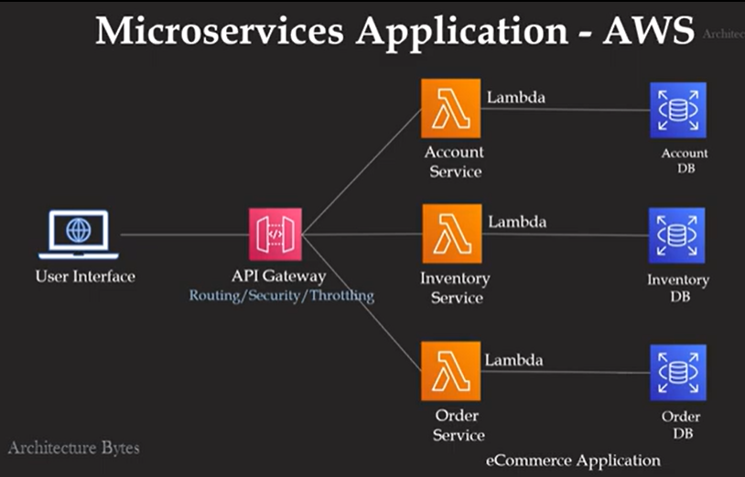

Figure no. 3 Microservices Diagram

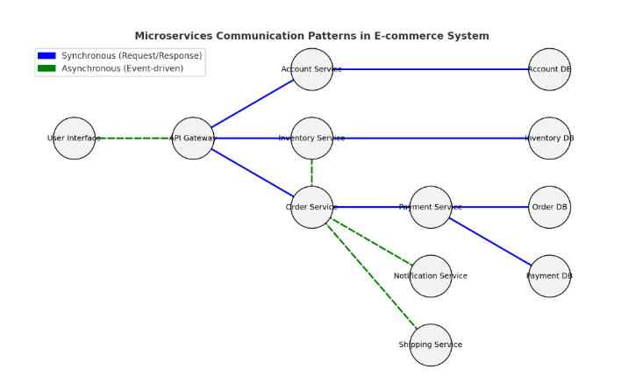
Figure no. 4 Communication Pattern for Microservices
Here’s the communication pattern diagram for an e-commerce microservices system:
- 🔵 Blue solid lines → Synchronous (Request/Response) calls (e.g., login, product search, payment validation).
- 🟢 Green dashed lines → Asynchronous (Event-driven) interactions (e.g., order triggers stock updates, shipping, notifications).

Dfd level 1
Level 1 DFD (Context Diagram)
This shows the entire e-commerce system as one process and how external entities interact with it.
- External Entity: Customer
- System (Process): E-commerce Microservices System
- Data Stores: Account DB, Inventory DB, Order DB, Payment DB
- Data Flows: Login, Browse Products, Place Order, Make Payment, Receive Notification, Shipping Info

Figure no. 5 Data Flow Diagram for Microservices

3.6 DevOps Implementation
DevOps combines IT operations (Ops) with software development (Dev) to improve collaboration, expedite delivery, and increase the dependability of public consultation platforms. It uses techniques like infrastructure as code (IaC), continuous integration/continuous deployment (CI/CD), and automated monitoring to meet the particular requirements of government-led engagement tools, such as scalability, security, transparency, and adherence to public sector rules.
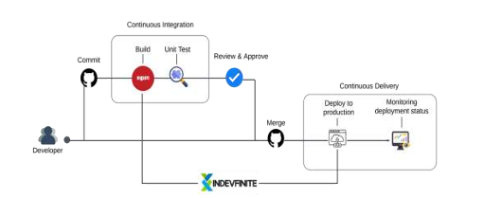
Figure no. 6 CI/CD Pipeline
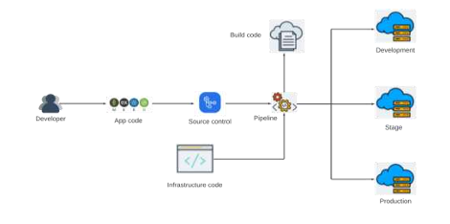
Figure no. 7 Infrastructure as a Code (IaC)

Public consultation focuses on tangible infrastructure outcomes, but IaC initiatives require addressing technical design choices that impact accessibility, security, transparency, and community trust. This research examines how to integrate public input into IaC-driven projects, ensuring technical decisions align with public needs while maintaining IaC’s efficiency benefits..

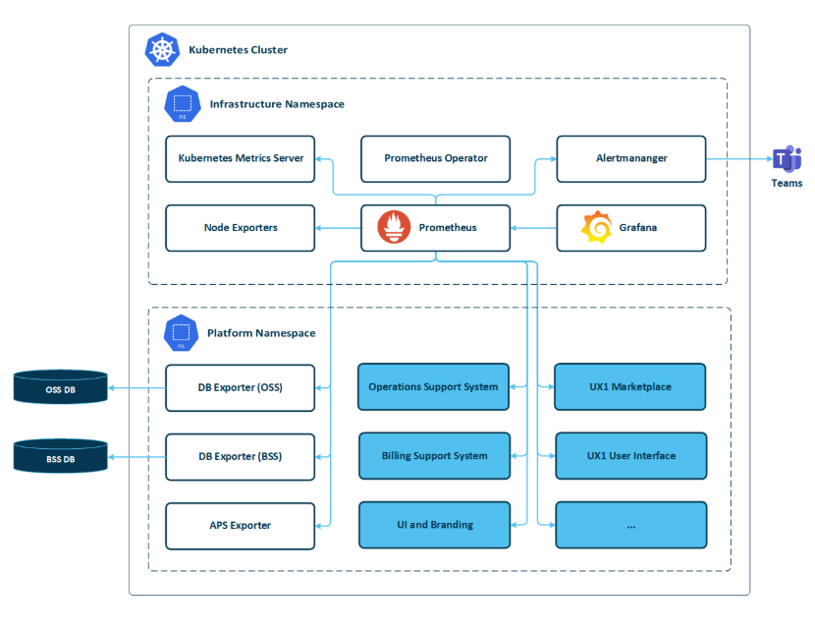
Figure no. 8 Monitoring and Alerting
M&A focuses on technical metrics, but public consultation ensures these systems prioritize community-relevant outcomes—such as service accessibility during peak engagement, data privacy protections, or timely alerts for issues affecting marginalized groups. This research examines how integrating public input into M&A design, implementation, and operation enhances transparency, accountability, and alignment with public needs.

3.7 Integration Approach for Information Systems
The Integration approaches for public consultation information systems aim to connect disparate tools, data sources, and stakeholder platforms into a cohesive ecosystem. This ensures seamless flow of information, consistent user experiences, and unified analysis of public input critical for effective decision-making in government and public sector organizations.
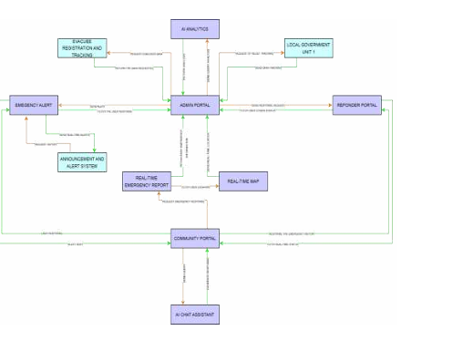
Figure no. 9 Business Process Architecture
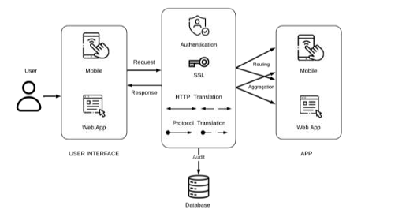
Figure no. 10 API Gateway
API gateways are traditionally designed for technical efficiency and security, public consultation ensures these systems prioritize community needs such as accessibility, transparency, equitable data access, and trust. This research examines how integrating public input into API gateway design, deployment, and governance enhances usability, accountability, and alignment with public priorities.

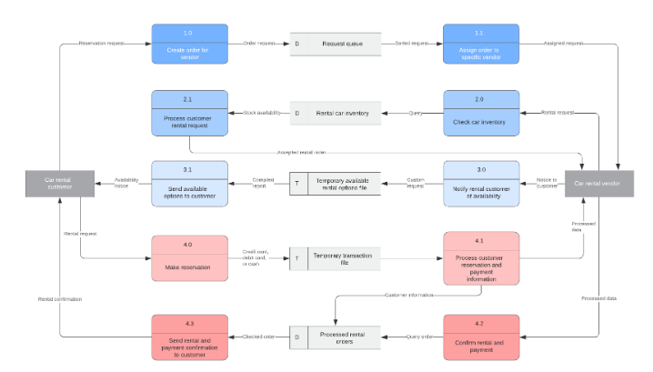
Figure no. 11 Data Flow Diagram
DFDs are traditionally designed for technical and compliance purposes, public consultation ensures these diagrams reflect community concerns about data privacy, transparency, equity, and accountability. This research examines how integrating public input into DFD design, validation, and communication enhances trust in data handling processes and ensures alignment with public values.
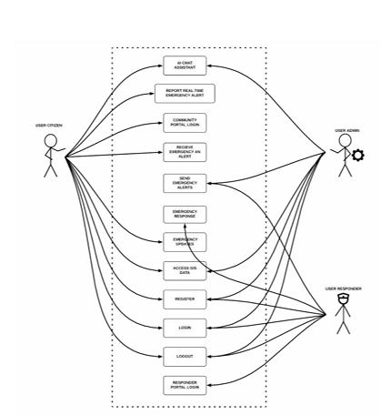
Figure no. 12 Use Case Diagram
Use case diagrams are traditionally designed for technical and functional planning, public consultation ensures these diagrams prioritize community needs such as accessibility, equity, transparency, and user-centricity. This research examines how integrating public input into use case diagram design, validation, and communication enhances system usability, ensures inclusive engagement, and builds trust in public services.

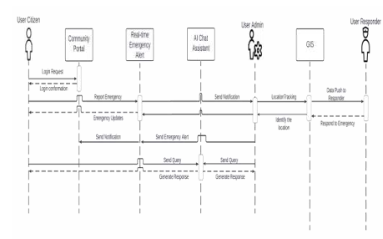
Figure no. 13 Sequence Diagram
Sequence diagrams are traditionally used for technical process planning and troubleshooting, public consultation ensures these diagrams prioritize community needs such as transparency, timeliness, equity, and clarity of communication. This research examines how integrating public input into sequence diagram design, validation, and communication enhances process accountability, ensures inclusive engagement, and builds trust in how public consultation activities are executed.
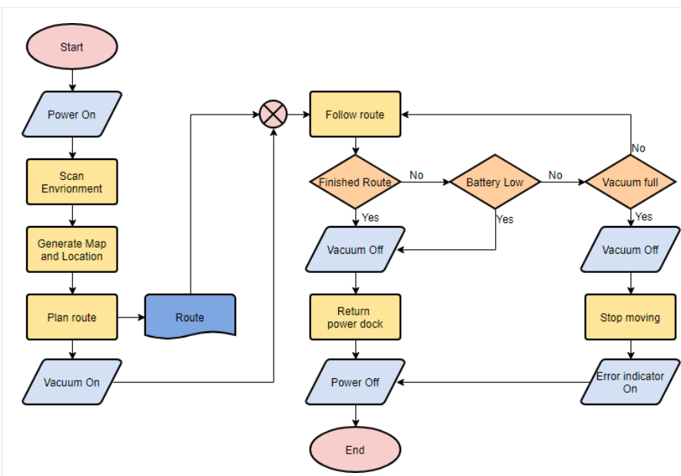
Figure no. 14 Flowchart
Flow charts are traditionally designed for operational efficiency and compliance, public consultation ensures these diagrams prioritize community needs such as clarity, equity, accessibility, and transparency. This research examines how integrating public input into flow chart design, validation, and communication enhances process understanding, ensures inclusive participation, and builds trust in how public institutions operate.

3.8 Introduction to TOGAF and the Four Architectural Domains
The Open Group Architecture Framework (TOGAF) is a vendor-neutral, flexible framework for designing and governing enterprise architectures. When applied to public consultation initiatives—whether for government policies, infrastructure projects, or digital services—TOGAF provides a structured approach to align consultation processes with organizational goals, community needs, and regulatory requirements. It ensures public engagement is holistic, scalable, and adaptable to diverse stakeholder groups, while maintaining transparency and accountability.

1. Business Architecture
Defines the purpose, governance, and processes of public consultation, aligning them with organizational and community objectives.
2. Data Architecture
Defines how feedback data and stakeholder information is collected, stored, managed, and shared.
3. Application Architecture
Defines the tools and systems used to support public consultation activities and integrate feedback into organizational workflows.
4. Technology Architecture
Defines the technical infrastructure that supports consultation applications and data systems.delivery of engagement services while aligning with business, data, and application architecture goal.

