u
log
2.0

Features
- Allows the user to store specific data into a log file as the simulation is executing.
- Provided are 1-, 2-, 3-, 4-, 5-, 6-, 7-, 8-, 9- and 10-input versions of the log component.
- C-Block source included to allow for customizations.
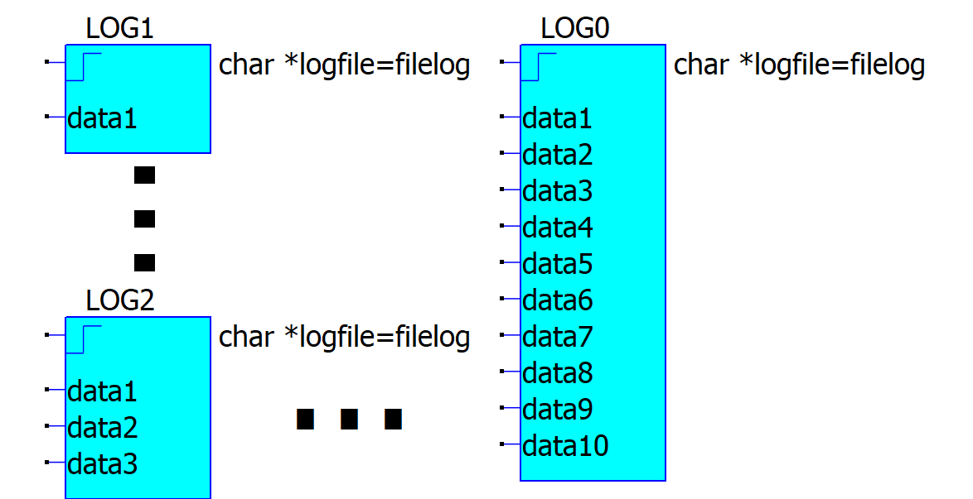
- Allows logging of data across steps.
- You can use multiple instances of the component in the same simulation.
- This version is an improvement of my previous “log” V1.0 component. Major improvements:
  - All input versions use the same DLL (log.dll).
  - Selecting the number of inputs allows the symbol to grow or shrink. (This feature uses the LOOPUP<> feature in symbols)
  - Data saved can be triggered on Rising Edge, Fall Edge, Window High or Window Low.
  - Data can be saved as CSV or Binary formatted.

General description
The log component provides a simple interface from a Schematic/Netlist to immediately log specific values into a named log file during the execution of the simulation.

This is similar to the post-simulation Waveform Analysis tool that uses .meas statements with the TRIG keyword. Using the Waveform Analysis tool, you can then direct it to export the requested data. With log component, you may be able to skip the Waveform Analysis phase or perform this phase at a later time with tools such as Excel with less extraneous data to parse.
When to use log component

If you have a simulation project that executes quickly, it probably has a relatively small .qraw file. The log component may be of little value. However, if you run long multi-dimensional stepped simulations, you may find log useful.

I developed a very data intensive multi-step transient simulation that required over 20 minutes to execute. All the time points are collected in the .qraw file. Once the simulation had completed, the .qraw file ended being over 28 GBytes big!!!

With this large .qraw file size, the .meas directives (there were 3 of them) took over 2 hours to complete into a .meas result. Therefore, my total time to acquire the needed data on a multi-step set of parameters was about 2 ½ hours. This is because each .meas directive parses each time quanta collected in the .qraw to meet the criteria of the directive.

I created log to eliminate the post-simulation analysis phase and removed the .meas directives. Therefore, my resultant time to gain the needed data was only the time to execute the simulation (in this case, 20 minutes).

Even using the batch mode, I had another very extensive multi-step sim that took over 8 days to complete! Trying to store .qraw data would have exceeded my hard drive capacity in just an hour. I needed to run the QSpice sim in batch mode with the .qraw file creation disabled but using a log component to obtain the needed data.

This allowed me to run multiple simulations with different sets of parameters much quicker.

Special Note: On my computer (with multiple CPUs) I ran 4 instances simultaneously of QSpice each with a different parameter set. Each sim run took only slightly longer than if I had just run one.

log Setup
The log Component has a 1-, 2-, 3-, 4-, 5- and 6-input versions. Included are symbol (.qsym) files for each version to simplify schematic integration.
There are some setup requirements but this can be achieved fairly easily.
Input-output connections
There are only hardware inputs but no hardware outputs on this component. This component does provide the logfile as the output.
datax
The number of inputs can be user-selected on the log Component. Up to 10 inputs can be selected. Ie. log3 has 3 data inputs labelled data1, data2, and data3.
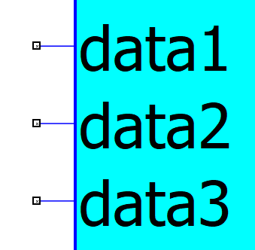
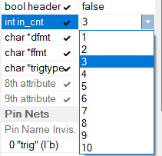
To change the number of inputs to use, open “Symbol Properties” (F3) and select the number from the “in_cnt” field. The symbol will then be populated with the desired inputs.
Each data input uses the default QSpice data type of “double” (64-bit floating). You can place signal into it since QSpice defines all node voltages as double.
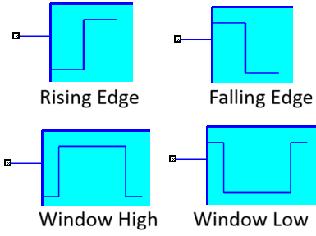
trig
This input (binary) is the trigger for logging data. It logs the values on the data inputs into the logfile only on the selected criteria: Rising Edge (RE), Falling Edge (FE), Window High (WH) or Window Low (WL).
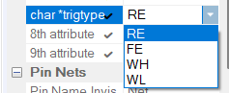
To change the trigger criteria, open “Symbol Properties” (F3) and select the criteria from the “trigtype” field. The symbol will then change to reflect the new selection.
Parameters and Settings
logfile
This parameter allows the assignment of the filename to use to log the data. Ex:
char *logfile=filelog // will store the logged data into “INSTANCENAME filelog<ffmt>”
Recommendations:
- You can use any legal file name. The file extension is added automatically to the end of the filename selected. The extension is based on the parameter “ffmt” selected.
- The logfile can be relative or absolute addressed. Leaving off any directory references assumes the file is located in the same directory as the simulation.
- If you use multiple instances of log in the same simulation, the INSTANCENAME (ie. LOG0) will be prepended to the logfile name to differentiate the data from each instance of the log component used.
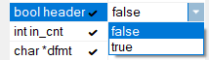
header
This parameter allows the user to assign a header to be placed at the top of the logfile. The default is false (OFF). This parameter is here to allow for clarity of the data in each column.
in_cnt
This parameter allows the user to assign the number of inputs to use. (See datax input explanation.) The symbol will change based on this selection.
dfmt
This parameter allows the user to determine the format of the data stored with the ability to determine precision. (Default: %.12f). This is a fprintf() format specifier. Any changes must adhere to legal format specifier rules.
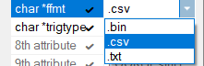
ffmt
This parameter allows the user to determine the file format of the data. (Default: .csv). File format .csv saves data in a text-based Comma Separated Value format commonly used by spreadsheet applications. The file format .txt is also an alias for .csv format.
Another file format is .bin This ffmt stores the data more compactly and may result in somewhat shorter simulation times. However, a special application is needed to convert .bin to .csv This tool can be provided upon request. (Courtesy of RDunn.)
trigtype
This parameter allows the user to configure the trigger criteria for capturing the data into the logfile. (See trig input explanation.)
LOOKUP<>
Leave the next two parameters alone. They are used to layer the symbol properties. “Don’t look behind the curtain!”

Output Format of the logfile
The format of the logfile is very simple and straight-forward.
Here’s an example of a few logged data points:
t | data1 | data2 | data3 | <= Here the header=1 was set.  Header (t=time of the log event; data’x’=data on input)
0.100001 | 0.01 | 0.904837 | 0.999861
0.300001 | 0.03 | 0.740817 | 0.998751
0.500001 | 0.05 | 0.60653 | 0.996534
Implementation Limitations
This version of the log Component has the following limitations:
- This component only logs the data on the inputs on the rising edge of the trigger (trig) input. However, the trigger signal can be controlled by the simulation with the use of clever expressions of B-sources.
- If you need to capture data in the same logfile across steps, no step value information is natively captured. There are two methods to capture the step values with the logged data.
  - Use extra input(s) with the step values assigned. These values will be logged in the file.
  - The step values can be encoded into the logfile name attribute parameter. See the Stepped Sim Example for the special QSpice “trick”. This creates extra logfiles with the step values encoded into the file name.
Future Improvements
I have included the C-block source files (.cpp) and the symbol files (.qsym) so that it might be instructive or even improve this component. For example, you can create your own versions of log with more inputs.
It is theoretically possible to create an accumulated transient analysis such as AVG between a “trigger” and a “target”. This is where the accumulated data can be averaged while the trig input is held at “1” instead of just the rising-edge.

Examples
Here are very simple examples on how to use the log component. One is non-stepped and the other stepped.
Example goal
Generate an exponential decay signal and sample it every 0.1s. Log the decay value.
Instructions: Common to both sims
- Unarchive the included files into a directory on your computer. Let’s call this directory “log”.
- Open QSpice and Right-click on the “Symbols & IP” level on the “Symbols & IP Browser”. Select “Add a symbol directory”.
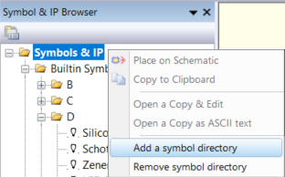
- On the file explorer find and select where you stored the “log” directory and click on “Select Folder”
- You’ll find the “log” directory added to the “Symbol & IP” hierarchy.
- Open the “log” directory. You’ll see all the symbols for each input count of log I created.
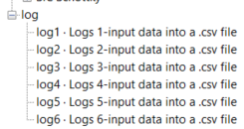
- Select the log’x’ symbol and drop it on your schematic.
- Add the signals to the data’x’ inputs you want to log and the signal that becomes the trigger event.
Instructions: Simulation Specific – Non-stepped.
Here is an example log_test.qsch I’ve included:
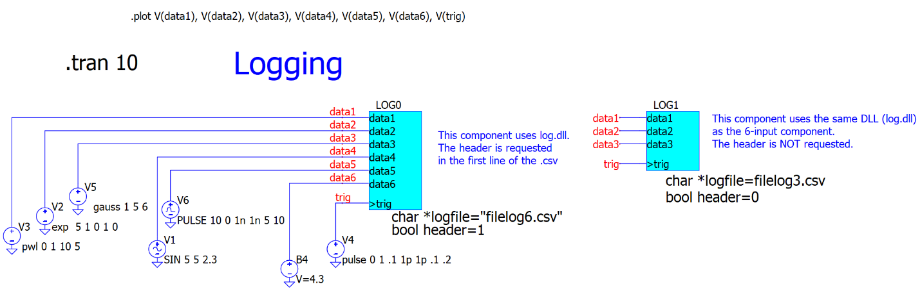
When you run the simulation, you will get a plot of the selected signals.
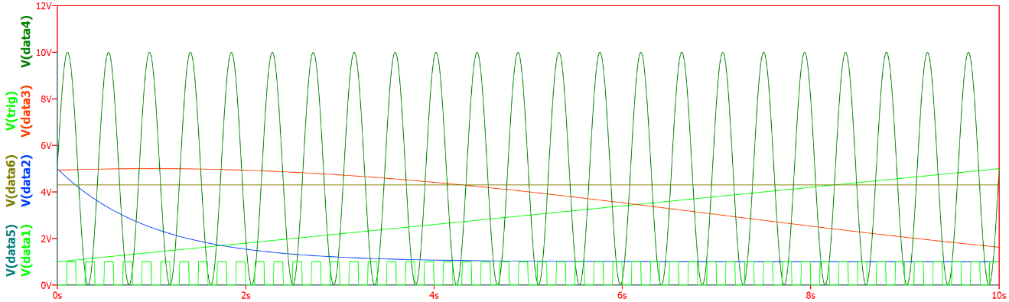
You will get two logfiles: “LOG0 filelog6.csv” and “LOG1 filelog3.csv”
Open up the logfile “LOG0 filelog6.csv”
t | data1 | data2 | data3 | data4 | data5 | data6
0.100001 | 1.04 | 4.619346 | 4.944065 | 9.960582 | 0 | 4.3
0.300001 | 1.12 | 3.96327 | 4.966088 | 0.351092 | 0 | 4.3
0.500001 | 1.2 | 3.42612 | 4.982669 | 9.045126 | 0 | 4.3
0.700001 | 1.28 | 2.986339 | 4.993754 | 1.812826 | 0 | 4.3
0.900001 | 1.36 | 2.626277 | 4.999306 | 7.12896 | 0 | 4.3
… | … | … | … | … | … | …

Open up the logfile “LOG1 filelog3.csv”. It will be the same data as with LOG0 instance except the header and columns data4, data5 and data6 are not present.

Instructions: Simulation Specific – Stepped.
- Modify the schematic for the non-step simulation to create a stepped version as shown below (log_test_step.qsch supplied):
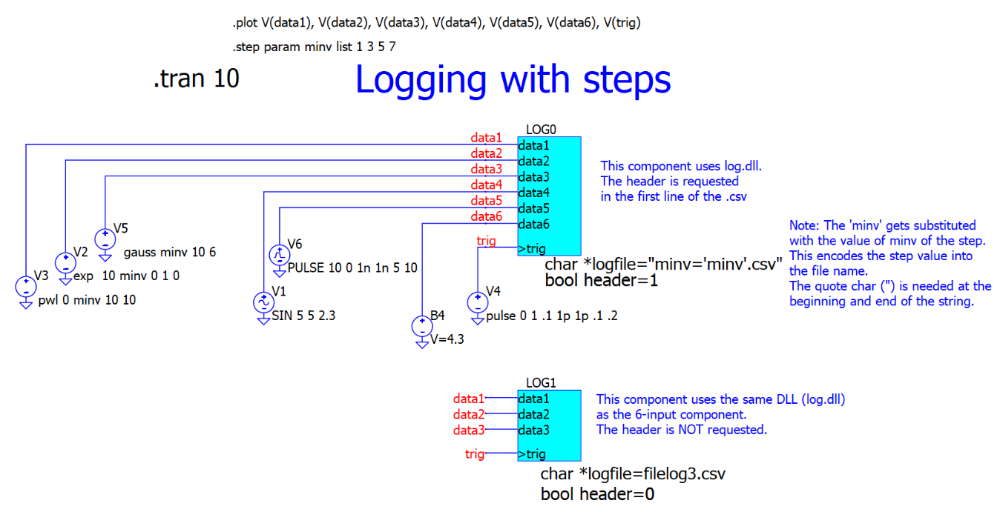
Notice the additions and changes:
- The addition of the “.step param minv” directive as a list.
- I added the ‘minv’ into logfile parameter for LOG0. This will generate a new log file with this in the file name for all steps with this minv value.

When you run the simulation, it yields multiple logfiles. One group of four files has “LOG0” prepended which has the minv value used in that run added to the file name. The other logfile is “LOG1 filelog3.csv”

Component Changes
Version | Description of changes | Reason for changes/impact
log 2.0 | Improvements to “log” component. Recommend: Use this component instead. | Reuses the same log.dll.  Uses LOOKUP<> feature to layer symbol properties.  Adds many other selectable properties:  - trigger type  - file format  - data format
log 1.0 | Improvements to “logger” component. Recommend: Use this component instead. | Reuses the same log.dll.
logger 2.0 | Eliminate the need of the “reset” input.  Minor document improvements | Needs QSpice Jan 1, 2024 build
logger 1.0 | first release of the component

References

© CONSULTRON, 2026 All Rights Reserved. CONSULTRON allows PUBLIC use of the file.
CONSULTRON allows public or commercial use of this product. Please use it for good.
DISCLAIMER: CONSULTRON provides NO WARRANTY expressed or implied.
This product is intended for non-critical or non-safety use and can be used for educational purposes.

