ASP.NET Ajax Library Beta version 0911
Release Notes
Contents
Summary 1
Overview 1
What’s Included in the Release 2
Visual Studio Compatibility 2
Tutorials, Reference Documentation, and Sample Code 2
Compatible Browsers 2
How to Use the ASP.NET Ajax Library Scripts 3
Adding the ASP.NET Ajax Library to the Visual Studio Toolbox 3
Adding a Control to a Web Forms Page from the Toolbox 5
Instantiating Controls by Using the script Element 6
Using the Microsoft Ajax Content Delivery Network (CDN) 7
Providing Feedback 7

Summary
This document describes the features of the ASP.NET Ajax Library Beta release. The goal of this release is to give you visibility into our design process, to allow you to test the technology early in the product cycle, and to give you a chance to send us feedback on the implementation.

Overview
The ASP.NET Ajax Library is a JavaScript library that enables you to build highly interactive Ajax applications. You can use the ASP.NET Ajax Library in both ASP.NET Web Forms and ASP.NET MVC applications. The library is compatible with modern browsers including Microsoft Internet Explorer, Mozilla Firefox, Apple Safari, and Google Chrome.
Using the ASP.NET Ajax Library, you can take advantage of ASP.NET Ajax client controls, client templates, and the client data context to build database-driven Web applications that execute entirely within the Web browser. For example, you can display database data retrieved from a WCF service, an ASP.NET Web service (.asmx), an ADO.NET Data Services service, or any endpoint that can return JSON-formatted data. The ASP.NET Ajax Library lets you both retrieve and modify database data in the client.
This release of the ASP.NET Ajax Library includes the Ajax Control Toolkit. You can use all the Ajax Control Toolkit controls in an ASP.NET Web Forms application like you use Web server controls or in any ASP.NET MVC or purely client-based Web application by using JavaScript.

What’s Included in the Release
When you install the Beta release, the following folders and files are created:
- Scripts. This is a folder that contains all the ASP.NET Ajax Library JavaScript files.
- Web Forms. This is a folder that contains the two assemblies that are required in order to use the controls from the Ajax Control Toolkit as Web server controls in Web Forms applications (System.Web.Ajax.dll and AjaxControlToolkit.dll).
- AspNetAjaxBetaSamples. This is a Visual Studio solution that contains sample code that illustrates how you can use features of the ASP.NET Ajax Library.

Visual Studio Compatibility
The ASP.NET Ajax Library is compatible with Visual Studio 2008 (including Visual Web Developer 2008). The ASP.NET Ajax Library also is compatible with Visual Studio 2010 Beta when targeting ASP.NET 3.5. When using Visual Studio 2010 and targeting ASP.NET 4, you cannot use the Extender Wizard from the Visual Studio Designer.
We plan to release a .NET 4 version of the ASP.NET Ajax Library when Visual Studio 2010 is released.

Tutorials, Reference Documentation, and Sample Code
To learn how to use the ASP.NET Ajax Library, visit the Ajax Library Web site at the following location:
http://www.ASP.net/ajaxLibrary
The Ajax Library Web site includes tutorials, sample code, and sample applications.

Compatible Browsers
This release has been tested on the following browsers. The library might work with other browsers and with other versions of the following browsers as well.
- Microsoft Internet Explorer 6, 7, and 8
- Mozilla Firefox 3 and 3.5
- Apple Safari 4
- Opera 10
- Google Chrome 3

How to Use the ASP.NET Ajax Library Scripts
There are two ways that you can use the ASP.NET Ajax Library scripts in a Web application. If you are building an ASP.NET Web Forms application, you can add the controls from the ASP.NET Ajax Library to the Visual Studio Toolbox. You can then add an ASP.NET Ajax control to a Web Forms page simply by dragging the control from the Toolbox.
Alternatively, if you are creating an ASP.NET Web Forms application, an ASP.NET MVC application, or any other type of Web application, you can instantiate ASP.NET Ajax controls in JavaScript code.

Adding the ASP.NET Ajax Library to the Visual Studio Toolbox
To add the controls in the library to the Visual Studio Toolbox, follow these steps:
- In Visual Studio, create a new ASP.NET Web Site project or ASP.NET Web Application project.
- Open the Default.aspx page in the Visual Studio designer. (The Toolbox displays different items depending on the type of file that is open in the designer, so you must open a Web Forms page.)
- Right-click the Toolbox and then click Add Tab. Name the new tab ASP.NET Ajax Library (you are free to use any name of your choice).
- Right-click beneath the new ASP.NET Ajax Library tab and then click Choose Items… to open the Choose Toolbox Items dialog box.
- Click the Browse button and browse to the location where you downloaded the ASP.NET Ajax Library.
- In the Web Forms folder, select the AjaxControlToolkit.dll assembly and then click OK.
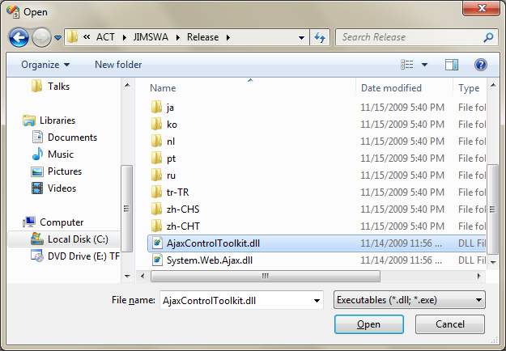
- Click OK to close the Choose Toolbox Items dialog and box and to update the Toolbox with the new controls. All the server controls that are included in the ASP.NET Ajax Library will appear in the Toolbox under the ASP.NET Ajax Library tab.
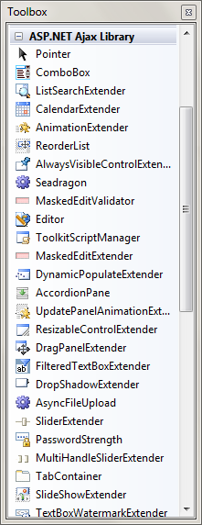

Adding a Control to a Web Forms Page from the Toolbox
To use the controls, you can drag them from the Toolbox to a page or you can use the Visual Studio Add Extender wizard. For example, to use an ASP.NET Ajax Calendar control in a Web Forms page, follow these steps:
- Open a Web Forms page and switch to Design view.
- From the Standard tab of the Toolbox, drag a TextBox control to the page.
- From the ASP.NET Ajax Library tab of the Toolbox, drag a ToolkitScriptManager control onto the page. When you do, the System.Web.Ajax.dll and AjaxControlToolkit.dll assemblies are added to the Web application’s Bin folder automatically.
- Right-click the TextBox control and then click Add Extender. Selecting this option causes the Extender Wizard to appear.
- Select the CalendarExtender from the wizard and then click OK.
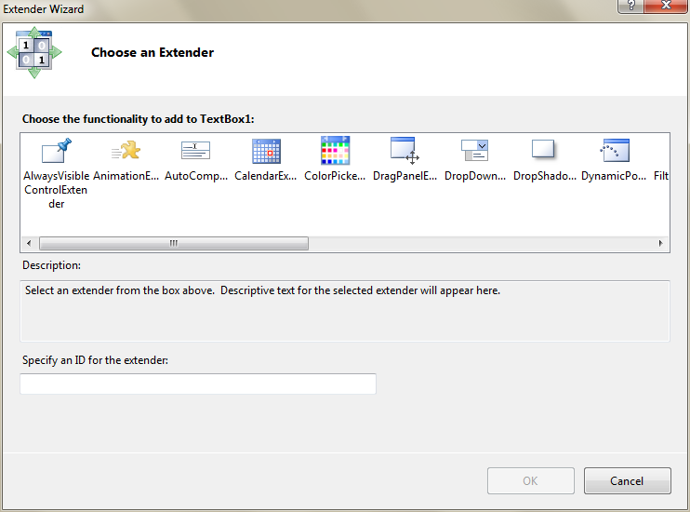
- Run the page. When you move focus to the TextBox control, a Calendar control appears.
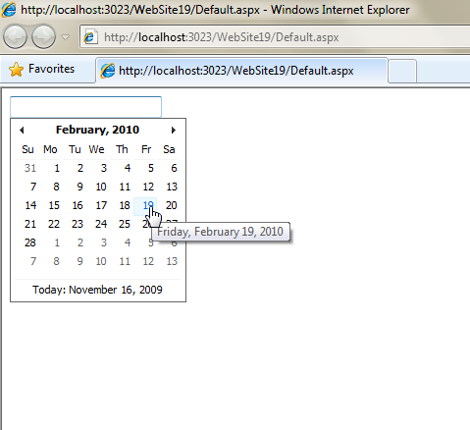

Instantiating Controls by Using the script Element
As an alternative to adding the ASP.NET Ajax Library to the Visual Studio Toolbox, you can add a script element to a page and set its src attribute to reference Start.js. For example, you can add the following script element to either an .aspx or .html page:
<script src="../Scripts/Start.js"
type="text/javascript"></script>
(This example assumes that you have copied the contents of the Scripts folder included in the ASP.NET Ajax Library download into a folder named Scripts in your Web application.)
In general, the only JavaScript file that you need to explicitly include in a page is the Start.js file. The Start.js script contains the client script loader that you can use to load all other script files that you need to use in the page.
While developing an application, you can add the debug version of the Start.js file, as in the following example:
<script src="../Scripts/Start.debug.js"
type="text/javascript"></script>
After you add a reference to the Start.js script, you can create and attach an ASP.NET Ajax control to a DOM element by using the Sys.create method. For example, the following page displays a Calendar control whenever you move focus to the input element:
<!DOCTYPE html PUBLIC "-//W3C//DTD XHTML 1.0 Transitional//EN" "http://www.w3.org/TR/xhtml1/DTD/xhtml1-transitional.dtd">

<html xmlns="http://www.w3.org/1999/xhtml">
<head>
<title>Simple Calendar</title>
<link href="../Scripts/Extended/Calendar/Calendar.css" rel="stylesheet" type="text/css" />

<script src="../Scripts/Start.debug.js" type="text/javascript"></script>
<script src="../Scripts/Extended/ExtendedControls.debug.js" type="text/javascript"></script>
<script type="text/javascript">

Sys.require(Sys.components.calendar, function() {
Sys.create.calendar("#travelDate");
});

</script>
</head>
<body>

<input id="travelDate" />

</body>
</html>

Using the Microsoft Ajax Content Delivery Network (CDN)
This Beta release of the ASP.NET Ajax Library is hosted on the Microsoft Ajax Content Delivery Network (CDN). You can use the ASP.NET Ajax Library directly from the CDN by adding the following script element to a page:
<script src="http://ajax.microsoft.com/ajax/beta/0911/Start.js"
type="text/javascript"></script>
Visual Studio 2010 supports IntelliSense from the CDN. (Visual Studio 2008 does not.)

Providing Feedback
To provide feedback on the ASP.NET Ajax Library, visit the following forums hosted at the ASP.NET Web site at the following location:
http://forums.asp.net/1214.aspx

Known Issues

A Reference is not added for System.Web.Ajax.dll
The AjaxControlToolkit.dll references System.Web.Ajax.dll. In a Web Application Project, if you drag and drop controls from the Toolkit onto the page, a reference to AjaxControlToolkit.dll is added, but not one to System.Web.Ajax.dll. Since both assemblies are actually added to the bin, this does not pose a run-time problem. However, if you subsequently drag a control which depends directly on System.Web.Ajax.dll into the project (AjaxScriptManager is currently the only such control), you will need to add the reference manually. This issue affects both Visual Studio 2008 and Visual Studio 2010.
Fix/Recommendation: Existing users of the ACT will not suffer at run-time because both assemblies are in bin. If you want to use AjaxScriptManager you will need to add System.Web.Ajax to the references section manually.

The Extender Wizard does not appear in Visual Studio 2010 when targeting ASP.NET 4
In Visual Studio 2010 Beta 2, the Extender smart tags will show only if you are targeting ASP.NET 3.5.
Fix/Recommendation: Visual Studio 2010 Beta 2 users will need to target 3.5 to get extenders.

Using the AjaxControlToolkit.dll from the Global Assembly Cache
In Visual Studio 2010, there is an issue where if you have AjaxControlToolkit.dll and System.Web.Ajax.dll added to the Global Assembly Cache, and then try to drag a control from the toolkit in a Web Application Project, the reference that gets added to your web.config for System.Web.Ajax.dll is missing a PublicKeyToken, which causes a runtime failure.
Fix/Recommendation: This issue only affects customers using Visual Studio 2010 Beta 2 in Web Application Projects.

