**Supporting information**

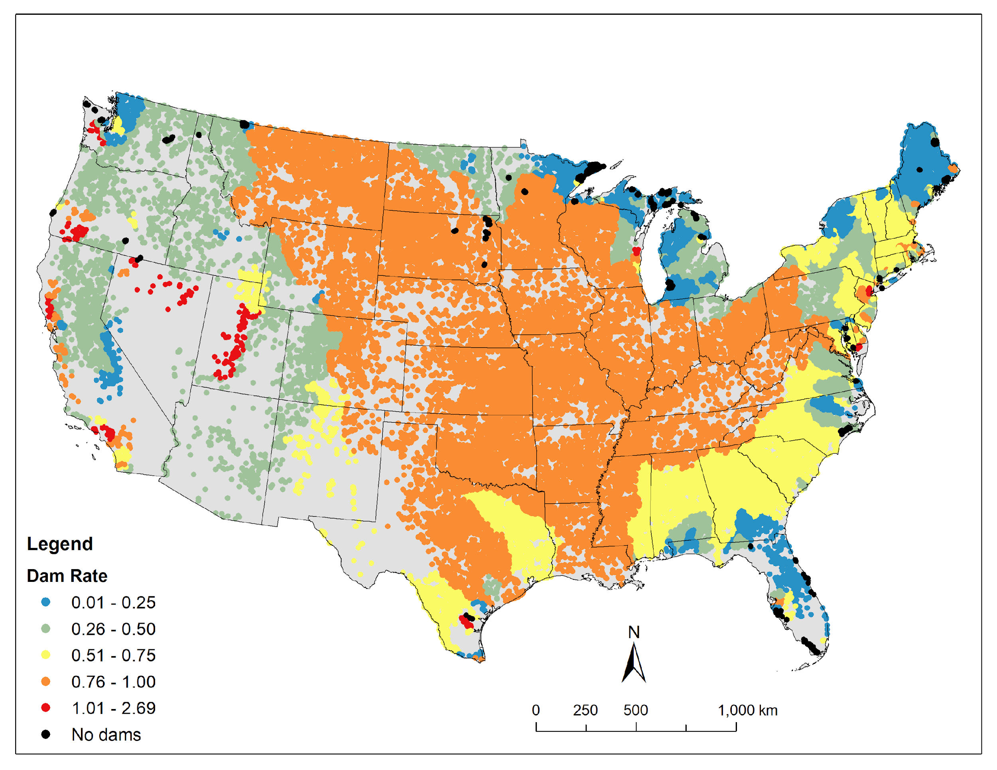

**Figure. S1.** Dam rate (number of lakes ≥ 1 ha divided by number of dams; unmodified before use in principal component analysis) in freshwater networks of the conterminous US. Shown are networks with > 4 lakes ≥ 1 ha per network (386 networks). Of these, 66 have no dams.

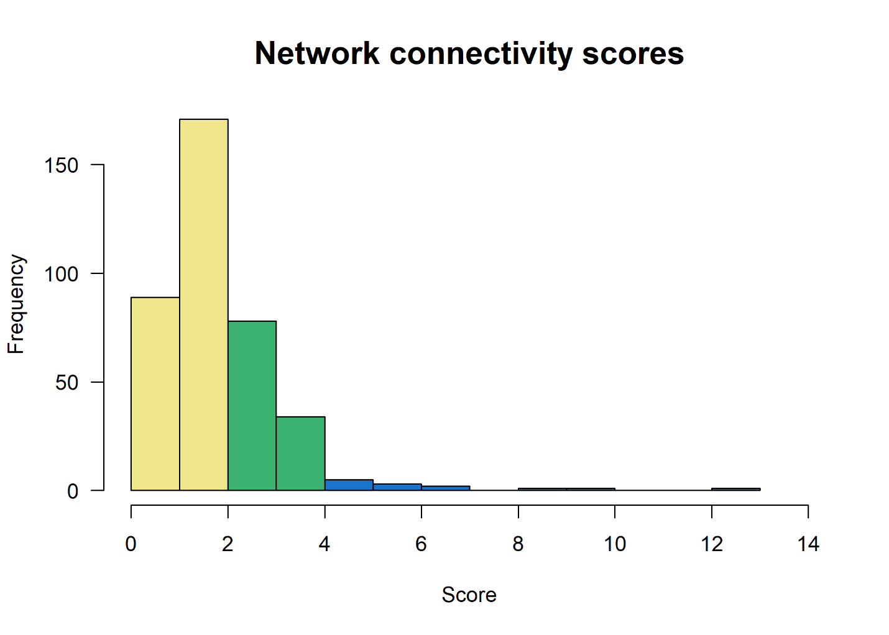

**Figure. S2.** Frequency distribution of freshwater network connectivity scores (n=385). Colors correspond to Fig. 4a.

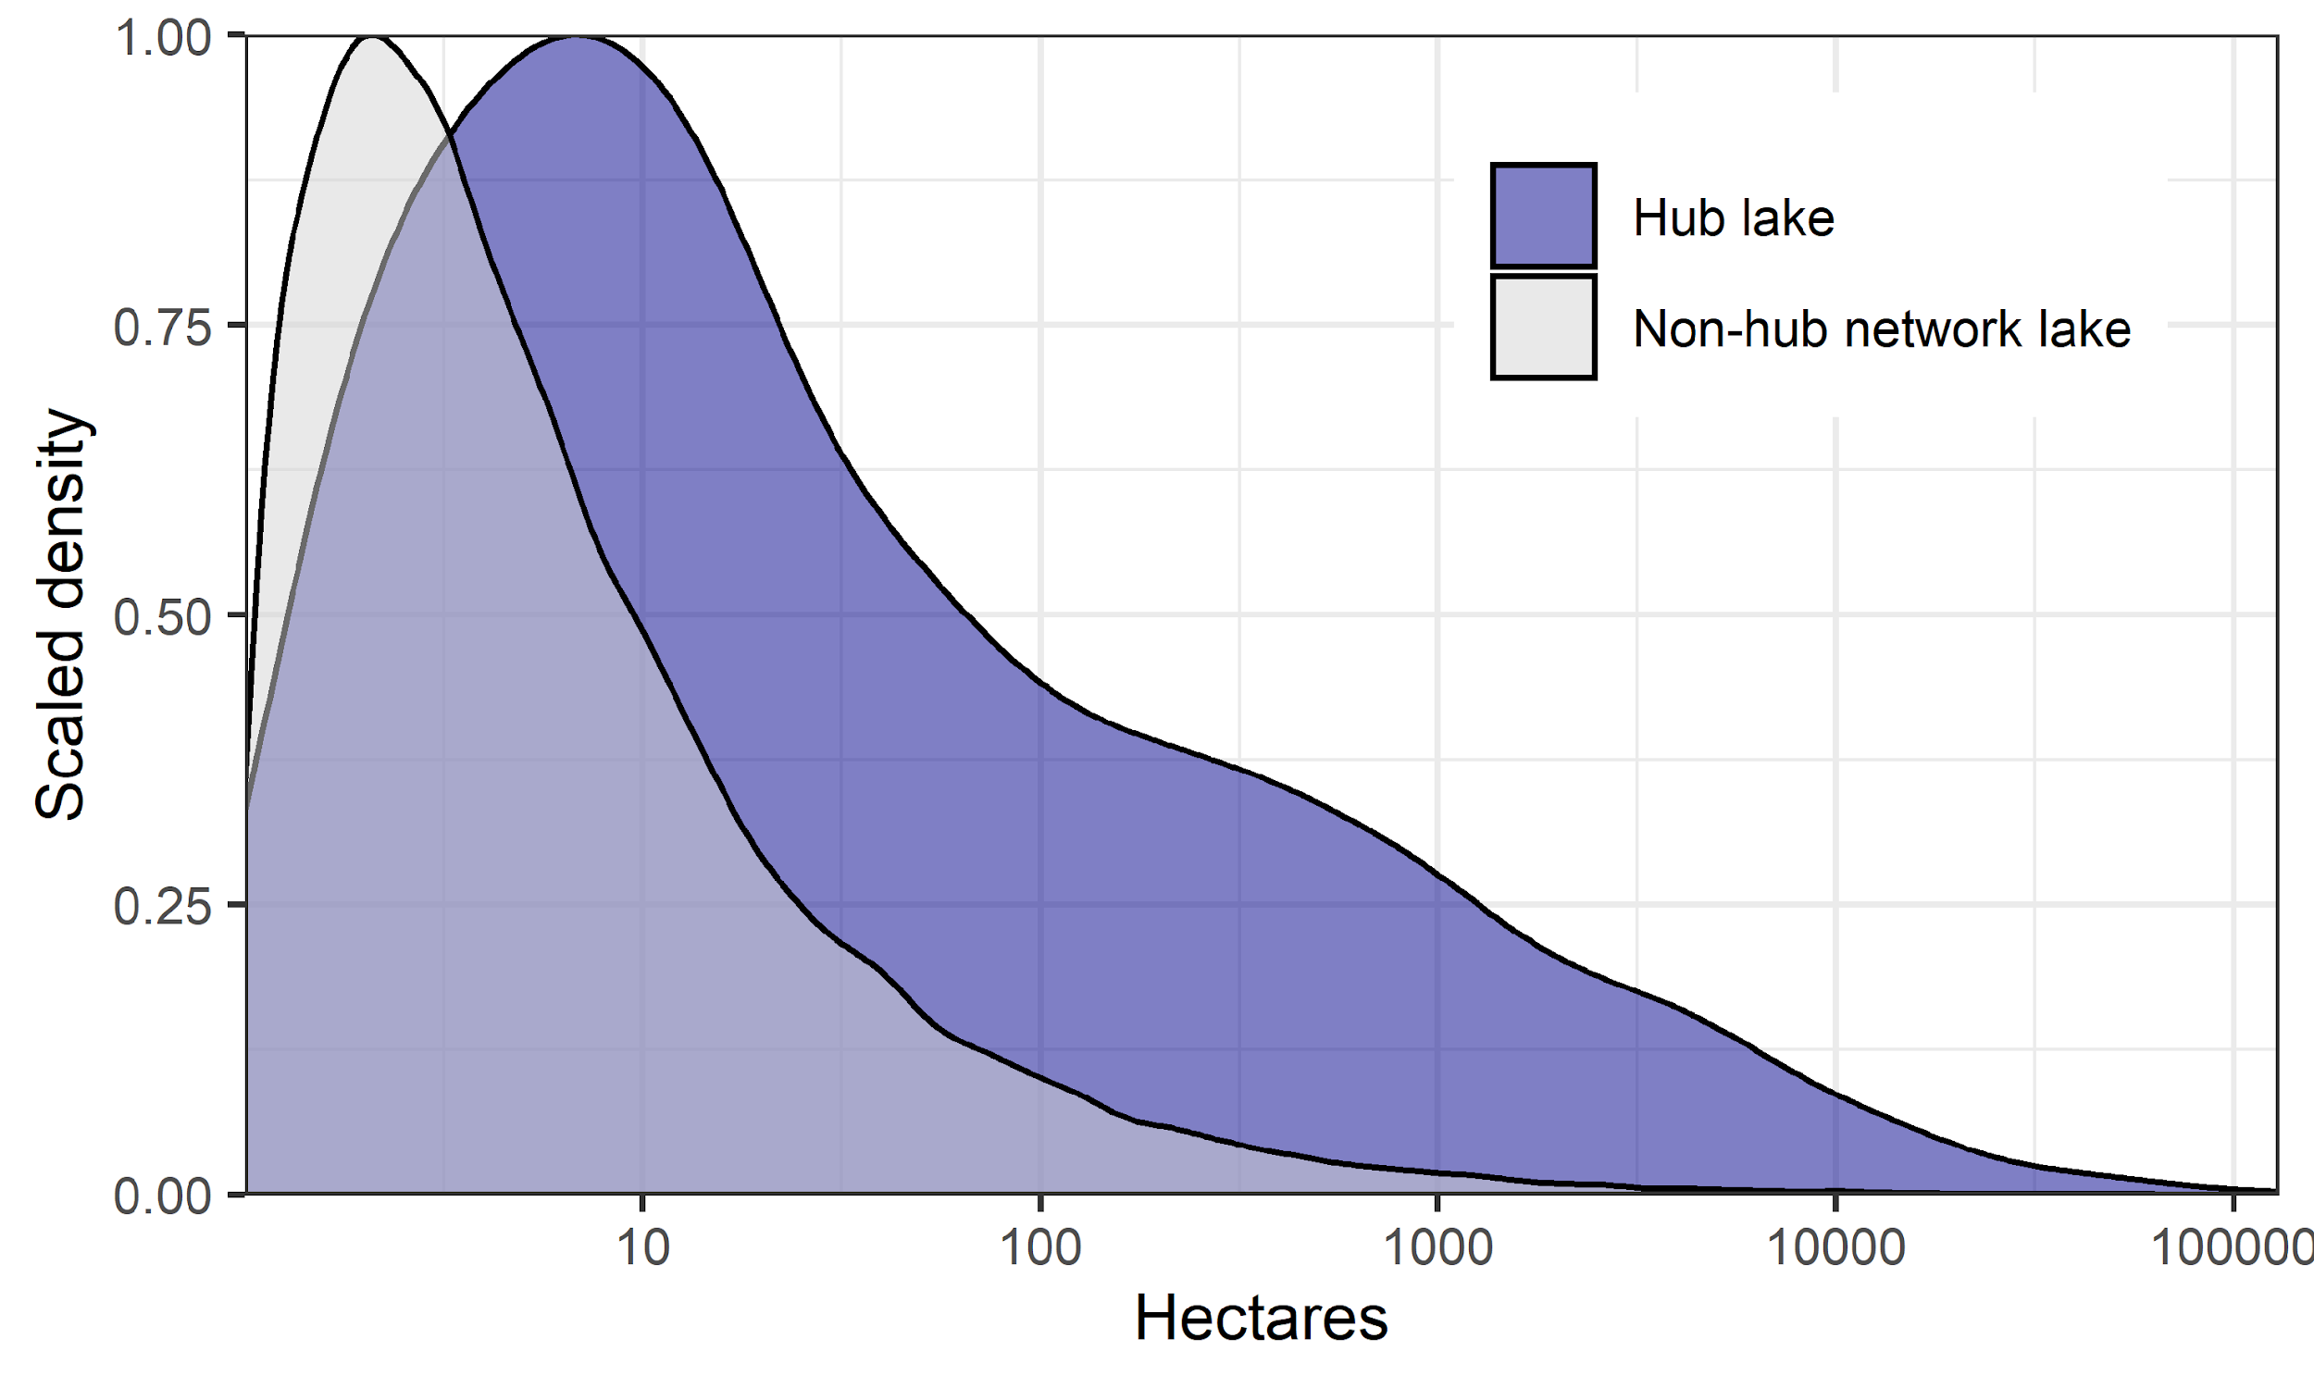

**Figure. S3.** Scaled density plot of the surface area (ha) of hub lakes (n = 2080) and non-hub lakes (n = 84431) in freshwater networks.

|  |  |  |  |  |  |  |  |  |  |  |
| --- | --- | --- | --- | --- | --- | --- | --- | --- | --- | --- |
| Table S1. Descriptive statistics of freshwater networks in the conterminous US | | | | | |  |  |  |  |  |
| Ecoregiona | Total Networksb | Number of lakes (min, median, max) | North-South distance (km) (min, median, max) | Number of dams (min, median, max) | % Articulation points (min, median, max) | Min cuts to disrupt max N-S distance (min, median, max) | Network lakes (number and % outside of MS River network) | Total network lakes (including MS River network) | Total hub lakes | % Hub lakes |
| CPL | 243 | 2, 3, 3241 | 0.0, 3.1, 539.4 | 0, 1, 1760 | 0.0, 0.0, 77.8 | 1, 1, 550 | 14862 (81.1%) | 18336 | 528 | 2.9% |
| NAP | 206 | 2, 4, 2659 | 0.0, 7.0, 505.4 | 0, 2, 1099 | 0.0, 31.2, 62.5 | 1, 1, 44 | 11934 (95.8%) | 12464 | 451 | 3.6% |
| NPL | 28 | 2, 2, 6 | 0.2, 2.5, 15.1 | 0, 0, 2 | 0.0, 0.0, 66.7 | 1, 1, 3 | 93 (1.1%) | 8166 | 5 | 0.1% |
| SAP | 10 | 11, 362, 1665 | 27.4, 139.7, 553.9 | 3, 159, 944 | 10.2, 21.1, 66.7 | 1, 4, 426 | 8287 (69.8%) | 11872 | 295 | 2.5% |
| SPL | 8 | 2, 166, 1529 | 0.6, 97.3, 1312.7 | 1, 132, 1273 | 0.0, 22.3, 40.0 | 1, 1, 65 | 2692 (39.2%) | 6871 | 103 | 1.5% |
| TPL | 58 | 2, 3, 0147 | 0.2, 4.4, 147.5 | 0, 0, 58 | 0.0, 33.3, 77.8 | 1, 1, 84 | 1073 (12.9%) | 8297 | 190 | 2.3% |
| UMW | 150 | 2, 4, 1190 | 0.0, 7.4, 380.4 | 0, 0, 250 | 0.0, 25.0, 75.0 | 1, 1, 30 | 6115 (63.1%) | 9691 | 260 | 2.7% |
| WMT | 108 | 2, 3, 2397 | 0.0, 8.5, 1330.3 | 0, 1, 954 | 0.0, 0.0, 60.0 | 1, 1, 131 | 6614 (78.0%) | 8476 | 169 | 2.0% |
| XER | 86 | 2, 3, 0105 | 0.2, 13.3, 216.8 | 0, 2, 68 | 0.0, 11.0, 86.7 | 1, 1, 18 | 2030 (86.8%) | 2338 | 79 | 3.4% |
| Overall | 897 | 2, 3, 3241 | 0.0, 5.9, 1330.3 | 0, 1, 1760 | 0.0, 21.1, 86.7 | 1, 1, 550 | 53700 (62.07%) | 86511 | 2080 | 2.4% |
| aCPL=Coastal Plains, NAP=Northern Appalachians, NPL=Northern Plains, SAP=Southern Appalachians, SPL=Southern Plains, TPL=Temperate Plains, UMW=Upper Midwest, XER=Xeric | | | | | | | | | | |
| bMississippi River basin network removed (32811 lakes, 24986 dams) in calculating columns 2-7 | | | | | | |  |  |  |  |

|  |  |  |  |  |  |  |  |  |  |
| --- | --- | --- | --- | --- | --- | --- | --- | --- | --- |
| Table S2. Freshwater networks in the conterminous US that meet conservation targetsa | | | | | | |  |  |  |
|  | 17% Aichi target | |  |  | 30% by 2030 |  |  |  |  |
| Ecoregionb | Strict, lake center | Strict + multi-use, lake center | Strict, 80% watershed | Strict + multi-use, 80% watershed | Strict, lake center | Strict + multi-use, lake center | Strict, 80% watershed | Strict + multi-use, 80% watershed | Total networksc |
| CPL | 88 (36.2%) | 106 (43.6%) | 21 (8.6%) | 28 (11.5%) | 81 (33.3%) | 94 (38.7%) | 16 (6.6%) | 23 (9.5%) | 243 |
| NAP | 29 (14.1%) | 73 (35.4%) | 15 (7.3%) | 26 (12.6%) | 19 (9.2%) | 48 (23.3%) | 12 (5.8%) | 23 (11.2%) | 206 |
| NPL | 11 (39.3%) | 15 (53.6%) | 1 (3.6%) | 3 (10.7%) | 10 (35.7%) | 13 (46.4%) | 0 (0.0%) | 3 (10.7%) | 28 |
| SAP | 0 (0.0%) | 3 (30.0%) | 0 (0.0%) | 0 (0.0%) | 0 (0.0%) | 2 (20.0%) | 0 (0.0%) | 0 (0.0%) | 10 |
| SPL | 1 (12.5%) | 1 (12.5%) | 0 (0.0%) | 1 (12.5%) | 0 (0.0%) | 1 (12.5%) | 0 (0.0%) | 1 (12.5%) | 8 |
| TPL | 16 (27.6%) | 23 (39.7%) | 2 (3.5%) | 2 (3.5%) | 11 (19.0%) | 16 (27.6%) | 2 (3.5%) | 2 (3.5%) | 58 |
| UMW | 35 (23.3%) | 75 (50.05%) | 39 (26.0%) | 52 (34.7%) | 30 (20.0%) | 63 (20.0%) | 32 (21.3%) | 43 (28.7%) | 150 |
| WMT | 41 (38.0%) | 67 (62.0%) | 31 (28.7%) | 53 (49.1%) | 37 (34.3%) | 63 (42.0%) | 28 (26.0%) | 53 (49.1%) | 108 |
| XER | 20 (23.3%) | 64 (74.4%) | 11 (12.8%) | 39 (45.4%) | 17 (19.8%) | 59 (68.6%) | 9 (10.5%) | 38 (44.2%) | 86 |
| Overall | 241 (26.9%) | 427 (47.6%) | 120 (13.4%) | 204 (22.7%) | 205 (22.9%) | 359 (40.0%) | 99 (11.0%) | 186 (20.7%) | 897 |
| aStrict protection=managed for biodiversity (GAPS 1-2), multi-use=managed for biodiversity and natural resource extraction (GAP 3) | | | | | | | | | |
| bCPL=Coastal Plains, NAP=Northern Appalachians, NPL=Northern Plains, SAP=Southern Appalachians, SPL=Southern Plains, TPL=Temperate Plains, UMW=Upper Midwest, XER=Xeric | | | | | | | | | |
| cAll freshwater networks in the conterminous US except the Mississippi River network | | | | | |  |  |  |  |

|  |  |  |  |  |  |  |  |  |  |  |
| --- | --- | --- | --- | --- | --- | --- | --- | --- | --- | --- |
| Table S3. Lake protectiona across all freshwater networks in the conterminous US | | | | | |  |  |  |  |  |
|  | Network lakes |  |  |  |  | Hub lakes |  |  |  |  |
| Ecoregionb | Strict, lake center | Strict + multi-use, lake center | Strict, 80% watershed | Strict + multi-use, 80% watershed | Total network lakes | Strict, lake center | Strict + multi-use, lake center | Strict, 80% watershed | Strict + multi-use, 80% watershed | Total hub lakes |
| CPL | 636 (3.5%) | 949 (5.2%) | 203 (1.1%) | 362 (2.0%) | 18336 | 34 (6.4%) | 51 (9.7%) | 9 (1.7%) | 11 (2.1%) | 528 |
| NAP | 635 (5.1%) | 1737 (13.9%) | 917 (7.4%) | 1389 (11.1%) | 12464 | 24 (5.3%) | 60 (13.3%) | 14 (3.1%) | 18 (4.0%) | 451 |
| NPL | 2507 (30.7%) | 4981 (61.0%) | 1407 (17.2%) | 4537 (55.6%) | 8166 | 1 (20.0%) | 1 (20.0%) | 0 (0.0%) | 0 (0.0%) | 5 |
| SAP | 92 (0.8%) | 210 (1.8%) | 38 (0.3%) | 85 (0.7%) | 11872 | 20 (6.8%) | 40 (13.6%) | 4 (1.4%) | 10 (3.4%) | 295 |
| SPL | 126 (1.8%) | 207 (3.0%) | 77 (1.1%) | 179 (2.6%) | 6871 | 3 (2.9%) | 6 (5.8%) | 0 (0.0%) | 0 (0.0%) | 103 |
| TPL | 63 (0.8%) | 90 (1.1%) | 13 (0.2%) | 15 (0.2%) | 8297 | 25 (13.2%) | 37 (19.5%) | 6 (3.2%) | 6 (3.2%) | 190 |
| UMW | 1302 (13.4%) | 2304 (23.8%) | 1165 (12.0%) | 1698 (17.5%) | 9691 | 42 (16.2%) | 78 (30.0%) | 23 (8.8%) | 57 (21.9%) | 260 |
| WMT | 3430 (40.5%) | 5205 (61.4%) | 3220 (38.0%) | 5183 (61.1%) | 8476 | 54 (32.0%) | 115 (68.0%) | 61 (36.1%) | 118 (69.8%) | 169 |
| XER | 81 (3.5%) | 253 (10.8%) | 39 (1.7%) | 170 (7.3%) | 2338 | 5 (6.3%) | 25 (31.6%) | 1 (1.3%) | 11 (13.9%) | 79 |
| Overall | 8872 (10.2%) | 15936 (18.4%) | 7079 (8.2%) | 13618 (15.7%) | 86511 | 208 (10.0%) | 413 (19.9%) | 118 (5.7%) | 231 (11.1%) | 2080 |
| aStrict protection=managed for biodiversity (GAPS 1-2), multi-use=managed for biodiversity and natural resource extraction (GAP 3) | | | | | | | | | |  |
| bCPL=Coastal Plains, NAP=Northern Appalachians, NPL=Northern Plains, SAP=Southern Appalachians, SPL=Southern Plains, TPL=Temperate Plains, UMW=Upper Midwest, XER=Xeric | | | | | | | | | | |