**Abstract**

Maintaining broad-scale freshwater connectivity is challenging owing to the dendritic, easily fragmented structure of freshwater networks, but is essential for facilitating species range shifts under climate change and long-distance migrations. Although the importance of stream network connectivity has been recognized, lake-stream network connectivity has largely been ignored. Furthermore, protected areas are generally not designed to maintain or encompass entire freshwater networks. We identified freshwater movement corridors (highways) for freshwater biodiversity in the conterminous US. We calculated connectivity scores for 385 networks with > 4 lakes (≥ 1 ha) using a principal component analysis and various graph-based network metrics. We also identified 2080 hub lakes (2% of all network lakes) that are disproportionately important for maintaining networks. Connectivity scores were not correlated with any type of protection. Just 4% of networks received high connectivity scores based on their large size and structure (medians of 1756 lakes, 487.2 km north-south), but these also contained a median of 930 dams. In contrast, undammed networks (17% of networks) were considerably smaller (medians of 6 lakes, 7.2 km north-south), suggesting that the largest networks in the conterminous US with the greatest potential for facilitating species’ range shifts and long-distance migrations contain numerous roadblocks. Network lakes and hubs were protected at similar rates nationally across different levels of protection (8-18% and 6-20%, respectively), but were generally more protected in the western US. Our results indicate that conterminous US protection of major freshwater biodiversity highways and the hubs that maintain them generally fell short of the international conservation goal of protecting an ecologically representative, well-connected set of fresh waters (≥ 17%) by 2020 (Aichi Target 11). Conservation planning efforts might consider focusing on hubs, particularly in larger networks or biodiverse regions such as the southeastern US, to support connectivity for freshwater biodiversity conservation under climate change.

**Introduction**

Connectivity is an important component of conservation under climate change. This includes both regional- to continental-scale connectivity for species range shifts (Littlefield et al. 2019) and local- to landscape-scale connectivity for access to seasonal refuges (Armstrong et al. 2021) or local range shifts in heterogeneous landscapes. As habitats are lost, degraded, or fragmented, corridors are essential for facilitating connectivity across habitats and these spatial scales (Beier & Noss 2008). From a biodiversity conservation perspective, it is important to identify and protect corridors to ensure long-term population maintenance and the potential for species range shifts under rapid climate change (Stralberg et al. 2020).

Maintaining connectivity among freshwater ecosystems is especially challenging owing to the dendritic nature of freshwater landscapes (i.e., networks of streams, rivers, and lakes; Fergus et al. 2011). In freshwater networks, connectivity can be affected by anthropogenic (e.g., impoundments, hydrologic alterations) or natural factors (e.g., flow direction, hydrologic isolation, or dead ends within networks) (Erős et al. 2012, LeMoine et al. 2020), limiting dispersal potential for obligate aquatic species. In other words, freshwater networks are susceptible to both losses of structural connectivity (i.e.,physical linkages) and functional connectivity (the degree to which organisms, energy, and nutrients can move throughout a network); both types of connectivity will be affected by a changing climate (Wainwright et al. 2011). For example, climate change heightens the importance of intact networks for freshwater biodiversity conservation purposes in the context of maintaining access to seasonal coldwater refuges (Armstrong et al. 2021) and persistent waterbodies in dry landscapes (Jaeger et al. 2014). Furthermore, functional connectivity is necessary for facilitating species range shifts in response to climate change (Comte et al. 2013, Lynch et al. 2016) and for providing access to climate change refugia (Ebersole et al. 2020). All of these key processes depend partly on the structure and characteristics of freshwater networks and thus conservation planning efforts under climate change would greatly benefit from prioritization criteria that account for the capacity of freshwater networks to support these processes.

Connectivity is also of central concern for the management of aquatic invasive species spread under a changing climate (Bierwagen et al. 2008). Identifying pathways of secondary spread of invasives throughout freshwater networks is an important component of management (Vander Zanden & Olden 2008). The spatial position and connections of a lake can drive the likelihood of spread of invasives to and from that lake (Muirhead & MacIsaac 2005), and connectivity can lead to taxonomic homogenization across lakes that may be in opposition to management goals (Strecker & Brittain 2017).

**Beyond corridors: highways and hubs for freshwater connectivity and conservation**

Freshwater networks lend themselves well conceptually to the same graph-based patch-corridor-matrix analytical framework typically used in terrestrial landscape ecology, but have been less widely applied to freshwater ecosystems (Erős et al. 2012). Under this framework, lakes represent habitat patches and streams and rivers represent habitat corridors, but few studies have integrated lakes, streams, and rivers across multi-regional to continental spatial scales (Saunders et al. 2015). We extend the patch-corridor concept to incorporate “hubs”: patches (i.e., lakes within freshwater networks) that disproportionately influence and reinforce whole-network structural connectivity (Muirhead & MacIsaac 2005) (Fig. 1a). In freshwater networks, propagules, organisms, and species move among habitats using corridor networks (i.e., “highways”), but often must travel through hubs to access different portions of networks. Whole-network connectivity is considerably reduced if hubs become compromised due to factors such as impoundments or other hydrologic alterations, water quality declines, biological invasions, or shoreline developments (Fig. 1b).

Important context for assessing current protection of freshwater highways and hubs is the conservation standard set by the Strategic Plan for Biodiversity at the 2010 Convention on Biological Diversity (CBD). Aichi Target 11 stated that at least 17% of global fresh waters should be protected by 2020 through ecologically representative, well-connected systems of protected areas (CBD 2010). In other words, conservation efforts should prioritize ecologically diverse waterbodies in ecologically diverse landscapes as well as freshwater connectivity. In 2020, the 5th Global Biodiversity Outlook deemed Target 11 as “partially achieved”: the 17% target was likely achieved globally, but not necessarily based on ecologically representative, well-connected fresh waters (Secretariat of the Convention on Biological Diversity 2020). This appears to be true in the conterminous US as well. Up to 17.8% of lakes are currently protected depending on how protection is defined and protected lakes tend to be more connected to streams and other lakes than unprotected lakes, but protected lakes are located disproportionately in the western US where protected areas are most prevalent and freshwater biodiversity is relatively low (McCullough et al. 2019). In fact, freshwater biodiversity (fishes, amphibians, and reptiles) is highest in the southeastern US in terms of both species richness and endemism where there are relatively few protected areas (Jenkins et al. 2015).

Interestingly, more ambitious conservation targets may be on the horizon in the US.

Section 216 of the January 2021 Biden administration executive order on “Tackling the Climate Crisis at Home and Abroad” established “the goal of conserving at least 30 percent of our lands and waters by 2030” (EO 14008). Although this directive may be a sign of federal leadership in conservation efforts, the order does not specifically distinguish freshwater from marine conservation targets, nor does it address the important topics of ecological representation or connectivity per the existing Aichi Target 11. Nonetheless, additional land protection has the potential to benefit freshwater ecosystems and help fully achieve Aichi Target 11 in the US if planned accordingly.

**Study objective and research questions**

Whereas past studies provide evidence that US protected areas do not contain an ecologically representative set of freshwater ecosystems, there have been no national-scale analyses of freshwater connectivity in relation to protected areas. Therefore, our objective was to provide better information on the conservation status of freshwater highways and hubs to help prioritize locations for conservation, maintain connectivity, and support the achievement of international and national conservation targets within a climate change context. In this study, we applied a novel, continental-scale freshwater connectivity dataset (i.e., networks of streams, rivers, and lakes) to examine the current distribution and conservation status of freshwater highways and hubs in the conterminous US.Specifically, we asked:

1. What freshwater networks can best function as biodiversity highways?
2. What lakes represent freshwater network hubs?
3. How well protected are these freshwater highways and hubs?

This analysis represents an important step for freshwater biodiversity conservation in a climate change context and is intended to pave the way for future biodiversity-centered work including observations of species and genetic diversity, as well as important processes of gene flow, migrations, and range shifts.

**Methods**

**Lake networks and connectivity metrics**

A challenge associated with assessing freshwater connectivity is obtaining data at ecologically appropriate resolutions across a spatial extent necessary for multi-regional- to continental-scale conservation planning. Datasets should resolve spatial connections among waterbodies taking into account flow direction, presence of impoundments, and seasonal flow changes (Erős et al. 2012, LeMoine et al. 2020). Emerging datasets and tools can help ensure that freshwater network datasets reflect these ecologically important phenomena that can help identify major highways and hubs.

We used a novel national dataset, LAGOS-US-NETWORKS v1.0 (King et al. in review a, b), that defined lake networks based on all connected lakes regardless of streamflow, such that lakes can be connected through a downstream confluence. This dataset includes 86511 on-network lakes > 1ha in surface area that comprise a total of 898 networks within the conterminous US (Fig 2a). LAGOS-US-NETWORKS also includes on-network dams (n = 48777) and metrics for the number of total dams within each network and the number of upstream or downstream dams from individual lakes. We calculated additional connectivity metrics described below using all pairs of connected lakes and the stream course distance connecting them regardless of streamflow direction.

Lake networks were considered in a graph theory framework (Bondy & Murty 1976), a concept that has been applied to ecological interaction networks (Eklöf et al. 2013), landscape connectivity (Bunn et al. 2000), and regional-level analyses of lentic networks (Ishiyama et al. 2014, Thornhill et al. 2018). Under a graph theory framework, a network is constructed from lakes (nodes) connected through streams (edges). In our treatment, the edges were weighted by the total stream course distance (km) and are undirected connections between pairs of nodes such that travel through each lake network is not dictated by the direction of streamflow. These graphs are subsequently analyzed through network analysis to describe the relationship between nodes within a graph through a number of metrics such as those that describe the number and strength of edge connections, network travel, and subnetwork structure (Rayfield et al. 2011). All network connectivity metrics were calculated using the ‘igraph’ R package (Csardi & Nepusz 2006). We then quantified network-scale connectivity using 7 metrics:

1. The number of lakes in a network.
2. The number of dams in a network.
3. The minimum number of cuts (i.e., edge removals) required to disconnect the highest and lowest latitude (north-south) lakes in the network.
4. The edge density of a network, which is the ratio of edges connecting lake nodes to the maximum number of potential edges among lake nodes.
5. The percent of lakes in a network that are articulation points, which are lakes that separate the total network into 2 or more subnetworks if removed.
6. The normalized mean betweenness centrality (*BC*) of all lakes within a network. Betweenness centrality is the number of shortest-distance pairwise paths in a network that pass through a lake, which we averaged across network lakes after normalization by the number of lakes within a network (*N*) using the formula for comparison of scores among networks.
7. The geographic distance (km) between the northernmost and southernmost lakes in a network.

To facilitate usefulness of our study for management and policy decision-making processes, we analyzed freshwater connectivity across 9 ecoregions used by the US Environmental Protection Agency National Aquatic Resource Survey (NARS) (Herlihy et al. 2008) (Fig. 2b). For networks that spanned multiple ecoregions, we assigned ecoregions based on the majority of lakes within those networks.

**Hub lake determination**

Conceptually, hubs are lakes within a network that are vital for maintaining connectivity across large expanses and are well-traveled centers for biota moving throughout a network. Hub lakes were determined based on the individual metrics of lake nodes within networks. We defined hub lakes as lakes that were articulation points in their network, were in the top quintile of total node strength within their network, and were in the top quintile of betweenness centrality within their network (Fig. 3). Hence, each network with ≥ 5 lakes will contain at least one hub lake using our definition as long as an articulation point exists in the network. Articulation points are by definition bridges among two or more subnetworks, meaning that an organism must travel through an articulation point to move aquatically from one subnetwork to another. High node strength for a lake indicates that it connects a high total network distance among lakes, whether through a multitude of short streams or a handful of long streams. Lakes with high betweenness centrality have shorter aquatic travel distances crossing through them and are more likely to be stepping stones for organisms moving within a network. Combined, these metrics indicate a lake that is necessary for network movement and connects long distances while being a more likely path for biota than other lakes in a network.

**Network connectivity scores**

We calculated freshwater network connectivity scores for each network with > 4 lakes using a principal component analysis (PCA). We considered the Mississippi River network separately due to its exceptional size. Although PCA is designed to handle highly correlated variables, we opted to use a “dam rate” variable (ratio between number of dams and number of lakes) rather than number of dams because number of dams was strongly correlated with number of lakes (Pearson’s r = 0.94, p < 0.001). Prior to the PCA, we rescaled dam rate such that higher numbers represented greater connectivity. Similarly, we treated the percent articulation points variable in this way to account for the negative effect of fragmentation on network connectivity. All input variables were rescaled (mean of 0 and standard deviation of 1) prior to PCA calculations. In the resulting PCA, we used 2 components, which explained 60.8% of variation in the data, to calculate connectivity scores based on the Pythagorean theorem. We opted to use 2 components based on agreement between the Kaiser criterion and Horn’s parallel analysis for component retention (Dinmo 2018). Resulting connectivity scores represented a composite of the input connectivity variables that could be easily compared across networks.

**Analysis of protected networks, network lakes, and hub lakes**

We examined overlap between protected areas and whole freshwater networks, network lakes and hub lakes across NARS ecoregions. Defining protected freshwater ecosystems depends on different levels of legal protection. Therefore, we considered both strict (i.e., managed for biodiversity; Gap Analysis Program (GAP) status 1-2) and multi-use (i.e., managed for both biodiversity and natural resource extraction; GAP status 1-3) protection (Fig 2c) in the US Protected Areas Database v1.4 (US Geological Survey 2016). We also considered protection based on lakes simply occurring within protected areas (i.e., based on lake centers) and on at least 80% of lake watersheds occurring within protected areas (sensu McCullough et al. 2019). Under these different definitions of protection, the narrowest is based on strict 80% watershed protection, whereas the loosest is based on lake centers occurring within either strict or multi-use protected areas. Watersheds were based on LAGOS-US-LOCUS v1.0 (Cheruvelil et al. in review). Using these different definitions, we calculated the percentage of lakes in each network currently protected. Similarly, we analyzed current protection of hub lakes using these same definitions and compared protection of hub lakes to protection of all network lakes. We also compared natural log-transformed network connectivity scores to proportions of networks protected under all definitions of protection using Pearson’s correlation coefficients. Finally, we analyzed protection of whole networks, network lakes, and hub lakes with respect to the 17% Aichi target and 30% by 2030 target both nationally and by NARS ecoregions.

All data, metadata, and R analysis scripts are currently available at <https://github.com/cont-limno/TripleC>. Upon publication, this repository will be permanently archived in a publicly accessible online location and cited in our methods.

**Results**

**Freshwater network characteristics**

Of the 898 freshwater networks across the conterminous US, the Mississippi River network contained approximately 37.9% of all network lakes (32811 lakes) and 51.2% of all network dams (24986 dams). In contrast, all other networks were relatively small (medians of 3 lakes and 5.9 km N-S distance) and contain a median of 1 dam. Some networks were relatively large, however, in terms of number of lakes and N-S distance: 12.6% of networks contain ≥ 49 lakes or span ≥ 70 km latitudinally. Additionally, the number of network lakes and N-S distance were positively correlated across all networks except the Mississippi River network (Pearson’s r = 0.78, p < 0.001). These larger networks also tended to have more dams: number of dams was positively correlated with number of lakes and N-S distance across all networks except the Mississippi River network (Pearson’s r = 0.94 and 0.74, respectively, p < 0.001). Nonetheless, these larger networks are currently among the most expansive freshwater highway systems in the conterminous US due to their combination of relatively high abundance of lakes, which can act as stepping stones for biodiversity, and latitudinal breadth.

Most freshwater networks were susceptible to habitat fragmentation. Across all networks, a median of 18.5% of lakes per network were articulation points (Table S1), but this value was 33.3% for networks with > 4 lakes, indicating that larger networks were more susceptible to fragmentation. Additionally, maximum N-S connectivity within networks was particularly fragile across all networks: a median of 1 network cut was needed to undermine the full latitudinal breadth of all networks, as well as those with > 4 lakes. Approximately 22.6% and 8.9% of all networks required at least 2 and 5 cuts, respectively, to disrupt maximum N-S connectivity. Although the degree of habitat fragmentation ultimately depends on where network disruptions occur, networks with higher proportions of lakes as articulation points and higher vulnerability to loss of latitudinal breadth demonstrate that habitat fragmentation is a major potential threat to regional- to continental-scale freshwater connectivity.

Freshwater network characteristics also varied across ecoregions (Table S1). Generally, lake-rich ecoregions (based on lakes outside the Mississippi River network) contained the most networks: Coastal Plains (CPL; 243 networks; 14862 lakes), Northern Appalachians (NAP; 206 networks; 11934 lakes), Upper Midwest (UMW; 150 networks; 6115 lakes). Three ecoregions were dominated by the Mississippi River network: 1.1%, 39.2%, and 12.9% of lakes in the Northern Plains (NPL), Southern Plains (SPL), and Temperate Plains (TPL), respectively, were not part of the Mississippi River network. Similarly, these ecoregions had relatively low numbers of independent networks (28, 8, and 58 networks respectively). Interestingly, however, the Southern Appalachians (SAP) ecoregion contained just 10 relatively large networks (medians of 362 lakes and 139.7 km N-S distance) across 8287 non-Mississippi River network lakes (69.8%). Additionally, networks in the SPL ecoregion (n = 8) were also relatively well connected with medians of 166 lakes and 97.3 km N-S distance outside the Mississippi River network. Susceptibility to habitat fragmentation varied somewhat across ecoregions: median percentage of lakes as articulation points ranged 0.0 - 33.3%. The CPL, NPL, and WMT ecoregions had the lowest (0%), whereas the UMW (25.0%), NAP (31.2%), and TPL (33.3%) ecoregions had the highest median percentage of lakes as articulation points. All ecoregions required a median of only 1 cut to undermine maximum N-S connectivity, except the SAP ecoregion (median of 4 cuts).

**Hub lakes**

We identified 2080 hub lakes across the conterminous US, representing 2.4% of network lakes (Table S1, Fig. 4a). This percentage varied marginally across most ecoregions, but was just 0.1% in the NPL ecoregion and 1.5 - 3.6% across all other ecoregions. Across NARS ecoregions, abundance of hub lakes was positively correlated with abundance of networks (Pearson’s r = 0.79, p = 0.01). Hubs were generally most abundant in the 3 ecoregions with the most networks (CPL: 528 hubs, NAP: 451 hubs, UMW: 260 hubs). Ecoregions with fewer networks were generally dominated by the Mississippi River network and also had generally fewer hubs (NPL: 28 networks/5 hubs, SAP: 10 networks/295 hubs, SPL: 8 networks/103 hubs, TPL: 58 networks/190 hubs). In the western US, which is mostly outside the Mississippi River network, the WMT and XER ecoregions had 169 and 79 hubs, respectively.

Of all 2080 hub lakes, 1616 (77.7%) ≥ 4 ha were classified as either reservoirs or natural lakes, of which 1168 (72.3%) were reservoirs and 448 (27.7%) were natural lakes. Hub lakes are considerably more likely to be reservoirs than the general population of lakes; 43.5% of 137465 lakes in the conterminous US ≥ 4 ha are classified as reservoirs. Of the 246 networks with hub lakes, just 27 networks (11.0%) had no dams. We found that 357 (21.5%) and 6 (0.4%) hub lakes (excluding the Mississippi network) had one dam or multiple dams directly on the lake, respectively. Additionally, even if a dam was not directly on a hub lake, dams upstream from hubs ranged from 0 - 301 and from 1 - 18 dams downstream from hubs. Hub lake surface area was a median of 15.4 ha (min = 1.0 ha; max = 107534.6 ha; Fig. S3) compared with a median surface area of 4.0 ha (min = 1.0 ha; max = 129612.0 ha) for the population of all lakes in LAGOS-US-NETWORKS.

**Network connectivity scores**

Network connectivity scores followed a left-skewed distribution (Fig. 4a, b, S2). Of the 385 assessed networks with > 4 lakes (excluding the Mississippi River network), 286 (74.3%) received scores < 2 (low), 83 (21.6%) received scores between 2 and 4 (medium), and 16 (4.2%) received scores > 4 (high). In general, networks in the western, southern, and eastern US received higher scores, whereas networks in the central US and most of Florida received predominantly low to medium scores (Fig. 4a, b). Of the 16 networks with high scores, 6 were found in the CPL ecoregion, 3 in the WMT ecoregion, 2 in each of the NAP, SAP, and SPL ecoregions, and 1 in the XER ecoregion (Table 1). The 3 highest-scoring networks were the Colorado River (WMT), Columbia River (WMT), and Savannah-Santee (CPL) networks. The UMW and NPL ecoregions had no high-scoring networks. Connectivity scores for all 385 networks are provided in Table S2.

High-scoring networks were generally larger and contained more lakes and dams (Tables 1, S4). The 16 highest-scoring networks spanned 29.3 - 1330.3 km north to south (median = 487.2 km) and had 15 - 3241 lakes (median = 1756 lakes) and 0 - 1760 dams (median = 930 dams). Conversely, low- to medium-scoring networks ranged 0.9 - 539.4 km (median = 22.4 km) and had 5 - 1463 lakes (median = 13 lakes) and 0 - 754 dams (median = 4 dams). Similarly, dam rate ranged 0.0 - 83.3% (median = 52.1%) across high-scoring networks and ranged 0.0 - 269.2% (median = 33.3%) across low- to medium-scoring networks. Dam rate was 100% or greater (i.e., at least as many dams as lakes) in 21 (5.5%) networks. Just 66 (17.1%) of scored networks contained no dams, but these networks were relatively small in terms of lakes (5 - 64 lakes; median = 6 lakes) and north-south distance (0.9 - 186.4 km; median = 7.2 km). Finally, high-scoring networks had 0 - 76 hubs (median = 45 hubs) and low- to medium-scoring networks had 0 - 46 hubs (median = 1 hub).

**Protection of networks, network lakes, and hub lakes**

Whole networks are poorly protected across the conterminous US (Table S3, Fig. 5). Median network protection was 0.0% across all networks, except under the loosest definition of protection (14.4%; strict + multi-use, lake center protection) (Fig. 5a, c). Fully protected networks were relatively rare and varied across definitions of protection (28 - 122 networks; 3.1 - 13.6% of networks). The SAP and SPL ecoregions had no fully protected networks based on all definitions of protection. Under the narrowest and loosest definitions of protection, the WMT (10.1%, 22.0%), CPL (3.3%, 19.8%), and XER (2.3%, 22.1%) ecoregions had the highest rates of full network protection, respectively. Approximately 13.4 - 47.6% and 11.0 - 40.0% of networks had at least 17% and 30% of their lakes protected from the narrowest to loosest definitions of protection, respectively. Across all ecoregions, the CPL ecoregion had the highest number of networks meeting the 17% and 30% targets based on lake center protection, whereas the UMW, WMT, and XER ecoregions had the highest, most consistent percentage of networks meeting the 17% and 30% targets across all definitions of protection. The SAP and SPL ecoregions had the fewest networks meeting either conservation target and were the ecoregions that most often had zero networks meeting conservation targets across definitions of protection. The Mississippi River network, approximately 10 times larger than the next-largest network in terms of number of lakes, was 4.3 - 15.1% protected across all definitions of protection. Additionally, network connectivity scores (natural log-transformed) were not correlated with the proportion of networks protected under all definitions of protection (absolute Pearson’s r < 0.1, p = 0.36 - 1.0), indicating that the most connected networks were generally not well protected. In summary, although whole network protection varied widely across ecoregions and definitions of protection, most networks were poorly protected as a whole.

Across all network lakes, protection varied from 8.2 - 18.4% from the narrowest to loosest definition of protection (Table S4). Therefore, lake protection in the conterminous US only narrowly met the 17% Aichi target under a generous definition of protection and was well short of the 30% by 2030 target. Network lake protection varied across ecoregions from a low of 0.8% in the SAP and TPL ecoregions to highs of 55.6% in the NPL and 61.4% in WMT ecoregions under the narrowest and loosest definitions of protection, respectively. The WMT and NPL ecoregions were the only ecoregions that met the 17% Aichi target across all definitions of protection. Similarly, both of these ecoregions consistently met the 30% by 2030 target, except for NPL under the narrowest definition of protection. In contrast, The CPL, NAP, SAP, SPL, TPL, and XER ecoregions met neither conservation target under no definitions of protection and were often near or below 5% protection. The UMW ecoregion met the 17% Aichi target only, but when considering both strict and multi-use protected areas.

Of the 2080 hub lakes in the conterminous US, 118 (5.7%) and 413 (19.8%) were protected under the narrowest and loosest definitions of protection, respectively, similar to protection levels of all network lakes (Fig. 5b, d, Table S4). The 17% Aichi target was only met for hub lakes under the loosest definition of protection. Across ecoregions, the WMT (36.1%), UMW (8.8%), and TPL (3.2%) ecoregions had the highest rates of hub lake protection under the narrowest definition of protection, whereas the WMT (68.0%), UMW (30.0%), and XER (31.6%) ecoregions had the highest rates of hub lake protection under the loosest definition of protection. The WMT ecoregion actually had a slightly higher hub lake protection rate under strict + multi-use 80% watershed protection (69.8%) than lake center protection, indicating that a few hubs themselves were not protected, but their watersheds largely were. Notably, the NPL ecoregion had only 5 hubs, one of which was protected based on both strict and multi-use lake center protection.

**Discussion**

**Freshwater connectivity and dams**

We found that the networks with the highest connectivity scores tended to be geographically expansive (median = 487.2 km north-south), but with higher dam rates (median = 52.1%). Presumably, human-made barriers such as dams represent potential roadblocks for functional connectivity. In addition to the 15 of 16 networks with high connectivity scores despite dams, the 66 smaller, undammed networks (median = 7.2 km north-south) provide relatively unimpeded highways for organisms and species to move throughout networks. Importantly, many undammed networks were found along the West, East, and Great Lakes Coasts (Fig. S1). These networks are important for many species, particularly diadromous fishes that use both fresh and saltwater for different life stages, and potamodromous fishes that use both the Great Lakes and inland waters for various life stages (D’Amelio et al. 2008, Hall et al. 2011). Nonetheless, our continental-scale analysis suggests that the largest freshwater highway systems in the conterminous US generally contain abundant dams and may therefore be limited in terms of functional connectivity, particularly for long-distance migrations and species range shifts under climate change.

Another important component of maintaining open freshwater highway systems is maintaining hubs. Our finding that most hubs were reservoirs (72.3%) is not surprising, as reservoirs tend to fall on large rivers and are therefore likely central in freshwater networks. This suggests that connectivity within many networks may be considerably compromised due to the location of dams on hub lakes. Likewise, the 27 hub lakes currently within undammed networks may be of greatest conservation concern for maintaining connectivity (Fig. S1). Additionally, dams can facilitate biological invasions through altering habitat by impoundment (Johnson et al. 2008), which is an important consideration when reservoirs are central nodes in many networks. Although outright removal of large reservoir dams is often societally challenging or unfeasible, connectivity mitigation measures (e.g., fish ladders) at hubs could help enhance and restore network connectivity (Muir & Williams 2012, McKay et al. 2013).

**Graph theory applications for freshwater conservation**

Graph theory has previously been applied toward conservation in river networks (Erős et al. 2011, Erős & Lowe 2019), including to predict current and future species’ ranges (Chaput-Bardy et al. 2017), but only a handful of studies has applied a similar framework to lakes. A review of graph theory applications for conservation in marine and freshwater networks identified that just two lake studies characterized how habitat alteration may influence lentic systems (Saunders et al. 2015). Although there exist other efforts to construct lake-stream networks (e.g., Chen et al. 2018), our study is the first multi-region analysis and characterization of lake-stream networks, which allows for cross-network comparisons at the national scale.

The concept of hub lakes in aquatic ecology (Muirhead and MacIsaac 2005, Bishop-Taylor et al. 2015) or general landscape ecology (Minor & Urban 2008) as highly connected nodes is not new, but our characterization using multiple axes of network analysis allows for a unified definition across all lake-stream networks in the conterminous US and can be similarly applied to other regions or even other systems and movement corridors. Critical nodes have also been identified for river networks previously without consideration for the placement of lakes (Sarker et al. 2019). This study also considered central nodes (employing betweenness centrality, a component of our hub lake definition), but adds a “critical node” component, which are nodes whose removal maximizes fragmentation on a pairwise basis. While we used articulation points, the potential separation points of our lake-stream networks into two or more subnetworks, as a comparable metric, the usage of critical nodes as a component of hub status is a suitable alternative. Efforts to identify important nodes have a longer history for terrestrial landscapes (e.g., Estrada & Bodin 2008, Saura & Rubio 2010), which have also often included ecological attributes of nodes (Saura & Torné 2009) unlike our hub identification that was not tailored to any specific organism(s) or species. “Stepping stone” characterization has been previously quantified using betweenness centrality (Zetterberg et al. 2010) and articulation points (Keitt et al. 1997), and our usage of total node strength is an extension of using the degree of a node with the added information of the distance of those connections. Thus, our multi-metric approach to classifying lakes within a network that are potentially more important for maintaining connectivity across large expanses extends past research and can help prioritize individual locations for conservation, particularly when whole-network conservation is impractical.

**Implications for conservation planning under climate change**

Whereas all freshwater networks can potentially play important roles in biodiversity conservation under climate change, many networks are relatively small and highly susceptible to fragmentation. Furthermore, as described above, many networks contain abundant dams. Therefore, relatively few networks in the conterminous US have the potential to function as major highways for regional-scale species range shifts under climate change. Maintenance of these highways depends disproportionately on hub lakes, yet current protection of hub lakes is similar to all network lakes and relatively low, meeting the 17% Aichi target only under the loosest definition of protection (19.9%). Managers might consider prioritizing hub lakes for future conservation given that maintaining these lakes would help promote network functionality. Additionally, regular monitoring of hub lakes may assist in water quality maintenance and early detection of aquatic invasive species within networks.

The 2020 assessment of progress toward the 17% Aichi conservation target for fresh waters identified current gaps in ecological representation and connectivity globally. Our analysis reinforces the notion that current US protected areas do not contain an ecologically representative portfolio of fresh waters (Jenkins et al. 2015, McCullough et al. 2019), but also shows that considerable work is still needed to improve protection of freshwater connectivity. Under a changing climate, ensuring functional connectivity for freshwater biodiversity is a key priority. Although many of the most connected networks in the conterminous US were located in the southeastern US where freshwater biodiversity is high, these areas were not well protected. In contrast, the 3 networks with high connectivity scores in the WMT ecoregion (Colorado River, Columbia River, and San Francisco Bay networks) were 32.5 - 72.6% protected across all definitions of protection, whereas none of the other high-scoring networks met the 17% Aichi target, except one network in the XER ecoregion (Lake Creek Network) that was 20.0 - 53.3% protected when considering multi-use protected areas (Table 1). Nonetheless, most high-scoring networks were < 10% protected across all definitions of protection, indicating a mismatch between current protected areas and freshwater connectivity. On the positive side, however, the overlap between freshwater biodiversity and freshwater connectivity in the southeastern US suggests that increasing protection in this region could benefit biodiversity conservation outcomes, particularly in the context of species range shifts under climate change given the abundance of large networks with high potential for greater structural connectivity. Future conservation planning efforts might consider focusing on the southeastern US given the high rates of species richness and endemism of freshwater fishes, reptiles, and amphibians (Jenkins et al. 2015), as well as species richness for bivalves (Lopes-Lima et al. 2014). Additionally, conservation prioritization of hub lakes may be disproportionately more beneficial and cost-effective for conservation under climate change as generalized percent network protection targets (17%, 30%, or otherwise) given their large effects on network intactness.

We envision our data, concepts of freshwater highways and hubs, and analytical approach making foundational contributions to future conservation planning efforts, particularly when integrated with other relevant datasets (e.g., downscaled climate, species distributions). Network connectivity scores and hub lakes could be incorporated into fully data-driven systematic conservation planning, or more participatory structured decision-making frameworks involving managers and stakeholders in conservation prioritization. For example, network connectivity scores could be one of several prioritization criteria considered for a suite of conservation goals, such as restoring anadromous fish migrations, maintaining water quality or limiting the spread of invasive species under climate change. Similarly, conservation analyses of both freshwater and terrestrial connectivity under climate change could be integrated by examining riparian habitats, which both represent terrestrial movement corridors (Krosby et al. 2018) and regulate water temperature, chemistry, and physical habitat characteristics (Johnson & Almlof 2016). Although such efforts are beyond the scope of this current study, our study demonstrates the potential for future advances in conservation planning under climate change, particularly for freshwater biodiversity and ecosystems.

**Literature Cited**

Armstrong, J. B., Fullerton, A. H., Jordan, C. E., Ebersole, J. L., Bellmore, J. R., Arismendi, I., Penaluna, B. E. & Reeves, G. H. (2021). The importance of warm habitat to the growth regime of cold-water fishes. *Nature Climate Change*, 11, 354-361.

Beier, P., & Noss, R. F. (1998). Do habitat corridors provide connectivity?. *Conservation Biology*, 12, 1241-1252.

Bierwagen, B. G., Thomas, R., & Kane, A. (2008). Capacity of management plans for aquatic invasive species to integrate climate change. *Conservation Biology*, 22, 568-574.

Bishop-Taylor, R., Tulbure, M. G., & Broich, M. (2015). Surface water network structure, landscape resistance to movement and flooding vital for maintaining ecological connectivity across Australia’s largest river basin. *Landscape Ecology*, 30, 2045-2065.

Bondy, J. A., & Murty, U. S. R. (1976). *Graph theory with applications* (Vol. 290). London: Macmillan.

Bunn, A. G., Urban, D. L., & Keitt, T. H. (2000). Landscape connectivity: a conservation application of graph theory. *Journal of Environmental Management*, 59, 265-278.

CBD. (2010). COP 10 decision X/2: Strategic plan for biodiversity 2011–2020. In 10th Meeting of the Conference of the Parties to the Convention on Biological Diversity, Nagoya, Japan. Available from<https://www.cbd.int/decision/cop/?id=12268>.

Chaput-Bardy, A., Alcala, N., Secondi, J., & Vuilleumier, S. (2017). Network analysis for species management in rivers networks: Application to the Loire River. *Biological Conservation*, 210, 26-36.

Chen, J., Xiao, C., & Chen, D. (2018). Connectivity evaluation and planning of a river-lake system in East China based on graph theory. *Mathematical Problems in Engineering*, *2018*.

Cheruvelil, K. S., Soranno, P. A., McCullough, I. M., Webster, K. E., Rodriguez, L. and N. J. Smith. (in review). LAGOS-US LOCUS v1.0: Data module of location, identifiers, and physical characteristics of lakes and their watersheds in the conterminous U.S. *Limnology and Oceanography Letters*.

Comte, L., Buisson, L., Daufresne, M., & Grenouillet, G. (2013). Climate‐induced changes in the distribution of freshwater fish: observed and predicted trends. *Freshwater Biology*, 58, 625-639.

Csardi G. & Nepusz, T. (2006). The igraph software package for complex network research, InterJournal, Complex Systems 1695. <https://igraph.org>.

D'Amelio, S., Mucha, J., Mackereth, R., & Wilson, C. C. (2008). Tracking coaster brook trout to their sources: combining telemetry and genetic profiles to determine source populations. *North American Journal of Fisheries Management*, 28, 1343-1349.

Dinmo, A. (2018). paran: Horn’s test of principal components/factors. R package version 1.5.2. [https://CRAN.R-project.org/package=paran](https://cran.r-project.org/package=paran).

Ebersole, J. L., Quiñones, R. M., Clements, S., & Letcher, B. H. (2020). Managing climate refugia for freshwater fishes under an expanding human footprint. *Frontiers in Ecology and the Environment*, 18, 271-280.

Eklöf, A., Jacob, U., Kopp, J., Bosch, J., Castro‐Urgal, R., Chacoff, N. P., Dalsgaard, B., de Sassi, C., Galetti, M., Guimaraes, P. R., Lomascolo, S. B., Martin Gonzalez, A. M., Aurelio Pizo, M., Rader, R., Rodrigo, A., Tylianakis, J. M., Vazquez, D. P. & Allesina, S. (2013). The dimensionality of ecological networks. *Ecology Letters*, 16, 577-583.

EO 14088. (2021). Executive Order on Tackling the Climate Crisis at Home and Abroad. <https://www.whitehouse.gov/briefing-room/presidential-actions/2021/01/27/executive-order-on-tackling-the-climate-crisis-at-home-and-abroad/>

Erős, T., & Lowe, W. H. (2019). The landscape ecology of rivers: from patch-based to spatial network analyses. *Current Landscape Ecology Reports*, 4, 103-112.

Erős, T., Olden, J. D., Schick, R. S., Schmera, D., & Fortin, M. J. (2012). Characterizing connectivity relationships in freshwaters using patch-based graphs. *Landscape Ecology*, 27, 303-317.

Erős, T., Schmera, D., & Schick, R. S. (2011). Network thinking in riverscape conservation–a graph-based approach. *Biological Conservation*, 144, 184-192.

Estrada, E., & Bodin, Ö. (2008). Using network centrality measures to manage landscape connectivity. *Ecological Applications*, 18, 1810-1825.

Fergus, C. E., Lapierre, J. F., Oliver, S. K., Skaff, N. K., Cheruvelil, K. S., Webster, K., Scott, C. & Soranno, P. (2017). The freshwater landscape: lake, wetland, and stream abundance and connectivity at macroscales. *Ecosphere*, 8, e01911.

Hall, C. J., Jordaan, A., & Frisk, M. G. (2011). The historic influence of dams on diadromous fish habitat with a focus on river herring and hydrologic longitudinal connectivity. *Landscape Ecology*, 26, 95-107.

Herlihy, A. T., Paulsen, S. G., Sickle, J. V., Stoddard, J. L., Hawkins, C. P., & Yuan, L. L. (2008). Striving for consistency in a national assessment: the challenges of applying a reference-condition approach at a continental scale. *Journal of the North American Benthological Society*, 27, 860-877.

Ishiyama, N., Akasaka, T., & Nakamura, F. (2014). Mobility-dependent response of aquatic animal species richness to a wetland network in an agricultural landscape. *Aquatic Sciences*, 76, 437-449.

Jaeger, K. L., Olden, J. D., & Pelland, N. A. (2014). Climate change poised to threaten hydrologic connectivity and endemic fishes in dryland streams. *Proceedings of the National Academy of Sciences*, 111, 13894-13899.

Jenkins, C. N., Van Houtan, K. S., Pimm, S. L., & Sexton, J. O. (2015). US protected lands mismatch biodiversity priorities. *Proceedings of the National Academy of Sciences*, 112, 5081-5086.

Johnson, P. T., Olden, J. D., & Vander Zanden, M. J. (2008). Dam invaders: impoundments facilitate biological invasions into freshwaters. *Frontiers in Ecology and the Environment*, 6, 357-363.

Johnson, R. K., & Almlöf, K. (2016). Adapting boreal streams to climate change: effects of riparian vegetation on water temperature and biological assemblages. *Freshwater Science*, *35*(3), 984-997.

Keitt, T. H., Urban, D. L., & Milne, B. T. (1997). Detecting critical scales in fragmented landscapes. *Conservation Ecology*, 1.

King, K., Wang, Q., Rodriguez, L.K., Haite, M., Danila, L., Pang-Ning, T., Zhou, J., & Cheruvelil, K.S. (in review (a)). LAGOS-US NETWORKS v1.0: Data module of surface water networks characterizing connections among lakes, streams, and rivers in the conterminous U.S. Environmental Data Initiative.<https://portal-s.edirepository.org/nis/mapbrowse?scope=edi&identifier=213>. Dataset accessed 6/1/2021.

King, K., Wang, Q., Rodriguez, L.K., & Cheruvelil, K.S. (in review (b)). Lake networks and connectivity metrics for the conterminous U.S. (LAGOS-US NETWORKS v1). *Limnology and Oceanography Letters*.

Krosby, M., Theobald, D. M., Norheim, R., & McRae, B. H. (2018). Identifying riparian climate corridors to inform climate adaptation planning. *PLoS One*, 13, e0205156.

LeMoine, M. T., Eby, L. A., Clancy, C. G., Nyce, L. G., Jakober, M. J., & Isaak, D. J. (2020). Landscape resistance mediates native fish species distribution shifts and vulnerability to climate change in riverscapes. *Global Change Biology*, 26, 5492-5508*.*

Littlefield, C. E., Krosby, M., Michalak, J. L., & Lawler, J. J. (2019). Connectivity for species on the move: supporting climate‐driven range shifts. *Frontiers in Ecology and the Environment*, 17, 270-278.

Lopes-Lima, M., Teixeira, A., Froufe, E., Lopes, A., Varandas, S., & Sousa, R. (2014). Biology and conservation of freshwater bivalves: past, present and future perspectives. *Hydrobiologia*, 735, 1-13.

Lynch, A. J., Myers, B. J., Chu, C., Eby, L. A., Falke, J. A., Kovach, R. P., Krabbenhoft, T. J., Kwak, T. J., Lyons, J., Paukert, C. P. & Whitney, J. E. (2016). Climate change effects on North American inland fish populations and assemblages. *Fisheries*, 41, 346-361.

McCullough, I. M., Skaff, N. K., Soranno, P. A., & Cheruvelil, K. S. (2019). No lake left behind: How well do US protected areas meet lake conservation targets?. *Limnology and Oceanography Letters*, 4, 183-192.

McKay, S. K., Schramski, J. R., Conyngham, J. N., & Fischenich, J. C. (2013). Assessing upstream fish passage connectivity with network analysis. *Ecological Applications*, 23, 1396-1409.

Minor, E. S., & Urban, D. L. (2008). A graph‐theory framework for evaluating landscape connectivity and conservation planning. *Conservation Biology*, 22, 297-307.

Muirhead, J. R., & MacIsaac, H. J. (2005). Development of inland lakes as hubs in an invasion network. *Journal of Applied Ecology*, 42, 80-90.

Muir, W. D., & Williams, J. G. (2012). Improving connectivity between freshwater and marine environments for salmon migrating through the lower Snake and Columbia River hydropower system. *Ecological Engineering*, 48, 19-24.

Rayfield, B., Fortin, M. J., & Fall, A. (2011). Connectivity for conservation: a framework to classify network measures. *Ecology*, 92, 847-858.

Sarker, S., Veremyev, A., Boginski, V., & Singh, A. (2019). Critical nodes in river networks. *Scientific Reports*, 9, 1-11.

Saunders, M. I., Brown, C. J., Foley, M. M., Febria, C. M., Albright, R., Mehling, M. G., Kavanaugh, M. T. & Burfeind, D. D. (2016). Human impacts on connectivity in marine and freshwater ecosystems assessed using graph theory: a review. *Marine and Freshwater Research*, 67, 277-290.

Saura, S., & Rubio, L. (2010). A common currency for the different ways in which patches and links can contribute to habitat availability and connectivity in the landscape. *Ecography*, 33, 523-537.

Saura, S., & Torne, J. (2009). Conefor Sensinode 2.2: a software package for quantifying the importance of habitat patches for landscape connectivity. *Environmental Modelling & Software*, 24, 135-139.

Secretariat of the Convention on Biological Diversity. (2020). Global Biodiversity Outlook 5 – Summary for Policy Makers. Montréal. <https://www.cbd.int/gbo/gbo5/publication/gbo-5-spm-en.pdf>

Stralberg, D., Carroll, C., & Nielsen, S. E. (2020). Toward a climate‐informed North American protected areas network: Incorporating climate‐change refugia and corridors in conservation planning. *Conservation Letters*, 13, e12712.

Strecker, A. L., & Brittain, J. T. (2017). Increased habitat connectivity homogenizes freshwater communities: historical and landscape perspectives. *Journal of Applied Ecology*, 54, 1343-1352.

Thornhill, I., Batty, L., Hewitt, M., Friberg, N. R., & Ledger, M. E. (2018). The application of graph theory and percolation analysis for assessing change in the spatial configuration of pond networks. *Urban Ecosystems*, 21, 213-225.

US Geological Survey. (2016). U.S. Geological Survey, Gap Analysis Program (GAP). Protected areas database of the United States (PAD-US), version 1.4 combined feature class.

Vander Zanden, M. J., & Olden, J. D. (2008). A management framework for preventing the secondary spread of aquatic invasive species. *Canadian Journal of Fisheries and Aquatic Sciences*, 65, 1512-1522.

Wainwright, J., Turnbull, L., Ibrahim, T. G., Lexartza-Artza, I., Thornton, S. F., & Brazier, R. E. (2011). Linking environmental regimes, space and time: Interpretations of structural and functional connectivity. *Geomorphology*, 126, 387-404.

Zetterberg, A., Mörtberg, U. M., & Balfors, B. (2010). Making graph theory operational for landscape ecological assessments, planning, and design. *Landscape and Urban Planning*, 95, 181-191.

**Tables**

|  |  |  |  |  |  |  |  |  |  |  |  |  |  |  |  |  |
| --- | --- | --- | --- | --- | --- | --- | --- | --- | --- | --- | --- | --- | --- | --- | --- | --- |
| Table 1. Freshwater network connectivity scores and statistics and protection statusa of networks and hub lakes in the conterminous US for high-scoring networks | | | | | | | | | | | | | | | |  |
|  |  |  |  |  |  |  |  |  | Network protection | |  |  | Hub protection | |  |  |
| Rank | Score | Network | Ecoregionb | Lakes | Hubs | Dams | Dam ratec | North-South distance (km) | Strict, lake center | Strict + multi-use, lake center | Strict, 80% watershed | Strict + multi-use, 80% watershed | Strict, lake center | Strict + multi-use, lake center | Strict, 80% watershed | Strict + multi-use, 80% watershed |
| 1 | 9.26 | Colorado River | WMT | 2027 | 42 | 954 | 47.1% | 1330.3 | 41.1% | 68.9% | 39.1% | 72.6% | 26.2% | 83.3% | 26.2% | 76.2% |
| 2 | 7.58 | Columbia River | WMT | 2397 | 55 | 915 | 38.2% | 820.4 | 36.3% | 67.0% | 32.5% | 67.0% | 12.7% | 43.6% | 16.4% | 47.3% |
| 3 | 7.40 | Savannah-Santee | CPL | 3241 | 72 | 1760 | 54.3% | 491.7 | 1.8% | 2.7% | 0.6% | 1.2% | 6.9% | 6.9% | 0.0% | 0.0% |
| 4 | 6.95 | Rio Grande River | SPL | 536 | 13 | 388 | 72.4% | 1312.7 | 17.2% | 30.4% | 11.2% | 30.0% | 0.0% | 23.1% | 0.0% | 30.8% |
| 5 | 6.48 | Mobile River | CPL | 2604 | 66 | 1612 | 61.9% | 482.6 | 1.3% | 2.0% | 1.1% | 2.1% | 1.5% | 3.0% | 0.0% | 0.0% |
| 6 | 6.30 | Susquehanna-Hudson | NAP | 2659 | 71 | 1099 | 41.3% | 505.4 | 5.3% | 11.7% | 11.9% | 15.8% | 12.7% | 19.7% | 4.2% | 9.9% |
| 7 | 5.76 | San Francisco Bay | WMT | 1780 | 49 | 484 | 27.2% | 629.5 | 52.9% | 65.3% | 51.5% | 62.4% | 46.9% | 59.2% | 42.9% | 46.9% |
| 8 | 5.51 | Suwannee River | CPL | 1076 | 38 | 268 | 24.9% | 245.9 | 0.5% | 1.2% | 0.0% | 0.2% | 2.6% | 7.9% | 0.0% | 0.0% |
| 9 | 5.42 | Brazos River | SPL | 1529 | 22 | 1273 | 83.3% | 611.9 | 1.8% | 2.4% | 0.9% | 1.0% | 22.7% | 22.7% | 9.1% | 9.1% |
| 10 | 5.38 | Apalachicola River | SAP | 1665 | 37 | 944 | 56.7% | 553.9 | 2.0% | 2.6% | 0.5% | 0.9% | 0.0% | 0.0% | 0.0% | 0.0% |
| 11 | 5.10 | Waccamaw-Cape Fear | CPL | 2247 | 36 | 1209 | 53.8% | 315.9 | 1.5% | 4.5% | 1.3% | 1.7% | 5.6% | 11.1% | 0.0% | 0.0% |
| 12 | 4.85 | Trinity-Sabine | CPL | 1603 | 67 | 1176 | 73.4% | 452.0 | 0.9% | 2.6% | 0.6% | 0.9% | 0.0% | 0.0% | 0.0% | 0.0% |
| 13 | 4.62 | Kennebec-Penobscot | NAP | 1731 | 76 | 286 | 16.5% | 392.1 | 3.8% | 8.4% | 6.8% | 11.1% | 1.3% | 5.3% | 2.6% | 2.6% |
| 14 | 4.60 | Altamaha River | CPL | 1810 | 61 | 910 | 50.3% | 316.4 | 2.5% | 3.3% | 1.0% | 1.6% | 8.2% | 9.8% | 4.9% | 4.9% |
| 15 | 4.34 | James River | SAP | 765 | 24 | 424 | 55.4% | 173.6 | 2.8% | 5.2% | 0.7% | 3.0% | 0.0% | 8.3% | 0.0% | 0.0% |
| 16 | 4.04 | Lake Creek | XER | 15 | 0 | 0 | 0.0% | 29.3 | 6.7% | 53.3% | 0.0% | 20.0% | NA | NA | NA | NA |
| aStrict protection=managed for biodiversity (GAPS 1-2), multi-use=managed for biodiversity and natural resource extraction (GAP 3) | | | | | | | | | | | | |  |  |  |  |
| bCPL=Coastal Plains, NAP=Northern Appalachians, NPL=Northern Plains, SAP=Southern Appalachians, SPL=Southern Plains, TPL=Temperate Plains, UMW=Upper Midwest, XER=Xeric | | | | | | | | | | | | | | | | |
| cDam rate=number of dams/number of lakes | | | |  |  |  |  |  |  |  |  |  |  |  |  |  |

**Figure Legends**

**Figure. 1.** Freshwater connectivity in Michigan, USA based on a) an intact network with an operational hub lake and b) a compromised hub lake, which results in network fragmentation and possible upstream habitat loss for freshwater biodiversity. Upstream streams are grayed out in b to represent loss of stream habitat. Isolated lakes are not accessible through networks.

**Figure. 2.** a) Freshwater networks of the conterminous US based on LAGOS-US-NETWORKS v1.0 (King et al. in review a, b). Contiguous colors represent individual networks (the largest of which is the Mississippi River basin in green in the central US). Shown are 898 unique networks containing a total of 86511 lakes ≥ 1 ha. b) Ecoregions used by the US Environmental Protection Agency National Aquatic Resource Survey (Herlihy et al. 2008). CPL=Coastal Plains, NAP=Northern Appalachians, NPL=Northern Plains, SAP=Southern Appalachians, SPL=Southern Plains, TPL=Temperate Plains, UMW=Upper Midwest, XER=Xeric. c) Strict (managed for biodiversity; GAPS 1-2) and multi-use (managed for biodiversity and natural resource extraction; GAP 3) protected areas based on the US Protected Areas Database v1.4 (US Geological Survey 2016).

**Figure. 3.**

**Figure. 4.** a) Freshwater network connectivity scores (for networks > 4 lakes) and hub lakes (n = 2080). The Mississippi River network (unscored) is shown in light blue dots. b) Highest-ranking freshwater network connectivity scores. Unique mapped colors represent individual, contiguous networks with high connectivity scores (n = 16), which are ranked by connectivity score (1 = highest).

**Figure. 5.** Percent of freshwater networks (lakes within networks) and hub lakes protected by NARS ecoregion and different levels of protection. The Mississippi River network (considered separately) has 7.6% and 15.1% of its lakes protected, respectively, under strict and strict + multi-use lake center protection (a), and 4.3% and 13.8% of its lakes protected, respectively, under strict and strict + multi-use 80% watershed protection, respectively (c). Mississippi River network hubs are reflected in b and d. Dotted lines represent 17% Aichi conservation target and dashed lines represent the 30% by 2030 conservation target. See Table S1 for number of networks and hub lakes per ecoregion. CPL=Coastal Plains, NAP=Northern Appalachians, NPL=Northern Plains, SAP=Southern Appalachians, SPL=Southern Plains, TPL=Temperate Plains, UMW=Upper Midwest, XER=Xeric.

**Figures**

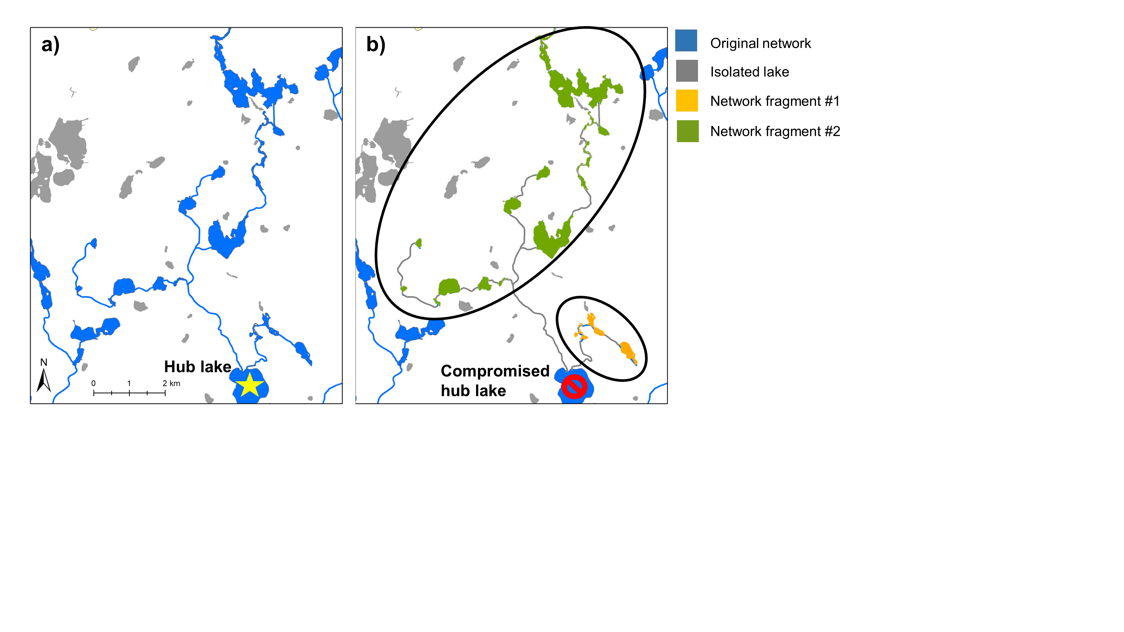

**Figure. 1.** Freshwater connectivity in Michigan, USA based on a) an intact network with an operational hub lake and b) a compromised hub lake, which results in network fragmentation and possible upstream habitat loss for freshwater biodiversity. Upstream streams are grayed out in b to represent loss of stream habitat. Isolated lakes are not accessible through networks.

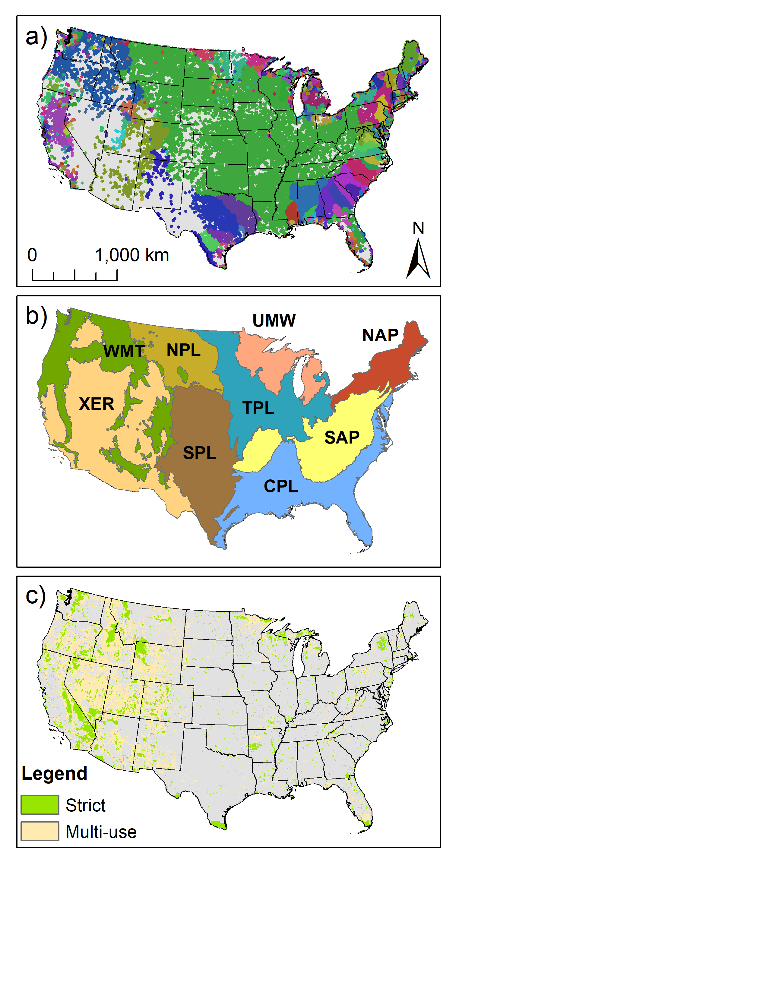

**Figure. 2.** a) Freshwater networks of the conterminous US based on LAGOS-US-NETWORKS v1.0 (King et al. in review a, b). Contiguous colors represent individual networks (the largest of which is the Mississippi River basin in green in the central US). Shown are 898 unique networks containing a total of 86511 lakes ≥ 1 ha. b) Ecoregions used by the US Environmental Protection Agency National Aquatic Resource Survey (Herlihy et al. 2008). CPL=Coastal Plains, NAP=Northern Appalachians, NPL=Northern Plains, SAP=Southern Appalachians, SPL=Southern Plains, TPL=Temperate Plains, UMW=Upper Midwest, XER=Xeric. c) Strict (managed for biodiversity; GAPS 1-2) and multi-use (managed for biodiversity and natural resource extraction; GAP 3) protected areas based on the US Protected Areas Database v1.4 (US Geological Survey 2016).

**Figure. 3.**

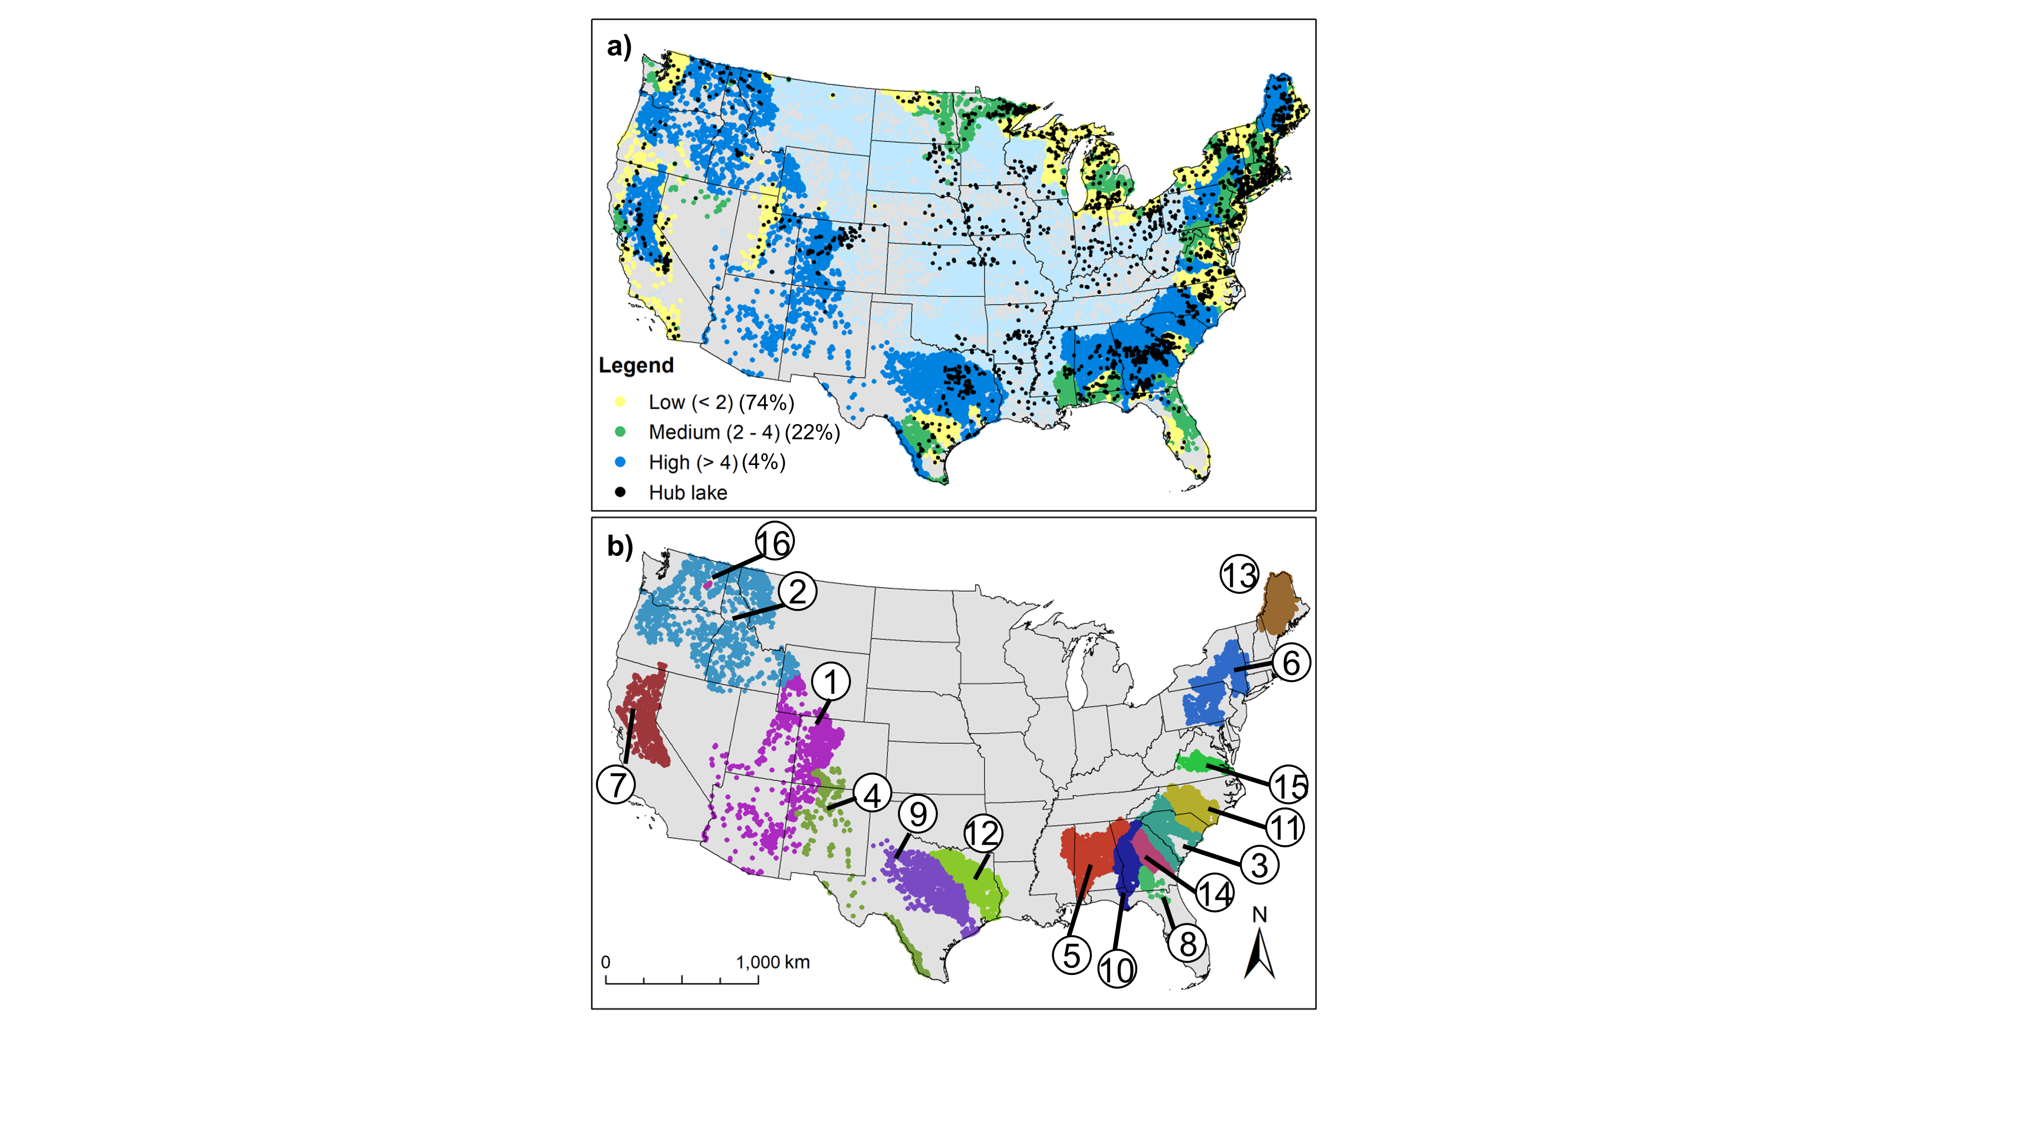

**Figure. 4.** a) Freshwater network connectivity scores (for networks > 4 lakes) and hub lakes (n = 2080). The Mississippi River network (unscored) is shown in light blue dots. b) Highest-ranking freshwater network connectivity scores. Unique mapped colors represent individual, contiguous networks with high connectivity scores (n = 16), which are ranked by connectivity score (1 = highest).

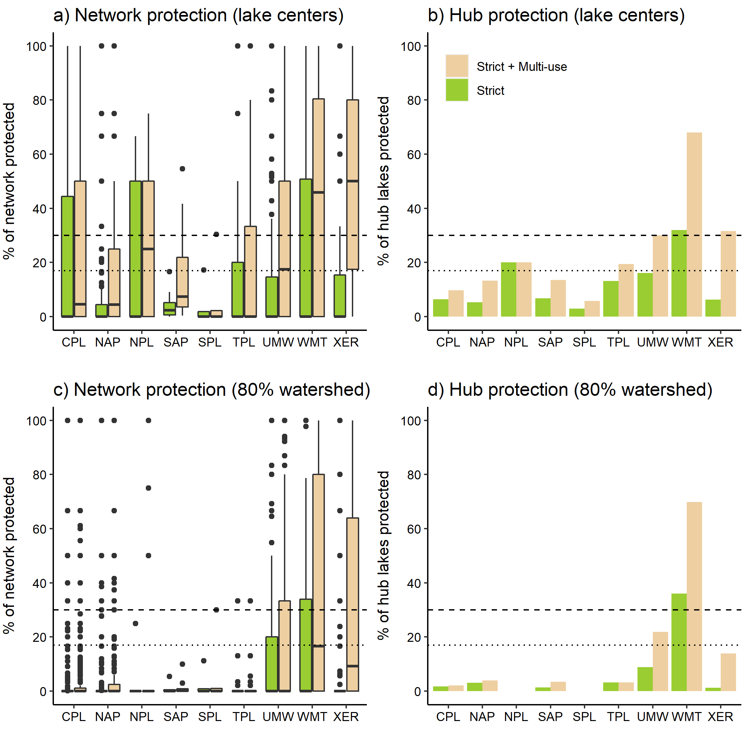

**Figure. 5.** Percent of freshwater networks (lakes within networks) and hub lakes protected by NARS ecoregion and different levels of protection. The Mississippi River network (considered separately) has 7.6% and 15.1% of its lakes protected, respectively, under strict and strict + multi-use lake center protection (a), and 4.3% and 13.8% of its lakes protected, respectively, under strict and strict + multi-use 80% watershed protection, respectively (c). Mississippi River network hubs are reflected in b and d. Dotted lines represent 17% Aichi conservation target and dashed lines represent the 30% by 2030 conservation target. See Table S1 for number of networks and hub lakes per ecoregion. CPL=Coastal Plains, NAP=Northern Appalachians, NPL=Northern Plains, SAP=Southern Appalachians, SPL=Southern Plains, TPL=Temperate Plains, UMW=Upper Midwest, XER=Xeric.