Srinivas Ventrapragada

Srinivas.ventrapragada@mavenir.com

Assignment

Deploying Voter app

Table of Contents

1. Introduction: 2

Deploying the apps: 2

Pods running: 2

Browser view: 3

2. Assignment observations: 4

1st ► VOTE pod ► Observe what happens both in frontEnd & in Unix 4

Front end Observations: 4

Unix/Terminal: 4

2nd ► WORKER pod ► Observe what happens both in frontEnd & in Unix 5

Front end Observations: 5

Unix /terminal : 5

3rd ► DB pod ► Observe what happens both in frontEnd & in Unix 5

Front end: 5

Unix: 5

Making result app to work: 6

Unix/Terminal logs: 6

Front end observation: 6

Figure 1 Pods creation 2

Figure 2 Pods running 3

Figure 3 Deleting Voting pod and checking status 5

Figure 4 Deleting worked pod and status 5

Figure 5 Deleting db pod and status 6

Figure 6 Restarting Results app 6

Image 1 Initial UI of Voting app 3

Image 2 Initial UI of Results app 4

Image 3 Result app before it is recreated 7

Image 4 Result app after pod is recreated 7

Image 5 User Voted newly and result app showing correctly 7

# Introduction:

The purpose is to run the following microservices that allow users to vote either ‘cat’ or ‘dog’ using Voting-app, and one can see the results of voting in result-app.

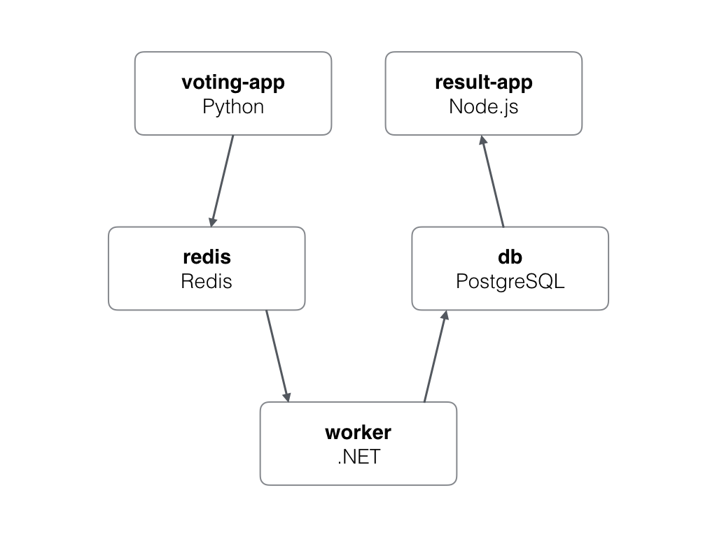

## Deploying the apps:

Pods created:

[root@ip-172-31-10-214 k8s-specifications]# kubectl apply -f .

deployment.apps/db created

service/db created

deployment.apps/redis created

service/redis created

deployment.apps/result created

service/result created

deployment.apps/vote created

service/vote created

deployment.apps/worker created

Figure 1 Pods creation

## Pods running:

[root@ip-172-31-10-214 k8s-specifications]# kubectl get pods

NAME READY STATUS RESTARTS AGE

db-b54cd94f4-vklsw 1/1 Running 0 80s

redis-868d64d78-5hdfz 1/1 Running 0 80s

result-5d57b59f4b-9p4gr 1/1 Running 0 80s

vote-94849dc97-smz4x 1/1 Running 0 79s

worker-dd46d7584-k9mxn 1/1 Running 0 79s

Figure 2 Pods running

## Browser view:

The apps are accessible in browser:

|  |  |
| --- | --- |
| Voting app | http://13.215.224.96:31002 |
| Result app | http://13.215.224.96:31003 |

Table 1 Accessing Voting & Result app from Browser

Image 1 Initial UI of Voting app

Image 2 Initial UI of Results app

# Assignment observations:

## 1st ► VOTE pod ► Observe what happens both in frontEnd & in Unix

### Front end Observations:

* No impact to the frontend or voting application even when pod is deleted.
* Another Voter pod got started or replaced the old one.
* Both Vote app and Result app are running properly.

### Unix/Terminal:

* After deleting the pod, the pod got recreated and replaced the old pod.

*[root@ip-172-31-10-214 k8s-specifications]# kubectl get pods*

*NAME READY STATUS RESTARTS AGE*

*db-b54cd94f4-vklsw 1/1 Running 0 46m*

*redis-868d64d78-5hdfz 1/1 Running 0 46m*

*result-5d57b59f4b-9p4gr 1/1 Running 0 46m*

*vote-****94849dc97-smz4x*** *1/1 Running 0 46m*

*worker-dd46d7584-k9mxn 1/1 Running 0 46m*

***[root@ip-172-31-10-214 k8s-specifications]# kubectl delete pod vote-94849dc97-smz4x***

*pod “vote-94849dc97-smz4x” deleted*

*^[[O[root@ip-172-31-10-214 k8s-specifications]# kubectl get pods*

*NAME READY STATUS RESTARTS AGE*

*db-b54cd94f4-vklsw 1/1 Running 0 49m*

*redis-868d64d78-5hdfz 1/1 Running 0 49m*

*result-5d57b59f4b-9p4gr 1/1 Running 0 49m*

*vote-****94849dc97-56vlw*** *1/1 Running 0 84s*

*worker-dd46d7584-k9mxn 1/1 Running 0 49m*

*[root@ip-172-31-10-214 k8s-specifications]#*

Figure 3 Deleting Voting pod and checking status

## 2nd ► WORKER pod ► Observe what happens both in frontEnd & in Unix

### Front end Observations:

* No impact to the frontend user.
* Both Vote app and Result app are running properly.

### Backend

* No impact, the pod again got recreated due to replica set in the deployment file.
* The logs pertaining to old worker instance were lost.

### Unix /terminal:

* The worker got recreated and all pods are running, please refer the below information.

[root@ip-172-31-10-214 k8s-specifications]# kubectl delete pod worker-dd46d7584-k9mxn

pod "worker-dd46d7584-k9mxn" deleted

[root@ip-172-31-10-214 k8s-specifications]# kubectl get pods

NAME READY STATUS RESTARTS AGE

db-b54cd94f4-vklsw 1/1 Running 0 56m

redis-868d64d78-5hdfz 1/1 Running 0 56m

result-5d57b59f4b-9p4gr 1/1 Running 0 56m

vote-94849dc97-56vlw 1/1 Running 0 8m45s

worker-dd46d7584-kxzdf 1/1 Running 0 81s

Figure 4 Deleting worked pod and status

## 3rd ► DB pod ► Observe what happens both in frontEnd & in Unix

### Front end:

Result app is not showing any votes posted using the voting app. Please refer image 4 & 5. You will see the there is no change in result app even when there is change in the voter app.

### Unix:

Db pod got recreated after getting deleted. Please refer the below logs.

*[root@ip-172-31-10-214 k8s-specifications]# kubectl delete pod db-b54cd94f4-vklsw*

*pod "****db-b54cd94f4-vklsw****" deleted*

*[root@ip-172-31-10-214 k8s-specifications]# kubectl get pods*

*NAME READY STATUS RESTARTS AGE*

***db-b54cd94f4-bzmh6***  *1/1 Running 0 89s*

*redis-868d64d78-5hdfz 1/1 Running 0 120m*

*result-5d57b59f4b-9p4gr 1/1 Running 0 120m*

*vote-94849dc97-56vlw 1/1 Running 0 72m*

*worker-dd46d7584-kxzdf 1/1 Running 1 64m*

Figure 5 Deleting db pod and status

## Making result app to work:

To recover the result app, delete the result app, it gets restarted due to replica set and gets connected to the DB again,

### Unix/Terminal logs:

*[root@ip-172-31-10-214 k8s-specifications]# kubectl delete pod result-5d57b59f4b-9p4gr*

*pod "****result-5d57b59f4b-9p4gr****" deleted*

*[O[root@ip-172-31-10-214 k8s-specifications]# kubectl get pods*

*NAME READY STATUS RESTARTS AGE*

*db-b54cd94f4-bzmh6 1/1 Running 0 8m51s*

*redis-868d64d78-5hdfz 1/1 Running 0 127m*

***result-5d57b59f4b-n2cv2*** *1/1 Running 0 61s*

*vote-94849dc97-56vlw 1/1 Running 0 79m*

*worker-dd46d7584-kxzdf 1/1 Running 1 72m*

*[root@ip-172-31-10-214 k8s-specifications]#*

Figure 6 Restarting Results app

### Front end observation:

* On restart the result app start from 1 again, All the previous votes are lost. Please refer image3, image 4.
* After that, the result app works and shows the newly cast votes. Please refer image 5.

Image 3 Result app before it is recreated

Image 4 Result app after pod is recreated

Image 5 User Voted newly and result app showing correctly