AIG DevOps PlayBook

This document provides the guidance to operate the DevOps pipeline built for Retirement Day-In and Day out by roles

PSO reference

# Table of Contents

Table of Contents 2

Introduction 5

DevOps high level process flow * 5

Solution View 5

User Access Set-up 5

Git Notification Set-up 5

What tasks do I need to for my role 5

Developer 5

Database Code 5

Setup 5

Create Local Copy 5

Work on a new element 7

Checkout Feature Branch 7

Develop 7

Make Changes 7

Fetch upstream updates 8

Commit/Push 8

Build 9

Request Merge 10

.NET code 11

Setup 11

Create Local Copy 11

Work on a new element 12

Synchronize Feature Branch 12

Develop 12

Make Changes 12

Fetch upstream updates 13

Commit/Push 14

Request Merge 15

Tester – N/A 15

Tech Lead 15

Database Code 15

Create Feature Branch 15

Create Release Branch 16

Process Pull requests to Release 17

Create Pull Request in INT 18

Remove Release branch 18

Remove Feature Branch 18

.NET Code 18

Create Feature Branch 18

Create Release Branch 19

Process Pull requests 20

Build 21

Create Pull Request in INT 22

Remove Feature Branch 22

CM/RM 22

Branch Set-up 22

Jenkins Set-up for branch 23

Database Code 23

Process Pull requests to QA 23

.NET Code 23

Process Pull requests to INT 23

DBA 23

Database code 23

Process Pull requests to INT 23

Create Pull Request in QA 23

Conflict Resolutions 24

Administrative 24

GITHUB 24

Tech Contact 24

Admin Contact 24

Jenkins 24

Tech Contact 24

Admin Contact 24

JIRA 24

Tech Contact 24

Admin Contact 24

XLR 24

Tech Contact 24

Admin Contact 24

XLD 24

Tech Contact 24

Admin Contact 24

FAQ 24

# Introduction

# DevOps high level process flow *

Provide a sequence or process flow diagram going from JIRA to XLD and XLR

# Solution View

Must cover JIRA, TFS, GIT, Artifactory, XLD and XLR

# User Access Set-up

* Roles and Responsibilities
* Access controls, permissions and grants

# Git Notification Set-up

# What tasks do I need to for my role

## Developer

### Database Code

This section provides step-by-step instruction for a developer to perform their actions working with git repositories

#### Setup

* Please ensure that you have access to “github.aig.net”
* Also ensure that you have the GIT desktop downloaded and installed on your local machine
* Supply the Enterprise login ID and password along with the necessary information to GIT desktop so that it can establish the necessary connections for further work

##### Create Local Copy

Git UI Steps:

A local copy is created by the process of “cloning” the remote repository from the branch that was created by the tech lead

Command:

**Git UI Steps**

1. If you have a previous local copy (clone) for which work has already been completed, please delete the local copy using Windows Explorer of Mac Finder
   1. **WARNING:** If you have not completed the previous work and start cloning then you will lose the changes that were made to the local copy from the previous time
2. Go to <https://github.aig.net/consumer-retirement/gr-valicpsoall>
3. Click on the “download” icon on the RIGHT of the frame as shown below

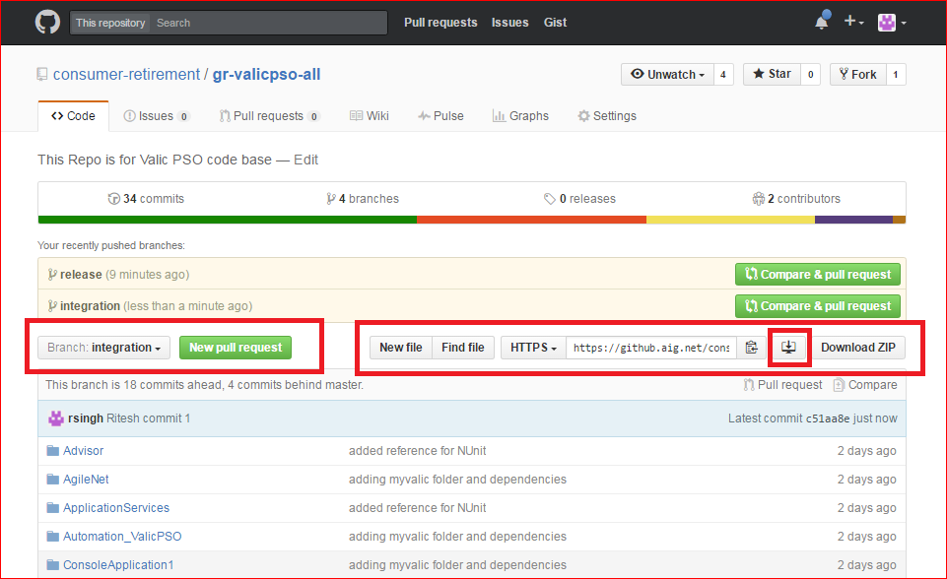

1. Upon download the GIT desktop should automatically open up to show the cloning progress

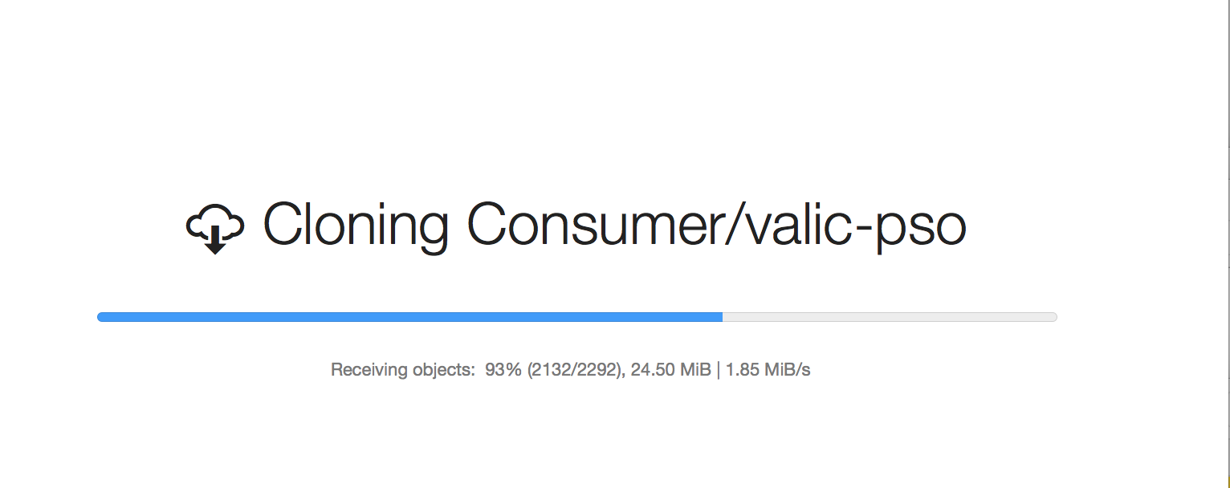

#### Work on a new element

##### Checkout Feature Branch

Git UI Steps

1. The “Synch” action helps synchronize your work with the remote repository
2. “Synch” is a two-way action whereby it would fetch changes in remote repository to your local repository and also helps to push your changes to remote repository
   1. This is the equivalent of “git fetch” and “git push” commands

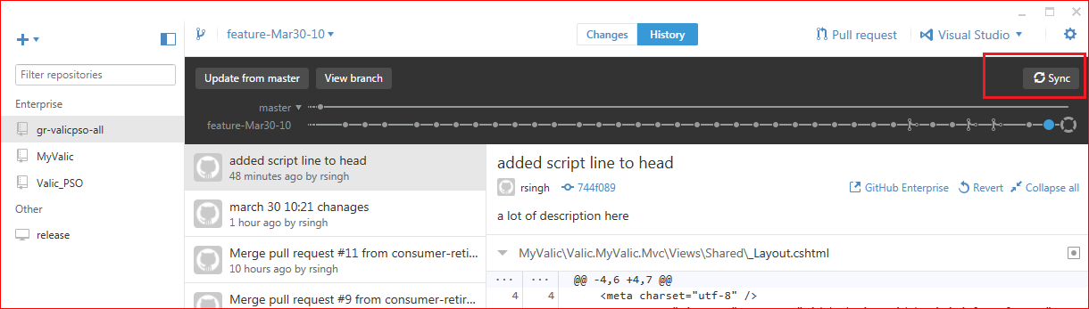

##### Develop

###### Make Changes

Git UI Steps

1. Choose the branch on your local repository in which you want to work on

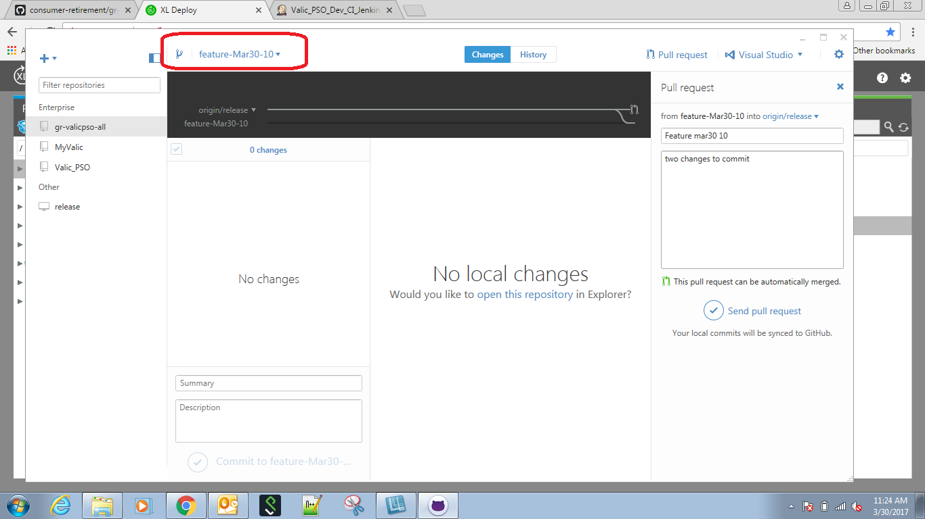

1. Open the local repository in either Windows Explorer or Mac Finder

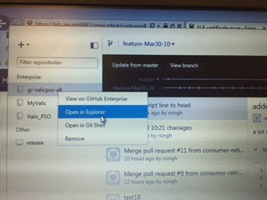

1. Complete the development activities using the tools that are needed and preferred and save your changes as usual

###### Fetch upstream updates

Git UI Steps:

1. At this point you want to make sure that you are able to merge your development/changes along with changes that done by other developers who may have been working on the same code as yours. The “Synch” action helps synchronize your work with the remote repository



1. Merge all changes as required and proceed to next step

###### Commit/Push

Git UI Steps

1. Commit your changes

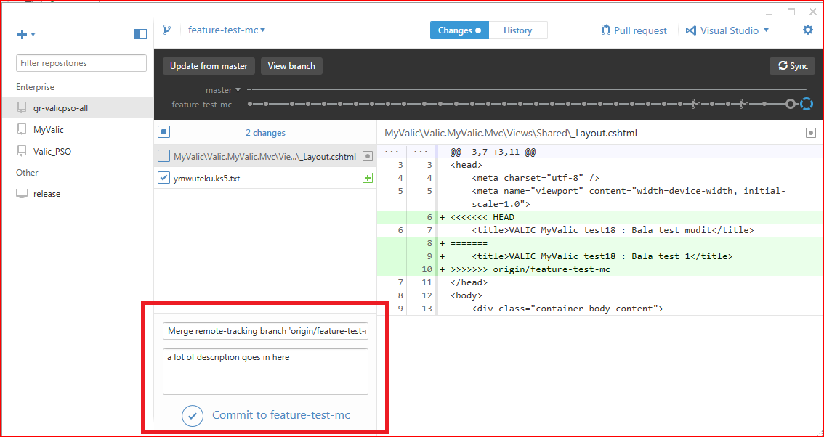

1. Push changes to remote repository



###### Build

Git UI Steps

1. Commit your changes



1. Push changes to remote repository

##### Request Merge

Git UI Steps

1. Upon completing committing and pushing your work, create a “Pull Request” to inform the Tech Lead to “pull” the changes that you have done into the Release branch

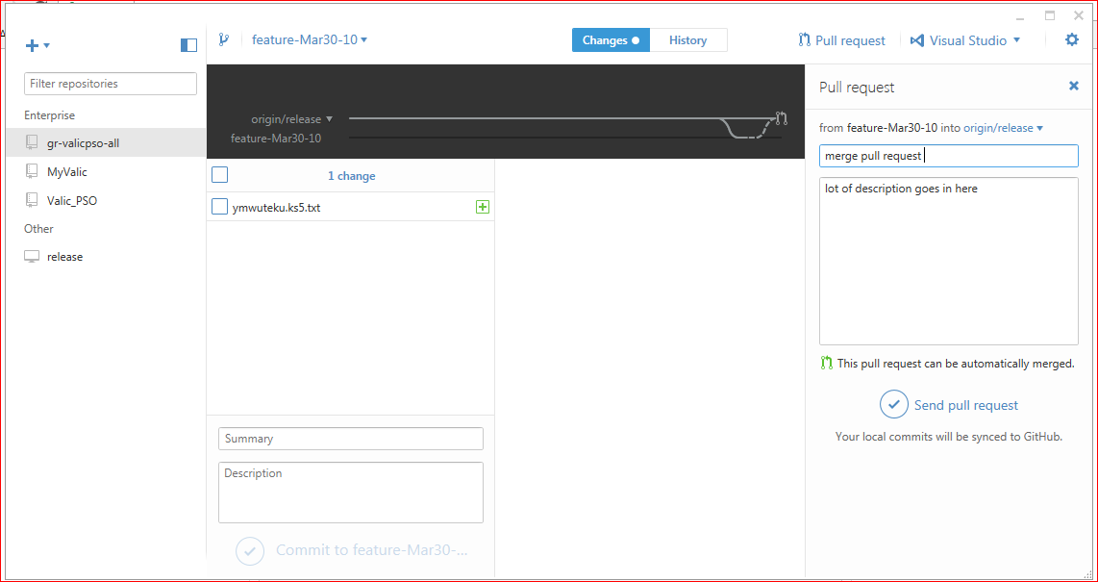

### .NET code

This section provides step-by-step instruction for a developer to perform their actions working with git repositories

#### Setup

* Please ensure that you have access to “github.aig.net”
* Also ensure that you have the GIT desktop downloaded and installed on your local machine
* Supply the Enterprise login ID and password along with the necessary information to GIT desktop so that it can establish the necessary connections for further work

##### Create Local Copy

A local copy is created by the process of “cloning” the remote repository from the branch that was created by the tech lead

**Git UI Steps**

1. If you have a previous local copy (clone) for which work has already been completed, please delete the local copy using Windows Explorer of Mac Finder
   1. **WARNING:** If you have not completed the previous work and start cloning then you will lose the changes that were made to the local copy from the previous time
2. Go to <https://github.aig.net/consumer-retirement/gr-valicpsoall>
3. Click on the “download” icon on the RIGHT of the frame as shown below



1. Upon download the GIT desktop should automatically open up to show the cloning progress



#### Work on a new element

##### Synchronize Feature Branch

Command:

Git UI Steps

1. The “Synch” action helps synchronize your work with the remote repository
2. “Synch” is a two-way action whereby it would fetch changes in remote repository to your local repository and also helps to push your changes to remote repository
   1. This is the equivalent of “git fetch” and “git push” commands



##### Develop

###### Make Changes

Git UI Steps

1. Choose the branch on your local repository in which you want to work on



1. Open the local repository in either Windows Explorer or Mac Finder



1. Complete the development activities using the tools that are needed and preferred and save your changes as usual

###### Fetch upstream updates

Git UI Steps

1. At this point you want to make sure that you are able to merge your development/changes along with changes that done by other developers who may have been working on the same code as yours. The “Synch” action helps synchronize your work with the remote repository



1. Merge all changes as required and proceed to next step

###### Commit/Push

Git UI Steps

1. Commit your changes



1. Push changes to remote repository



##### Request Merge

Git UI Steps

1. Upon completing committing and pushing your work, create a “Pull Request” to inform the Tech Lead to “pull” the changes that you have done into the Release branch



## Tester – N/A

## Tech Lead

### Database Code

#### Create Feature Branch

Git UI Steps

1. Ensure that you are on the correct branch (“release”) from which you want to create the “feature” branch
2. Name the “feature” branch you want to create
3. Click on “Create <feature branch name> from release” message that shows up
   1. **WARNING:** Hitting “Enter” key after typing name does not seem to work in multiple instances

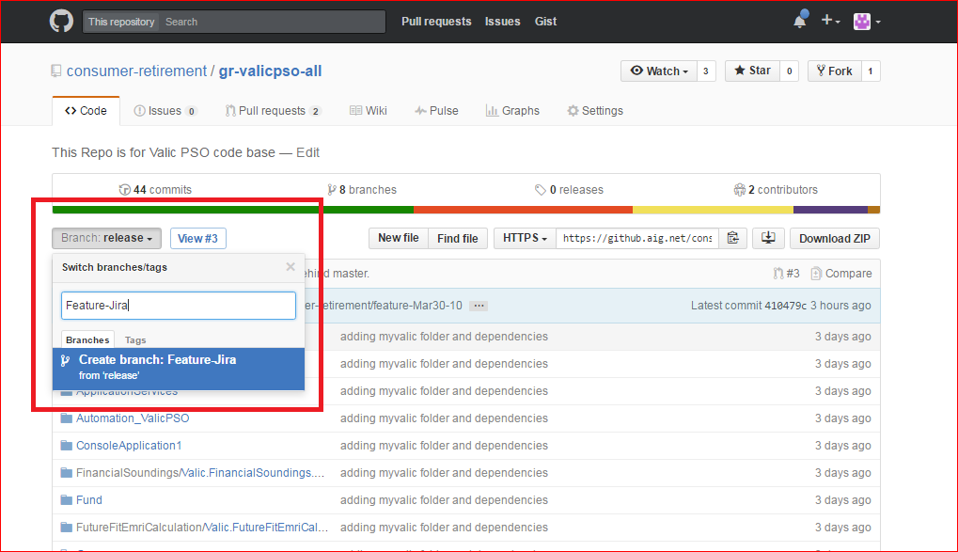

#### Create Release Branch

Git UI Steps

1. Ensure that you are on the correct branch (“integration”) from which you want to create the “release” branch
2. Name the “release” branch you want to create
3. Click on “Create <release branch name> from integration” message that shows up
   1. **WARNING:** Hitting “Enter” key after typing name does not seem to work in multiple instances

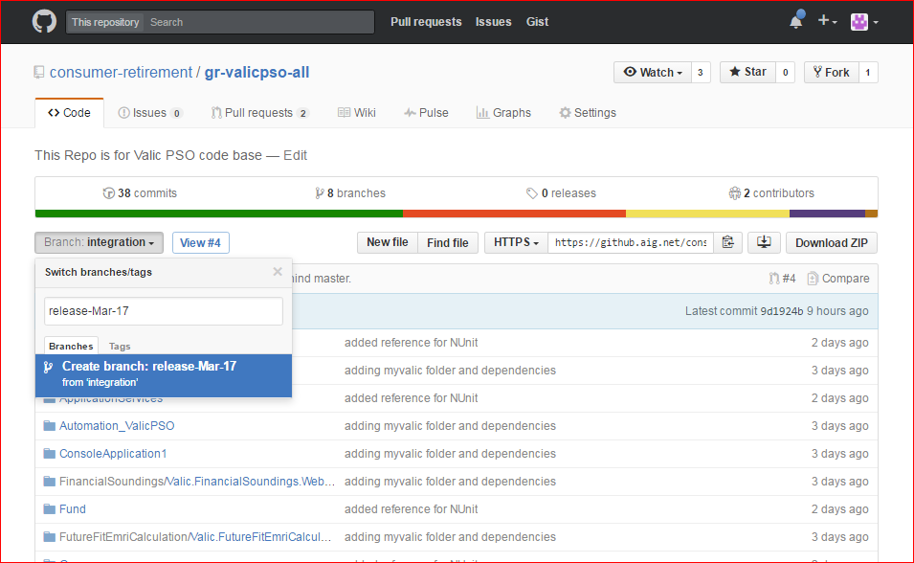

#### Process Pull requests to Release

Git UI Steps

1. Go to <https://github.aig.net/consumer-retirement/gr-valicpsoall>
2. Click on the “Pull requests” tab on top

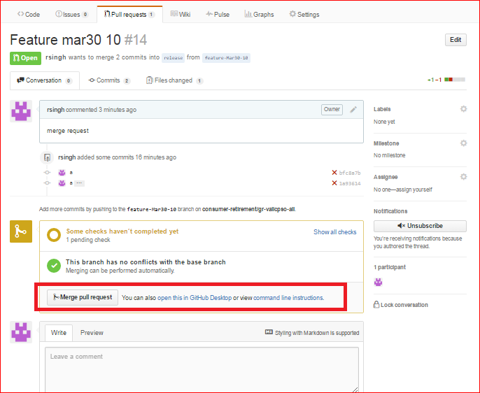

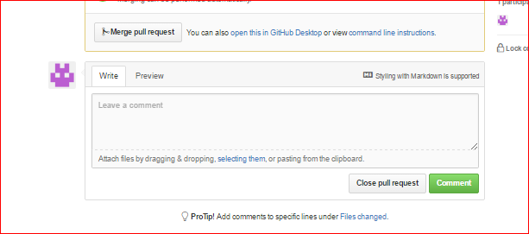

#### Create Pull Request in INT

Git UI Steps

#### Remove Release branch

Command:

Git UI Steps

#### Remove Feature Branch

Command:

Git UI Steps

### .NET Code

#### Create Feature Branch

Tech Leads are required to have created the “Feature Branch” from which the developers would start cloning their local copies for development

Command:

Git UI Steps

1. Ensure that you are on the correct branch (“release”) from which you want to create the “feature” branch
2. Name the “feature” branch you want to create
3. Click on “Create <feature branch name> from release” message that shows up
   1. **WARNING:** Hitting “Enter” key after typing name does not seem to work in multiple instances



#### Create Release Branch

Command:

Git UI Steps

1. Ensure that you are on the correct branch (“integration”) from which you want to create the “release” branch
2. Name the “release” branch you want to create
3. Click on “Create <feature branch name> from integration” message that shows up
   1. **WARNING:** Hitting “Enter” key after typing name does not seem to work in multiple instances



#### Process Pull requests

Command:

Git UI Steps

1. Go to <https://github.aig.net/consumer-retirement/gr-valicpsoall>
2. View pull requests and process them

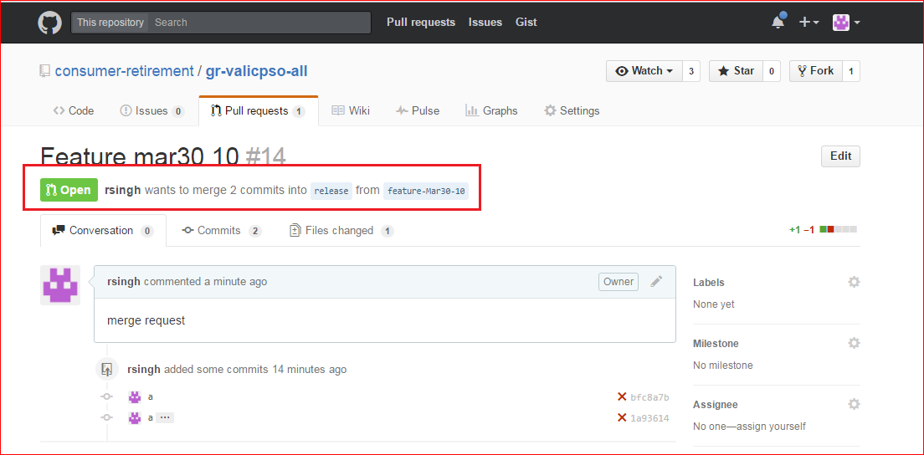



###### Build

Build is configured to be kicked-off automatically upon processing pull request and code is merged.

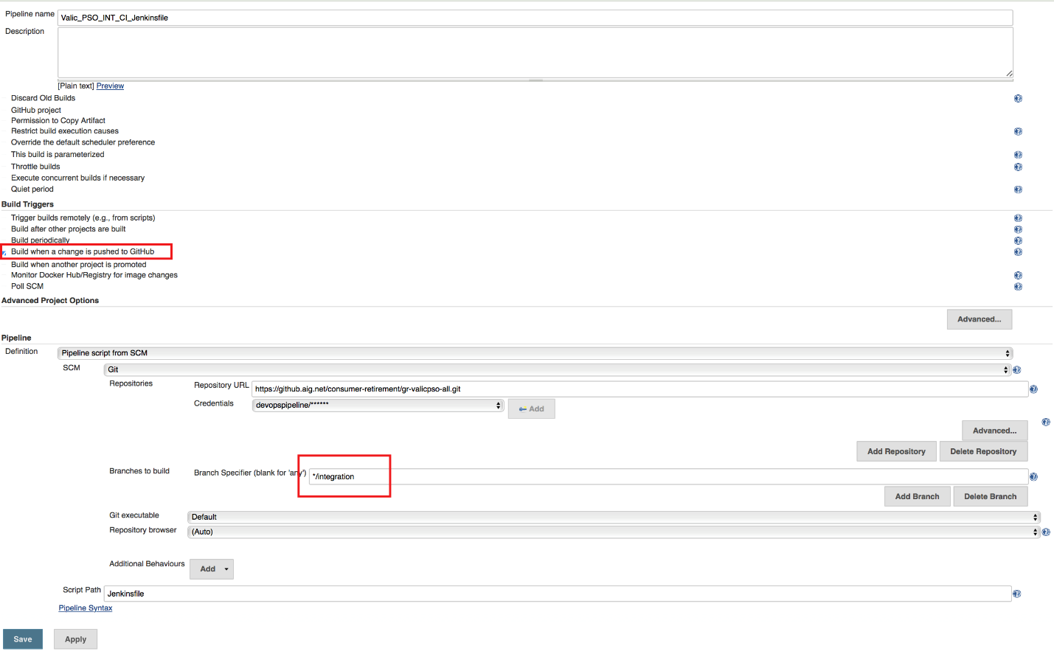

#### Create Pull Request in INT

Command:

Git UI Steps

#### Remove Feature Branch

Command:

Git UI Steps

## CM/RM

### Branch Set-up

Naming Conventions

Git

Git-TFS

Branch level properties

#### Jenkins Set-up for branch

Create Jenkinsfile

### Database Code

#### Process Pull requests to QA

Command:

Git UI Steps

### .NET Code

#### Process Pull requests to INT

Command:

Git UI Steps

## DBA

### Database code

#### Process Pull requests to INT

Command:

Git UI Steps

#### Create Pull Request in QA

Command:

Git UI Steps

# Conflict Resolutions

## Administrative

### GITHUB

#### Tech Contact

#### Admin Contact

### Jenkins

#### Tech Contact

#### Admin Contact

### JIRA

#### Tech Contact

#### Admin Contact

### XLR

#### Tech Contact

#### Admin Contact

### XLD

#### Tech Contact

#### Admin Contact

## FAQ

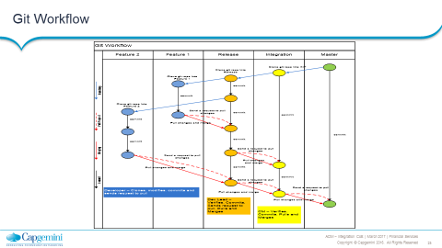

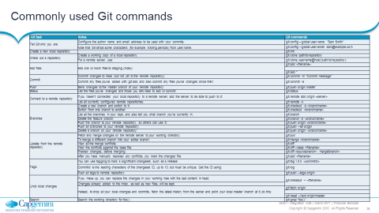

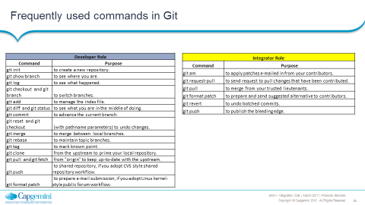Reference

