To check how git is storing commit

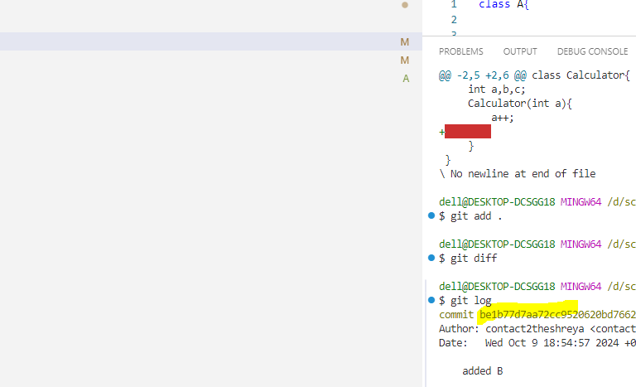  
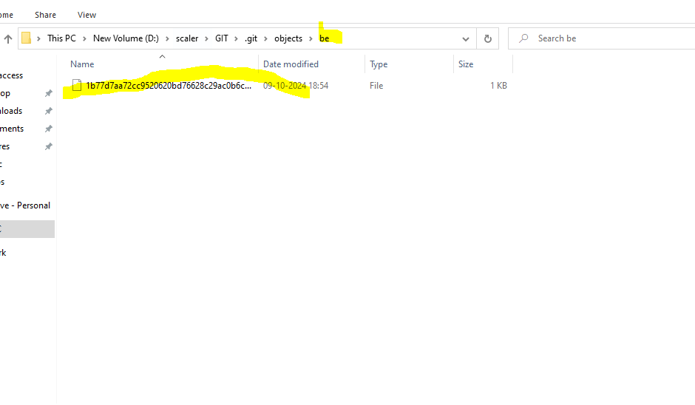

Or type .patch in url

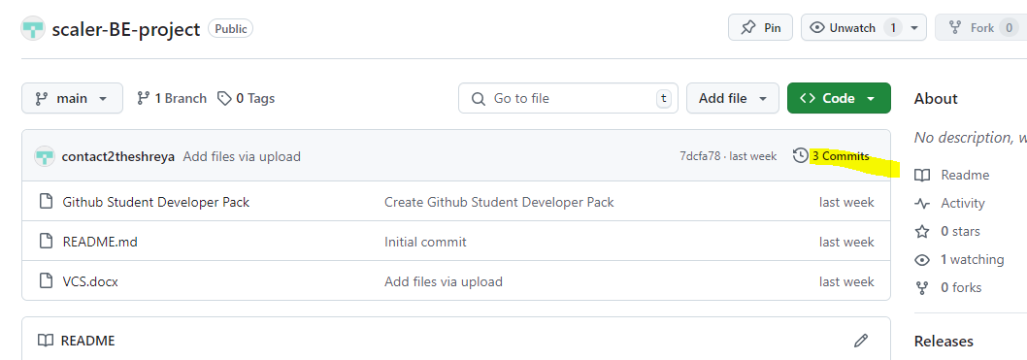

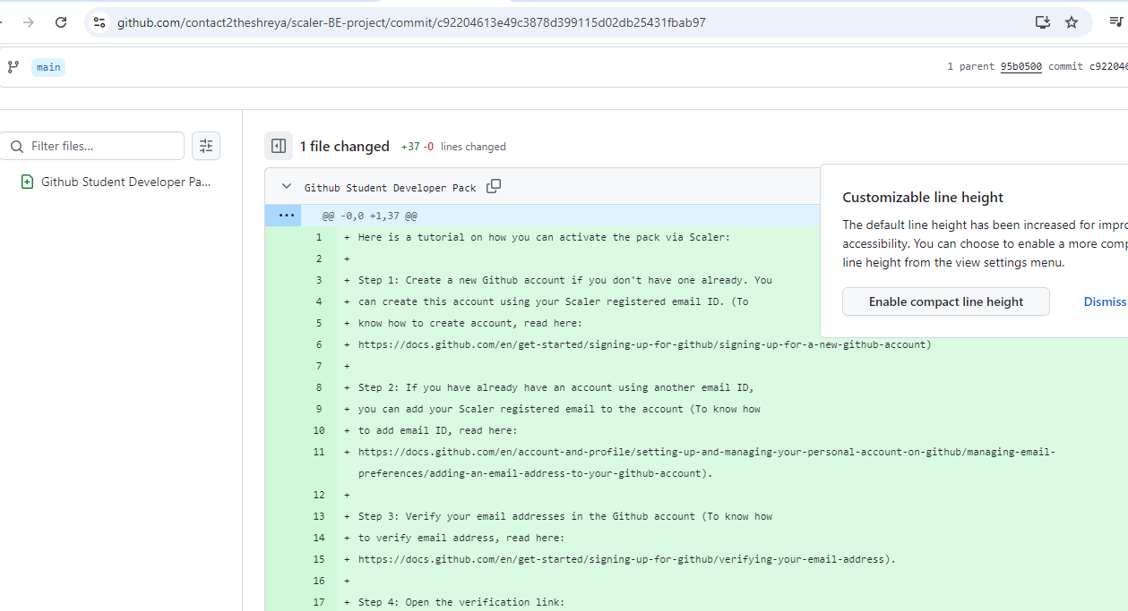

Add .patch in above URL

<https://github.com/contact2theshreya/scaler-BE-project/commit/c92204613e49c3878d399115d02db25431fbab97.patch>

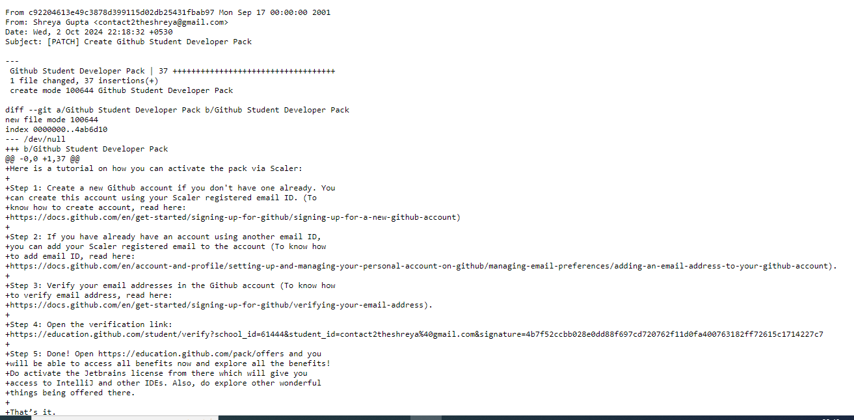

So this is how git is storing delta