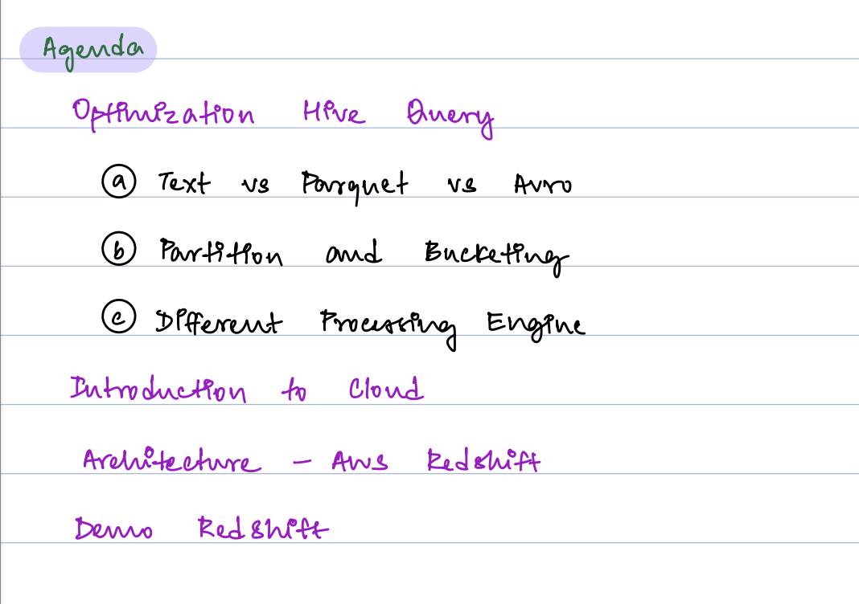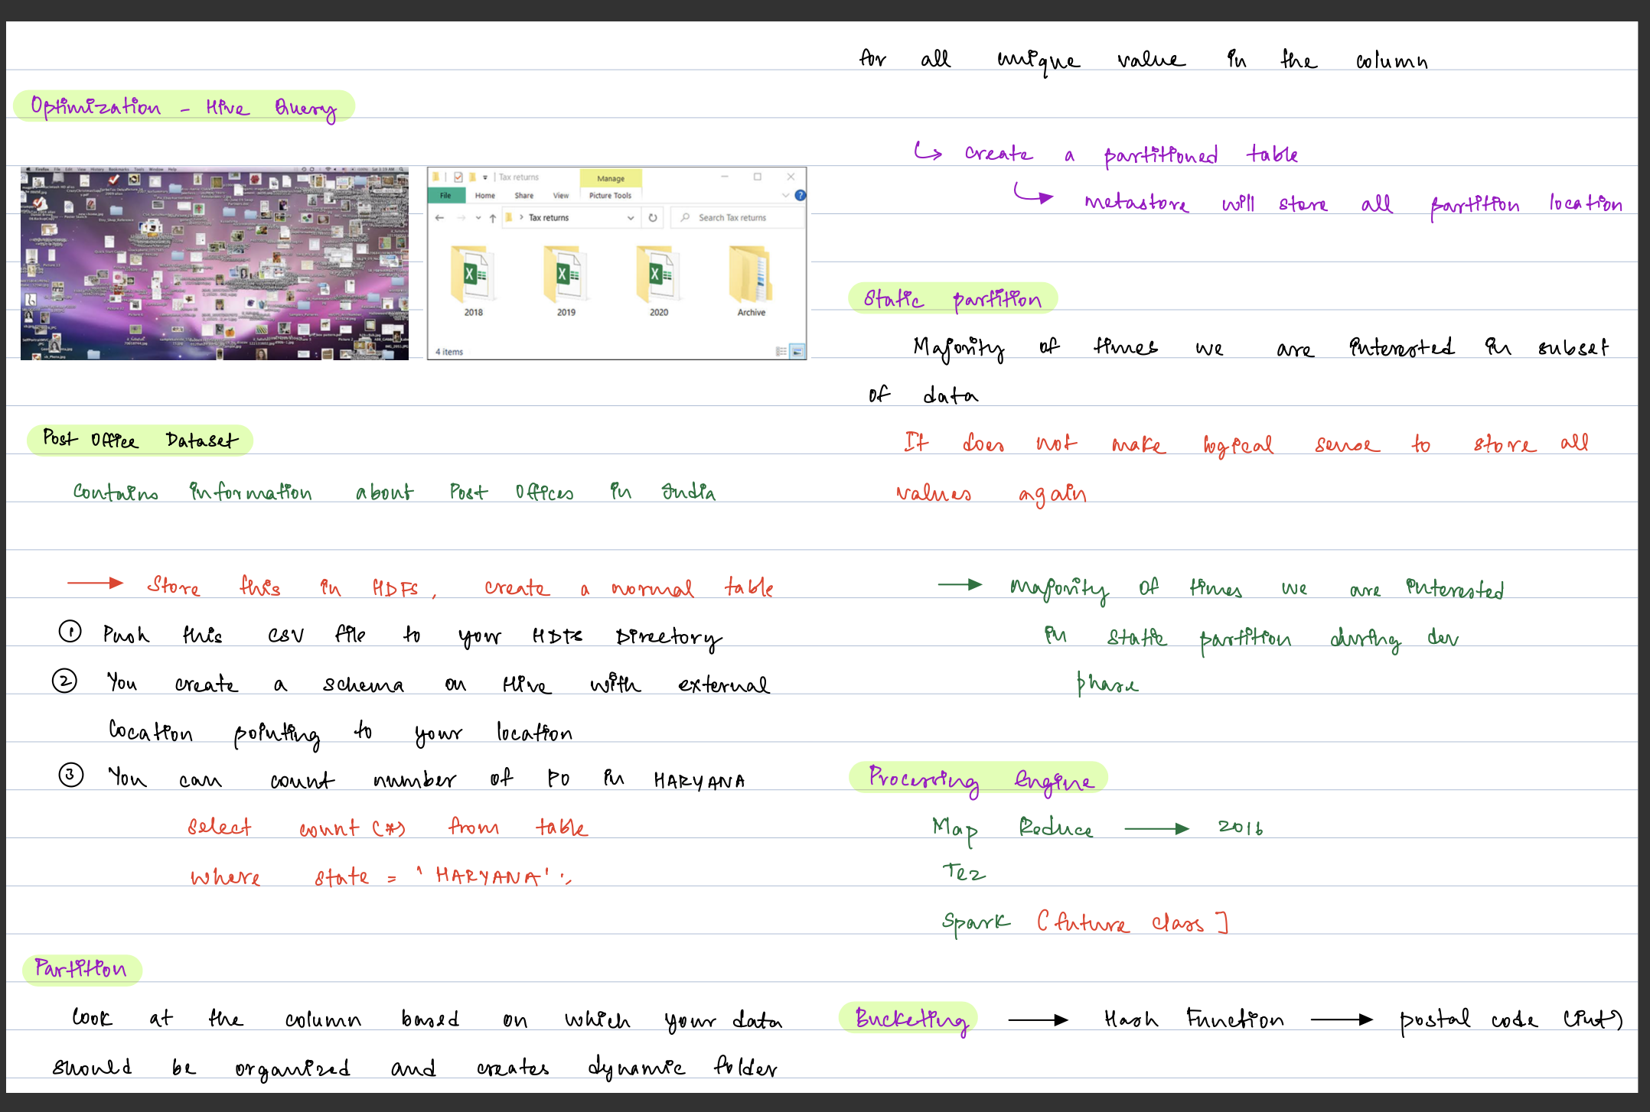
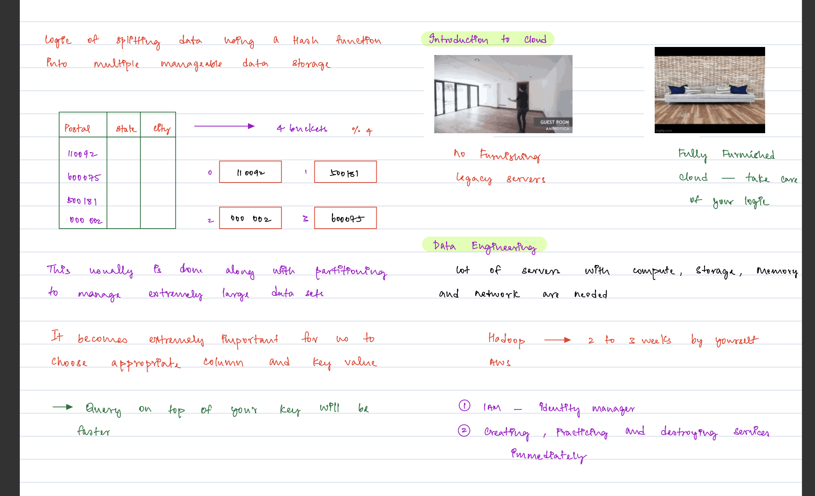
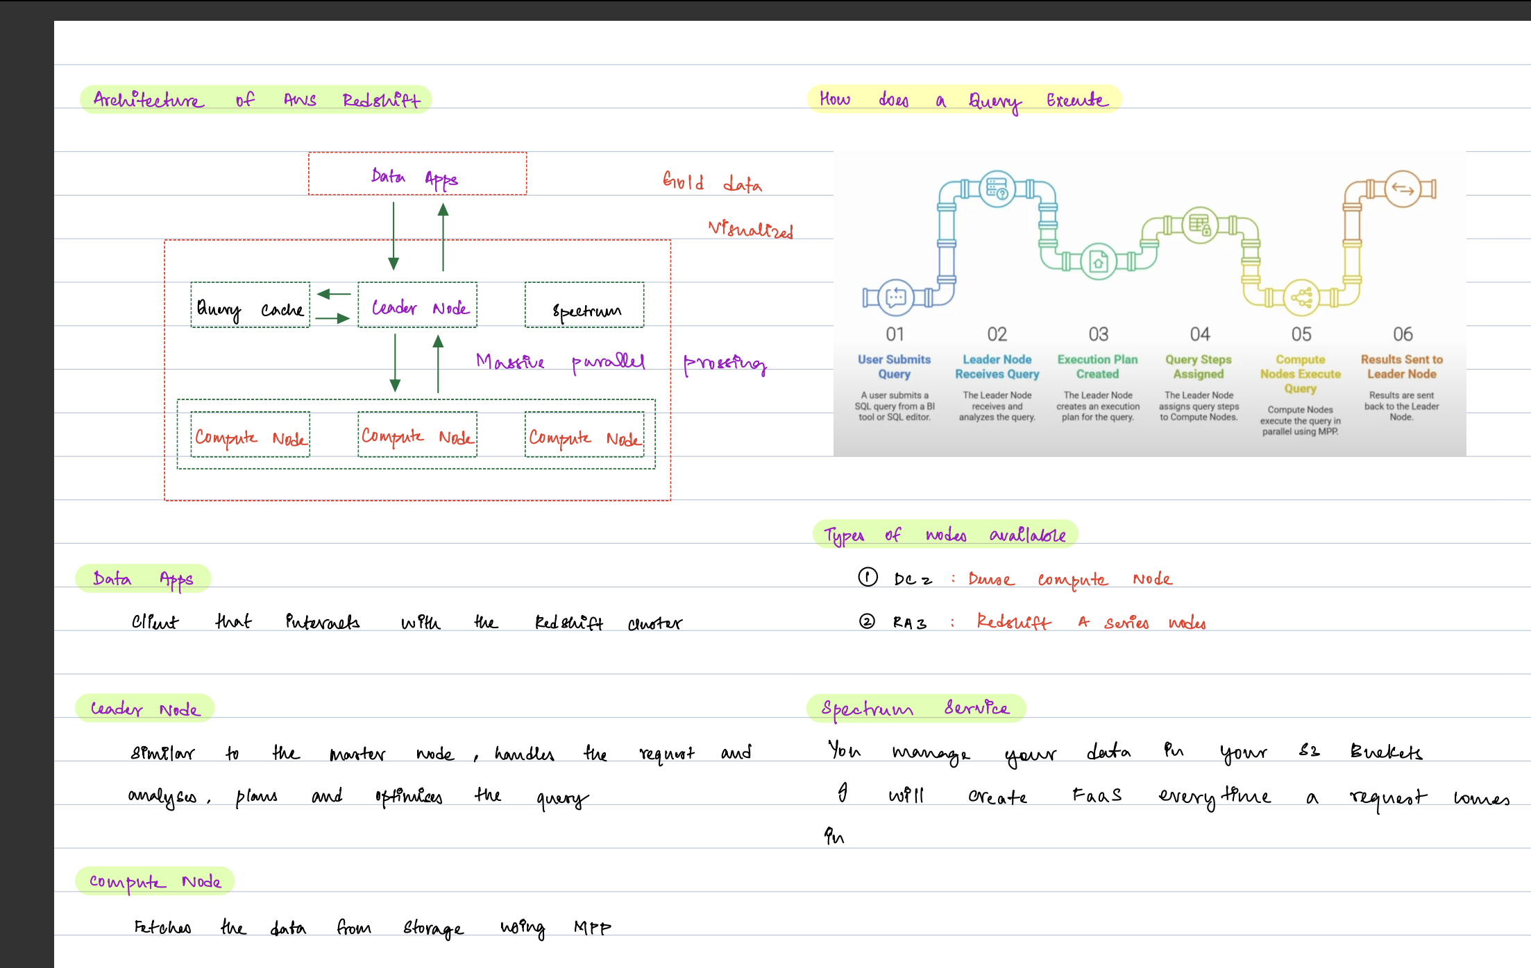
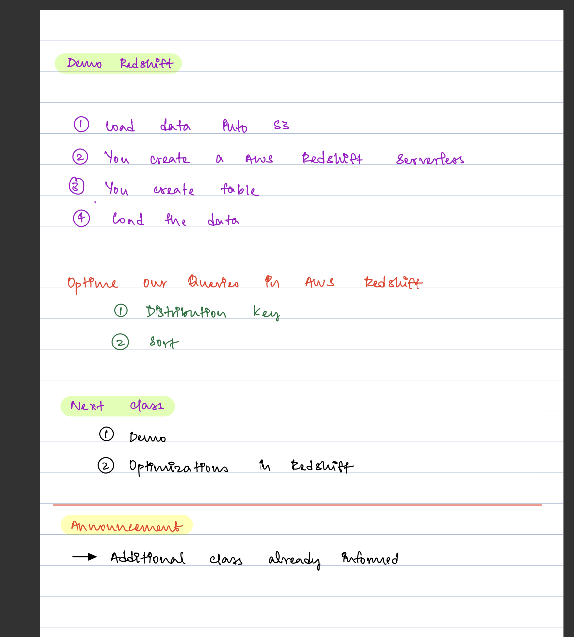
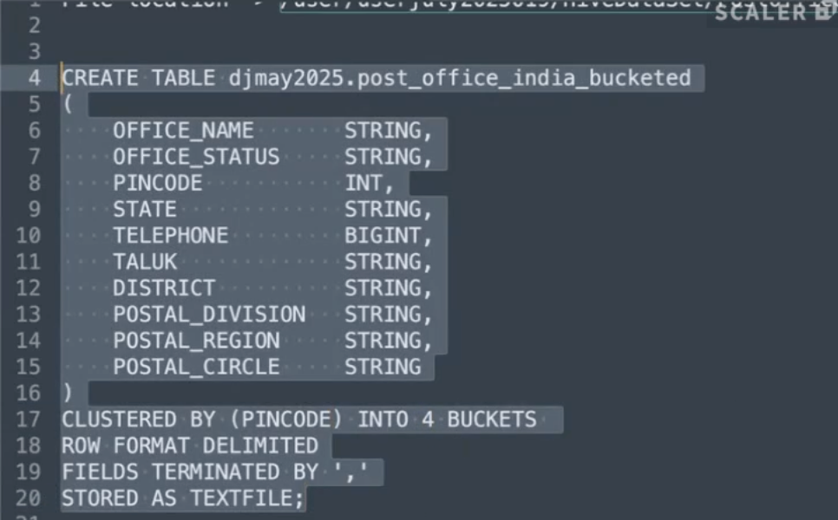
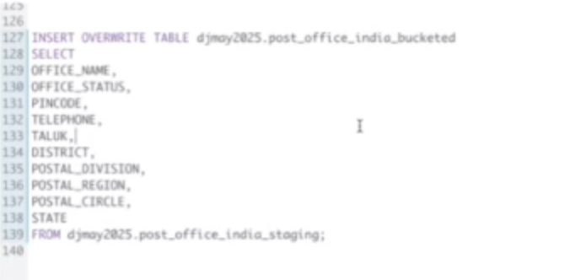
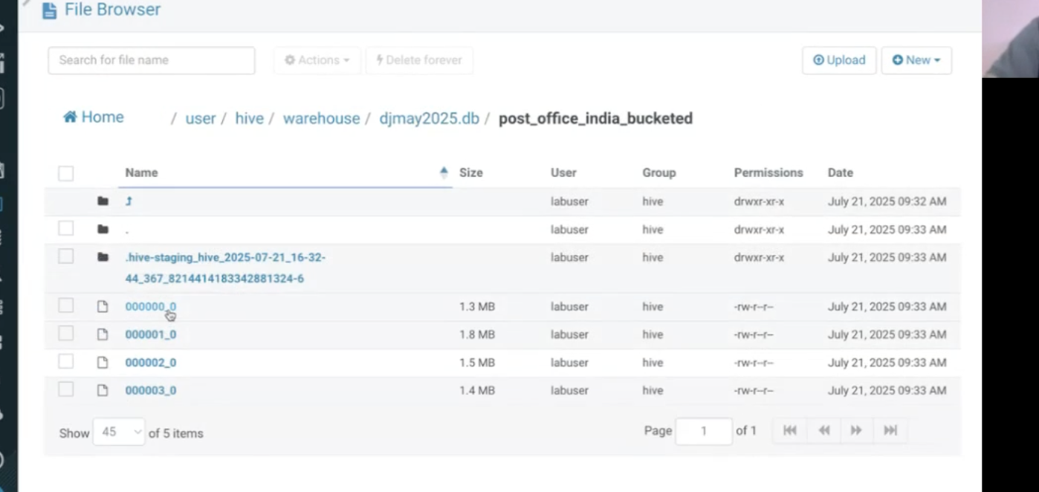
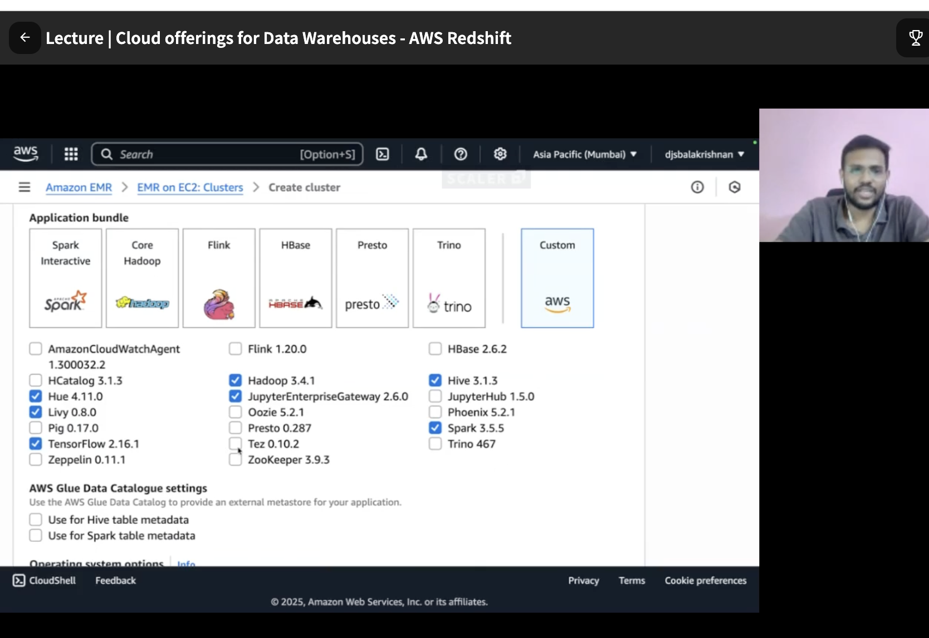
IN REDSHIFT u only worry about writing sql and yarn ,Hadoop etc will be managed by redshift
U write sql in datat apps
Witgh spectrum ,leader node will go to spectrum instead of cumpute node to save cost
In the context of AWS Redshift, a DAG (Directed Acyclic Graph) is not a feature inherent to Redshift itself. Instead, DAGs are used in conjunction with Redshift, typically through orchestration tools like Apache Airflow, especially when using Amazon Managed Workflows for Apache Airflow (MWAA).
Here's a breakdown:
- Directed Acyclic Graph (DAG) Definition:
  - A DAG is a mathematical structure consisting of nodes (representing tasks or operations) and directed edges (representing dependencies or the flow of execution) where there are no cycles (meaning you can't start at a node and follow the edges to return to the same node).
  - In data engineering, DAGs are used to define and manage complex data pipelines or workflows, illustrating the sequence and dependencies of various tasks.
- DAGs in Apache Airflow (and MWAA):
  - Apache Airflow is an open-source platform used to programmatically author, schedule, and monitor workflows.
  - In Airflow, a DAG represents a complete workflow or data pipeline, with each node in the DAG corresponding to a specific task (e.g., extracting data, transforming it, loading it into a database).
  - Amazon MWAA is a managed service that makes it easier to run Apache Airflow on AWS, handling the infrastructure management.
- Using DAGs with AWS Redshift:
  - When you're building data pipelines that interact with Amazon Redshift (e.g., loading data into Redshift, running transformations within Redshift, or extracting data from Redshift), you would define these operations as tasks within an Apache Airflow DAG.
  - Airflow provides operators, such as the RedshiftSQLOperator, that allow you to execute SQL commands directly on your Redshift cluster as part of your DAG's tasks.
  - You can also use other operators to interact with Redshift, such as those for S3 (to stage data before loading into Redshift) or other data sources.
In essence, while Redshift is the data warehouse where your data resides and is processed, DAGs (defined and managed in tools like Apache Airflow/MWAA) provide the framework for orchestrating the entire data pipeline that involves interacting with Redshift.

LEADER NODE
Acts as the master, handling requests, analyzing and optimizing queries in AWS Redshift.

COMPUTE NODES
Stores actual data and processes plans from the leader node in AWS Redshift.

QUERY CACHES
Caches results of queries for quicker response in AWS Redshift using LRU principle.
Massive Parallel Processing (MPP)
Redshift's method for fast data processing using proprietary, Spark-like technology.

AWS Spectrum
Service that manages data in S3, reducing dependency on compute nodes.

STAIC PARTITION
Creates subsections of data to store only relevant records for efficient querying.

PARTITIONING
Organizes data in unique folders based on specified columns for efficient data retrieval.

BUCKETING
Divides data into buckets through hash functions for large dataset management.

Partitioned Table
A table splitting data into partitions for better query performance.

IAM - Identity Access Management
AWS service for managing access to AWS services.

FaaS - Function as a Service
AWS Spectrum's approach to handling functions dynamically on data requests.

The ability to horizontally scale compute resources so it’ll take less time to execute large amounts of data.
Explaination: Redshift’s ability to horizontally scale compute resources allows it to process large amounts of data quickly
and efficiently. By adding more compute nodes to the cluster, the processing power of the cluster can be increased as needed.
This feature is particularly useful for companies that have large and complex data processing needs.

Correct Answer: The use of sort keys to optimizing query execution
Explaination: Sort keys are a Redshift feature that help optimize query performance by physically sorting data
within each node according to the sort key. This allows Redshift to skip over irrelevant data when executing a
query and improve query performance. By choosing an appropriate sort key for the data being analyzed, the analyst
can significantly improve query performance.

Correct Answer: EVEN Distribution, which distributes data evenly across nodes then the queries can be executed in parallel
with minimal data movement, resulting in faster query execution times.
Explaination: By distributing data evenly across nodes, queries can be executed in parallel with minimal data movement,
resulting in faster query execution times for retrieving a small subset of rows.

