META ADS PERFORMANCE AUDIT
Ecocare Home Comfort
Read-only diagnostic audit · Prepared by PPC Guru · 22 July 2026

Ad account | ecocare — 1806978566910515
Business portfolio | Ecocare homecomfort
Currency / time zone | CAD · America/Los_Angeles (Pacific)
Conversion destination | Meta Instant Forms (on-platform)
Objective | More qualified leads at a lower cost per lead
Current period | 22 Jun – 21 Jul 2026 (30 complete days)
Previous period | 23 May – 21 Jun 2026 (30 complete days)
7-day pulse | 15–21 Jul vs 8–14 Jul 2026
Account status | ACTIVE · queryable · no delivery-blocking errors

Headline verdict
Mixed but fundamentally healthy. Leads are up +5.5% (565 → 596) on +16.7% more spend; CPL is up +10.7% to CA$29.97 — driven almost entirely by a +33.9% rise in CPM (media cost), not a broken funnel (CTR, click-to-lead and leads-per-impression all improved). The recent 7-day dip reflects deliberate campaign pauses and a new campaign in learning, not a structural collapse. The prior cost-per-lead control did starve delivery — but it has already been removed. Meta's own account Opportunity Score is 53/100.

Account-ID note: the brief's ID 276592374807928 is the PPC Guru business-portfolio ID, not an ad account. The Ecocare ad account is 1806978566910515, confirmed before any data was pulled.

Contents
Right-click and choose “Update Field” to build the table of contents.

Situation Update — Constrained-Budget Action Plan
Added 22 July 2026, in response to new information from the account team. This section takes priority over the general plan below and upgrades the cost-control finding in Sections 5-6 to client-confirmed.
The new constraints (as described by the team):
- A cost-per-lead control was added to the two best campaigns — All In One and Tankless — last week, by mistake, and it 'hit hard.'
- The client cut budget from ~CA$700-800/day to ~CA$500/day.
- The client wants CPL down from ~CA$25 to ~CA$15 without losing lead volume.
- FIFA / World-Cup ads should be removed (event over), but removing them would drop leads and raise CPL.
- The team feels it can't safely change the current campaigns and can't afford new test campaigns.
Bottom line up front
The recent CPL spike was caused by the changes — the CPL cap, the budget cut, and the learning disruption they triggered — not by the market. The fastest way to get CPL back down is to stop fighting the auction and let it recover, replace FIFA IN PLACE rather than pausing it, and pull the levers that cost no budget and don't reset learning. A blended CA$15 CPL is not realistically reachable short-term on this account — but CA$20-24 is, and that is the honest number to give the client while we work toward lower.

A1. What happened last week — confirmed by the data
In the 7 days after the cap went on (15-21 Jul vs 8-14 Jul):
Campaign | Spend | Leads | CPL
All In One | CA$1,843 -> CA$1,130 (-39%) | 83 -> 37 (-55%) | CA$22.20 -> CA$30.53
Tankless | CA$494 -> CA$140 (-72%) | 18 -> 6 (-67%) | CA$27.43 -> CA$23.26

Textbook cost-cap-starvation: a cap set at/near current CPL, on campaigns without enough conversions to feed it, so Meta stops bidding and volume collapses — the same failure that hit the old HVAC campaign. The cap, not the market, is why CPL jumped. First action: confirm All In One and Tankless are back on Highest Volume with NO cost/bid cap (they read 'Highest volume' at the audit pull — verify), then freeze bids and let delivery settle 7-10 days.

A2. The honest truth about a CA$15 CPL
- Best SUSTAINED CPL is ~CA$20-24 (Tankless, EV, All In One on good days).
- CA$15 has only ever occurred on isolated exceptional days (27 May CA$13.38; 30 May CA$11.88) — never as a 30-day blended average.
- CPL is driven by CPM; a smaller CA$500/day budget on fewer conversions tends to raise CPM/CPL, not lower it.
- Chasing CA$15 with a cost cap caps delivery, not cost — a few cheap leads, then nothing.
Realistic target
CA$22-24 CPL at ~CA$500/day (~21-23 leads/day) now; ~CA$18-20 achievable over 30-60 days via creative + tracking work. CA$15 blended is a long-term stretch, not a lever you can pull now — re-derive any target from booked-job value (close rate x job value).

A3. The FIFA problem — replace in place, don't remove
Pausing FIFA cold would tank leads (FIFA-V1: 45 leads @ CA$25.29, CTR 4.02%; FIFA-V2: best hook 45%). Don't choose between stale World-Cup ads and losing leads — twin them:
- Duplicate each winning FIFA ad (V1, V2) inside its existing ad set — no new campaign, no new budget.
- Re-edit only the World-Cup references out; keep the 'stay cool this summer -> home comfort -> free consultation' structure.
- Run the evergreen twin alongside the FIFA original 5-7 days so it proves out.
- Only then pause the FIFA original — leads never drop because the replacement is already live.
- Replace FIFA-V3 outright (Meta flags it low quality) rather than twinning.
This is the one change worth making now: it reduces risk (off-season creative decays) and adding an ad to an out-of-learning ad set is the least disruptive edit.

A4. Five moves that cost no budget and don't reset learning
- Let it settle — patience is the highest-value action; let the two winners recover on Highest Volume for 7-10 days.
- Reconnect the CRM 'Quoted' signal — a back-end/tracking change (zero delivery risk, zero budget) that re-enables quality optimisation and optimising for booked leads.
- Concentrate the CA$500 on the cheapest engine (All In One ~CA$25 / IG Reels ~CA$26) over pricey HVAC-New (CPM ~CA$76).
- Test with creative rotation inside existing ad sets, not new campaigns — that's your budget-neutral test lab.
- Piggy-back the free win: when you open an ad set for a twin, exclude the Instream Video placement (CA$75 CPL sink).

A5. What NOT to do
- Do NOT add any cost cap / bid cap / cost-per-result goal to chase CA$15 — that starved delivery last week.
- Do NOT pause FIFA before its evergreen twin is live.
- Do NOT keep cutting budget while demanding more leads — at CA$500/day you can protect CPL OR volume, not both.
- Do NOT stack multiple edits at once — make the one change (the twins), then wait.

A6. Realistic CPL glide path (~CA$500/day)
Phase | Actions | Expected CPL | Leads/day
Now (week 1) | Remove any residual cap; freeze bids; let settle; reconnect CRM signal | CA$25 -> ~CA$23 | ~20-22
Weeks 2-3 | Launch evergreen FIFA twins; retire originals & FIFA-V3; exclude Instream | ~CA$21-22 | ~22-24
Weeks 4-8 | Fresh water-softener hooks; concentrate on IG Reels; optimise to 'Quoted' once CRM live | ~CA$18-20 | ~24-26
CA$15 target | Only realistic once quality-optimised on a cheaper creative engine; likely needs slightly more budget | stretch | --

If the client still insists on CA$15 now
At ~CA$500/day you can have a low CPL or high volume, not both — and CA$15 blended has never been sustained here. The credible path to cheaper QUALIFIED leads: fix tracking so we optimise for booked jobs, refresh the creative engine, and let the winners run un-capped — over 30-60 days. A cost cap shows a low CPL for a day or two then stops the leads; last week is the proof.

1. Executive Summary
Is the account improving or declining? Neither dramatically — it is holding lead volume while paying more per impression.
- Leads +5.5% (565 → 596) on +16.7% more spend (CA$15,301 → CA$17,863).
- CPL +10.7% (CA$27.08 → CA$29.97). The entire increase is media cost: CPM +33.9%. Funnel metrics improved — CTR +14%, click-to-lead 11.0% → 11.8%, leads/1,000 impressions +21%.
- Why CPM rose: budget shifted from the cheap 'All In One' water-softener campaign (CPM ~CA$17) to the pricier HVAC + Water Heater CBO (CPM ~CA$76); All In One 47% → 40% of spend, HVAC-New 24% → 35%.
- The 7-day dip (81 leads @ CA$33.27 vs 143 @ CA$30.39) reflects pausing WhatsApp & EV Charger (~17 Jul) and the new Ottawa campaign entering learning — not a collapse.
- The cost-per-lead control backfired (delivery starvation) but is already removed; all live campaigns use Highest Volume.
- Over-reliance on one ad: the Water Softener CA$29.99/mo video drove 278 of 596 leads (47%) and is fatiguing.
- Measurement gap: the GoHighLevel CRM pixel last fired Nov-2025 and 0 custom conversions exist, yet 6 of 13 ad sets optimise for QUALITY_LEAD; the two LEAD_GENERATION ad sets have the lowest CPLs (CA$23–25).
Meta's own diagnosis (Opportunity Score 53/100)
Top-ranked fixes: SCALE 'All In One' (est. +52% conversions); FIX ad-set fragmentation in HVAC-New (est. −27% cost/result); INCREASE budget on the budget-limited Tankless campaign. These align with our recommendations.

2. Overall Performance Scorecard
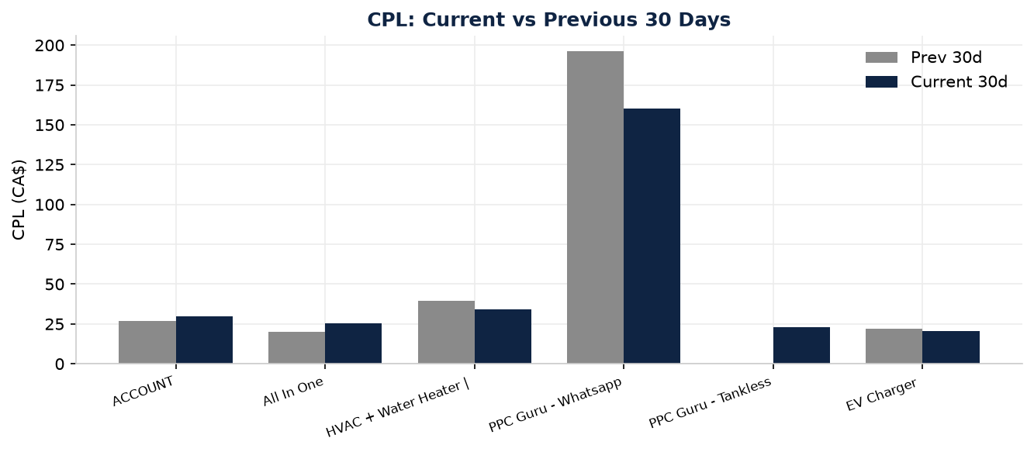
Figure — Cost per lead, current vs previous 30 days (account + top campaigns)
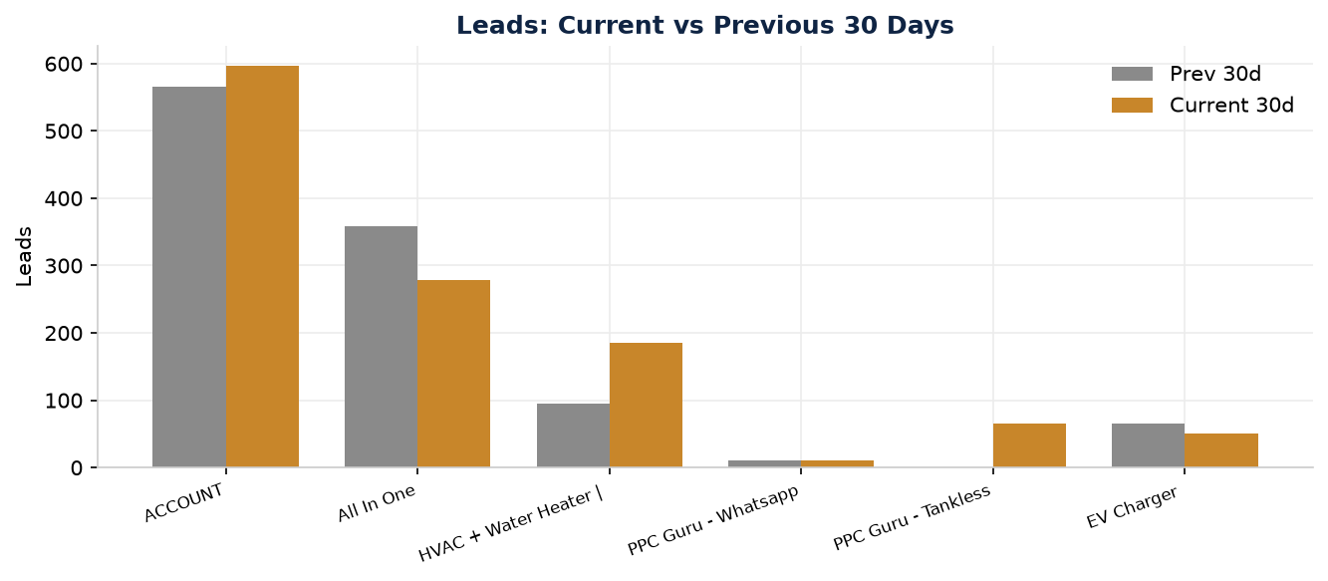
Figure — Leads, current vs previous 30 days
KPI (last 30 days) | Current | Previous | Change | Read
Spend | CA$17,862.89 | CA$15,301.09 | +16.7% | Scaling
Leads (Instant Form) | 596 | 565 | +5.5% | Good
Cost per lead | CA$29.97 | CA$27.08 | +10.7% | Worse
CPM | CA$27.69 | CA$20.68 | +33.9% | Main culprit
Impressions | 645,038 | 739,793 | -12.8% | Fewer, dearer
Reach | 274,677 | 291,442 | -5.8% | ~
Frequency | 2.35 | 2.54 | -7.5% | Healthier
CTR (all) | 1.27% | 1.11% | +14.4% | Good
Link CTR | 0.79% | 0.69% | +14.5% | Good
CPC (all) | CA$2.18 | CA$1.86 | +17.2% | Dearer clicks
Click -> lead rate | 11.8% | 11.0% | +6.4% | Funnel improving
Leads / 1,000 impr | 0.92 | 0.76 | +21.0% | Funnel improving
Video hook rate | 14.3% | 15.7% | -8.9% | Mild fatigue

PPC Guru account score: 61 / 100
A capable, actively-managed account with strong creative and a proven winner — held back by structural fragmentation, an optimisation-goal/tracking mismatch, and over-reliance on a single ad. Category breakdown in Section 12.

3. Current vs Previous 30 Days — CPL Decomposition
CPL = CPM ÷ (leads per 1,000 impressions). Current: 27.69 ÷ 0.924 = CA$29.97. Previous: 20.68 ÷ 0.764 = CA$27.08. This confirms 100% of the CPL increase is the CPM increase; the funnel partially offset it.
What it means / What to do
The rising CPL is a media-efficiency problem, not a funnel problem. The lever is where and to whom budget is delivered — re-weight toward low-CPM engines (All In One ~CA$17 CPM; IG Reels ~CA$18 CPM / CA$26 CPL) and reduce CPM drivers (fragmented HVAC-New ad sets ~CA$76 CPM; 65+ at CA$63 CPM; Feed at CA$48 CPM).

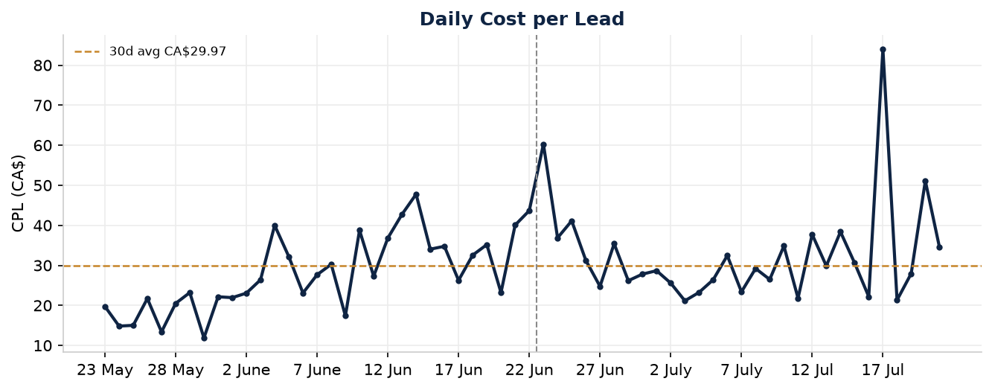
Figure — Daily cost per lead (dashed line = 30-day average CA$29.97)
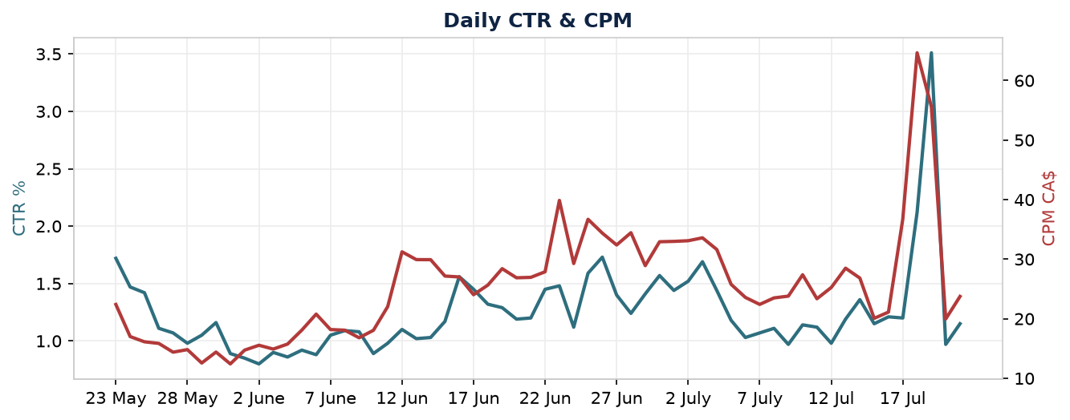
Figure — Daily CTR (rising) vs CPM

4. Recent 7-Day Performance Pulse
KPI | Current 7d | Previous 7d | Change
Spend | CA$2,695.03 | CA$4,346.31 | -38.0%
Leads | 81 | 143 | -43.4%
CPL | CA$33.27 | CA$30.39 | +9.5%
CPM | CA$23.68 | CA$25.42 | -6.8%
CTR | 1.19% | 1.12% | +6.3%
Frequency | 1.31 | 1.54 | -14.9%

Spend and leads fell ~40% in the most recent week, but CPM fell and CTR rose — a volume/delivery dip, not an efficiency collapse. Daily spend cratered to CA$106–252/day on 17–19 July after WhatsApp and EV Charger were paused, and the Ottawa campaign launched 20 July.
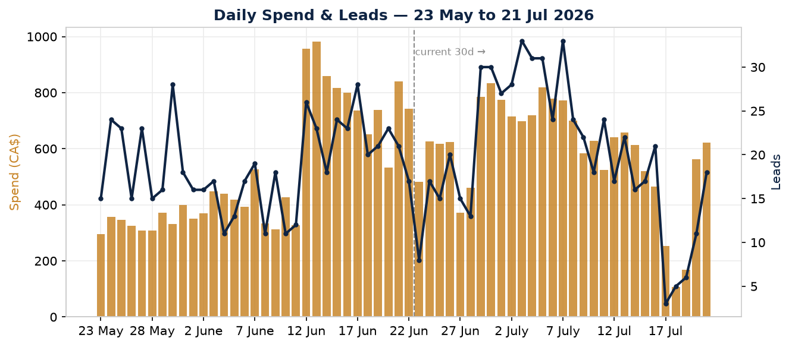
Figure — Daily spend (bars) & leads (line); dashed line marks the start of the current 30-day window

5. What Went Wrong (ranked by impact)
Meta's change-history / activity-log tool is not enabled for this account. Where a change can't be read directly, the timeline is inferred from entity creation/update timestamps (API-confirmed) and daily delivery patterns, and labelled below.
# | Cause | What changed | Before -> after | Impact | Confidence
1 | CPM inflation via budget mix-shift | Budget moved to HVAC-New (CPM ~76) from All In One (CPM ~17) | CPM 20.68 -> 27.69 | = entire CPL rise | Confirmed / High
2 | Over-reliance on one fatiguing ad | Water Softener video = 47% of leads since 8 May | Ad CPL 19.97 -> 25.46 -> 30.53 | Rising CPL on ~half of leads | Confirmed / High
3 | Cost-cap starved delivery (removed) | Old HVAC CBO 'Cost per result goal' | Spent only CA$555 (~half budget) | Lost HVAC volume ~2 wks | Inferred / Med-High
4 | Recent pauses + learning reset | WhatsApp & EV paused ~17 Jul; Ottawa new 20 Jul | Daily spend 700+ -> 106-252 | -62 leads in 7d pulse | Inferred / Med-High
5 | Optimisation-goal / tracking mismatch | 6 ad sets QUALITY_LEAD; CRM signal stale; 0 custom conv | LEAD_GEN 23-25 vs QUALITY 30-40 | Higher CPL on affected sets | Confirmed / Med
6 | Ad-set fragmentation / overlap | 3 near-identical HVAC ad sets; same GTA cities | Meta: -27% cost/result available | Waste + higher frequency | Confirmed / Med-High
7 | Mid-June over-pacing | Daily budget ~doubled 12-14 Jun | CPL spiked to 43-48 | Short-term CPL spike | Inferred / Med

6. Why the Cost-Control Change Backfired
- Affected entity: the original 'EC | HVAC + Water Heater | CBO' campaign used a 'Cost per result goal' — a cost cap near the historical ~CA$30 CPL (a sibling ad was even named 'Bundles | BROAD | tCPA_$30').
- Delivery starved: over the previous 30 days it spent only CA$555 and produced 18 leads (CA$30.85) — roughly half of its CA$100/day budget delivered. Its ad sets used QUALITY_LEAD, an even sparser event, so the auction had far fewer than the ~50 conversions/week a cost cap needs.
- Classic failure mode: a cap set at (not below) current CPL, on a campaign without enough conversion volume, tells Meta to skip most of the auction -> delivery slows and volume collapses.
- Already corrected: the campaign was paused (~3 Jun) and rebuilt as '...CBO - New' on Highest Volume (now CA$6,312 / 185 leads). No active campaign uses a cost cap today.
Conclusion
The cost control did backfire — in the textbook way — but it is no longer active. The current CPL elevation is CPM mix-shift and creative fatigue, not an active cost cap. We do NOT recommend re-introducing a cap now (conditions for a future retest are in Section 14).

7. Campaign-by-Campaign Audit
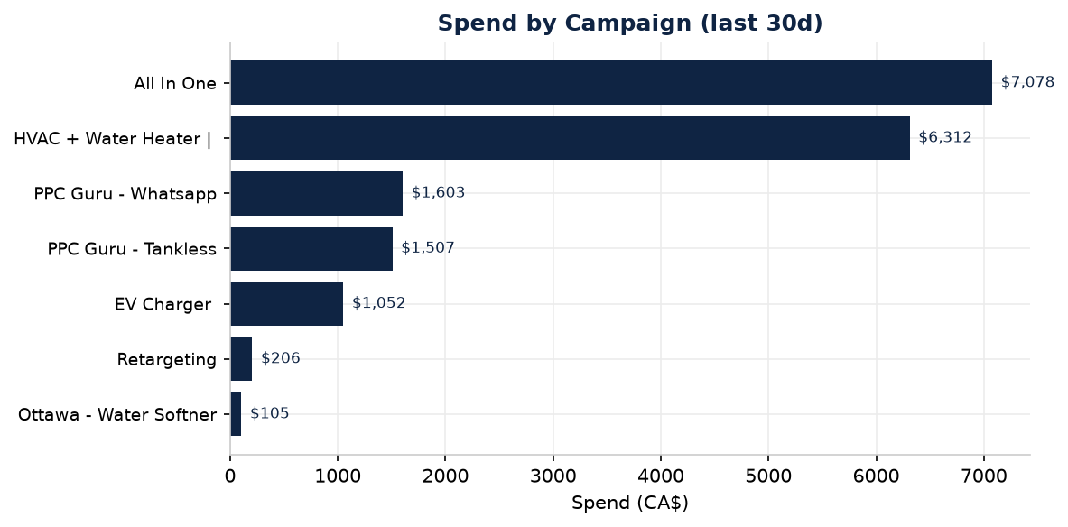
Figure — Spend by campaign (last 30 days)
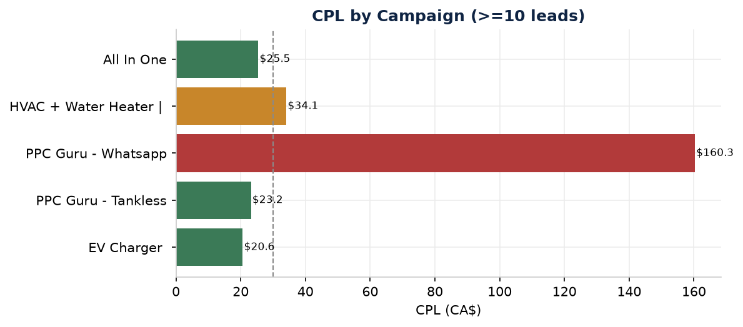
Figure — CPL by campaign (campaigns with 10+ leads; green<CA$30, red>CA$40)
Campaign | Objective | Bid | Status | Spend | Leads | CPL | CPM | P.Spend | P.Leads | P.CPL
All In One | PPC Guru | LEADS | Highest volume | ACTIVE | 7077.55 | 278.0 | 25.46 | 17.09 | 7168.75 | 359.0 | 19.97
EC | HVAC + Water Heater | CBO | LEADS | Highest volume | ACTIVE | 6311.94 | 185.0 | 34.12 | 75.87 | 3743.49 | 95.0 | 39.41
PPC Guru - Whatsapp | LEADS | Not available | PAUSED | 1603.19 | 10.0 | 160.32 | 21.14 | 2155.62 | 11.0 | 195.97
PPC Guru - Tankless | LEADS | Highest volume | ACTIVE | 1507.2 | 65.0 | 23.19 | 43.83 | 0.0 | 0
EC | EV Charger | PPC Guru | LEADS | Highest volume | PAUSED | 1052.02 | 51.0 | 20.63 | 34.67 | 1441.69 | 65.0 | 22.18
EC | Retargeting | PPC Guru | LEADS | Highest volume | ACTIVE | 205.95 | 4.0 | 51.49 | 51.12 | 236.19 | 17.0 | 13.89
Ottawa - Water Softner & Tankl | LEADS | Highest volume | ACTIVE | 105.04 | 3.0 | 35.01 | 34.42 | 0.0 | 0
EC | HVAC + Water Heater | CBO | LEADS | Cost per resul | PAUSED | 0.0 | 0 |  |  | 555.35 | 18.0 | 30.85

Classification — Keep & scale: All In One, Tankless. Keep + optimise: HVAC-New. Investigate: EV Charger. Rebuild: Retargeting. Insufficient data: Ottawa. Keep paused: WhatsApp, old HVAC CBO.

8. Ad-Set Audit (spending ad sets)
Ad set | Campaign | Opt. goal | Spend | Leads | CPL | Freq | Note
Water Treatment | All In One | LEAD_GENERATION | 7,078 | 278 | 25.46 | 1.95 | Workhorse; cheapest CPM
Complete Home Comfort | HVAC-New | QUALITY_LEAD | 2,620 | 89 | 29.44 | 1.95 | CTR 3.73% — consolidation anchor
HVAC (AC+Heat Pump) | HVAC-New | QUALITY_LEAD | 2,890 | 76 | 38.02 | 2.16 | Higher CPL/CPM
Tankless $1/day | Tankless | LEAD_GENERATION | 1,507 | 65 | 23.19 | 1.87 | Efficient
EV Charger Install | EV (paused) | QUALITY_LEAD | 1,052 | 51 | 20.63 | 3.24 | Efficient but over-frequent
Bundles $79.00 | HVAC-New | QUALITY_LEAD | 802 | 20 | 40.12 | 1.70 | Weak conversion
WH Retargeting | Retargeting | QUALITY_LEAD | 107 | 4 | 26.69 | 2.70 | Small pool
HVAC Retargeting | Retargeting | QUALITY_LEAD | 99 | 0 | -- | 2.41 | CA$99, zero leads
WhatsApp ad sets x3 | WhatsApp (paused) | REPLIES | 1,603 | 10 | 68-484 | 2.2-2.5 | Wrong goal

- Optimisation goal predicts CPL: LEAD_GENERATION ad sets are cheapest (CA$23–25); QUALITY_LEAD run CA$30–40; REPLIES are catastrophic (CA$68–484).
- Fragmentation: all prospecting ad sets share the same GTA cities (Vaughan/Ajax/Aurora/Barrie/Brampton/Burlington ~10mi), age 25–65, all genders, Advantage+ Audience ON, same interests — Meta flags the 3 HVAC ad sets for overlap.
- Retargeting pools are tiny (~1,000–1,900; Website Visitors just 20) so it can't scale; one ad set burned CA$99 for zero leads.

9. Ad Audit (highlights)
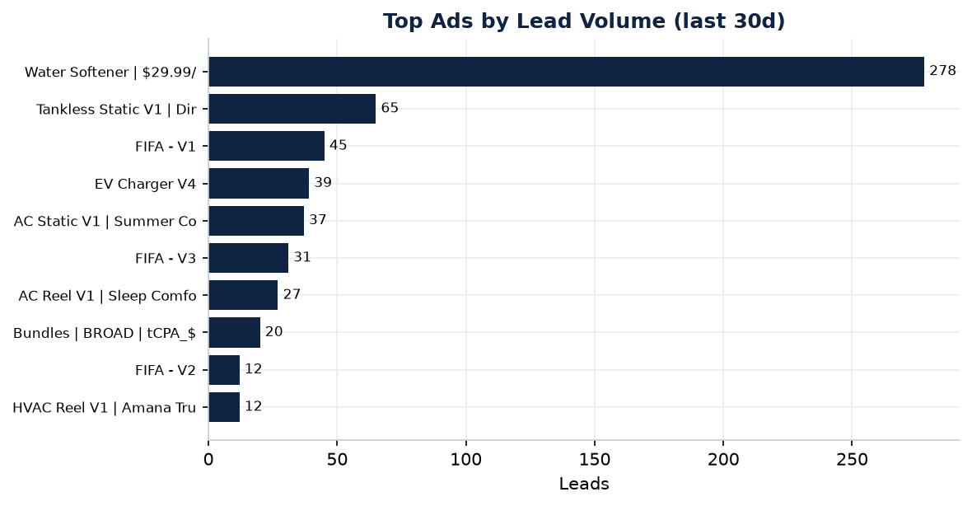
Figure — Top ads by lead volume (last 30 days)
Ad | Type | Spend | Leads | CPL | CTR | Hook | Hold | Verdict
Water Softener CA$29.99/mo | Video | 7,078 | 278 | 25.46 | 1.00% | 17.3% | 21.6% | Current winner (fatiguing)
Tankless Static V1 | Static | 1,507 | 65 | 23.19 | 1.68% | -- | -- | Winner (best static)
FIFA - V1 | Video | 1,138 | 45 | 25.29 | 4.02% | 27.0% | 36.4% | Winner (World-Cup hook)
AC Reel - Sleep Comfort | Video | 727 | 27 | 26.92 | 1.71% | 20.3% | 20.7% | Stable
HVAC Reel - Amana Trust | Video | 332 | 12 | 27.69 | 2.71% | 20.5% | 34.5% | Stable (trust)
FIFA - V2 | Video | 377 | 12 | 31.43 | 4.41% | 45.2% | 25.4% | Strong hook, mid conv
EV Charger V4 | Static | 706 | 39 | 18.10 | 1.44% | -- | -- | Efficient (paused)
FIFA - V3 | Video | 1,016 | 31 | 32.78 | 2.95% | 20.5% | 36.8% | REPLACE - low quality
AC Static - Summer Countdown | Static | 1,831 | 37 | 49.48 | 1.70% | -- | -- | REPLACE - expensive
Bundles - tCPA_$30 | Video | 802 | 20 | 40.12 | 2.78% | 28.7% | 17.3% | Iterate - weak conversion
WhatsApp ads | Static/Video | 1,021 | 3 | 269-484 | ~1% | -- | -- | Dead (paused)

Low-sample caution: several ads have 0–3 leads and are flagged 'insufficient data' — we do not declare winners/losers on 1–3 leads.

10. Creative & Video Audit
Creative is a strength: copy is offer-led and specific, CTAs are consistent ('Get Offer'), and offers match your price points — Water Softener CA$29.99/mo; Bundle from CA$79.99/mo + up to CA$1,000 rebates + 10-yr warranty; AC from CA$39.99/mo; Tankless ~CA$1/day. The Amana 'lifetime warranty' ad carries a real trust signal.
- Creative fatigue (top priority): the single water-softener video carries 47% of leads and is 2.5 months old; refresh the first 3 seconds.
- Offer/seasonal mismatch: 'Spring Bundle' running in mid-summer — update framing.
- Rebate compliance: keep 'up to / eligibility applies' on the CA$1,000 rebate; don't imply everyone qualifies.
- Metadata gaps: several ads render as SHARE with a literal {{product.name}} placeholder — verify the name resolves and rebuild as standard creatives.
- Reverse-osmosis / free-water-test is absent from active creative despite being a listed offer — a whitespace opportunity.
- Video: hooks are healthy (17–45%); the weak link is click-to-lead on a few high-hook videos (Bundles, FIFA-V2) — an offer-clarity gap mid-video.
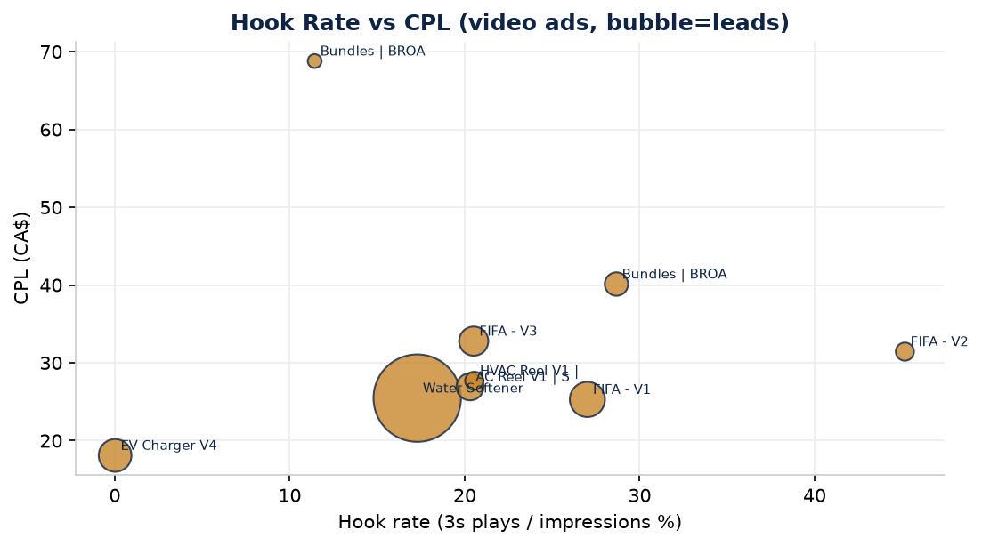
Figure — Hook rate vs CPL for video ads (bubble size = leads)
Meta auction-quality read
Water Softener workhorse: Average / Average / Average — 'you are all good'. FIFA-V3: Below Average (bottom 35%) — 'perceived as low quality' -> replace.

11. Audience, Geography, Placement & Device
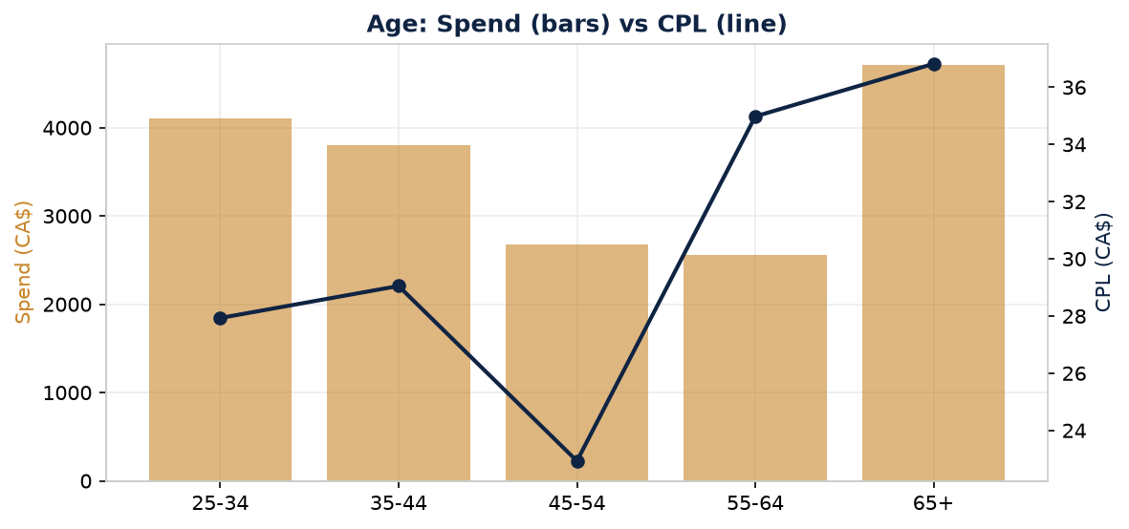
Figure — Age: spend (bars) vs CPL (line)
Age | Spend | Leads | CPL | CPM | CTR
25-34 | 4,106 | 147 | 27.93 | 14.54 | 0.78%
35-44 | 3,806 | 131 | 29.05 | 25.50 | 1.16%
45-54 | 2,682 | 117 | 22.93 | 33.58 | 1.48%
55-64 | 2,554 | 73 | 34.98 | 43.42 | 1.77%
65+ | 4,713 | 128 | 36.82 | 63.21 | 2.73%

45–54 is the most efficient age (CA$22.93); 65+ consumes the most spend at the worst CPL (CA$36.82) and highest CPM (CA$63.21) — but may be higher-value homeowners, which Meta can't confirm. Male skews cheaper (CA$28.38 vs female CA$32.37) and larger.
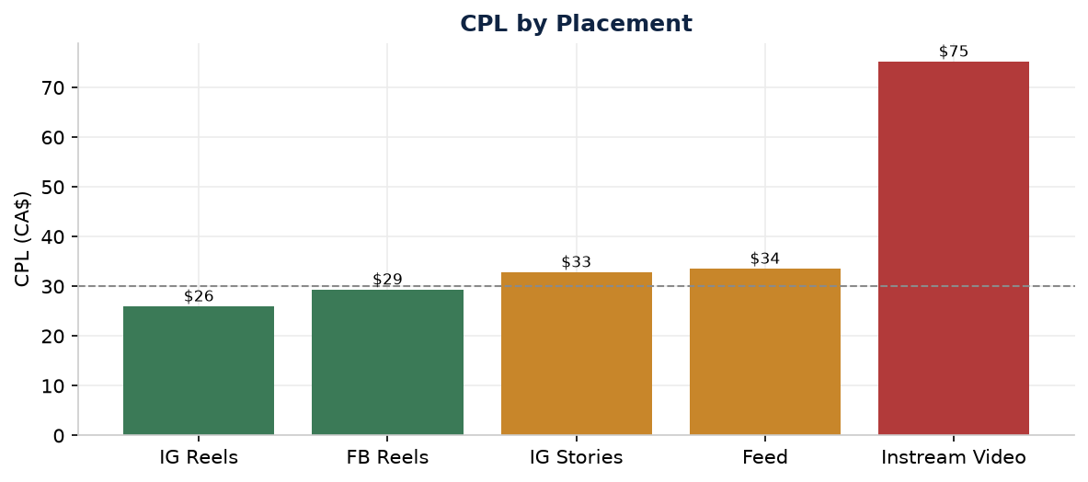
Figure — CPL by placement (green<CA$30, red>CA$40)
Placement | Spend | Leads | CPL | CPM | Read
Instagram Reels | 4,833 | 186 | 25.99 | 17.81 | Best CPL & CPM
Facebook Reels | 6,169 | 210 | 29.38 | 32.58 | Biggest, solid
Instagram Stories | 2,235 | 68 | 32.86 | 36.63 | High CTR, mid CPL
Feed (FB+IG) | 4,362 | 130 | 33.56 | 47.86 | Most expensive
Instream Video | 150 | 2 | 75.22 | 6.81 | WASTE - exclude

- Platform: Instagram cheaper (CA$28.76) than Facebook (CA$31.11); NO Audience Network spend (good).
- Geography: 99.8% Ontario; only CA$39 spilled to New York (negligible); geo waste is essentially nil. (Per-region lead attribution is unavailable via the tool.)
- Device: ~99% mobile in-app (CA$29.95 CPL). Creative must be mobile-first 9:16.

12. Tracking, Data Limitations & Performance Scoring
- Primary pixel 'Ecocare Home Comfort': healthy, PageView firing hourly. A 'Quoted' CRM event exists with 100% email/phone/name/city match — a strong asset that is NOT wired to a custom conversion or optimisation.
- GHL-Pixels dataset: stale — last fired 2025-11-01. Ecocare Website Tracking pixel: never fired (audience holds 20 people). 0 custom conversions defined.
- Lead QUALITY, booked appointments, sales and revenue are unknown from Meta alone (modelled/attributed Instant-Form submissions). Connect CRM/offline conversions to distinguish cheap leads from qualified ones.
- Tool limitations (nothing fabricated): change-history tool unavailable (timeline inferred); industry benchmark returned no data; form-open/completion metrics, quality rankings, numeric bid caps and form IDs not exposed as fields.
Category (max) | Score | Evidence | Improvement
Account structure | 6/10 | 5 active of 66 campaigns; 58 dormant; HVAC internally fragmented | Consolidate & archive
Budget allocation | 6/10 | 9% spend (WhatsApp) -> <2% leads; CPM-heavy HVAC over-weighted | Re-weight to All In One/Tankless
Bidding strategy | 8/10 | Correct default (Highest Volume); prior cap already reverted | Keep uncapped; retest cap only at scale
Audience strategy | 6/10 | Broad + Advantage+ good, but overlap/fragmentation; tiny LAL seed | Consolidate; refresh customer list
Creative quality | 11/15 | Offer-led, clear, trust signals; a few low-quality/expensive ads | Replace FIFA-V3, AC Static
Creative freshness | 5/10 | 47% of leads on one 2.5-month-old ad; hook slipping | Monthly refresh cadence
Click efficiency | 8/10 | CTR 1.27% & link-CTR rising; click-to-lead 11.8% | Maintain
Form conversion | 6/10 | Click-to-lead healthy but quality unmeasured; goal mismatch | Wire CRM signal; test Higher-Intent
Tracking & measurement | 3/10 | CRM pixel stale; 0 custom conversions; quality loop broken | Top infrastructure priority
Testing process | 2/5 | Multiple creatives exist but no controlled tests visible | Adopt one-variable roadmap

Total: 61 / 100
Strongest: bidding discipline and click efficiency. Weakest: tracking/measurement (3/10) and testing process (2/5). Fixing the CRM quality loop and adopting controlled tests would move the account into the 75+ band.

13. Budget Allocation
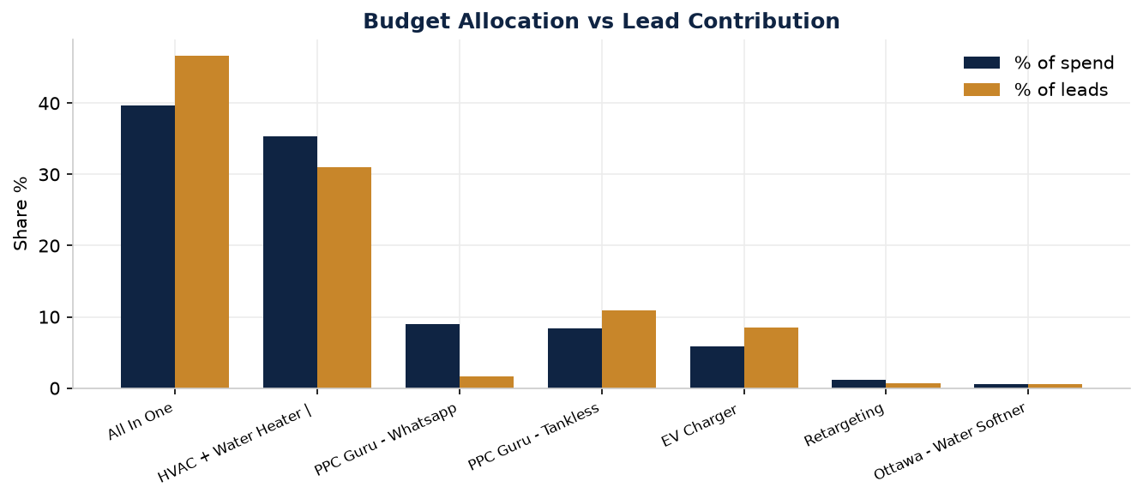
Figure — Budget allocation vs lead contribution by campaign
All In One (40% spend / 47% leads) and Tankless (8% / 11%) over-deliver on leads-per-dollar — exactly the campaigns Meta flags to scale. WhatsApp took 9% of spend for <2% of leads. Reallocate freed budget to the winners in 20–25% steps; hold HVAC-New flat until its ad sets are consolidated.

14. Bidding-Strategy Plan
- Keep 'Highest volume' on all campaigns now — per-campaign conversion volume is below the ~50/week a cost cap needs, and CPL is day-to-day variable.
- Do NOT re-introduce a cost cap until: (a) one consolidated campaign reliably makes >=50 leads/week; (b) CPL is stable 2-3 weeks; (c) the CRM quality signal is reconnected; (d) any cap is set ABOVE the recent stable CPL (e.g. ~CA$33-35 if CPL settles near CA$28-30), after learning completes.
- If tested later, use a Cost-per-result goal (not a hard bid cap) on ONE campaign, changing nothing else simultaneously.

15. Keep / Change / Replace

Keep running
Entity | Level | Reason | Recommendation
All In One | PPC Guru | Campaign | 47% of leads at CA$25.46; Meta flags as scale candidate (+52 | Keep + add fresh creatives; consider +20-25% budget
PPC Guru - Tankless | Campaign | New, efficient CA$23.19; Meta flags budget-limited | Keep + scale carefully (+20%/wk)
COMPLETE HOME COMFORT PLAN (HVAC-N | Ad set | 89 leads @ CA$29.44, CTR 3.73% | Keep as the anchor ad set when consolidating HVAC
Water Softener | $29.99/mo (video) | Ad | Workhorse, avg quality ranking, 278 leads | Keep running; build 2-3 refresh variants before pausing
FIFA - V1 | Ad | CA$25.29 CPL, CTR 4.02%, hook 27% | Keep through World Cup window; plan post-event replacement

Change
Entity | Level | Reason | Recommendation
EC | HVAC + Water Heater CBO - New | Campaign | 3 near-identical ad sets = fragmentation (Meta: -27% CPR); C | Consolidate 3 ad sets into 1 broad ad set
All QUALITY_LEAD prospecting ad se | Ad set | GHL/CRM qualified-lead signal stale since Nov-2025; LEAD_GEN | Switch to LEAD_GENERATION (Maximise leads) OR reconnect CRM
EV Charger Installation | Ad set | Efficient (CA$20.63) but freq 3.24 and paused | Re-activate at lower freq or fold into prospecting; not core
65+ age / Feed placement / Instrea | Account | 65+ worst CPL CA$36.82 + CPM CA$63; Feed CPM CA$48; Instream | Cap/observe 65+ spend; exclude Instream Video; trim Feed vs

Replace
Entity | Level | Reason | Recommendation
FIFA - V3 | Ad | Below-average quality (Meta bottom 35%), CPM CA$135 | Replace with new HVAC video hook
AC Static V1 | Summer Countdown | Ad | CA$49.48 CPL, CPM CA$79, static | Replace with product-visible AC static + clear offer
Bundles | BROAD | tCPA_$30 | Ad | CA$40.12 CPL, weak hold 17%, 'Spring' copy in July | Replace with summer bundle creative; fix seasonal copy
PPC Guru - Whatsapp (paused) | Campaign | REPLIES goal gave CA$160-484 CPL; not form leads | Keep paused; rebuild as Instant-Form lead campaign if messag
{{product.name}} SHARE ads (Tankle | Creative | Dynamic product-name placeholder may not resolve; metadata b | Verify rendered name/offer; rebuild as standard image/video

16. Prioritised Test Roadmap
Test | Type | Hypothesis | Variant | KPI | Window
T1 (High) | Optimization goal | QUALITY_LEAD ad sets running blind (CRM signal stale | Same ad set duplicated to LEAD_GENERATIO | CPL | 14 days / 50+ leads
T2 (High) | Ad set consolidation | 3 fragmented HVAC ad sets self-compete (Meta -27% CP | 1 consolidated broad ad set (same budget | CPL | 14 days
T3 (High) | Creative fatigue | Workhorse water-softener video since 8 May; hook 17% | 2-3 fresh water-softener videos (new hoo | CPL | 10 days / 30+ leads
T4 (Med) | Placement | Manual placements exclude some inventory; Instream V | Advantage+ Placements (excl. Instream Vi | CPL | 14 days
T5 (Med) | Offer / Form intent | Improve lead quality without CRM proof | Add 1 qualifying question (own vs rent / | Cost per qualified lead (needs CRM) | 14-21 days
T6 (Med) | Budget scaling | Meta flags All In One + Tankless as scale/budget-lim | +20-25% budget increments | Leads at stable CPL | 7-10 days per step
T7 (Low) | Retargeting structure | Tiny pools + freq 2.4-2.7; HVAC RT 0 leads on CA$99 | 1 consolidated RT ad set + frequency cap | CPL | 21 days
T8 (Low) | Service split | Water softener is the strongest service; test dedica | Dedicated Water Softener prospecting cam | CPL, lead volume | 21 days

Rule: one variable per test — never change creative + audience + bid + form together.

17. Action Plan

Immediate (24–48 hours)
- Do NOT touch All In One or Tankless (a big edit resets learning ~1-2 weeks).
- Exclude the Instream Video placement (CA$75 CPL waste). [Meta Ads Manager]
- Confirm the GHL 'Quoted' CRM event fires and map it to a custom conversion. [Web/CRM Dev]
- Start 2-3 new water-softener creatives; do not pause the original yet. [Designer/Video]
- Client decision: re-activate EV Charger at lower frequency, or retire it. [Client Approval]
- Keep bidding uncapped (Highest Volume). Approve reallocating paused-campaign budget to the winners. [Client Approval]

Week 1
- Archive dormant campaigns; standardise province exclusions.
- Consolidate HVAC-New 3 ad sets -> 1; consolidate retargeting -> 1 + frequency cap.
- Launch water-softener refreshes; replace FIFA-V3 and AC-Static.
- Exclude Instream; launch Advantage+ Placements test.
- Wire CRM event to a custom conversion; set up weekly CPL + hook-rate report.

Weeks 2–4
- Iterate winning creative; begin the reverse-osmosis / free-water-test line.
- Scale All In One + Tankless in 20-25% steps while CPL holds.
- Run the optimisation-goal test once CRM signal is confirmed; test a Higher-Intent form.
- Begin CRM tagging of booked vs junk leads; start offline-conversion uploads.

Days 31–60
- Scale consolidated winners; consider a dedicated Water-Softener campaign.
- Retest a cost-per-result goal ONLY if all four Section-14 conditions are met.
- Monthly creative refresh so no single ad exceeds ~40% of leads; post-World-Cup replacements.
- Once offline conversions flow, optimise the strongest campaign for the CRM 'Quoted'/booked event.
Operational CPL benchmark (not a profitability target)
Blended historical CPL ~CA$27-30; best sustained days CA$12-20. Proposed operational target: CA$26-28 CPL at >=600 leads/30 days — from the account's own history, NOT a confirmed profitable CPL. Confirm the true allowable CPL from booked-rate x close-rate x customer value with the sales team.

18. Final Conclusions
Improving or declining? Holding — leads +5.5%, CPL +11% on rising CPM; recent 7-day dip is pauses + learning, not collapse.
Three largest reasons for current CPL (1) CPM +34% from budget mix-shift to HVAC-New; (2) creative fatigue on the single workhorse; (3) ad-set fragmentation/overlap.
Campaigns to keep All In One, Tankless (scale); HVAC-New (keep + consolidate).
Ads working Water Softener CA$29.99 video, Tankless Static V1, FIFA-V1, AC Reel, HVAC Reel Amana, EV Charger V4.
Ads to replace FIFA-V3, AC Static Summer Countdown, Bundles-tCPA_$30, the {{product.name}} SHARE ads.
Audiences working Broad + Advantage+ Audience, ages 25-54 (45-54 best CA$22.93), male skew; 1% LAL helps (small seed).
Placements working Instagram Reels (best), Facebook Reels; Instream Video is waste.
Frequency fatigue? Account 2.35 healthy; retargeting (2.4-2.7) & EV (3.24) over-frequent; workhorse shows creative fatigue.
Video hooks strong enough? Mostly yes (17-45%); the workhorse's 17% is moderate and slipping — top refresh priority.
Instant Form converting? Yes on available data (click-to-lead 11.8% and rising); form-open metrics & lead quality are unmeasured.
Did the cost control cause the decline? It starved HVAC delivery while active, but is already removed; it is NOT the current cause.
Bidding strategy now? Highest Volume everywhere; no cost cap until the four conditions are met.
Data needed for lead quality? CRM/offline data: booked appointments, quotes, close rate, customer value, connected back to Meta.
Clearest path to more leads at lower CPL? Refresh water-softener creative + consolidate HVAC-New + cut Instream/WhatsApp waste + reconnect CRM signal, then scale All In One & Tankless on Highest Volume in 20-25% steps.

Appendix — Complete Data Tables
The complete entity-level data — every campaign, ad set and ad including zero-delivery entities, plus all breakdowns and 60 days of daily data — accompanies this report as CSV files. The tables below reproduce the spending entities; the CSVs are authoritative and complete.
File | Contents
Ecocare_Campaign_Performance.csv | All 66 campaigns, both periods
Ecocare_Ad_Set_Performance.csv | All 153 ad sets, both periods
Ecocare_Ad_Performance.csv | All ads with activity + video funnel + hook/hold
Ecocare_Audience_Breakdowns.csv | Age + gender
Ecocare_Geographic_Breakdowns.csv | Region
Ecocare_Placement_Breakdowns.csv | Platform + position + device
Ecocare_Instant_Form_Performance.csv | Per-campaign form proxy
Ecocare_Account_Change_History.csv | Inferred change timeline
Ecocare_Keep_Change_Replace_Action_Plan.csv | Full decision matrix
Ecocare_Creative_Testing_Roadmap.csv | Prioritised test plan
Ecocare_Daily_Trend.csv | 60 days of daily performance

Appendix A — Inferred Change History
Date | Entity | Change | Likely impact | Confidence
2025-08-16 | Ecocare Website Tracking | Pixel created | n/a | Confirmed (c
2025-08-26 | Ecocare Home Comfort | Primary pixel created | n/a | Confirmed
2025-10-19 | GHL-Pixels | GoHighLevel CRM dataset create | n/a | Confirmed
2025-11-01 | GHL-Pixels | Stale (stopped firing) | Undermines QUALITY_LEAD signal the | Confirmed (l
2026-05-05 | EcoCare retargeting audien | Created (Video Viewers, Form A | n/a | Confirmed
2026-05-08 | All In One | PPC Guru + Wa | Created | Large positive | Confirmed
2026-05-20 | EC | EV Charger | PPC Guru | Created | Positive | Confirmed
2026-06-02 | PPC Guru Customer Lookalik | Created | Mixed (small seed) | Confirmed
2026-06-02 | EC | HVAC + Water Heater C | Created | HVAC positive; WhatsApp very poor | Confirmed
2026-06-03 (approx) | EC | HVAC + Water Heater C | Paused; replaced by '-New' (Hi | Volume collapse under cost cap; fi | INFERRED (no
2026-06-12..14 | Account daily budget | ~CA$900/day (surge) | CPL spiked to CA$43-48; spend outp | INFERRED (de
2026-06-15 | FIFA V1-V6 (World Cup them | Created | Mixed (V1 strong, V3 low quality) | Confirmed
2026-06-29 | PPC Guru - Tankless + Tank | Created | Positive (~$23 CPL) | Confirmed
2026-07-14 | All In One / Water Softene | Edited (updated_time) | Possible minor learning nudge | Confirmed (u
2026-07-17 | PPC Guru - Whatsapp; EC | | Paused | Spend collapsed to CA$106-252/day | INFERRED (de
2026-07-20 | Ottawa - Water Softner & T | Created | Learning reset; early CPL CA$35-51 | Confirmed

