**Functional English**

**Assignment**

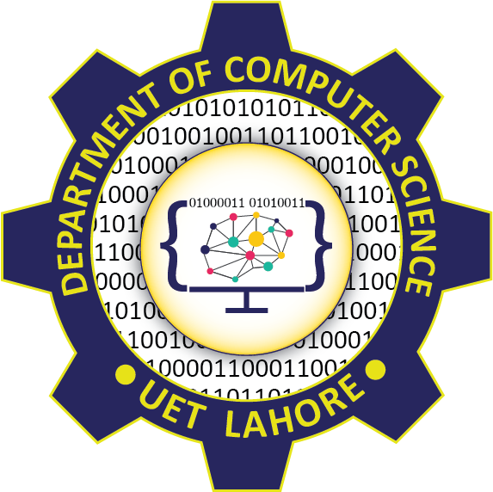

Session: 2021 – 2024

**Submitted by:**

Muqaddas Nazeer

2021-CS-183

**Submitted to:**

Sir Hassan

Department of Computer Science

**University of Engineering and Technology**

**Lahore Pakistan**

**Corruption**

When there is no moral degradation, or there is no amount of honest valuation that can make you realize that you have gone on the wrong path, it leads to corruption. The desire for power and wealth are the common reasons for corruption. It disposes a person away from his character, and this leads to the deteriorating ability of duties. In this era, there may be a difference in the amount of corruption in all the countries, but it exists all the time. Corruption is in every department and arena of the government. There are many methods of corruption the most common is bribery. Bribery means the tactic that is used for using favors or gifts for personal acquire. In fact corruption is an act of misconduct that not only ruins lives but also ruins families because a person once gets habituated to it no one but themselves can stop them from it is cannot be finished if it is not inside a man’s heart to stop it.