CS223
Digital Design
SECTION-3
Lab-02
3.03.20

Tuna Dalbeler
21802539

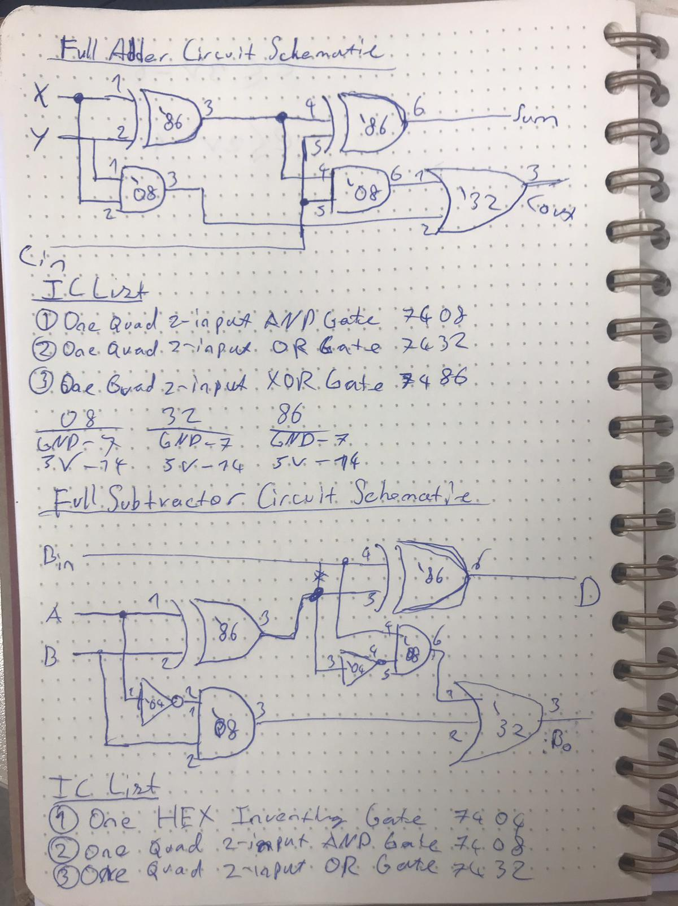
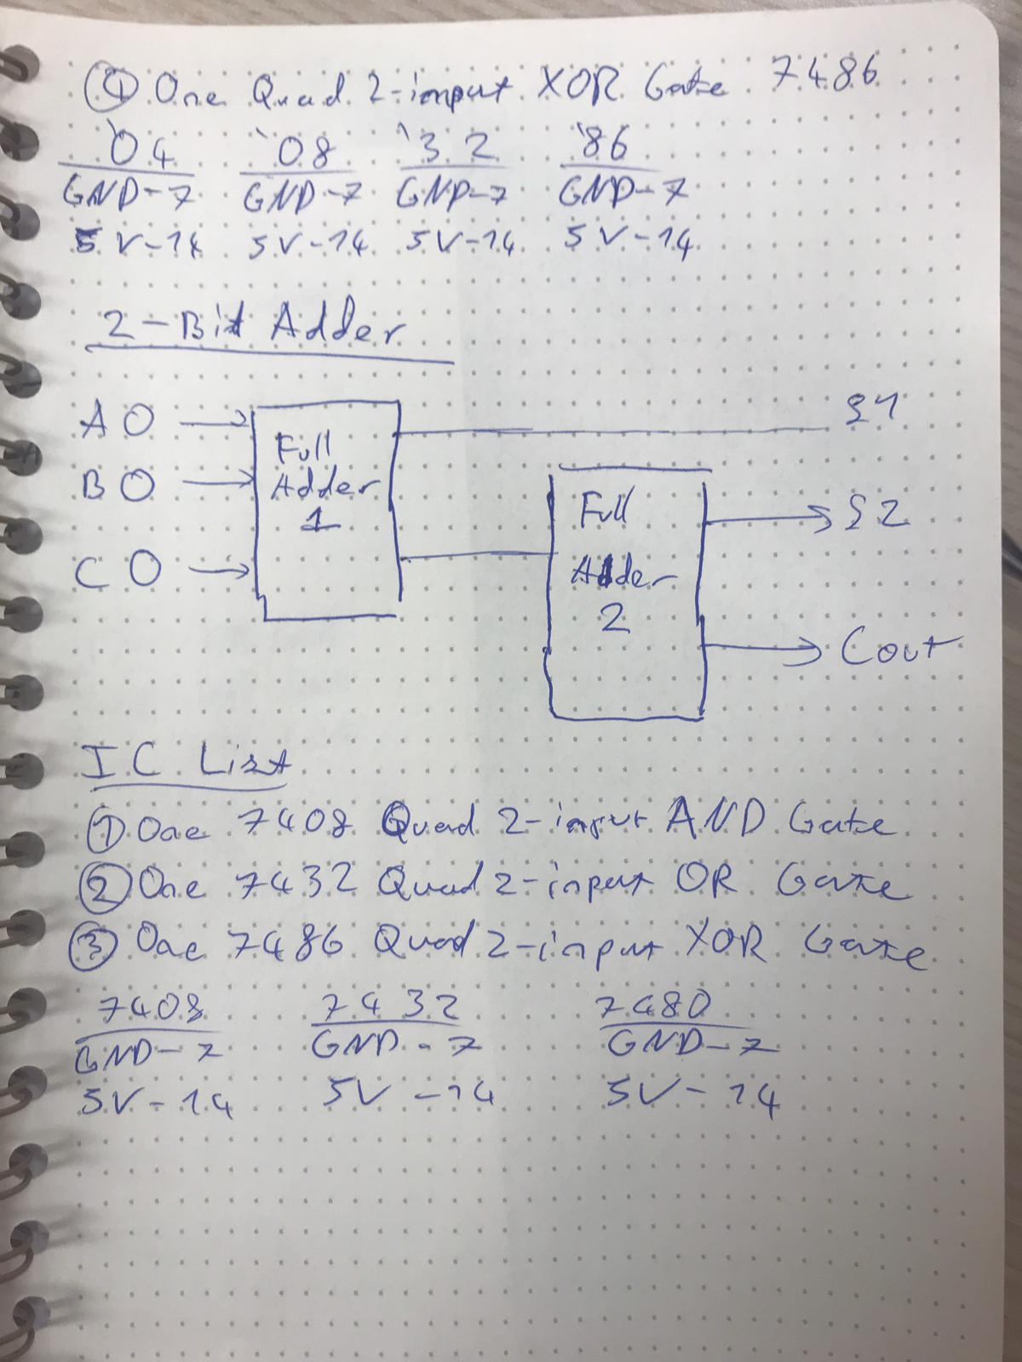
Behavioral SystemVerilog module for the full adder and a testbench for it

Module:

module adder(x, y, cin, sum, cout);
input logic x, y, cin;
output logic sum, cout;

assign sum = ~x & ~y & cin | ~x & y & ~cin | x & ~y & ~cin | x & y & cin ;
assign cout = x & y | y & cin | x & cin ;

endmodule

Test Bench:
module sim1();
logic x, y, cin;
logic sum, cout;
adder uut(x ,y ,cin ,sum ,cout);
initial begin
x=0;y=0;cin=0;#5;
x=1;y=0;cin=0;#5;
x=0;y=1;cin=0;#5;
x=1;y=1;cin=0;#5;
x=0;y=0;cin=1;#5;
x=1;y=0;cin=1;#5;
x=0;y=1;cin=1;#5;
x=1;y=1;cin=1;#5;
end
endmodule

Structural SystemVerilog module for the full adder and a testbench for it
Module:

module fullAdder( x, y, cin, sum, cout);
input logic x, y, cin;
output logic sum, cout;
wire s1, c1, c2;
xor xor1(s1, x, y);
xor xor2(sum, s1, cin);
and and1(c1, x, y);
and and2(c2, s1, cin);
or or1(cout, c1, c2);
endmodule

Test Bench:

module fullAdderSim();

logic sum, cout;
logic x, y, cin;
fullAdder uut(x ,y ,cin ,sum ,cout);
initial begin
x=0;y=0;cin=0;#5;
x=1;y=0;cin=0;#5;
x=0;y=1;cin=0;#5;
x=1;y=1;cin=0;#5;
x=0;y=0;cin=1;#5;
x=1;y=0;cin=1;#5;
x=0;y=1;cin=1;#5;
x=1;y=1;cin=1;#5;
end
endmodule

Structural SystemVerilog module for the full subtractor and a testbench for it
Module:
module fullSubtractor(
input logic A,B, Bin,
output logic D,Bout );
wire W1,W2,W3;
halfSubtractor hlf1(A,B,W1,W2);
halfSubtractor hlf2(W1,Bin,D,W3);

or or1(Bout,W3,W2);

endmodule

Test Bench:
module sim1( );

logic A, B, Bin;
logic Bout, D;
fullSubtractor full( A,B,Bin,Bout,D);

initial begin

A = 0; B = 0; Bin = 0; #10;
A = 0; B = 0; Bin = 1; #10;
A = 0; B = 1; Bin = 0; #10;
A = 0; B = 1; Bin = 1; #10;
A = 1; B = 0; Bin = 0; #10;
A = 1; B = 0; Bin = 1; #10;
A = 1; B = 1; Bin = 0; #10;
A = 1; B = 1; Bin = 1; #10;

end
endmodule

Structural SystemVerilog module for the 2-bit adder and a testbench for it.

Module:
module twoBitAdder(

input logic A0,A1,B0,B1,C0,
output logic S1,S2,Cout
);

wire W1;

fullAdder adder1(A0,B0,C0,S1,W1);
fullAdder adder2(A1,B1,W1,S2,Cout);

endmodule
Test Bench:
module twoBitSim();

logic A0,B0,A1,B1,C0;
logic C0,S1,S2,Cout;

twoBitAdder tba(A0,A1,B0,B1,C0,S1,S2,Cout);//C0 = cin

initial begin

A0=0;B0=0;A1=0;B1=0;C0=0;#5;
A0=1;B0=0;A1=0;B1=0;C0=0;#5;
A0=0;B0=1;A1=0;B1=0;C0=0;#5;
A0=1;B0=1;A1=0;B1=0;C0=0;#5;
A0=0;B0=0;A1=1;B1=0;C0=0;#5;
A0=1;B0=0;A1=1;B1=0;C0=0;#5;
A0=0;B0=1;A1=1;B1=0;C0=0;#5;
A0=1;B0=1;A1=1;B1=0;C0=0;#5;
A0=0;B0=0;A1=0;B1=1;C0=0;#5;
A0=1;B0=0;A1=0;B1=1;C0=0;#5;
A0=0;B0=1;A1=0;B1=1;C0=0;#5;
A0=1;B0=1;A1=0;B1=1;C0=0;#5;
A0=0;B0=0;A1=1;B1=1;C0=0;#5;
A0=1;B0=0;A1=1;B1=1;C0=0;#5;
A0=0;B0=1;A1=1;B1=1;C0=0;#5;
A0=1;B0=1;A1=1;B1=1;C0=0;#5;
A0=0;B0=0;A1=0;B1=0;C0=1;#5;
A0=1;B0=0;A1=0;B1=0;C0=1;#5;
A0=0;B0=1;A1=0;B1=0;C0=1;#5;
A0=1;B0=1;A1=0;B1=0;C0=1;#5;
A0=0;B0=0;A1=1;B1=0;C0=1;#5;
A0=1;B0=0;A1=1;B1=0;C0=1;#5;
A0=0;B0=1;A1=1;B1=0;C0=1;#5;
A0=1;B0=1;A1=1;B1=0;C0=1;#5;
A0=0;B0=0;A1=0;B1=1;C0=1;#5;
A0=1;B0=0;A1=0;B1=1;C0=1;#5;
A0=0;B0=1;A1=0;B1=1;C0=1;#5;
A0=1;B0=1;A1=0;B1=1;C0=1;#5;
A0=0;B0=0;A1=1;B1=1;C0=1;#5;
A0=1;B0=0;A1=1;B1=1;C0=1;#5;
A0=0;B0=1;A1=1;B1=1;C0=1;#5;
A0=1;B0=1;A1=1;B1=1;C0=1;#5;
end

endmodule

