Job Offer Letter
Dear [Candidate Name].
We are pleased to offer you the position of (Job Title] at BHARTI SEWA SADAN TRUST. We believe your skills and experience make you an excellent fit and a valuable addition to our organization. We look forward to welcoming you to our team.
Your starting date will be (Start Date], and your initial salary will be (Salary). Your salary will be paid on a [weekly/bi-weekly/monthly] basis, starting [date of next pay period].
As part of your compensation package, we're also offering:
* [List your core benefits like bonus structure, health insurance, 401k]
* (Benefit 2]
* (Benefit 3]
As a (Job Title], your key responsibilities will be as follows:
* [Job Responsibility 1]
* [Job Responsibility 2]
* [Job Responsibility 3]
You will report to manager, and your work schedule will be [Work Schedule, including any hybrid or remote work scheduling].
Please rewiew the attached documents, including the employee handbook and employment agreement, and let us know if you have any questions or concerns. To accept this offer, please sign and return a copy of this letter by (Acceptance Due Date). If we do not receive your acceptance by this date, we will assume that you have declined the offer.
Please note that your employment with BHARTI SEWA SADAN TRUST is contingent upon your compliance with all applicable laws, regulations, and company policies, including but not limited to our Code of Conduct and Confidentiality Agreement.
Thank you for your interest in BHARTI SEWA SADAN TRUST. We look forward to working with you.
Sincerely,

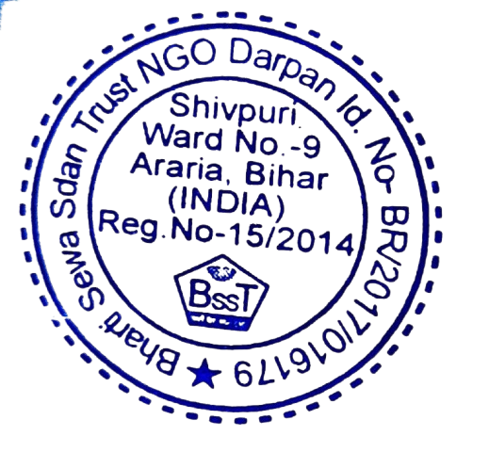

DR RAM NARAYAN BHARTI
FOUNDER CUM PRISEDENT
BHARTI SEWA SADAN TRSUT
\

