Assignment
Name ihsan ul haq
Reg no sp21-bse -013

Question no 1
Let's consider a legacy system example to illustrate the application of these techniques.
Legacy System Example:
Suppose we have a monolithic e-commerce application written in an outdated programming language (e.g., COBOL) with a complex, tightly coupled architecture. The system is difficult to maintain, and its performance is degrading over time.

Applying Modernization Techniques:

1. Static Code Analysis: We use tools like SonarQube to analyze the codebase and identify potential issues, such as security vulnerabilities and performance bottlenecks.

2. Reverse Engineering: We use tools like IDA Pro to analyze the existing system and understand its design and implementation. This helps us identify areas that need improvement.

3. Code Refactoring: We restructure the codebase to improve its maintainability, scalability, and performance. For example, we might break down the monolithic architecture into smaller, independent services using microservices architecture.

4. Code Documentation: We create and maintain documentation for the codebase using tools like Javadoc or Doxygen. This improves code readability and reduces knowledge loss.

5. Automatic Testing: We write automated tests using tools like JUnit or TestNG to ensure the system is thoroughly tested and reduce testing time.

6. Microservice Architecture: We break down the monolithic application into smaller, independent services using microservices architecture. For example, we might create separate services for order management, inventory management, and customer management.

7. Containerization: We package the application and its dependencies into containers using Docker. This improves deployment efficiency and reduces environment inconsistencies.

8. Database Migration: We modify the database schema to accommodate changing requirements using tools like Flyway or Liquibase. This improves data consistency and reduces data loss.

9. API Integration: We integrate the application with external services using APIs. For example, we might integrate with a third-party payment gateway or shipping provider.

10. UI Modernization: We update the user interface to improve the user experience using modern front-end frameworks like React or Angular.

Example Outcome:
After applying these modernization techniques, our legacy e-commerce application is transformed into a scalable, maintainable, and high-performance system. The microservices architecture allows us to deploy individual services independently, reducing the risk of system downtime. The containerized application ensures consistent deployment across environments. The modernized UI provides a better user experience, improving customer engagement and conversion rates.

By applying these techniques, we have successfully modernized our legacy system, improving its maintainability, scalability, and performance, and reducing technical debt.

Question no 2
Eslint
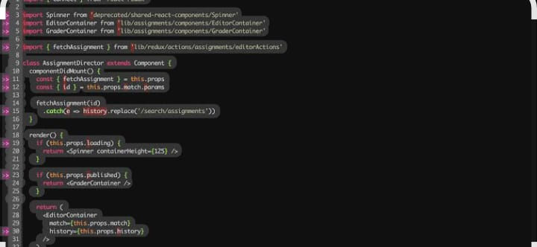
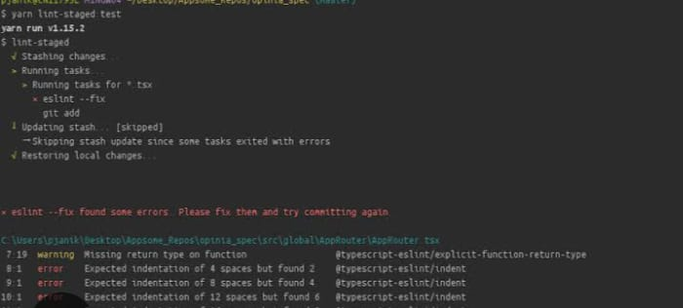

2 JProfiler
