

[Tutorials ](https://www.softwaretestinghelp.com/)

[](https://www.softwaretestinghelp.com/types-of-software-testing/)

Courses  [Automation ](https://www.softwaretestinghelp.com/automation-testing-tutorial-1/) [Types Of Testin](https://www.softwaretestinghelp.com/types-of-software-testing/)

[](https://www.softwaretestinghelp.com/manual-testing-tutorial-1/)

[Home](https://www.softwaretestinghelp.com/) [Resources](https://www.softwaretestinghelp.com/resources/) [FREE EBooks](https://www.softwaretestinghelp.com/practical-software-testing-new-free-ebook-download/) [QA Testin](https://www.softwaretestinghelp.com/manual-testing-tutorial-1/)

[Help](https://www.softwaretestinghelp.com/)

[Software Testin](https://www.softwaretestinghelp.com/)

**SEARCH**

Custom Search

**Top 50+ Database Interview Questions And Answers**



|  |
| --- |
| About SoftwareTestin Help  **Helpin**  **our community since 2006!** Most popular portal for Software professionals with **100 million+ visits and 300,000+ followers!** You will absolutely love our tutorials on QA Testin , Development, Software Tools and Services Reviews and more! |
|  |
|  |
|  |
| Recommended Readin  [Top 32 Best Datasta e Interview Questions And Answers](https://www.softwaretestinghelp.com/datastage-interview-questions/)  [31 Top Database Testin Interview Questions and Answers](https://www.softwaretestinghelp.com/31-best-database-testing-interview-questions-and-answers-for-qa-testers/) |

Last Updated: [September 13, 2020](https://www.softwaretestinghelp.com/database-interview-questions/)

## Most Frequently asked Database Interview Questions and answers:

**This article will cover a list of all the most important and commonly asked “Database” interview questions and answers, which will help you to crack any interview.**

Or anizational skills, stron problem-solvin capability, attention to details and hi h level of accuracy, are some of the essential qualities which a person should possess in order to be in the **“Database”** eld.



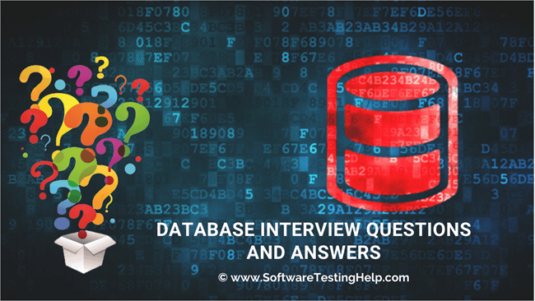

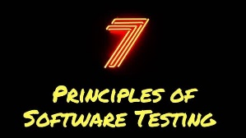

|  |
| --- |
| [40+ Best Database Testin Tools – Popular Data Testin Solutions](https://www.softwaretestinghelp.com/tools/40-best-database-testing-tools/)  [Database Testin Complete Guide (Why, What, and How to Test Data)](https://www.softwaretestinghelp.com/database-testing-process/)  [Top 30 Most Popular Database Mana ement Software: Complete List](https://www.softwaretestinghelp.com/database-management-software/)  [Top 50+ Database Interview Questions and Answers](https://www.softwaretestinghelp.com/database-interview-questions/) |
|  |
|  |
|  |

FEATURED VIDEOS

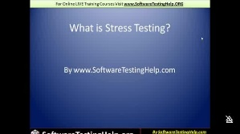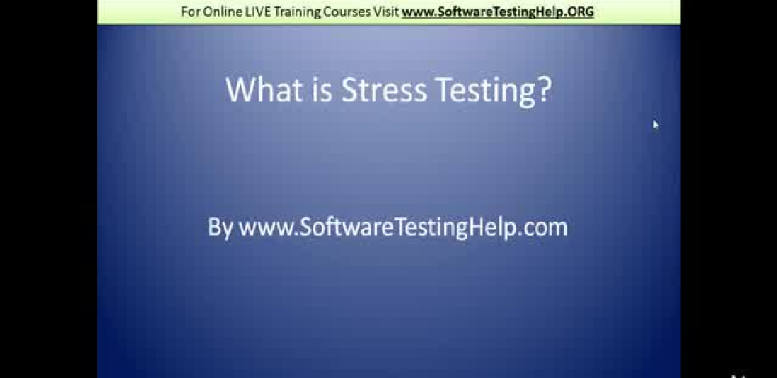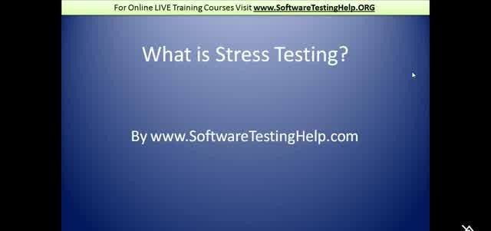

While you should be updated with the latest trends in the industry, your basics should also be stron on the other hand. In order to start your career in Database, the rst and foremost essential thin that you need to have is the knowled e of DBMS (Database Mana ement System) and SQL (Structured Query lan ua e).

# Most Popular Database Interview Questions And Answers

Given below is a list of most popular Database interview questions and answers for your reference.

## Q #1) What do you understand by ‘Database’?

**Answer:** Database is an or anized collection of related data where the data is stored and or anized to serve some speci c purpose.

**For Example**, A librarian maintain a database of all the information related to the books that are available in the library.

## Q #2) De ne DBMS.

**Answer:** DBMS stands for Database Mana ement System. It is a collection of application pro rams which allow the user to or anize, restore and retrieve information about data e ciently and as e‰ectively as possible.

Some of the popular DBMS’s are MySql, Oracle, Sybase, etc.

## Q #3) De ne RDBMS.

**Answer:** Relational Database Mana ement System(RDBMS) is based on a relational model of data that is stored in databases in separate tables and they are related to the use of a common column. Data can be accessed easily from the relational database usin Structured Query Lan ua e (SQL).

## Q #4) Enlist the advanta es of DBMS. Answer: The advantaes of DBMS includes:

Data is stored in a structured way and hence redundancy is controlled.

Validates the data entered and provide restrictions on unauthorized access to the database.

Provides backup and recovery of the data when required. It provides multiple user interfaces.

## Q #5) What do you understand by Data Redundancy?

**Answer:** Duplication of data in the database is known as data redundancy. As a result of data redundancy, duplicated data is present at multiple locations, hence it leads to wasta e of the stora e space and the inte rity of the database is destroyed.

## Q #6) What are the various types of relationships in Database? De ne them. Answer: There are 3 types of relationships in Database:

**One-to-one:** One table has a relationship with another table havin the similar kind of column. Each primary key relates to only one or no record in the related table.

**One-to-many:** One table has a relationship with another table that has primary and

forei n key relations. The primary key table contains only one record that relates to none, one or many records in the related table.

**Many-to-many:** Each record in both the tables can relate to many numbers of records in another table.

## Q #7) Explain Normalization and De-Normalization. Answer:

**Normalization** is the process of removin redundant data from the database by splittin the table in a well-de ned manner in order to maintain data inte rity. This process saves much of the stora e space.

**De-normalization** is the process of addin up redundant data on the table in order to speed up the complex queries and thus achieve better performance.

## Q #8) What are the di‰erent types of Normalization? Answer: Di‰erent types of Normalization are:

**First Normal Form (1NF):** A relation is said to be in 1NF only when all the entities of the table contain unique or atomic values.

**Second Normal Form (2NF):** A relation is said to be in 2NF only if it is in 1NF and all the non-key attribute of the table is fully dependent on the primary key.

**Third Normal Form (3NF):** A relation is said to be in 3NF only if it is in 2NF and every non-key attribute of the table is not transitively dependent on the primary key.

## Q #9) What is BCNF?

**Answer:** BCNF is the Boyce Code Normal form. It is the hi her version of 3Nf which does not have any multiple overlappin candidate keys.

## Q #10) What is SQL?

**Answer:** Structured Query lan ua e, SQL is an ANSI(American National Standard Institute) standard pro rammin lan ua e that is desi ned speci cally for storin and mana in the data in the relational database mana ement system (RDBMS) usin all kinds of data operations.

## Q #11) How many SQL statements are used? De ne them.

**Answer:** SQL statements are basically divided into three cate ories, DDL, DML, and DCL.

## They can be de ned as:

**Data De nition Lan ua e (DDL)** commands are used to de ne the structure that holds the data. These commands are auto-committed i.e. chan es done by the DDL commands on the database are saved permanently.

**Data Manipulation Lanua e (DML)** commands are used to manipulate the data of the database. These commands are not auto-committed and can be rolled back.

**Data Control Lanua e (DCL)** commands are used to control the visibility of the data in the database like revoke access permission for usin data in the database.

## Q #12) Enlist some commands of DDL, DML, and DCL. Answer: Data De nition Lanua e (DDL) commands:

CREATE to create a new table or database. ALTER for alteration.

TRUNCATE to delete data from the table. DROP to drop a table.

RENAME to rename a table.

## Data Manipulation Lanua e (DML) commands:

INSERT to insert a new row.

UPDATE to update an existin row. DELETE to delete a row.

MERGE for mer in two rows or two tables.

## Data Control Lanua e (DCL) commands:

COMMIT to permanently save. ROLLBACK to undo the chan e. SAVEPOINT to save temporarily.

## Q #13) De ne DML Compiler.

**Answer:** DML compiler translates DML statements in a query lan ua e into a low-level instruction and the enerated instruction can be understood by Query Evaluation En ine.

## Q #14) What is DDL interpreter?

**Answer:** DDL Interpreter interprets the DDL statements and records the enerated statements in the table containin metadata.

## Q #15) Enlist the advantaes of SQL. Answer: Advantaes of SQL are:

Simple SQL queries can be used to retrieve a lar e amount of data from the database very quickly and e ciently.

SQL is easy to learn and almost every DBMS supports SQL.

It is easier to mana e the database usin SQL as no lar e amount of codin is required.

## Q #16) Explain the terms ‘Record’, ‘Field’ and ‘Table’ in terms of database.

**Answer:**

**Record:** Record is a collection of values or elds of a speci c entity. **For Example,** An employee, Salary account, etc.

**Field:** A eld refers to an area within a record that is reserved for speci c data. **For Example,** Employee ID.

**Table:** Table is the collection of records of speci c types. **For Example,** the Employee table is a collection of records related to all the employees.

## Q #17) What do you understand by Data Independence? What are its two types?

**Answer:** Data Independence refers to the ability to modify the schema de nition in one level in such a way that it does not a‰ect the schema de nition in the next hi her level.

## The 2 types of Data Independence are:

**Physical Data Independence**: It modi es the schema at the physical level without a‰ectin the schema at the conceptual level.

**Lo ical Data Independence:** It modi es the schema at the conceptual level without a‰ectin or causin chan es in the schema at the view level.

## Q #18) De ne the relationship between ‘View’ and ‘Data Independence’.

**Answer:** View is a virtual table that does not have its data on its own rather the data is de ned from one or more underlyin base tables.

Views account for lo ical data independence as the rowth and restructurin of base tables are not re½ected in views.

## Q #19) What are the advantaes and disadvantaes of views in the database? Answer: Advanta es of Views:

As there is no physical location where the data in the view is stored, it enerates output without wastin resources.

Data access is restricted as it does not allow commands like insertion, updation, and deletion.

## Disadvanta es of Views:

The view becomes irrelevant if we drop a table related to that view.

Much memory space is occupied when the view is created for lar e tables.

## Q #20) What do you understand by Functional dependency?

**Answer:** A relation is said to be in functional dependency when one attribute uniquely de nes another attribute.

**For Example,** R is a Relation, X and Y are two attributes. T1 and T2 are two tuples. Then, T1[X]=T2[X] and T1[Y]=T2[Y]

Means, the value of component X uniquely de ne the value of component Y. Also, X->Y means Y is functionally dependent on X.

## Q #21) When is functional dependency said to be the fully functional dependent?

**Answer:** To ful ll the criteria of fully functional dependency, the relation must meet the requirement of functional dependency.

A functional dependency ‘A’ and ‘B’ are said to be fully functional dependent when removal of any attribute say ‘X’ from ‘A’ means the dependency does not hold anymore.

## Q #22) What do you understand by the E-R model?

**Answer:** E-R model is an Entity-Relationship model which de nes the conceptual view of the database.

The E-R model basically shows the real-world entities and their association/relations. Entities here represent the set of attributes in the database.

## Q #23) De ne Entity, Entity type, and Entity set. Answer:

**Entity** can be anythin , be it a place, class or object which has an independent existence in the real world.

**Entity Type** represents a set of entities that have similar attributes.

**Entity Set** in the database represents a collection of entities havin a particular entity type.

## Q #24) De ne a Weak Entity set.

**Answer:** Weak Entity set is the one whose primary key comprises its partial key as well as the primary key of its parent entity. This is the case because the entity set may not have su cient attributes to form a primary key.

## Q #25) Explain the terms ‘Attribute’ and ‘Relations’ Answer:

**Attribute** is described as the properties or characteristics of an entity. **For Example**, Employee ID, Employee Name, A e, etc., can be attributes of the entity Employee.

**Relation** is a two-dimensional table containin a number of rows and columns where every row represents a record of the relation. Here, rows are also known as ‘Tuples’ and columns are known as ‘Attributes’.

## Q #26) What are VDL and SDL?

**Answer: VDL** is View De nition Lan ua e which represents user views and their mappin to the conceptual schema.

**SDL** is Stora e De nition Lan ua e which speci es the mappin between two schemas.

## Q #27) De ne Cursor and its types.

**Answer:** Cursor is a temporary work area that stores the data, as well as the result set, occurred after manipulation of data retrieved. A cursor can hold only one row at a time.

## The 2 types of Cursor are:

**Implicit cursors** are declared automatically when DML statements like INSERT, UPDATE, DELETE is executed.

**Explicit cursors** have to be declared when SELECT statements that are returnin more than one row are executed.

## Q #28) What is the Database transaction?

**Answer:** Sequence of operation performed which chan es the consistent state of the database to another is known as the database transaction. After the completion of the transaction,

either the successful completion is re½ected in the system or the transaction fails and no chan e is re½ected.

## Q #29) De ne Database Lock and its types.

**Answer:** Database lock basically si ni es the transaction about the current status of the data item i.e. whether that data is bein used by other transactions or not at the present point of time.

There are two types of Database lock: **Shared Lock** and **Exclusive Lock. Q #30) What is Data Warehousin?**

**Answer:** The stora e as well as access to data, that is bein derived from the transactions and other sources, from a central location in order to perform the analysis is called Data Warehousin .

## Q #31) What do you understand by Join?

**Answer:** Join is the process of derivin the relationship between di‰erent tables by combinin columns from one or more tables havin common values in each. When a table joins with itself, it is known as Self Join.

## Q #32) What do you understand by Index huntin?

**Answer:** Index huntin is the process of boostin the collection of indexes which helps in improvin the query performance as well as the speed of the database.

## Q #33) How to improve query performance usin Index huntin? Answer: Index huntin help in improvin query performance by:

Usin a query optimizer to coordinate queries with the workload. Observin the performance and e‰ect of index and query distribution.

## Q #34) Di‰erentiate between ‘Cluster’ and ‘Non-cluster’ index.

**Answer:** Clustered index alters the table and re-order the way in which the records are stored in the table. Data retrieval is made faster by usin the clustered index.

A Non-clustered index does alter the records that are stored in the table but creates a completely di‰erent object within the table.

## Q #35) What are the disadvantaes of a Query? Answer: Disadvantaes of a Query are:

Indexes are not present.

Stored procedures are excessively compiled. Di culty in interfacin .

## Q #36) What do you understand by Fra mentation?

**Answer:** Fra mentation is a feature that controls the lo ical data units, also known as fra ments that are stored at di‰erent sites of a distributed database system.

## Q #37) De ne Join types.

**Answer:** Given below are the types of Join, which are explained with respect to the tables as an **Example.**

## employee table:

**employee_info table:**

1. **Inner JOIN:** Inner JOIN is also known as a simple JOIN. This SQL query returns results from both the tables havin a common value in rows.

## SQL Query:

**SELECT** * **from** employee, employee_info **WHERE** employee.EmpID = employee_info.Emp



## Result:

1. **Natural JOIN:** This is a type of Inner JOIN that returns results from both the tables havin the same data values in the columns of both the tables to be joined.

## SQL Query:

**SELECT** * **from** employee NATURAL JOIN employee_info;

## Result:

1. **Cross JOIN:** Cross JOIN returns the result as all the records where each row from the rst table is combined with each row of the second table.

## SQL Query:

**SELECT** * **from** employee CROSS JOIN employee_info;

## Result:

**Let us do some modi cation in the above tables to understand Riht JOIN, Left JOIN, and Full JOIN.**

**employee table:**

**employee_info table:**

1. **Riht JOIN:** Ri ht JOIN is also known as Ri ht Outer JOIN. This returns all the rows as a result from the ri ht table even if the JOIN condition does not match any records in the left table.

## SQL Query:

**SELECT** * **from** employee RIGHT OUTER JOIN employee_info **on** (employee.EmpID = emp



## Result:

1. **Left JOIN:** Left JOIN is also known as Left Outer JOIN. This returns all the rows as a result of the left table even if the JOIN condition does not match any records in the ri ht table. This is exactly the opposite of Ri ht JOIN.

## SQL Query:

**SELECT** * **from** employee LEFT OUTER JOIN employee_info **on** (employee.EmpID = empl



## Result:

1. **Outer/Full JOIN:** Full JOIN return results in combinin the result of both the Left JOIN and Ri ht JOIN.

## SQL Query:

**SELECT** * **from** employee **FULL** OUTER JOIN employee_info **on** (employee.EmpID = empl



## Result:

**Q #38) What do you understand by ‘Atomicity’ and ‘A re ation’?**



**Answer: Atomicity** is the condition where either all the actions of the transaction are performed or none. This means, when there is an incomplete transaction, the database mana ement system itself will undo the e‰ects done by the incomplete transaction.

**A re ation** is the concept of expressin the relationship with the collection of entities and their relationships.



## Q #39) De ne Phantom deadlock.

**Answer:** Phantom deadlock detection is the condition where the deadlock does not actually exist but due to a delay in propa atin local information, deadlock detection al orithms identify the deadlocks.

## Q #40) De ne checkpoint.

**Answer:** Checkpoint declares a point before which all the lo s are stored permanently in the stora e disk and is the inconsistent state. In the case of crashes, the amount of work and time is saved as the system can restart from the checkpoint.

## Q #41) What is Database partitionin ?

**Answer:** Database partitionin is the process of partitionin tables, indexes into smaller pieces in order to mana e and access the data at a ner level.

This process of partitionin reduces the cost of storin a lar e amount of data as well as enhances the performance and mana eability.

## Q #42) Explain the importance of Database partitionin . Answer: The importance of Database partitionin are:

Improves query performance and mana eability. Simpli es common administration tasks.

Acts as a key tool for buildin systems with extremely hi h availability requirements. Allows accessin a lar e part of a sin le partition.

## Q #43) Explain the Data Dictionary.

**Answer:** Data dictionary is a set of information describin the content and structure of the tables and database objects. The job of the information stored in the data dictionary is to control, manipulate and access the relationship between database elements.

## Q #44) Explain the Primary Key and Composite Key.

**Answer: Primary Key** is that column of the table whose every row data is uniquely identi ed. Every row in the table must have a primary key and no two rows can have the same primary key. Primary key value can never be null nor can it be modi ed or updated.

**Composite Key** is a form of the candidate key where a set of columns will uniquely identify every row in the table.

## Q #45) What do you understand by the Unique key?

**Answer:** A Unique key is the same as the primary key whose every row data is uniquely identi ed with a di‰erence of null value i.e. Unique key allows one value as a NULL value.

## Q #46) What do you understand by Database Tri ers?



**Answer:** A set of commands that automatically et executed when an event like Before Insert, After Insert, On Update, On Delete of row occurs in a table is called as Database tri er.



## Q #47) De ne Stored procedures.

**Answer:** A Stored procedure is a collection of pre-compiled SQL Queries, which when executed denotes a pro ram takin input, process and ives the output.

## Q #48) What do you understand by B-Trees?

**Answer:** B-Tree represents the data structure in the form of a tree for external memory that reads and writes lar e blocks of data. It is commonly used in databases and le systems where all the insertions, deletions, sortin , etc., are done in lo arithmic time.

## Q #49) Name the di‰erent data models that are available for database systems. Answer: Di‰erent data models are:

Relational model Network model Hierarchical model

## Q #50) Di‰erentiate between ‘DELETE’, ‘TRUNCATE’ and ‘DROP’ commands.

**Answer:** After the execution of **‘DELETE’** operation, COMMIT and ROLLBACK statements can be performed to retrieve the lost data.

After the execution of **‘TRUNCATE’** operation, COMMIT, and ROLLBACK statements cannot be performed to retrieve the lost data.

**‘DROP’** command is used to drop the table or key like the primary key/forei n key.

## Q #51) Based on the iven table, solve the followin queries.

**Employee table**

1. Write the SELECT command to display the details of the employee with empid as 1004.

## SQL Query:

**SELECT** empId, empName, Age, Address **from** Employee **WHERE** empId = 1004;

## Result:

1. Write the SELECT command to display all the records of table Employees.

## SQL Query:

**SELECT** * **from** Employee;

## Result:

1. Write the SELECT command to display all the records of the employee whose name starts with the character ‘R’.

## SQL Query:

**SELECT** * **from** Employee **WHERE** empName LIKE ‘R%’;

## Result:

1. Write a SELECT command to display id, a e and name of the employees with their a e in both ascendin and descendin order.

## SQL Query:

**SELECT** empId, empName, Age **from** Employee **ORDER BY** Age;

## Result:

**SELECT** empId, empName, Age **from** Employee **ORDER BY** Age **Desc**;

## Result:

1. Write the SELECT command to calculate the total amount of salary on each employee from the below Emp table.

## Emp table:

**SQL Query:**

**SELECT** empName, SUM(Salary) **from** Emp **GROUP BY** empName;

## Result:

Conclusion

These are the set of Database interview questions and answers which are mostly asked in the interview.

Mostly the basics of every subject are questioned in the interviews. It is a well-known fact to everyone that, if your basics are clear, you can reach top hei hts.

***However, there may be some more tricky questions. Just be con dent and face each question with clarity in your subject knowled e.***

**Further readin :**

[**Top SQL Interview Questions**](https://www.softwaretestinghelp.com/50-popular-sql-interview-questions-for-testers/)

[**Top Database Testin** **Interview Questions**](https://www.softwaretestinghelp.com/31-best-database-testing-interview-questions-and-answers-for-qa-testers/)**** [**Top Data Modelin**  **Interview Questions**](https://www.softwaretestinghelp.com/data-modeling-interview-questions-answers/)**** [**Top SQL Server Interview Questions**](https://www.softwaretestinghelp.com/sql-server-interview-question-for-testers-2/)

Recommended Readin

[Top 32 Best Datasta e Interview Questions And Answers](https://www.softwaretestinghelp.com/datastage-interview-questions/) [31 Top Database Testin Interview Questions and Answers](https://www.softwaretestinghelp.com/31-best-database-testing-interview-questions-and-answers-for-qa-testers/)

[40+ Best Database Testin Tools - Popular Data Testin Solutions](https://www.softwaretestinghelp.com/tools/40-best-database-testing-tools/) [Database Testin Complete Guide (Why, What, and How to Test Data)](https://www.softwaretestinghelp.com/database-testing-process/) [Top 30 Most Popular Database Mana ement Software: Complete List](https://www.softwaretestinghelp.com/database-management-software/) [Top 50+ Database Interview Questions and Answers](https://www.softwaretestinghelp.com/database-interview-questions/)

[**ABOUT US**](https://www.softwaretestinghelp.com/about/) **|** [**CONTACT US**](https://www.softwaretestinghelp.com/contact/) **|** [**ADVERTISE**](https://www.softwaretestinghelp.com/advertise-on-software-testing-help/) **|** [**TESTING SERVICES**](https://www.softwaretestinghelp.com/best-qa-software-testing-service-provider-company/)

ALL ARTICLES ARE COPYRIGHTED AND CAN NOT BE REPRODUCED WITHOUT PERMISSION.

© COPYRIGHT SOFTWARETESTINGHELP 2020 — READ OUR [**COPYRIGHT POLICY**](https://www.softwaretestinghelp.com/copyright-policy/) **|** [**PRIVACY POLICY**](https://www.softwaretestinghelp.com/privacy/) **|** [**TERMS**](https://www.softwaretestinghelp.com/terms-of-use/) **|** [**COOKIE POLICY**](https://www.softwaretestinghelp.com/cookie-policy/) **|** [**AFFILIATE DISCLAIMER**](https://www.softwaretestinghelp.com/affiliate-disclaimer/) **|** [**LINK TO US**](https://www.softwaretestinghelp.com/link-to-us/)