DETAILED METHODOLOGY OF VARIOUS ANALYTICAL PROTOCOLS USED IN THE STUDY.
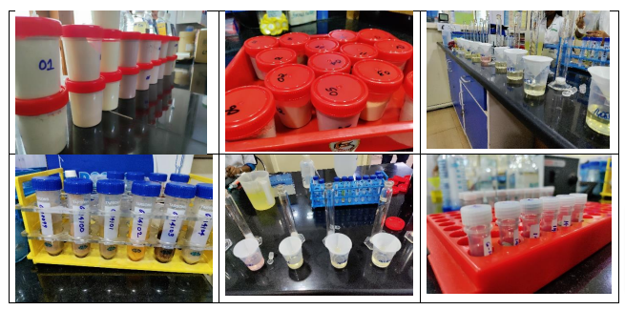
Total protein analysis: The Kjeldahl method was used for estimation of total protein on the Pelican Digestor and Nitrogen Analyzer (Pelican Equipments, Chennai, India). This method involved a three-step approach to quantification of protein which includes digestion, distillation, and titration. Briefly, 1g of the powder was digested by mixing it with 10ml of concentrated sulfuric acid with the addition of sodium and copper sulphate as catalysts. The mixture was kept in a block digestion system and once the solution became blue in color, it was cooled to room temperature and diluted with 20ml of water and dissolved. The tube of mixture was then set up on the nitrogen distillation system. Water and 40% sodium hydroxide solution (total 50ml) was added to the mixture thereafter. This process converts any nitrogen in the sample to ammonium sulphate and then to ammonia, which is thereafter distilled off and collected in receiving flask of 30ml of 4% boric acid, forming ammonium borate. The residual boric acid was titrated with standard 0.1 N hydrochloric acid with the use of a suitable end point indicator to estimate the total nitrogen content of the sample using specific conversion factor (N X 6.25) to convert measured nitrogen to protein. Calculation of protein content was performed using the formula: Protein content in % = titre volume x normality of HCL x 14 x 100 X 6.25 $÷$weight of the sample x 1000.
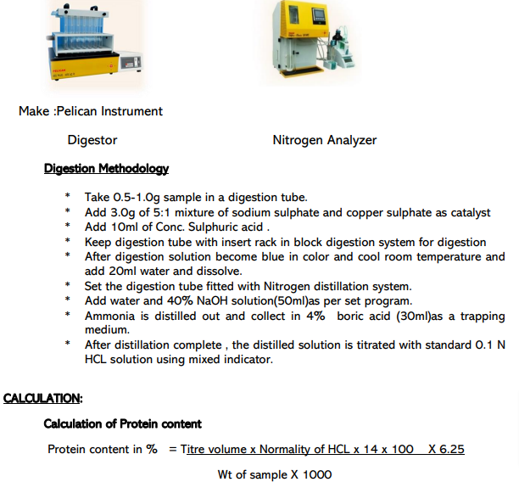
Detection of aflatoxin: Mycotoxins, produced by fungi as secondary metabolites, can infect crops at pre- and post-harvest stages and adversely affect quality of food. Aflatoxin is one of the most prevalent mycotoxins that contaminate foods. They are difuranocumarine derivatives that are mainly produced by Aspergillus flavus. Detection and quantification of aflatoxin was performed as per the Official Analytical Methods of the American Spice Trade Association (ASTA) using high pressure liquid chromatography (HPLC) with fluorescence detection (FLD) technique using the HPLC-FLD Agilent, Model 1260 (Agilent Technologies, California, USA). Briefly, 25g of the protein sample was added to 100ml of methanol-soluble water and blended for 1-2 minutes at high speed and thereafter filtered through fluted paper. 20 ml of the filtrate was made up to 50ml with water and Tween20 added to reduce turbidity. Filtration using microfiber filter paper was performed thereafter and 10ml of the sample solution was passed through the clean-up column. The column was then washed twice with 10ml of methanol-soluble water and eluted with 1ml of 2% acetic acid. This was followed by water wash of 1ml and the final sample was then injected into a standard HPLC-FLD instrument for quantification.
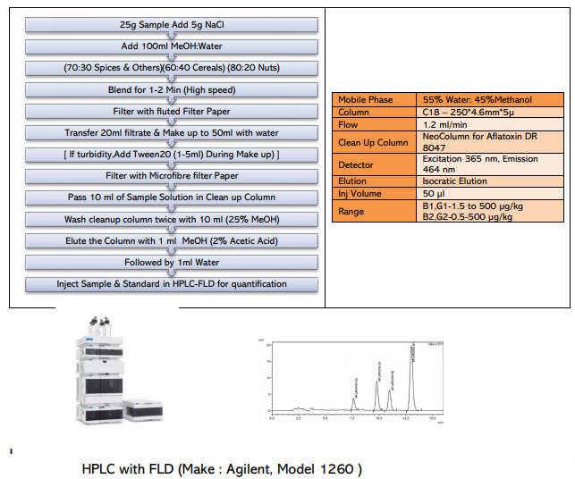
Estimation of pesticides: Pesticides were estimated using the Association of Official Analytical Chemists (AOAC) standard method which utilizes gas and liquid chromatography tandem mass spectrometry (GC- & LC-MS/MS). The GC works on the principle that a mixture will separate into individual substances when heated. The heated gases are carried through a column with an inert gas (such as helium). As the separated substances emerge from the column opening, they flow into the MS. Mass spectrometry identifies compounds by the mass of the analyte molecule. A library of known mass spectra, covering several thousand compounds, is stored on a computer. Mass spectrometry is considered the only definitive analytical detector. Followed by quantification of compounds, a sample solution containing analytes of interest are pumped through a stationary phase (LC column) by a mobile phase flowing through at high pressure. Chemical interaction between the components of the sample, the stationary phase and the mobile phase affects different migration rates through the LC column affecting a separation. After elution from the LC column, the effluent is directed to the mass spectrometer. The mass spectrometer for an LC-MS/MS system has an ionization source where the LC column effluent is nebulized, de-solvated and ionized creating charged particles. The resulting isolated product ions are then quantified with an electron multiplier. This transition of ions from the precursor to product ion (also referred to as MS2) is highly specific to the structure of the compound of interest and therefore provides a high degree of selectivity.
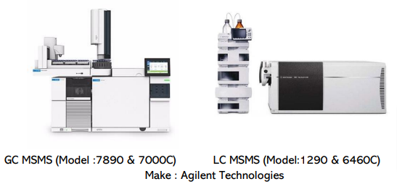
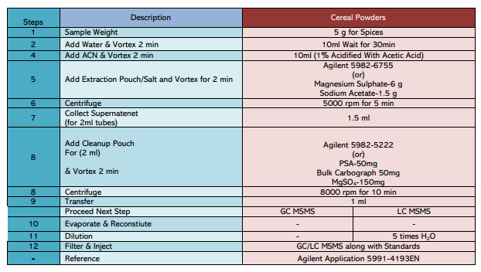
Estimation of heavy metals: Heavy metals were estimated using the AOAC standard method which utilizes inductively coupled plasma mass spectrometry (ICP-MS) technique. Briefly, a fine aerosol of a sample is introduced into a hot (6000–10,000 K) argon plasma column energy to dry the aerosol and form analyte atoms, which are simultaneously ionized. Ions are then sorted and quantified based on their mass-to-charge (m/z) ratio in the mass analyser. Six elements were selected for the quantification and samples preparations were performed using microwave digestion system followed by ICP MS analysis on the Microwave Digestion System by CEM Mars Model 2 (CEM Corporation, North Carolina, USA) and Agilent ICP-MS 7850 (Agilent Technologies, California, USA).
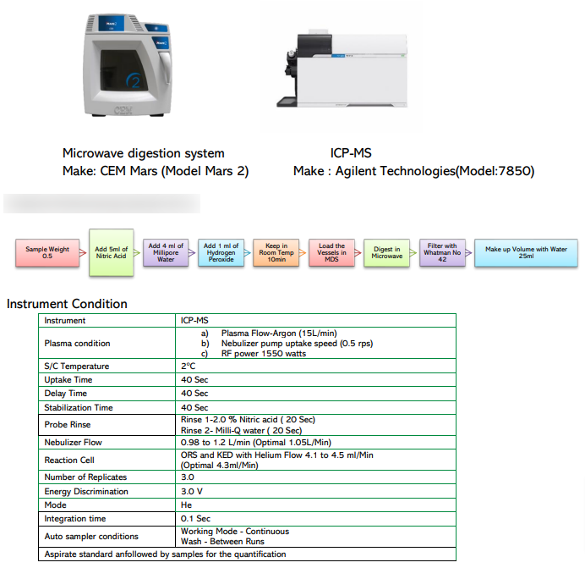
Complete profile scan of powders: A full scan using GC-MS/MS using headspace was performed to identify known or unknown organic and inorganic compounds within the powders analysed. The headspace GC is a sampling and injection technique involving the indirect determination of volatile constituents in liquid or solid samples by analysing the associated vapor phase. In GC/MS, this is referred to as scan mode, where the instrument acquires a continuous range of ion fragmentation data to detect all possible compounds within the sample. All the samples were weighed and directly introduced into headspace and followed by GC-MS scan mode, The area% was calculated based on peak detection and identification done using the updated National Institute of Standards and Technology (NIST) library coupled with the instrument output (Agilent GC-MS with Headspace, Model 7697A, Agilent Technologies, California, USA). The output chromatogram showed Included compounds retention time (RT), molecular formula, match score, area, and area % (as shown in the picture below). According to the NIST MS Library User’s Guide [NIST mass spectral database for NIST/EPA/NIH and mass spectral search program (version 2.3). Natl. Inst. Stand. Technol. Nist 2017, 6, 1–73], match factor (MF) can be classified in the following way: “900 (90%) or greater is an excellent match; 800–900 (80-90%), a good match; 700–800 (70-80%), a fair match and less than 600 (60%) a very poor match.” We considered reporting all compounds with MF ≥70% for the purpose of this study.
