

Supplier & Logistics Payments
How to enter advance and balance bills and payments — step by step, with screenshots
Covers: the supplier (quarry / factory), the CHA and transporter, and the freight forwarder.
Does not cover: money received from the buyer.
For: Accounts, Procurement and Logistics staff · Version 3 — 13 November 2026
All names, numbers and bills in this guide are SAMPLES (TEST-…). They are not real records.

Contents
1. The idea in 5 lines | 3
2. The example order used in this guide | 4
3. Reading a paper bill | 5
A. Supplier advance (Step 7e) | 7
B. Supplier balance (Step 10a) | 10
C. CHA / transport — advance and final bill | 13
D. Freight forwarder — ocean freight bill | 18
E. What you see afterwards | 19
F. 10 common mistakes and how to fix them | 20
G. One-page cheat sheet | 22

Where to open this in the app: on the order page, the link "How to fill this — step-by-step guide with screenshots" on Step 7e, Step 10a and the Logistics Partner Bills card opens the same instructions on screen.

1. The idea in 5 lines
- A proforma asks for money. It is not a cost yet. You pay an advance against it.
- A tax invoice is the real bill. It is the cost of the order.
- The advance is paid against the proforma. The app shows it as "paid, not a cost yet".
- The final tax invoice replaces the proforma. When you add it, you pick the proforma it replaces, so the advance already paid counts towards it.
- Balance = bill total − advance already paid. The app works it out and shows it as "Due". Every payment needs the bank UTR.

Golden rule for the "Taxable value" box: it is the amount before GST, and for a tax invoice it is the whole invoice, never the balance. The app adds the GST and takes off the advance for you.

The flow at a glance
Who | First (advance) | Then (final / balance)
Supplier | Step 7e: add the proforma → Mark Paid (amount, date, mode, UTR) | Step 10a: add the tax invoice, pick the proforma it replaces → Mark Paid the Due amount
CHA / transport | Logistics Partner Bills: add an Advance + Proforma bill → Mark Paid | Add a Final + Tax invoice bill, pick the proforma → Mark Paid the Due amount (CFR/CIF: only after Step 9d)
Freight forwarder | (optional) Advance + Proforma, as for the CHA | Add For = Ocean freight, Final + Tax invoice → Mark Paid

2. The example order used in this guide
Who | What they asked for
Supplier (Sample Quarry) | Supplier PO SC/SPO/26/GUIDE457: ₹45,000.00 before GST + 5% GST ₹2,250.00 = ₹47,250.00. Terms: 30% advance = ₹14,175.00, balance ₹33,075.00 before packing.
CHA & transport (Sample CHA & Transport) | One combined bill: ₹1,00,000.00 + 18% GST ₹18,000.00 = ₹1,18,000.00. First an advance proforma asking for ₹25,000.00 now, later the tax invoice. Balance ₹93,000.00.
Freight forwarder (Sample Freight Forwarder) | Ocean freight tax invoice ₹85,000.00, no GST (0%).

The sums, worked out
Line | Supplier | CHA & transport
Taxable value (before GST) | 45,000.00 | 1,00,000.00
GST | 5% = 2,250.00 | 18% = 18,000.00
Bill total | 47,250.00 | 1,18,000.00
Advance paid on the proforma | 14,175.00 (30%) | 25,000.00
Balance to pay on the tax invoice | 47,250.00 − 14,175.00 = 33,075.00 | 1,18,000.00 − 25,000.00 = 93,000.00

3. Reading a paper bill
Every bill shows the same few figures. This sample tax invoice shows where each one is and which box it goes into.
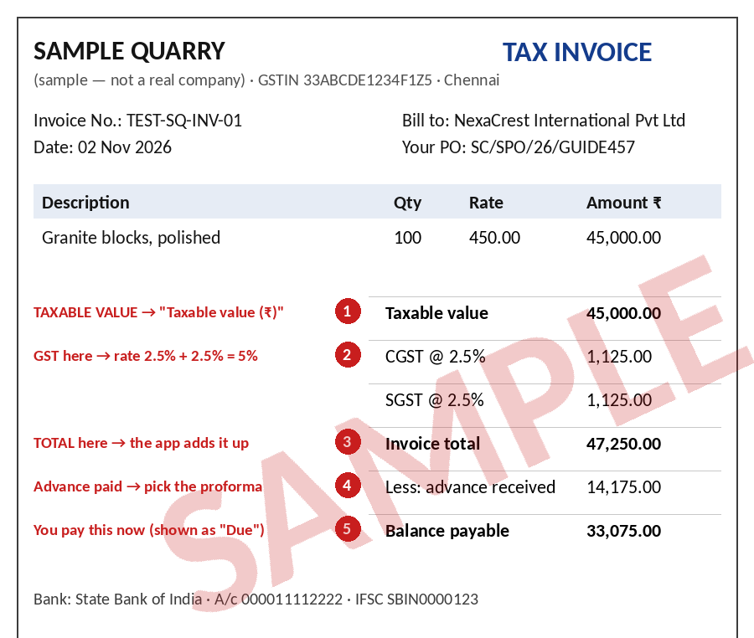
SAMPLE — not a real bill. Red numbers show where each figure is.
No. | Field | What to type | Where it comes from
1 | Taxable value (₹) | The amount before GST: 45,000.00 | "Taxable value" / "Sub-total" / "Assessable value" — the line just above CGST/SGST/IGST
2 | GST rate (%) | CGST + SGST added up (2.5% + 2.5% = 5%), or the IGST rate | The GST lines
3 | Bill total | Nothing — the app adds it up (47,250.00) | "Invoice total" / "Grand total"
4 | Advance already paid on a proforma | Pick the proforma you paid (only on a tax invoice) | "Less: advance received"
5 | Amount to pay | Already filled in as "Due" (33,075.00) | "Balance payable"

Where the UTR is
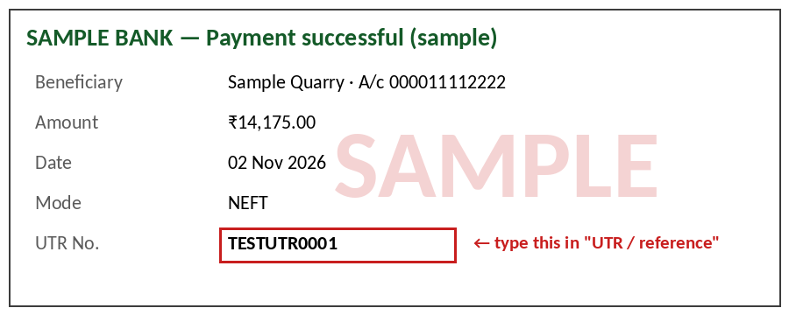
SAMPLE bank confirmation — the UTR goes in the "UTR / reference" box of every payment.

A. Supplier advance (Step 7e)
Open the order → Step 7e · Supplier Advance Paid → click + Add the supplier's advance bill. The taxable value, GST rate and amount asked now are already filled in from the Supplier PO — check them against the paper bill and change them only if the bill shows something different.
Where the Supplier PO figures come from (since 13 Nov 2026): on Step 7a · Save Supplier PO Terms the supplier and the unit price are chosen from the table of the product's supplier offers (the price the supplier quoted, per SQM, SQFT or CBM). If a different price was agreed with the supplier, it is typed there with a reason. The Supplier PO prints every rupee amount in Indian grouping (₹1,18,000.00). Steps 7e and 10a start from that PO, so check the paper bill against it as below.

A1. Add the supplier's advance bill (proforma)
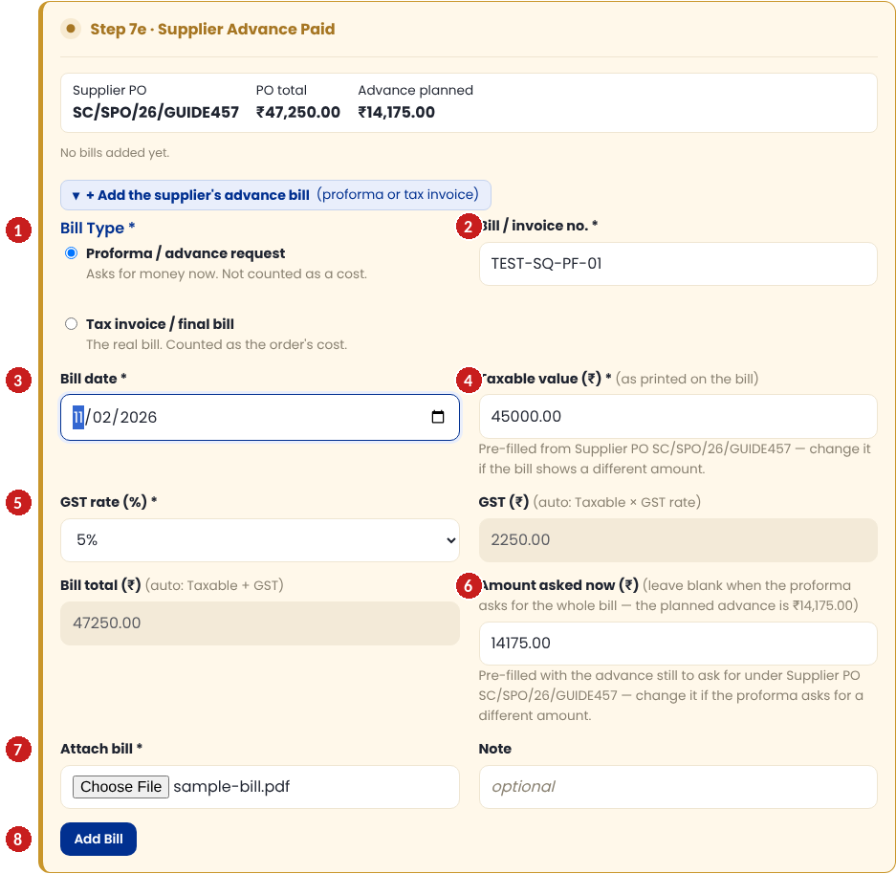
No. | Field | What to type | Where it comes from
1 | Bill type | Proforma / advance request (most advances). Tax invoice only if the supplier sent a real GST invoice for the advance. | Title on the paper: "Proforma Invoice" / "Advance request" → proforma; "Tax Invoice" → tax invoice
2 | Bill / invoice no. | Exactly as printed, e.g. TEST-SQ-PF-01 | "Invoice No." / "PI No." at the top
3 | Bill date | The date printed on the bill (not today, unless it is today's bill) | "Date" at the top
4 | Taxable value (₹) | Amount before GST: 45,000.00 (pre-filled from the PO) | The line just above CGST/SGST/IGST
5 | GST rate (%) | 5% (pre-filled). GST ₹ and Bill total ₹ fill themselves in | CGST + SGST added up, or IGST
6 | Amount asked now (₹) | What this proforma asks you to pay now: 14,175.00 (pre-filled with the planned advance). Leave blank if it asks for the whole bill. | "Advance payable" / "Amount due now"
7 | Attach bill | The scan or PDF of the bill | —
8 | Add Bill | Click to save | —

A2. Record the advance payment
After the money has left the bank, click Mark Paid on the bill's row. First check that Pay to shows ✓ Verified — never pay to unverified bank details.
To pay now (3 Nov 2026): above the amount, every payment form now shows, read-only, what is to be paid now and how the app worked it out — e.g. "To pay now: ₹33,075.00 (bill total ₹47,250.00 − advance paid on proforma TEST-SQ-PF-01 ₹14,175.00)". Steps 7e and 10a also show "Advance to pay now" / "Balance to pay now" from the Supplier PO. Compare it with what the supplier asks for before you pay.

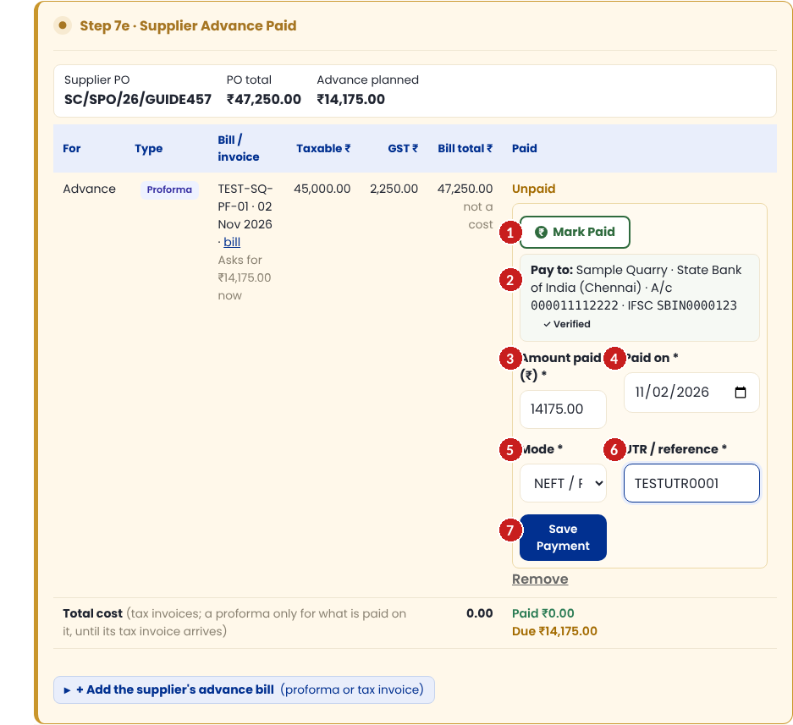
No. | Field | What to type | Where it comes from
1 | Mark Paid | Click to open the payment form | —
2 | Pay to | Check the bank details show ✓ Verified | Supplier's verified bank details
3 | Amount paid (₹) | What actually left the bank: 14,175.00 (pre-filled with what is due) | Your bank's transfer confirmation
4 | Paid on | The transfer date | Bank confirmation / statement
5 | Mode | NEFT / RTGS, IMPS, UPI or Cheque | How you paid
6 | UTR / reference | Always the UTR (cheque no. for a cheque) — the app refuses to save without it | "UTR No." / "Transaction reference" on the bank confirmation
7 | Save Payment | Click to save | —

A3. What you see afterwards
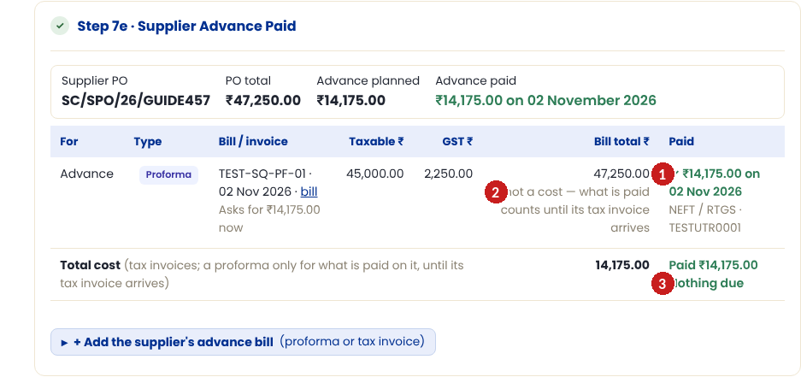
No. | Field | What to type | Where it comes from
1 | Paid | ✓ ₹14,175.00 on 02 Nov 2026 with mode and UTR | —
2 | "not a cost" | A paid proforma is not a cost yet — only what was paid counts until the tax invoice arrives | —
3 | Total | Paid ₹14,175.00 · Nothing due on this proforma | —

B. Supplier balance (Step 10a)
When the supplier sends the real tax invoice (before packing), open Step 10a · Supplier Balance Paid → + Add the supplier's balance bill.
Most important box: "Advance already paid on a proforma" — pick the proforma from A1. That is what makes the ₹14,175.00 you already paid count towards this invoice.

B1. Add the supplier's tax invoice
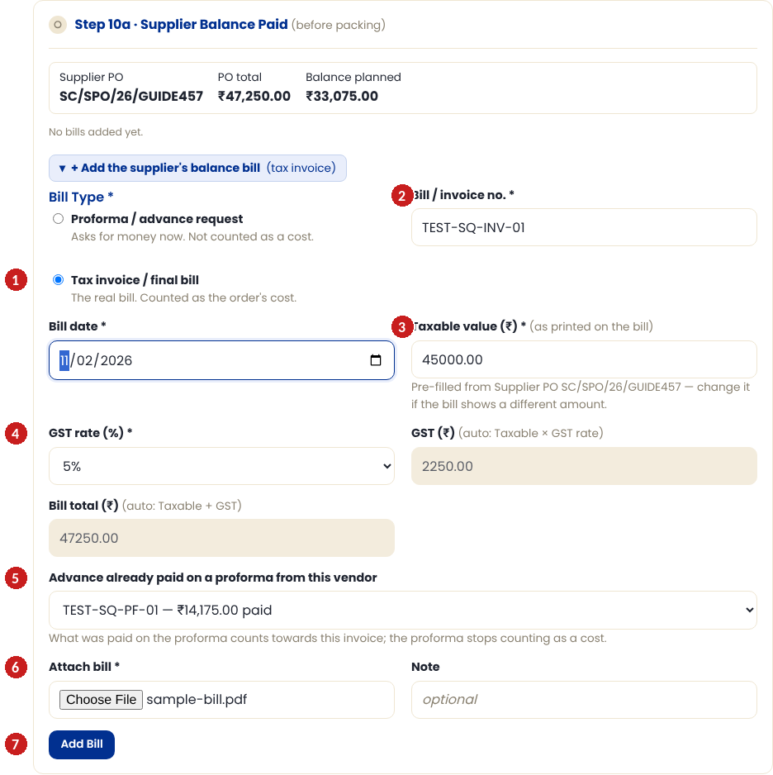
No. | Field | What to type | Where it comes from
1 | Bill type | Tax invoice / final bill | "Tax Invoice" at the top
2 | Bill / invoice no. and date | As printed, e.g. TEST-SQ-INV-01 | Top of the invoice
3 | Taxable value (₹) | The whole invoice before GST: 45,000.00 (pre-filled from the PO). Not the balance. | "Taxable value" line
4 | GST rate (%) | 5% | CGST + SGST, or IGST
5 | Advance already paid on a proforma | The proforma from A1 (TEST-SQ-PF-01) | "Less: advance received"
6 | Attach bill | The scan or PDF | —
7 | Add Bill | Click to save | —

B2. Pay the balance
The row now shows the advance already paid and Due ₹33,075.00 (bill total ₹47,250.00 − advance ₹14,175.00). Click Mark Paid — the amount is pre-filled with that balance.
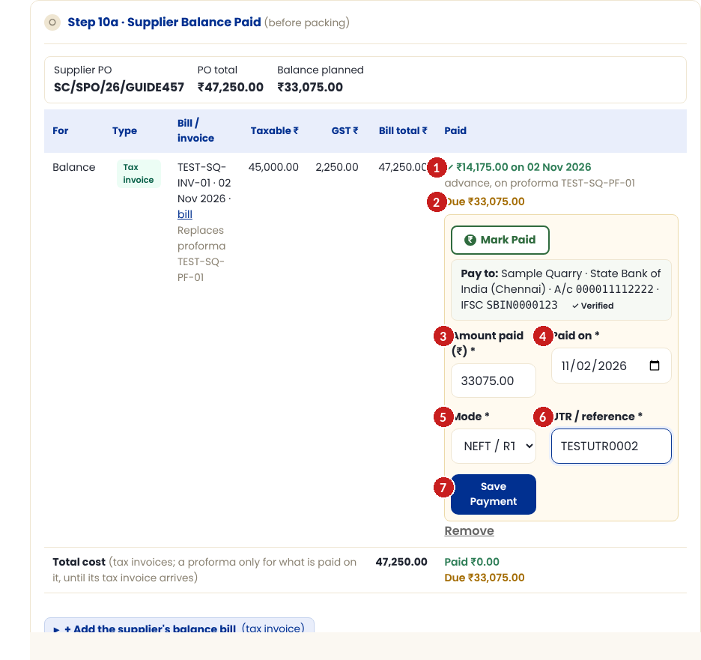
No. | Field | What to type | Where it comes from
1 | Advance shown | ✓ ₹14,175.00 — advance, on proforma TEST-SQ-PF-01. Nothing to type | —
2 | Due | ₹33,075.00 — what is left to pay | "Balance payable" on the invoice
3 | Amount paid (₹) | 33,075.00 (pre-filled) — change only if you paid a different amount | Bank confirmation
4 | Paid on | The transfer date | Bank confirmation
5 | UTR / reference | The UTR of this payment (a new one, not the advance's) | Bank confirmation
6 | Save Payment | Click to save | —

B3. Done
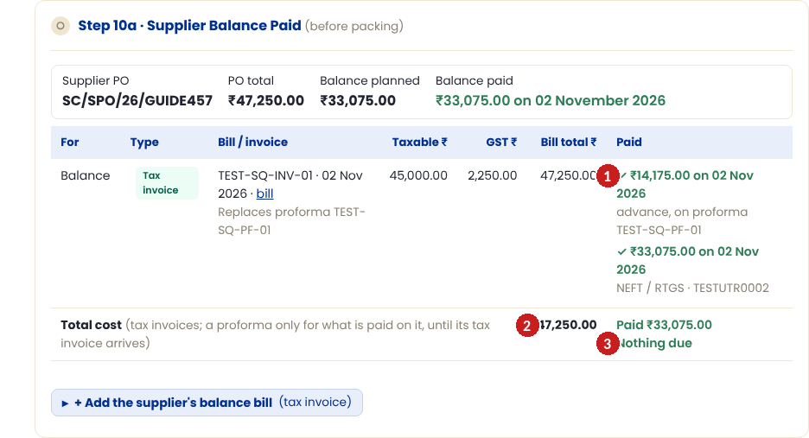
No. | Field | What to type | Where it comes from
1 | Paid | Both payments listed: the advance (on the proforma) and the balance with its UTR | —
2 | Total cost | ₹47,250.00 — the tax invoice is now the order's cost; the proforma no longer counts separately | —
3 | Nothing due | This bill is fully paid | —

C. CHA / transport — advance and final bill
All CHA, transport and freight forwarder bills go in the Logistics Partner Bills & Payments card on the order page. One row per bill. A partner doing both CHA and transport can send one combined bill (For = "CHA + Transport (one bill)") or separate bills.
Who does what: Logistics (Executive / Manager / Director) adds the partner's bill as soon as it arrives; Accounts / Finance records the payment and its UTR. On a Logistics login the bill row says "Accounts records the payment." instead of a Mark Paid button.

CFR / CIF orders: an Advance bill can be paid any time. A Final bill can be paid only after the buyer's Debit Note payment has cleared (Step 9d). On FOB orders both can be paid any time.

C1. Add the partner's advance proforma
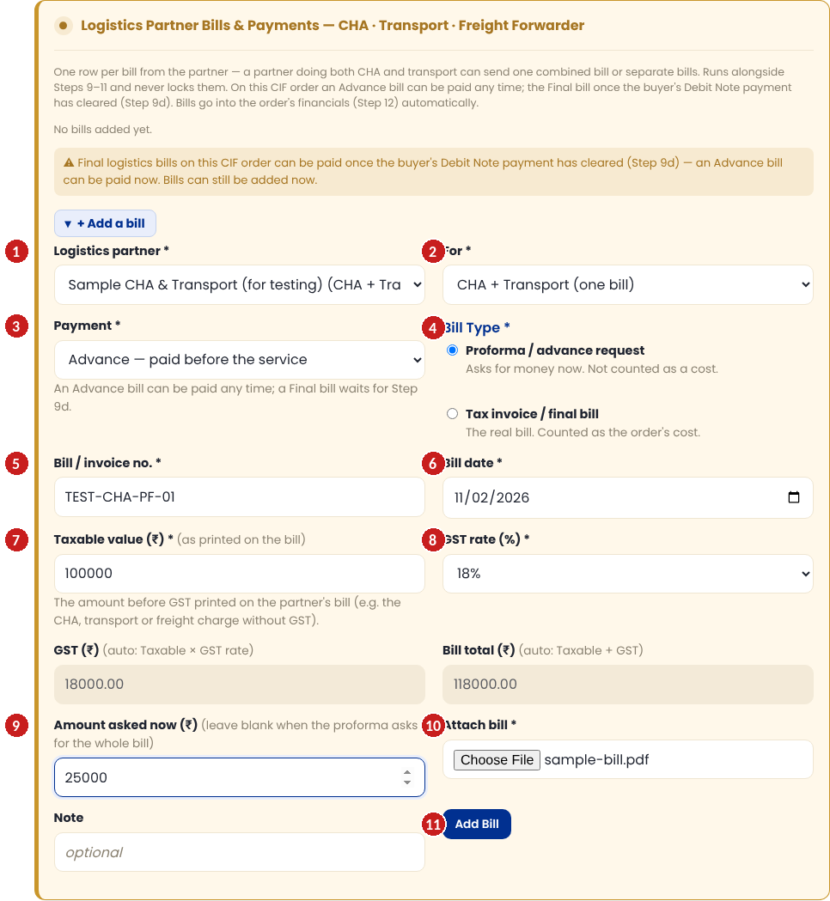
No. | Field | What to type | Where it comes from
1 | Logistics partner | Sample CHA & Transport | Letterhead of the bill
2 | For | CHA + Transport (one bill) — or CHA charges / Transport / Ocean freight / Other | What the bill is for
3 | Payment | Advance — paid before the service | "Advance" / "Proforma" on the paper
4 | Bill type | Proforma / advance request — picked for you when Payment is Advance (Final picks Tax invoice / final bill) | "Proforma Invoice"
5 | Bill / invoice no. | As printed, e.g. TEST-CHA-PF-01 | Top of the bill
6 | Bill date | Date printed on the bill | Top of the bill
7 | Taxable value (₹) | 1,00,000.00 — before GST. No pre-fill here (there is no PO for partners) | Line above the GST
8 | GST rate (%) | 18%. A road transporter under reverse charge (no GST on the bill): pick 0% and "Reverse charge" | GST line, or "reverse charge" / GTA note
9 | Amount asked now (₹) | 25,000.00 | "Advance payable"
10 | Attach bill | The scan or PDF | —
11 | Add Bill | Click to save | —

C2. Record the advance payment
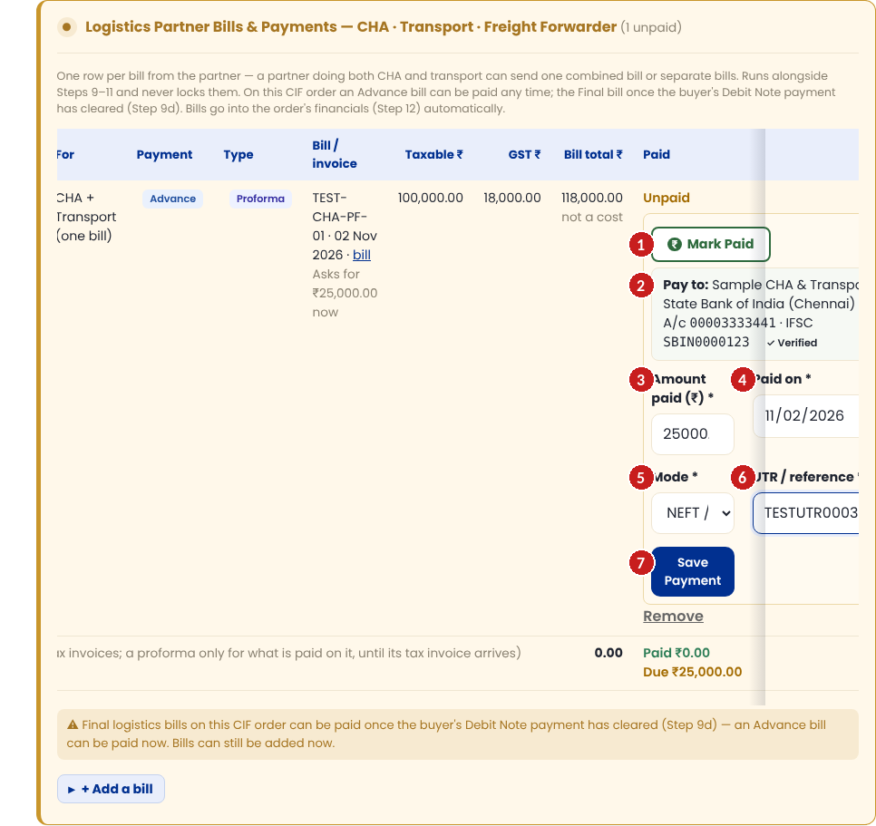
No. | Field | What to type | Where it comes from
1 | Mark Paid | Click to open the payment form | —
2 | Pay to | Check ✓ Verified | Partner's verified bank details
3 | Amount paid (₹) | 25,000.00 | Bank confirmation
4 | Paid on | Transfer date | Bank confirmation
5 | Mode | NEFT / RTGS etc. | How you paid
6 | UTR / reference | The UTR — always | Bank confirmation
7 | Save Payment | Click to save | —

C3. Add the partner's final tax invoice
When the service is done, click + Add a bill again and add their tax invoice.
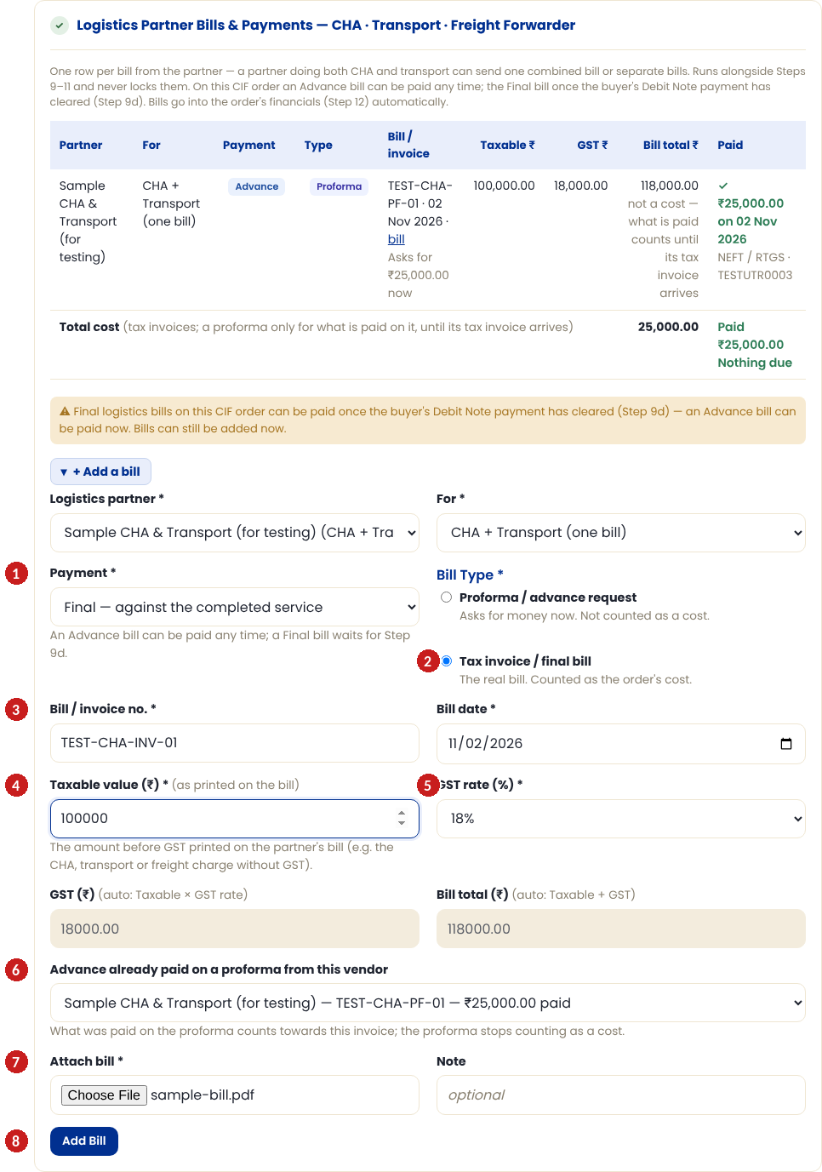
No. | Field | What to type | Where it comes from
1 | Payment | Final — against the completed service | —
2 | Bill type | Tax invoice / final bill | "Tax Invoice"
3 | Bill / invoice no. | TEST-CHA-INV-01 | Top of the invoice
4 | Taxable value (₹) | The whole invoice before GST: 1,00,000.00 — not the balance | "Taxable value"
5 | GST rate (%) | 18% | GST lines
6 | Advance already paid on a proforma | Pick the proforma from C1 (TEST-CHA-PF-01 — ₹25,000.00 paid) | "Less: advance"
7 | Attach bill | The scan or PDF | —
8 | Add Bill | Click to save | —

C4. The balance — and the Step 9d rule
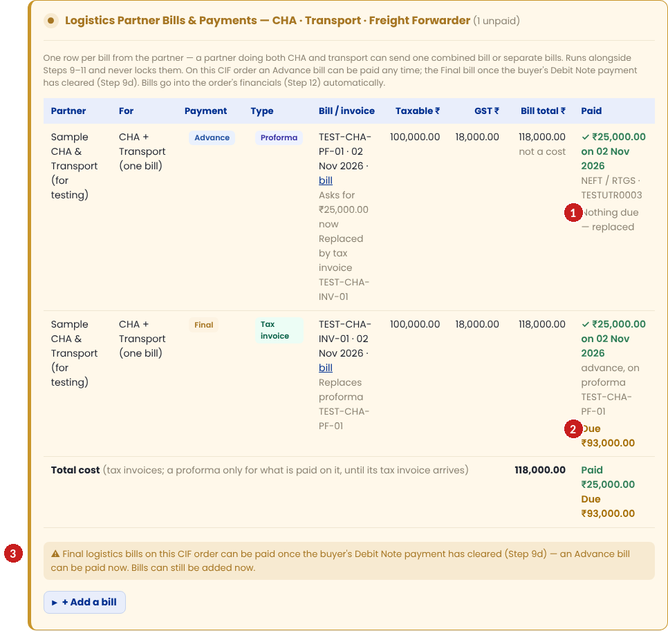
No. | Field | What to type | Where it comes from
1 | Proforma row | "Nothing due — replaced": its ₹25,000.00 now counts towards the tax invoice | —
2 | Tax invoice row | ₹25,000.00 advance shown, Due ₹93,000.00 | —
3 | Yellow note | On CFR/CIF the final bill waits for Step 9d. Once the buyer's Debit Note payment has cleared, Mark Paid appears on the row — pay ₹93,000.00 with the UTR, as in C2 | —

D. Freight forwarder — ocean freight bill
Add the forwarder's bill in the same Logistics Partner Bills card with For = Ocean freight. In Step 9a you saved the confirmed freight rate (what the buyer is charged on the Debit Note). Once an ocean freight bill is added, the order's freight cost comes from this bill, in rupees, instead of the Step 9a rate.
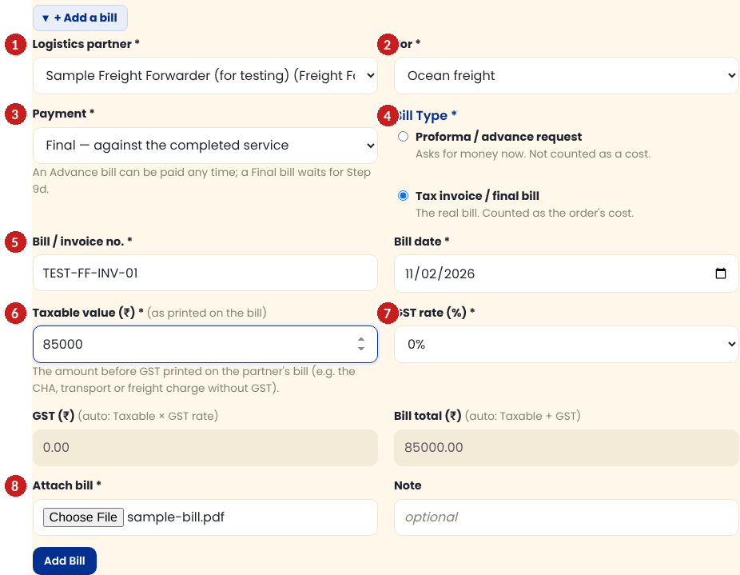
No. | Field | What to type | Where it comes from
1 | Logistics partner | The forwarder (usually the one picked in Step 9a) | Letterhead
2 | For | Ocean freight | —
3 | Payment | Final (or Advance + Proforma first, exactly as in C1–C3) | —
4 | Bill type | Tax invoice / final bill | "Tax Invoice"
5 | Bill / invoice no. and date | As printed, e.g. TEST-FF-INV-01 | Top of the bill
6 | Taxable value (₹) | The rupee amount before GST: 85,000.00 | Forwarder's bill
7 | GST rate (%) | Often 0% on export ocean freight — use what the bill shows | GST line
8 | Attach bill | Scan or PDF, then Add Bill and pay with Mark Paid + UTR | —

If the forwarder bills in USD/EUR, enter the rupee amount shown on the bill or charged by your bank, not the foreign amount.

E. What you see afterwards
When it reaches Zoho Books: saving a bill or a payment does not send it to Zoho Books at that moment. It goes at the next sync — the hourly automatic sync, or Sync Now / Sync this order to Zoho now. Until then the order page shows "Waiting for Zoho: N" (Finance and management see it); if a sync fails, Finance gets an e-mail listing what could not be sent.

What the row says | What it means | What to do
Unpaid | The bill is saved, nothing paid yet | Pay it with Mark Paid when due
✓ ₹… on <date> · mode · UTR | A payment is recorded | Nothing
not a cost — what is paid counts until its tax invoice arrives | A paid proforma. The paid amount counts for now | Add the tax invoice when it comes, and pick this proforma
Nothing due — replaced | The proforma has been replaced by a tax invoice | Nothing
Due ₹… | Still to pay on this bill | Pay it with Mark Paid
Total cost | Tax invoices, plus proformas only for what is paid on them | Check it matches the bills you hold
Nothing due | Every bill on this card is fully paid | Nothing
Yellow note about Step 9d | CFR/CIF: a Final logistics bill cannot be paid until the buyer's freight payment has cleared | Wait for Step 9d, then pay

The supplier and logistics costs go into the order's financials (Step 12) automatically.

F. 10 common mistakes and how to fix them

1. Wrong bill type
What happens: An advance request saved as a Tax invoice (it is counted as a cost twice once the real invoice comes), or a tax invoice saved as a Proforma.
How to fix it: Before any payment: click Remove on the bill row and add it again with the right type. Once a payment is on it, the bill stays on record and cannot be removed — tell Accounts straight away so they can correct it with the supplier and the CA.

2. GST-inclusive amount typed as taxable
What happens: Typing 47,250 as taxable makes the bill ₹49,612.50.
How to fix it: Remove the bill and add it again with the amount before GST (45,000.00).

3. Balance typed as taxable on the tax invoice
What happens: Typing 33,075 as taxable — the app then takes the advance off again.
How to fix it: Taxable value is always the whole invoice before GST. Remove and re-add.

4. Forgot the UTR
What happens: The app refuses to save a payment without it.
How to fix it: Get the UTR from the bank confirmation or statement, then save.

5. Paid a Final logistics bill before Step 9d (CFR/CIF)
What happens: The app does not show Mark Paid until Step 9d. If the money already left the bank, the payment cannot be recorded yet.
How to fix it: Tell Accounts. Record the payment as soon as Step 9d is cleared, with the real transfer date and UTR.

6. Proforma counted as a cost
What happens: A proforma with no tax invoice after it stays "paid, not a cost yet".
How to fix it: Ask the supplier/partner for the tax invoice and add it, picking the proforma it replaces.

7. Partial payments
What happens: You paid only part of what is due.
How to fix it: Enter what actually left the bank. The rest stays as "Due"; pay it later with another Mark Paid and its own UTR.

8. Bank charges deducted
What happens: The bank took a fee and the supplier received less.
How to fix it: Enter the amount the supplier was paid for the bill. Record the bank fee separately as an order cost: Step 12a → + Add a cost → category Bank Charges — never inside the bill.

9. Wrong partner or wrong date
What happens: The bill is on the wrong partner or has today's date instead of the bill date.
How to fix it: No payment yet: click Remove and add it again correctly. Already paid: the bill cannot be removed — tell Accounts so they can correct it with the partner and the CA.

10. Duplicate bill
What happens: The same bill added twice.
How to fix it: Click Remove on the duplicate row (the one without a payment). Never pay both.
How to remove or correct an entry: a bill with no payment can be removed with Remove on its row (the removal is recorded in the audit log), then added again correctly. A bill that already has a payment stays on record and cannot be removed in the app — check every figure before you click Save Payment, and if a paid bill is wrong, tell Accounts at once so they can correct it with the supplier/partner and the CA. Never edit Zoho by hand to "fix" a bill.

G. One-page cheat sheet
Situation | Where | Payment / Bill type | Taxable value | Pick proforma? | Pay
Supplier asks for advance | Step 7e | — / Proforma | Before GST (pre-filled) | No | Mark Paid: advance + UTR
Supplier sends tax invoice | Step 10a | — / Tax invoice | WHOLE invoice before GST | Yes | Mark Paid: the Due + UTR
CHA/transport advance | Logistics Partner Bills | Advance / Proforma | Before GST | No | Any time
CHA/transport final | Logistics Partner Bills | Final / Tax invoice | WHOLE invoice before GST | Yes | CFR/CIF: after Step 9d
Freight forwarder | Logistics Partner Bills, For = Ocean freight | Final / Tax invoice | Rupee amount before GST | If you paid a proforma | CFR/CIF: after Step 9d

Before every payment
- "Pay to" shows ✓ Verified
- Amount = what actually leaves the bank
- Date = the transfer date
- UTR typed exactly as on the bank confirmation
- Bill scan attached

Remember
- Taxable value = before GST
- Tax invoice taxable = whole invoice, never the balance
- Advance request = Proforma
- Tax invoice → pick the proforma it replaces
- On screen: the "How to fill this" link on Step 7e, Step 10a and the Logistics Partner Bills card

