NEXACREST INTERNATIONAL PRIVATE LIMITED  ANNEXURE A — PRODUCT TECHNICAL SPECIFICATIONS | Quotation No.: [SC/QT/YYYY/DDMMNNN]  Annexure forms part of the Quotation above.

Note: All images, drawings, and photographs in this Annexure are for product identification purposes only and do not constitute agreed specifications. The binding specifications are the dimensions, finish, and material stated in the text table for each product. Any variation between images and delivered product that is within the stated dimensions and finish standards is not a defect. Natural stone characteristics including colour variation, veining, and texture may differ between pieces. Where products meet the stated specifications, such variation is not a defect. Actual product appearance may differ due to the Natural Variation of granite.

PRODUCT 1 — European-Style Full Cover Grave Monument Set

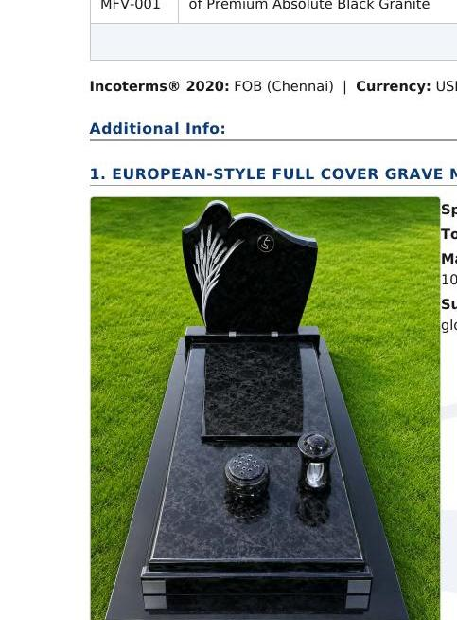 | Product Code: SCI-AB-MS-001  European-Style Full Cover Grave Monument Set  Material: Premium Grade-A Southern Indian Absolute Black Granite, 100% Natural, Un-dyed  Surface Finish: All visible faces mirror-polished to minimum 95+ gloss rating  HS Code: 6802.93 — Worked Monumental Granite  Country of Origin: India  Total Net Volume: 0.235 m³ (approx. — actuals confirmed on Packing List)  Includes: Monument frame, cover slab, headstone, base supports — complete set as per technical drawing

Technical Drawing & Component Dimensions
Terms used in this document are defined in Section 8 — Legal Terms & Definitions at the end of this document.
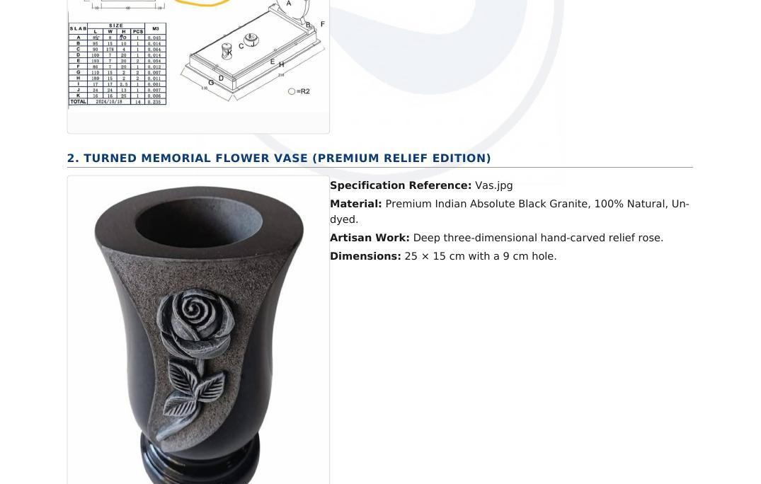 | Component Dimensions
  Slab | L (cm) | W (cm) | H (cm) | Pcs | m³
  A | 45 | 6 | 40 | 1 | 0.011
  B | 80 | 17 | 10 | 1 | 0.014
  C | 80 | 178 | 4 | 1 | 0.057
  D | 102 | 7 | 20 | 1 | 0.014
  E | 193 | 7 | 20 | 1 | 0.027
  F | 60 | 7 | 20 | 1 | 0.008
  G | 110 | 15 | 2 | 2 | 0.007
  H | 100 | 15 | 2 | 2 | 0.006
  J | 17 | 11 | 11 | 2 | 0.004
  K | 84 | 24 | 11 | 1 | 0.022
  TOTAL |  |  |  | 14 | 0.235

PRODUCT 2 — Turned Memorial Flower Vase (Premium Relief Edition)

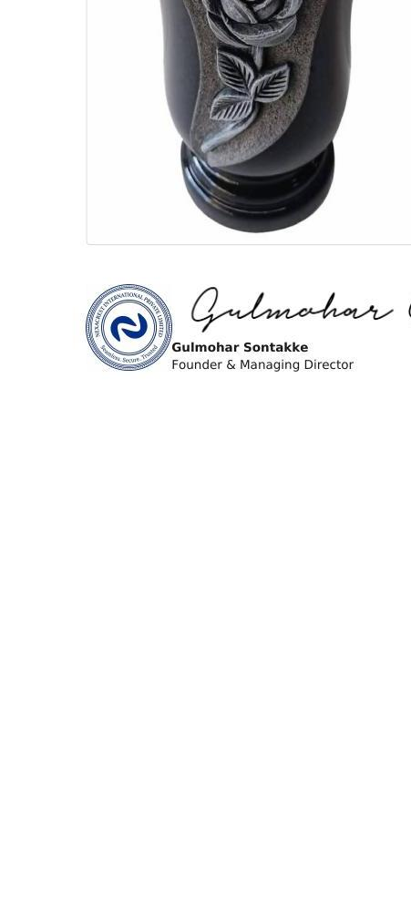 | Product Code: SCI-AB-MFV-001  Turned Memorial Flower Vase — Premium Relief Edition  Material: Premium Indian Absolute Black Granite, 100% Natural, Un-dyed  Artisan Work: Deep 3D hand-carved relief rose — each piece individually carved  Dimensions: Height: 25 cm | Diameter: 15 cm | Hole diameter: 9 cm  Surface Finish: Exterior: mirror-polished | Carved rose area: natural/rough contrast  HS Code: 6802.93 — Worked Monumental Granite  Country of Origin: India  Note: Due to handcrafted nature, slight variation in rose carving pattern is natural and expected.

This Annexure A forms an integral part of [Quotation No. SC/QT/YYYY/DDMMNNN / Proforma Invoice No. SC/PI/YYYY/DDMMNNN] dated [DD Month YYYY]. The commercial terms, pricing, payment conditions, and quantities stated in the main document take precedence in all cases. Product images and technical drawings in this annexure are for reference and identification purposes only. This Annexure is not valid as a standalone document.

TERMS & CONDITIONS

8. LEGAL TERMS & DEFINITIONS

LEGAL TERMS
These terms govern all commercial obligations under this document.
• Cancellation: Orders may not be cancelled after production commences. The Advance Payment is non-refundable once production commences. In the event of cancellation after production commences, NexaCrest's total recovery shall not exceed the Advance Payment plus 20% of the total FOB Order value. The parties agree this represents a genuine pre-estimate of NexaCrest's unrecoverable production costs, overhead, opportunity loss, and market price risk.
• Limitation of Liability: NexaCrest's maximum liability under this document shall not exceed the total FOB Order value stated herein. NexaCrest is not liable for any indirect, consequential, or punitive damages, or for loss of profit or business.
• Production Timeline: The estimated shipment timeline stated in this document is indicative only and does not constitute a guaranteed delivery date. NexaCrest will make every effort to meet the estimated timeline. NexaCrest will notify the Buyer in writing within 5 Business Days of becoming aware of any delay to production or shipment, and will provide a revised estimated timeline within 10 Business Days of such notification.
• Re-inspection and Loading: NexaCrest shall load only the confirmed passed pieces. Confirmed failed pieces shall be excluded from the shipment. The Commercial Invoice and all payment obligations shall be adjusted to reflect only the pieces actually loaded and shipped. Neither Party shall have any further claim in respect of the excluded pieces.
• Structural Defect Claims: NexaCrest confirms to the best of its knowledge that Products are free from structural defects present at Loading and not detectable at Pre-loading Inspection. No claim accepted for: (a) conditions detectable at Pre-loading Inspection; (b) damage from Buyer's processing, cutting, handling, or installation; or (c) natural stone characteristics. Any claim must be raised by the Buyer in writing with photographic evidence within 14 Calendar Days of confirmed receipt at Buyer's premises. No claim accepted after this period.
• Governing Law and Dispute Resolution: This document is governed by the laws of India. Any dispute shall first be notified in writing by email or WhatsApp. Both parties shall attempt amicable resolution within 45 Calendar Days of written notice. If unresolved, the dispute shall be referred to binding arbitration under the Arbitration and Conciliation Act, 1996. Seat: Bengaluru, Karnataka, India. Language: English. The United Nations Convention on Contracts for the International Sale of Goods does not apply.

DEFINITIONS
The following terms have the meanings given below wherever they appear in this document.
• NexaCrest: In this document, "NexaCrest International Private Limited" is referred to as "NexaCrest". Both names refer to the same legal entity.
• T/T (Telegraphic Transfer): an electronic bank wire transfer sent directly from the Buyer's bank to NexaCrest's designated bank account at State Bank of India as stated in this document.
• Payment Cleared: the relevant payment confirmed as actually credited to NexaCrest's bank account by NexaCrest's accounts team. A Remittance Copy alone does not constitute Payment Cleared.
• Remittance Copy: the bank transfer receipt or SWIFT confirmation sent by the Buyer as evidence of transfer. Receipt of a Remittance Copy by NexaCrest does not constitute Payment Cleared.
• Advance Payment: the advance percentage of the FOB Order value paid by T/T before production commences, as stated in this document.
• Balance Payment: the remaining FOB Order value after the Advance Payment, paid by T/T as per the payment trigger stated in this document.
• Debit Note: a written demand issued by NexaCrest for any agreed cost additional to the FOB Order value, including but not limited to freight, cargo insurance, inspection fees, or certificate fees. Each Debit Note must be confirmed as Payment Cleared before NexaCrest proceeds with the related activity.
• Loading: the physical act of stuffing Products into the container at NexaCrest's designated processing facility. Loading is distinct from Shipment.
• Shipment: the departure of the vessel from the port of loading. Shipment is distinct from Loading and from Delivery.
• FCL (Full Container Load): a shipment occupying one complete container, approximately 24-27 MT including packing. Minimum order quantity is 1 FCL.
• Production Commences: the point at which NexaCrest begins manufacturing the Products for this Order. Production commences only after the Advance Payment is confirmed as Payment Cleared. The Advance Payment is non-refundable from this point.
• Shipment Readiness Confirmation: a written notification from NexaCrest by email or WhatsApp confirming that the Products have passed quality inspection (NexaCrest's internal quality check, or third-party Pre-loading Inspection where applicable), are fully packed, and are ready for vessel booking.

For  NexaCrest International Private Limited   | Authorised Signatory      Gulmohar Sontakke  Founder & Managing Director  NexaCrest International Private Limited

