NEXACREST INTERNATIONAL PRIVATE LIMITED  ANNEXURE A — PRODUCT TECHNICAL SPECIFICATIONS | Quotation No.: SC/QT/YYYY/MMNNN  Annexure forms part of the Quotation above.

Note: Product images and drawings are for reference only and may show optional accessories or decorative elements not included in the quoted price. All binding specifications are as stated in each product section below. Actual product appearance may vary slightly due to the natural characteristics of granite.

PRODUCT 1 — European-Style Full Cover Grave Monument Set

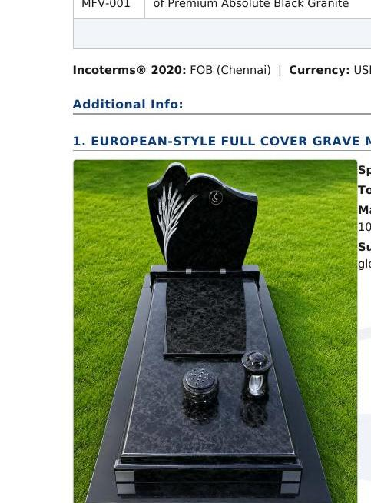 | Product Code: SCI-AB-MS-001  European-Style Full Cover Grave Monument Set  Material: Premium Grade-A Southern Indian Absolute Black Granite, 100% Natural, Un-dyed  Surface Finish: All visible faces mirror-polished to minimum 95+ gloss rating  HS Code: 6802.93 — Worked Monumental Granite  Country of Origin: India  Total Net Volume: 0.235 m³ (approx. — actuals confirmed on Packing List)  Includes: Monument frame, cover slab, headstone, base supports — complete set as per technical drawing

Technical Drawing & Component Dimensions
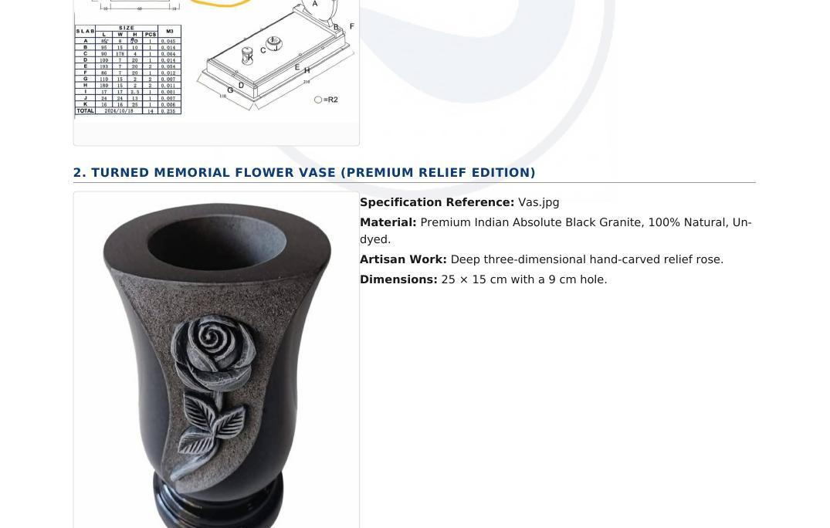 | Component Dimensions
  Slab | L (cm) | W (cm) | H (cm) | Pcs | m³
  A | 45 | 6 | 40 | 1 | 0.011
  B | 80 | 17 | 10 | 1 | 0.014
  C | 80 | 178 | 4 | 1 | 0.057
  D | 102 | 7 | 20 | 1 | 0.014
  E | 193 | 7 | 20 | 1 | 0.027
  F | 60 | 7 | 20 | 1 | 0.008
  G | 110 | 15 | 2 | 2 | 0.007
  H | 100 | 15 | 2 | 2 | 0.006
  J | 17 | 11 | 11 | 2 | 0.004
  K | 84 | 24 | 11 | 1 | 0.022
  TOTAL |  |  |  | 14 | 0.235

PRODUCT 2 — Turned Memorial Flower Vase (Premium Relief Edition)

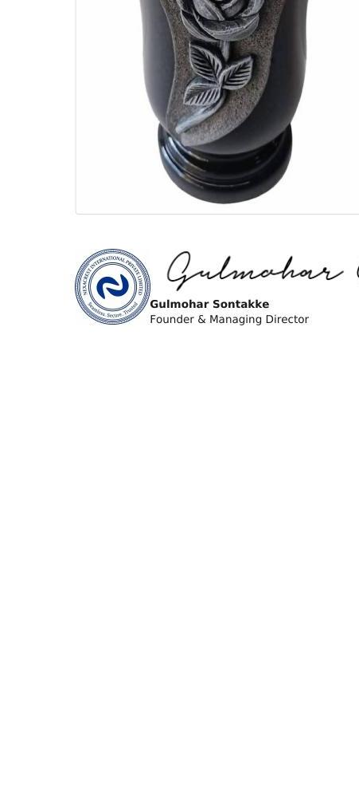 | Product Code: SCI-AB-MFV-001  Turned Memorial Flower Vase — Premium Relief Edition  Material: Premium Indian Absolute Black Granite, 100% Natural, Un-dyed  Artisan Work: Deep 3D hand-carved relief rose — each piece individually carved  Dimensions: Height: 25 cm | Diameter: 15 cm | Hole diameter: 9 cm  Surface Finish: Exterior: mirror-polished | Carved rose area: natural/rough contrast  HS Code: 6802.93 — Worked Monumental Granite  Country of Origin: India  Note: Due to handcrafted nature, slight variation in rose carving pattern is natural and expected.

This Annexure A forms an integral part of [Quotation No. SC/QT/YYYY/DDMMNNN / Proforma Invoice No. SC/PI/YYYY/DDMMNNN] dated [DD Month YYYY]. The commercial terms, pricing, payment conditions, and quantities stated in the main document take precedence in all cases. Product images and technical drawings in this annexure are for reference and identification purposes only. This Annexure is not valid as a standalone document.

For  NexaCrest International Private Limited   | Authorised Signatory      Gulmohar Sontakke  Founder & Managing Director  NexaCrest International Private Limited

