Doctor Portal
Analytics Dashboard
Design Specification & Feature Reference — v1.0 (Prototype Stage)

Anava Clinic — Patient Reported Scale (PRS) Analytics
Covers everything discussed through the working prototype build: dashboard scope, features, underlying data model, visual system, and current build status.

1. Purpose
Doctors treating patients across 14 tracked neurological and psychiatric conditions need one place to see whether a patient is improving, and to triage which of their patients need attention first — without reading raw questionnaire answers or doing normalization math themselves. This dashboard turns the PRS scoring engine's output (a 0–100 severity score per scale and per condition, computed for every assessment a patient completes) into two views a doctor actually uses day to day: a triage list across all their patients, and a full progress history for one patient at a time.
It sits directly on top of the scoring work already built: 37 of 41 PRS scales have a validated scoring method in code today (see Anava_PRS_Scoring_Engine_Specification_v1.docx), and every score this dashboard displays is direction-corrected — a higher number always means worse, regardless of whether the underlying scale is naturally “higher = better” or “higher = worse.”

2. Where This Fits in the Bigger Picture
The dashboard is the last of four layers discussed, each one feeding the next:
- Scale-level scoring — every PRS answer a patient gives is scored into a 0–100 severity value per scale (GAD-7, COMPASS-31, THI, etc.), with a clinical severity label (Normal / Mild / Moderate / Severe / Very Severe).
- Disease composite scoring — the scales mapped to one condition (e.g. ADHD's SNAP-IV, DASS-21, COMPASS-31) are combined with clinical weights into a single composite score for that condition.
- Progress computation — every composite score is compared against the patient's first-ever assessment for that condition (the baseline), producing a delta: how many points better or worse they are now.
- This dashboard — renders all of the above as charts, tables and trend lines a doctor can read at a glance.
DECISION Baseline is always the patient's first-ever completed assessment for a condition, not the start of their current treatment course — this was a deliberate choice made earlier in the discussion, so the dashboard shows lifetime progress rather than resetting every time a new protocol starts.

3. Two Views, One Screen
The dashboard is a single screen with two switchable views — not two separate pages. A doctor lands on the population view first.

3.1 Analytics View (population / triage)
Every patient the doctor tracks for the currently selected condition, side by side, so worsening cases surface immediately instead of requiring the doctor to open each patient individually.

3.2 Patient Detail View (single-patient deep dive)
Opened by clicking any patient row. Shows that one patient's full history — trend, scale-by-scale breakdown, and raw assessment timeline — for whichever of their tracked conditions the doctor selects.
Switching between the two is a single click (“Back to patient list”), and switching condition within the detail view (for a patient tracked on more than one, e.g. ADHD and Tinnitus together) is a tab click that recomputes every chart on the page for that condition.

4. Feature Breakdown

4.1 Analytics View

Condition tabs
One tab per tracked condition (ADHD, Insomnia, Tinnitus, Depression/Anxiety, and the other 10 discussed). Switching tabs re-filters every KPI, both charts, and the table to only the patients tracked for that condition — nothing on the page is condition-agnostic.

Provisional-composite banner
Shown only when the selected condition's composite score is missing a large share of its intended clinical weight — currently ADHD, because ASRS-v1.1 (40%) and EQ-5D-5L (10%) are both still unresolved scales (see Section 5.3). Deliberately styled as a warning banner, not a subtle badge, so it can't be missed or mistaken for a normal informational note.

KPI row (6 cards)
- Patients — how many are tracked for this condition
- Avg Assessments — average number of completed PRS instances and the time span they cover
- Avg Score Change — mean composite delta since baseline across the whole cohort, colored green (improving) or red (worsening)
- Responders — % of patients whose score dropped by 50% or more from baseline
- Remitters — % of patients who reached the “Normal” severity band
- Provisional Scores — % of the cohort whose composite is running on an incomplete formula

Two trend charts
- Mean Composite Score by Visit — the cohort's average score at each visit number, with a shaded band showing the spread across patients and a dashed reference line at the Normal/Mild boundary.
- Scale Trajectories — the mean score of every scale mapped to this condition, plotted as separate lines with a legend, so a doctor can see which specific scale is driving the composite's movement.

Patient data table
One row per patient: name (click to open detail view), first assessment date, assessment count, overall change, and one colored score badge per visit with the point-to-point delta shown underneath. This is the single most information-dense element on the page — a doctor can read an entire patient's trajectory without opening their record.

Sidebar filters
Patient name search is live and actually filters the cohort. Baseline-score range and the “≥2 assessments” checkbox are included in the current build as visual placeholders matching the requested layout — not yet wired to filtering logic (see Section 8).

4.2 Patient Detail View

Identity header
Patient name, avatar, and one tab per condition they're tracked for — tabs carry a small warning icon when that condition's composite is provisional.

Hero stat cards
- Current Composite Score — large number plus its severity label
- Change Since First Assessment — large delta with a direction arrow, colored green/red, captioned “lower score = improvement” so the direction is never ambiguous
- Assessments Completed — total count across general registration, main clinical, and follow-up stages

Composite trend chart
The same 0–20 / 21–40 / 41–60 / 61–80 / 81–100 severity bands used everywhere else in the product, shaded behind the line so the doctor sees not just the trend shape but which clinical zone the patient is in at every visit. Each point is colored by that visit's own severity, and hovering a point shows the exact date, score and label.

Scale comparison radar
One axis per scale mapped to the selected condition. Two overlaid shapes — a dashed outline for baseline, a solid filled shape for the latest visit — so a shrinking shape reads immediately as “getting better” without needing to read any numbers.

Subscale breakdown bars
For scales that have clinical subscales (DASS-21's Depression/Anxiety/Stress, COMPASS-31's six autonomic domains, MFIS's three subscales), a small bar chart at the latest visit, each bar colored by its own severity — so a doctor can see which specific subscale is the problem, not just the scale's overall number.

Individual scale trend cards
Every scale contributing to the composite gets its own small card: a mini trend line, current value, and severity label — the scale-level equivalent of the condition-level chart above it.

Assessment timeline
A chronological list of every PRS instance for this condition, tagged by stage (General Registration, Main Clinical, Follow-up, Device Session) — the raw record a doctor can fall back on if they want to see exactly when and how a score was captured.

Session-by-session sparkline
A separate, higher-frequency mini-trend for PRS captured during device sessions specifically — kept apart from the main follow-up timeline because the two happen on different cadences and answer different questions (“how is this protocol going session to session” vs. “how is the condition trending over months”).

5. How the Data Drives the Dashboard

5.1 From raw answers to a displayed number
- A patient answers a PRS scale's questions during a general registration, main clinical, follow-up, or device-session assessment.
- The scoring engine computes that scale's raw score using its specific method (flat sum for most scales; domain-weighted for COMPASS-31; subscale-split with its own formula for DASS-21, FIQR, MSQ, SNAP-IV, MFIS, SS-QOL, PainDETECT, SLEEP-50).
- The raw score is normalized to 0–100 and direction-corrected, so a higher number always means worse — even for scales like Barthel Index or MoCA where a higher raw score is naturally better.
- Scores for every scale mapped to a condition are combined into that condition's composite using the disease-specific weight table, with any unresolved scale's weight excluded and the remaining weights re-normalized to still total 100%.
- The dashboard reads the resulting per-scale and per-condition scores, plus each instance's timestamp and stage, and renders them as-is — no additional computation happens in the dashboard layer itself.

5.2 Severity bands
Applied consistently everywhere a score appears — the chart backgrounds, the table badges, the KPI cards, the scale cards — so the same color always means the same clinical severity across the entire screen:
Score Range | Severity | Color used
0–20 | Normal | Green
21–40 | Mild | Amber
41–60 | Moderate | Orange
61–80 | Severe | Red
81–100 | Very Severe | Dark Red

5.3 Why some conditions carry a provisional warning
Four scales — PSQI, the Modified Ashworth Scale, the official EQ-5D-5L index, and ASRS-v1.1 — don't yet have a resolved scoring method (see Anava_PRS_Scoring_Engine_Specification_v1.docx, Section 4). Any condition whose composite formula depends heavily on one of these runs on a re-normalized formula missing that scale's weight entirely. ADHD is the clearest case: ASRS-v1.1 and EQ-5D-5L together were over half of its original formula, so its composite today is a weaker signal than the other 13 conditions until those two scales are resolved. The dashboard surfaces this honestly with the amber banner rather than showing a confident-looking number that doesn't deserve the confidence.

6. Visual & Color System
The dashboard uses exactly one color language for clinical meaning — the five-band severity scale above — everywhere data is shown, and a separate, unrelated color (deep teal) purely for navigation chrome (the top bar, active tab underlines). This separation matters clinically: a doctor should never have to wonder whether a color means “severity” or just “this is a button.”
- Color is never the only signal. Every colored score, badge or arrow is paired with a text label (“Severe”, “Worsening”, “+23 pts”) so the dashboard remains legible for colorblind users and in black-and-white printouts.
- Baseline vs. latest comparisons (the radar chart) use shape and line style — dashed outline vs. solid fill — rather than two competing colors, avoiding a second color system fighting the severity scale for attention.
- No decorative color. Every color on the screen carries information; there are no gradient backgrounds or brand-color flourishes competing with the clinical data.
- Large, legible numbers for the two things a doctor checks first — current score and change since baseline — sit in bigger type than any other element on the page.

7. Prototype Screenshots
Captured from the working clickable prototype. All patient names and scores are sample data generated for the design review — not real patient records.
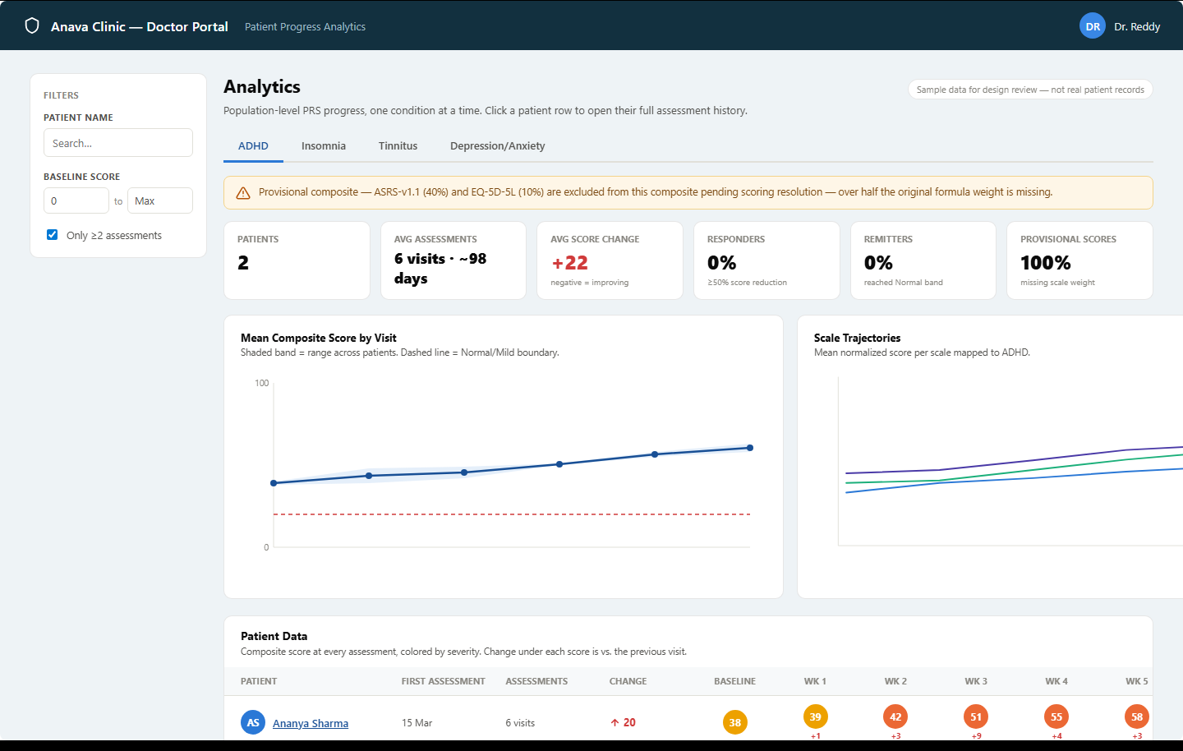
Fig. 1 — Analytics view, ADHD tab selected. Provisional-composite banner, six KPI cards, and the two trend charts.

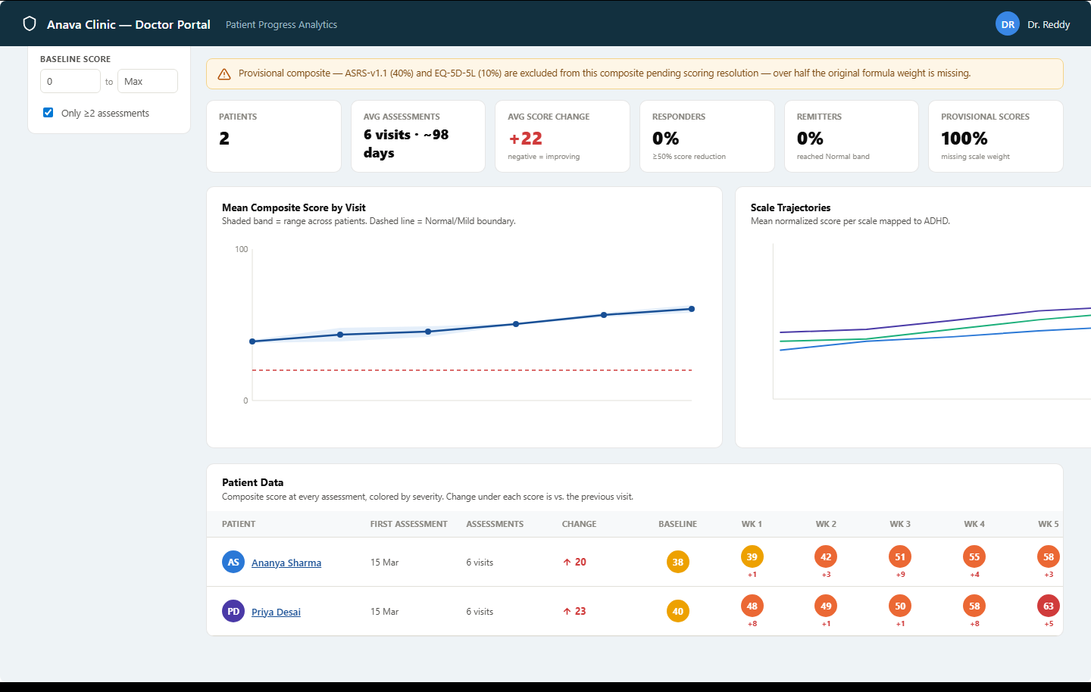
Fig. 2 — Patient data table: one colored score badge per visit, with the point-to-point delta beneath each.

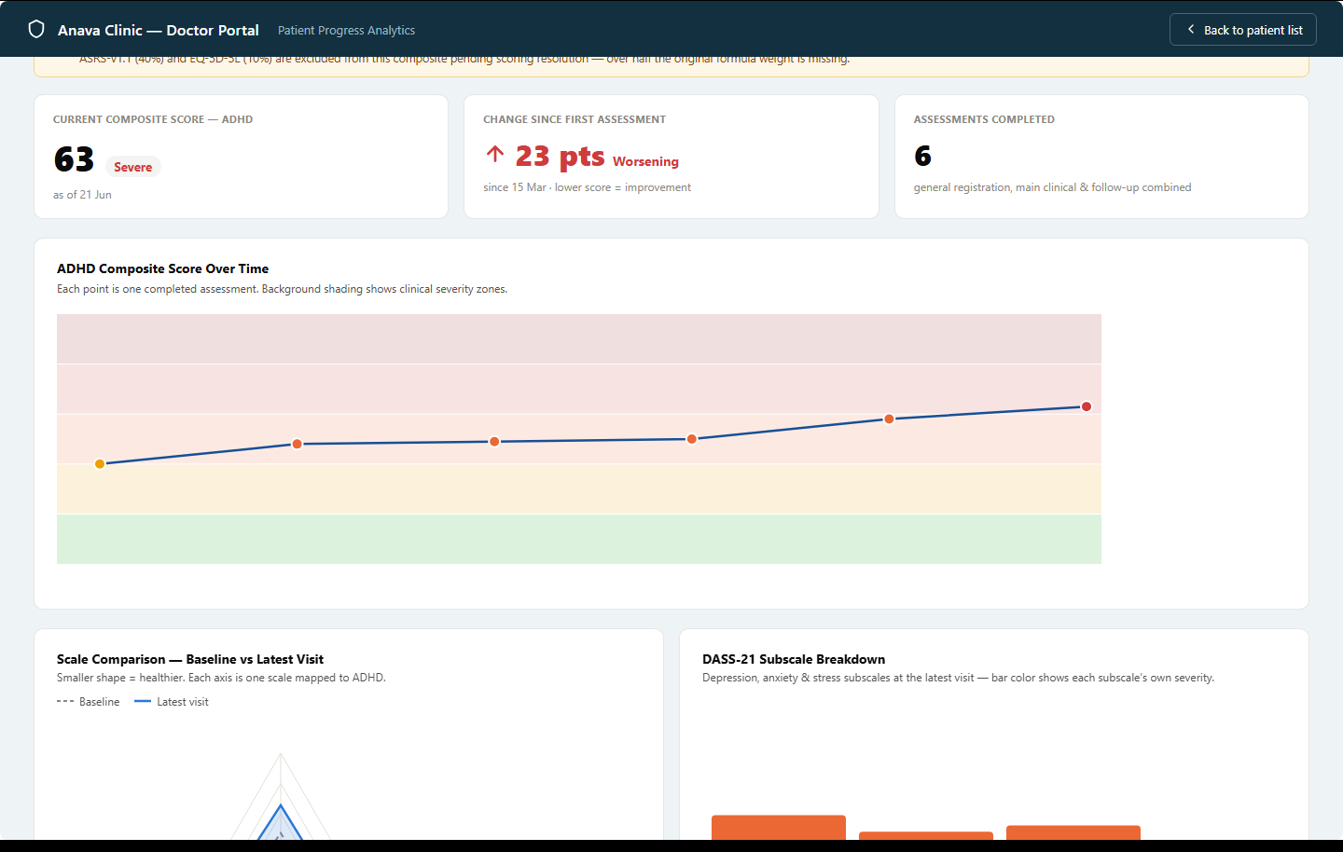
Fig. 3 — Patient detail view (Priya Desai, ADHD): hero stat cards and the composite trend chart with severity-band shading.

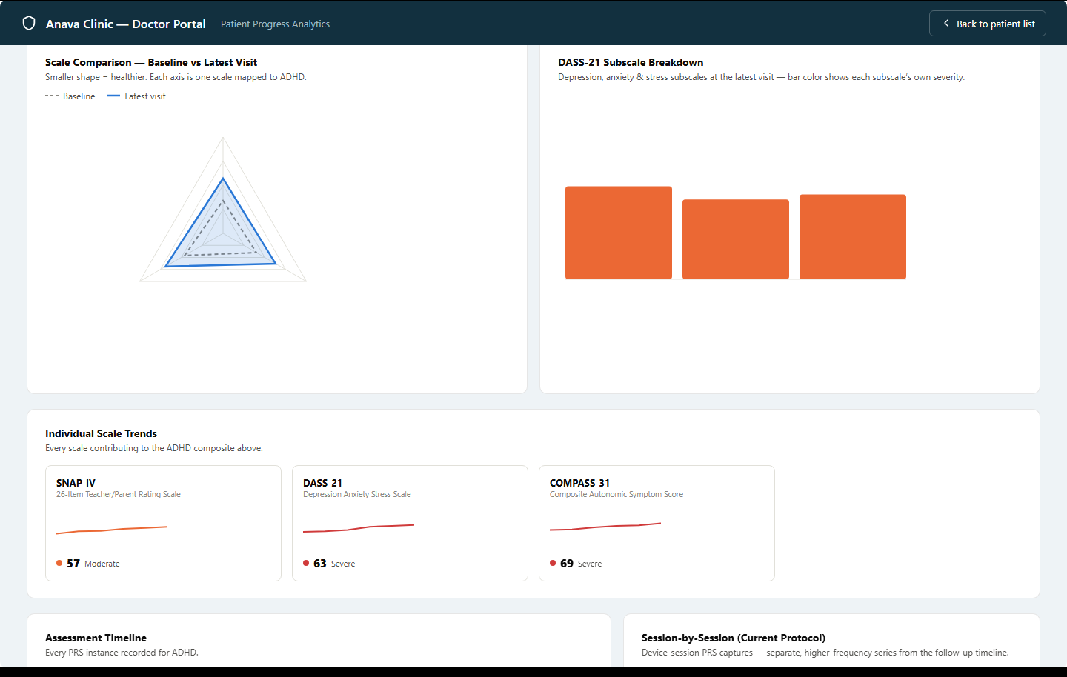
Fig. 4 — Baseline-vs-latest radar chart and the DASS-21 subscale breakdown, side by side.

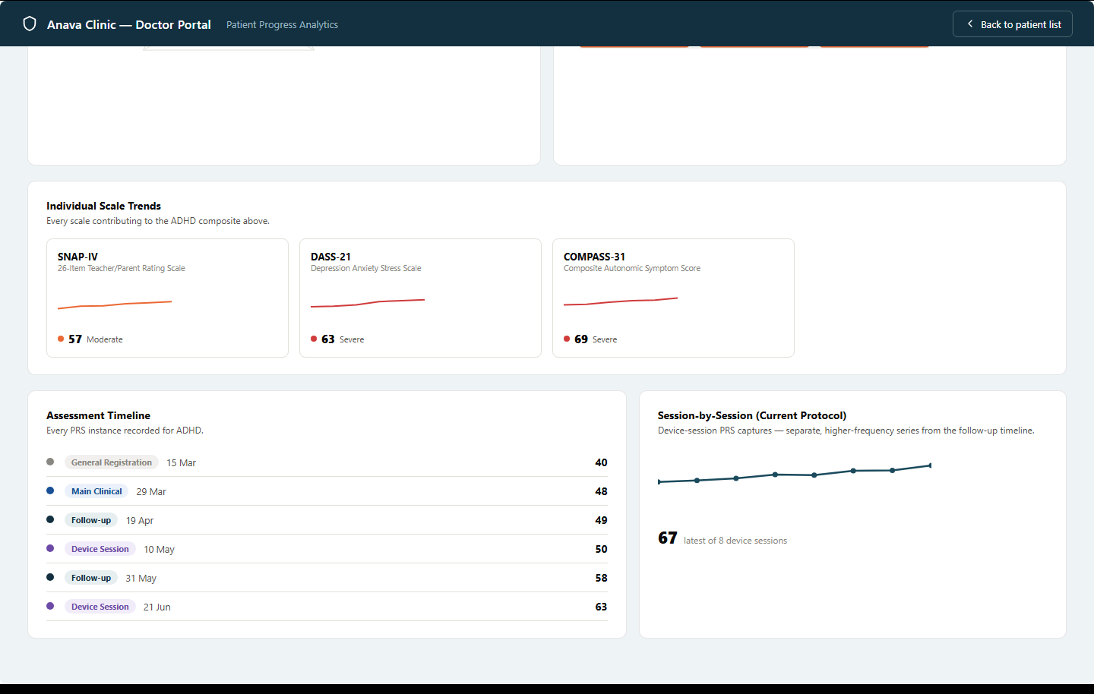
Fig. 5 — Individual scale trend cards, the full assessment timeline with stage tags, and the session-by-session sparkline.

8. Current Build Status
Honest accounting of what exists today versus what this document specifies for later:
Layer | Status
Scale-level scoring (37 of 41 scales) | Built and tested in code (scoring_rules.py) — see the scoring engine spec doc
Disease composite scoring | Formulas designed and documented (Section 5.3 here; full detail in the scoring spec doc's Section 3) — not yet implemented in code
Dashboard front end | Working clickable prototype (Claude Design canvas) with realistic sample data — not yet wired to the real backend/database
Reports/analytics API | Not started — the prototype's data is generated client-side for demonstration
4 remaining scales (PSQI, MAS, EQ-5D-5L, ASRS-v1.1) | Documented gaps with a path to close each — see the scoring engine spec doc, Section 4

SCOPE This is a design and data specification for a prototype, not a shipped feature. Every screenshot in Section 7 is real output from the interactive prototype, but the numbers behind it are sample data, not live patient records — the point of this stage was to lock down the layout, the data model, and the interaction model before building the real backend integration.

9. Next Steps
- Implement disease composite scoring in code (currently formulas only) — the next item already agreed on.
- Resolve or formally park the 4 remaining scales; re-run the exposure analysis once ASRS-v1.1 and EQ-5D-5L are closed, since ADHD's provisional flag should clear at that point.
- Build the reports/analytics API endpoints (patient timeline, condition progress, doctor-wide list) that this dashboard's front end will call instead of its current sample-data generator.
- Wire the sidebar's baseline-score range and assessment-count filters to real filtering logic.
- Replace the prototype's synthetic patient data with real API calls once the backend layer above exists.

