Agile Manifesto|Principles

Team Name: Neo | EBAC4|K.E.29 |

[Anusuya Manickavasagam: A0163300Y,

Lydia: A0163289U,

Muni: A0163382E,

Pradeep: A0163453]

Contents

Business Objectives 2

Project Deliverables 2

Initial Technical Strategy/Analytical/Modeling Approach 3

System Diagram 3

Data Gathering 4

Project Planning 5

Project Methodologies 6

Source Code Management 6

Project Tasks Management 6

Roles and Responsibilities 7

Resources Requirement 7

Project Deliverables and Plan (Gantt Chart) 8

Current Problems and Risks 8

Initial Analysis and Modeling 9

References 11

# Objectives

This assignment is part of CA1 to explore the agile manifesto and principles. We will be defining a project definition first and based on the project definition we will come up with the principles we are going to follow for our project.

# Team Agreements

Before starting as a team, it is very important to have team agreements. We have come up with following agreements. Based on the work experience, we agree to edit them on the go:

* Respect every member’s time
* Be attentive in the discussions
* No usage of Mobile phones during the discussions
* Standup in every class
* Full attendance

# Project Definition

We define our project deliverable as below;

*“A working Portable System which could be hosted at any place to smart monitoring the infants.”*

The above system will help parents to:

1. Setup the devise anywhere in the house within the Wi-fi network
2. Device able to analyze and predict the incoming stream of audio.
3. Device should generate successful, accurate and timely alerts in case infant is in distress.

Project will be verified as below:

1. Validating the models against actual historical data.
2. Customer feedback post alert generation

# Manifesto and Agile Principles Groups

Based on the team discussions, below figure, shows the grouping of principles against the manifesto in 4 quadrants.

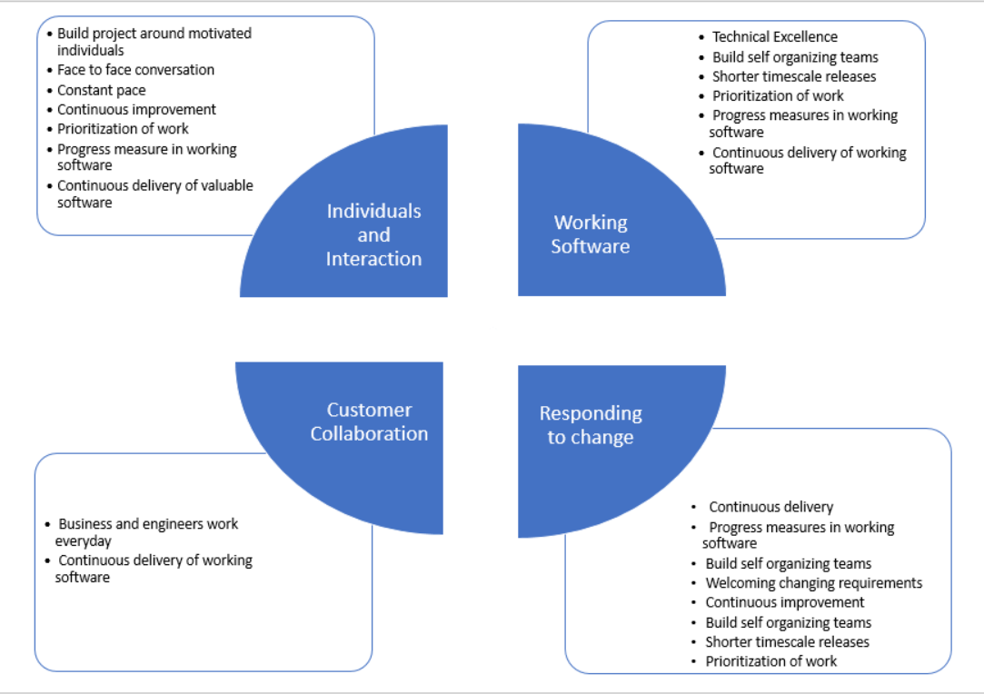

# Team NEO Top Five Principles

1. The most efficient and effective method of conveying information to and within development team is face to face conversation
2. Our highest priority is to satisfy the customer through early and continuous delivery of valuable software
3. Deliver working software frequently, from a couple of weeks to a couple of months, with a preference to the shorter timescale
4. The best architectures, requirements and designs emerge from self-organizing teams.
5. Welcome changing requirements even late in development. Agile process harness change for customer competitive advantage.

Before analyzing why, we selected above principles, lets dive in to key points of our project:

1. This project will be carried out by working professionals and in a part time basis
2. The Project has a R&D piece and other is usual software development component.
3. Supervisor of the project is business owner.

Below is the justification for selecting the above principles in the same order:

1. Since we are part timers working on this project. It will be very critical to maintain the rhythm and keep meeting or at least talking on a group call to check progress, unblock each other etc.
2. We would like to start with R&D piece and checking its feasibility. Showing it to supervisor on continuous basis will help with that
3. We would like to build smaller components on the shortest possible timescale to give an early idea of the product from functional and non-functional perspective.
4. We need to assign roles to each member so that the team performs seamlessly and is self-organized at the same time.
5. We would like to accept changes/modifications based on feedback and implement them in our product. Hence it is very much necessary that we remain agile in terms of requirement prioritization

# Propose removal of two Existing Principles

1. Business people and developers must work daily throughout the project because developers may not have sufficient time to react to the clarifications if business people meets every day. It will help them sort out the cycle of confusions with over communication.
2. Simplicity the art of maximizing the work not done is essential because prioritization could be covered from other principles like deliver working software frequently also caters to the same concept. To deliver frequently a working software, prioritization plays a key part.

# Propose addition of Custom Principles derived in Team

1. Business people and developers can work on need basis but no later than once or twice in a week to be able clarify the requirement and then take some dedicated time to build upon that. For example, developer team has clarified on the requirement now they need some time to prove that concept So it may be necessary to give some break.
2. Currently, the agile could become monotonous and teams could be stuck in the monolithic chain of work. The short spike days (1-2) after couple of Sprints could help team to go beyond agile boundaries and innovate. So, we can propose a principle of *“healthy breaks within agile instead of constant momentum on agile”*

# Top 3 risks in applying the Agile principles

1. Our big piece of project is to find the unknown in the audio data. Following agile principles may not help to innovate.
2. Meeting every day with business owner will lead to lot of wastage. There might not be much inputs and collaboration on daily basis. With the current nature or project where we work on few days in a week. Meeting everyday within team will be overkill too.
3. Working on a shorter timescale may affect add unnecessary pressure on deliverables. We need to well balance it with the estimation and can start for bit longer than 1 week or 2-weeks cycle.
4. Agile principles of highly individual motivated team are impractical and it may not be always true to have such team in place. Often people are demotivated, leave companies etc.

## References

1. Lecture Notes
2. Team brainstorming and innovation