Agile Benefit Realization – Case Study

Team Name: Neo | EBAC4|K.E.29 |

[Anusuya Manickavasagam: A0163300Y,

Lydia: A0163289U,

Muni: A0163382E,

Pradeep: A0163453]

# Objectives

*This report provides an analysis and evaluation of* ***‘Our Bank IT Inc’*** *past investment versus gain, customer features missed, and defect density increase from 2000 to 2006. The ROI has been negative for past 7 years in a row.*

*Products has shown increased defects density and customer features are missed consistently in deliveries. Taking these factors into consideration, a high-level roadmap/plan has been made for the fiscal year 2007.*

# High level roadmap/plan:

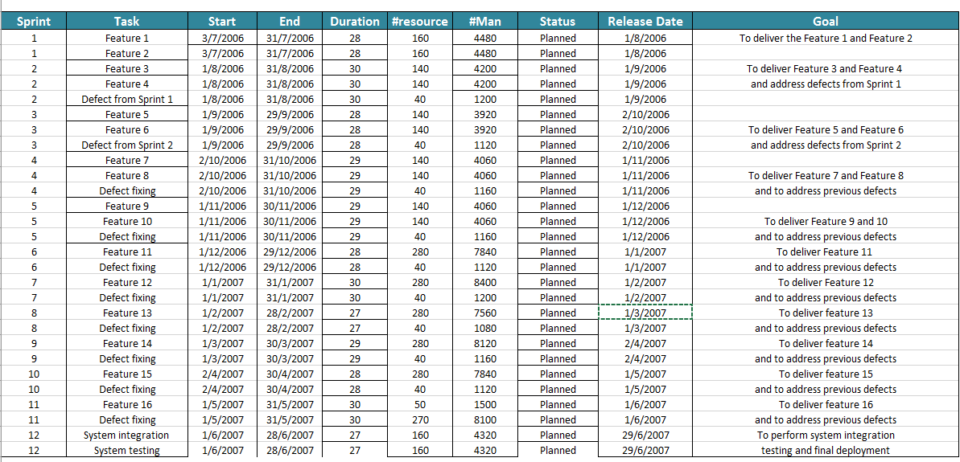

The calculations and resource allocation can be found in the spreadsheet.



# Recommendations

The current prospects of the company in its current position are not positive.

1. By implementing Agile process and methodology in the company and coaching the team members for the process.
2. The course of each sprint resource allocation has been done keeping in mind the previous sprint’s defects thus aiming to make the teams both cross-functional and self-organizing.
3. By time boxing each Sprint we can inspect and adapt the process and improve further in forthcoming sprints.
4. The features have been prioritized with the highest priority ones occupying the initial stages of the sprint.
5. Further, by conducting daily scrums, the impediments could be discussed and building on team’s trust, openness and consent.
6. Throughout the Sprint, the sprint goal must be kept in mind and after each sprint, conducting a sprint retrospective to make work more effective and enjoyable.
7. Make team understand that Sprint burndown is just for team and Release burndown for the stakeholders and what are other roles and responsibilities in different roles of agile methodologies to use.

The article by Ian Mitchell which tells about ***Twenty Top Fails in Executive Agile Leadership*** is relevant at this point. The responsibility for organizational change lies with the higher management and cannot be delegated to subordinates and hirelings.

Among the top reasons for failure for Agile, the ones that is important to be noted are:

1. Thinking that agile change is technical, which can mislead stakeholders including higher management.
2. Trying to change agile practice instead of changing the organization. If this is understood and implemented rightly then the process would be a success. A great example of this is of Google.

This can be understood from the article [Google’s Agility](http://steve-yegge.blogspot.sg/2006/09/good-agile-bad-agile_27.html) – A good agile and bad agile – case study by Steve Yeggee. To summarize, Google’s Agile works in a different way, the managers code half of the time, the developers are not told what to work on, there are not many meetings and there are no Gantt charts.

The Agile process works because Google is an exceptionally disciplined company and they take things like unit testing, design documents and code reviews seriously. Thus, bringing the organization in a single Agile mindset is important for the continuous success of an organization.