Univariate Time Series Analysis and Forecasting GRP of an Indian TV Channel

Team Name: Ensemble

EBAC 4 (Mixed Group), Institute of Systems Science, NUS

[Abhilasha: A0163276B, Muni: A0163382E, Pradeep: A0163453H, Sambit: A0163285B]

# Abstract

*This work is part of assignment to apply different time series forecasting methods a.k.a* ***Exponential Smoothing****,* ***Decomposition Methods****,* ***ARIMA****, and* ***Time Series Regression.*** *We will analyze each method output and compare their performances. Also, based on the nature of time series, we would like to evaluate if one or other methods are not suitable for analysis. Different model assumptions, model performances will be the key indicators to decide upon that.*

# Executive Summary

Our business problem is to forecast the GRP of an Indian TV channel. Proliferation of TV channels started to happen in 90s with socio and economic reforms under that time government of [India [1]](https://en.wikipedia.org/wiki/Television_in_India#Phase_I). Currently, there are total 857 permitted private satellite channels in India and more than 190 government [channels [2]](https://en.wikipedia.org/wiki/Lists_of_television_stations_in_India). Nowadays, Indian TV channels face stiff competition to maintain high rankings. Hence it is critical for them to be able to forecast the accurate GRP to maintain profits. We used the weekly data provided as part of assignment and applied following methods to build and compare performances:

* Exponential Smoothing,
* Decomposition Methods
* ARIMA
* Trend Models (Time Series Regression)

Our model **XXX** performance was best with RMSE XXX and MAPE XXX. The model performance was found to be stable over the period of test data XXX.

# Data Selection, Partition & Preprocessing

The data provided is a weekly time series of GRP ratings of an Indian TV channel. The data is between **17 June 2007** to **15 March 2009**.

## 3.1 Data Partition

As per the guidance, data partition was performed as below:

|  |  |
| --- | --- |
| Train Set | 17 Jun 2007 – 28 Dec 2008 |
| Forecast Period | 04 Jan 2009 – 15 Mar 2009 |

## 3.2 Tools

We used the following tools for our analysis:

* Excel (Smoothing Models, Decomposition, Time Series Regression),
* Jmp (ARIMA)

## Data Preprocessing

GRP time series plot with trend line is as show below. Clearly, we can see there is a downtrend in the GRP of this Indian channel. The visual inspection indicates it’s a linear kind of downtrend.

**Fig (1) GRP Time Series Plot**

# Model Building

## Exponential Smoothing

## ARIMA

## Decomposition

## Time Series Regression

# Model Performance

Below is shown the different method performances and comparison for our Test Data ( 04 Jan 2009 – 15 Mar 2009)

|  |  |  |  |  |
| --- | --- | --- | --- | --- |
| Model | RMSE | MAE | MAD | RMAD |
| Exponential Smoothing |  |  |  |  |
| ARIMA |  |  |  |  |
| Decomposition |  |  |  |  |
| Time Series Regression |  |  |  |  |

**Fig 4. Error plot for Decision Tree Prediction**

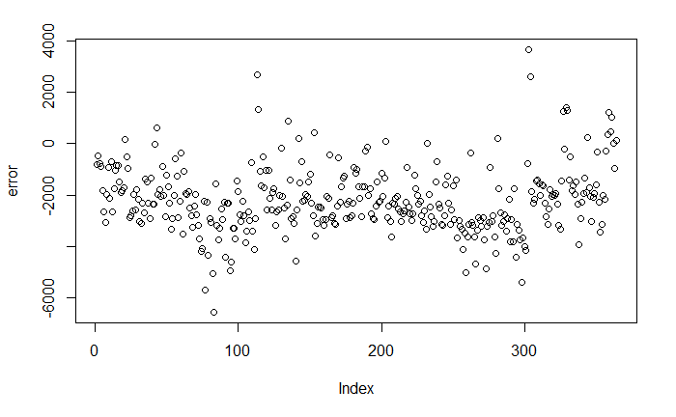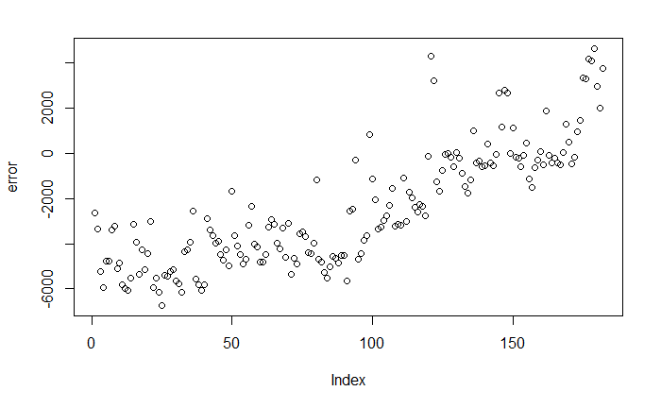

## References

## Q/A

* What is the observations per period? For monthly data, its 12, for quarterly it’s 4. What about weekly and daily, hourly?
* Does logarithmic value take helped?
* Is it a case of Multiplicative or additive case?
* When single mean ADF and trend ADF are similar values, it has seasonality?
* How to detect seasonality from ACF and PACF?