Univariate Time Series Analysis and Forecasting GRP of an Indian TV Channel

Team Name: Ensemble

EBAC 4 (Mixed Group), Institute of Systems Science, NUS

[Abhilasha: A0163276B, Muni: A0163382E, Pradeep: A0163453H, Sambit: A0163285B]

# Abstract

*This work is part of assignment to apply different time series forecasting methods a.k.a* ***Exponential Smoothing****,* ***Decomposition Methods****,* ***ARIMA****, and* ***Time Series Regression.*** *We will analyze each method output and compare their performances. Also, based on the nature of time series, we would like to evaluate if one or other methods are not suitable for analysis. Different model assumptions, model performances will be the key indicators to decide upon that.*

# Executive Summary

Our business problem is to forecast the GRP of an Indian TV channel. Proliferation of TV channels started to happen in 90s with socio and economic reforms under that time government of [India [1]](https://en.wikipedia.org/wiki/Television_in_India#Phase_I). Currently, there are total 857 permitted private satellite channels in India and more than 190 government [channels [2]](https://en.wikipedia.org/wiki/Lists_of_television_stations_in_India). Nowadays, Indian TV channels face stiff competition to maintain high rankings. Hence it is critical for them to be able to forecast the accurate GRP to maintain profits. We used the weekly data provided as part of assignment and applied following methods to build and compare performances:

* Exponential Smoothing,
* Decomposition Methods
* ARIMA
* Trend Models (Time Series Regression)

Our model **XXX** performance was best with RMSE XXX and MAPE XXX. The model performance was found to be stable over the period of test data XXX.

# Data Selection, Partition & Preprocessing

The data provided is a weekly time series of GRP ratings of an Indian TV channel. The data is between **17 June 2007** to **15 March 2009**.

## Data Partition

As per the guidance, data partition was performed as below:

|  |  |
| --- | --- |
| Train Set | 17 Jun 2007 – 28 Dec 2008 |
| Forecast Period | 04 Jan 2009 – 15 Mar 2009 |

## Tools

We used the following tools for our analysis:

* Excel (Smoothing Models, Decomposition, Time Series Regression),
* Jmp (ARIMA)

## Data Preprocessing

GRP time series plot with trend line is as show below. Clearly, we can see there is a downtrend in the GRP of this Indian channel. The visual inspection indicates it’s a linear kind of downtrend.

**Fig (1) GRP Time Series Plot**

# Model Building

## Exponential Smoothing

The data shows a distinct downward trend as per below char:

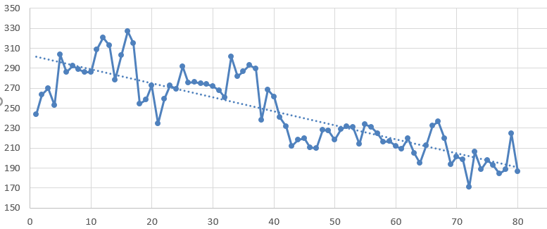

The Moving Average and Simple Exponential Smoothing methods don’t adequately model this, but **Holt’s Linear Trend Method** (aka **Double Exponential Smoothing**) does. This is accomplished by adding a second single exponential smoothing model to capture the trend (either upwards or downwards).

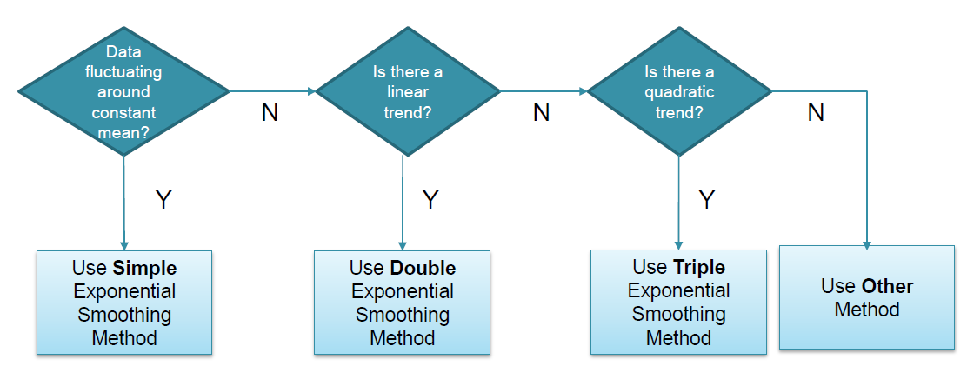

Here the cell D2 contains the formula =C2, cell E2 contains the value 0, cell D3 contains the formula = (C$96 * C3 + (1-C$96) * (D2+E2)), cell E3 contains the formula = (D$96 * (D3-D2) + (1-D$96) * E2) and cell F3 contains the formula =D2+E2. We tried minimizing the value of MAE by changing the value of alpha and beta subject to the constraint that alpha <= 1.0 and beta <= 1.0. The result shown below is that α = .5 and β = .1, with MAE = 13.2. ([REFERENCE](http://www.real-statistics.com/time-series-analysis/basic-time-series-forecasting/holt-linear-trend/))

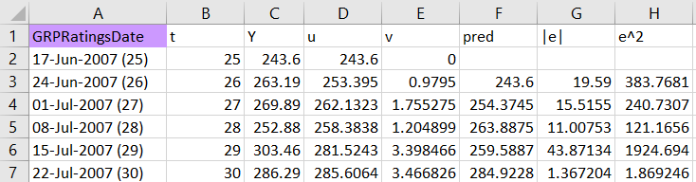

Next step is to forecast the next 12 values in the times series. The y (blue) and predicted y (red) values shown below. The straight line (in red) at the tail shows the forecasting using smoothening while the blue curve shows the actual value.

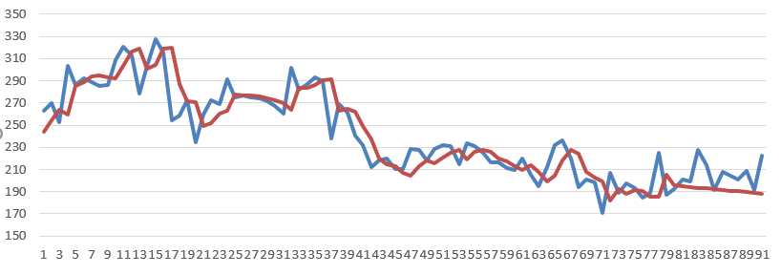

## ARIMA

To analyze data by implementing ARIMA and to assess the prediction and forecasting of TV channel forecast for the coming a period of time where TV GRP fluctuated during varying temporal movements. Since ARIMA models help in forecast nonstationary series and are better in formulating incremental rather than structural changes over the time, its well suited for the given data.

***The Steps:***

After Checking the validity of basic assumptions for ARIMA (Discrete Time series Data, equally spaced over time and have no missing values), the correct model for prediction and explanation was identified as follows:

Data was observed to be non-stationary by visual inspection and with Augmented Dickey fuller test value >-4 , so was differenced with difference 1 to produce a stationary time series (de-trended) with **ADF** value **-12.41** and can be seen thatAfter one differencing , the model produces gradually expanding forecast profile.

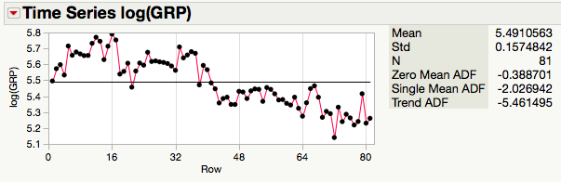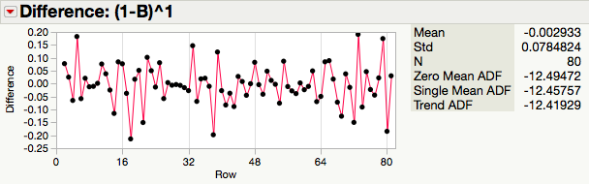

* The parameters autoregressive and moving‐average portions of the ARIMA model, i.e., the p ,d and q terms, where, p refers to the AR part, q refers to MA part and d is the order of differencing were examined with the help of ACF and PACF plots. The Plots suggests the model to be of AR(2), MA(1) , with no significant seasonality observed given the length of data.However in interest of better model fit other models were also tested by running arima model group which suggested (2,1,1) and (0,1,1) to be best models in terms of low AIC value , low MAPE and MAE values ,(0,1,1) performed the best.
* *After approximation of ARIMA model, estimated model parameters were*

*Checked to be significant and Ljung Box test was observed to confirm that the white noise was achieved , Residuals were checked for constant mean and constant variance, on analysis it was found that the variance is not uniform ,so data was transformed with the help of natural log and steps were redone .*

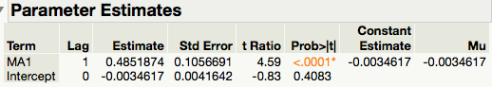

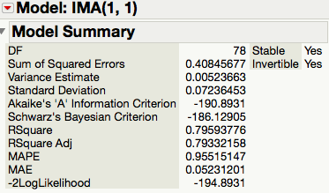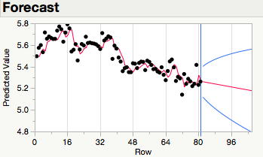

* *MAE,MSE, RMSE,MAD, were calculated to evaluate forecast fit measures and model accuracy*

The result shows best performance for IMA(0,1,1 )model, and for this model the forecast of all future time is an exponentially weighted moving average of current and past observations and thus represent disturbances leading to given observation and does not vary in a stable manner about a fixed mean.

EQUATION

## Decomposition

Decomposition methods are based on an analysis of the individual components of a time series. The strength of each component is estimated separately and then substituted into a model that explains the behavior of the time series. Two of the more important decomposition methods are:

* Multiplicative decomposition
* Additive decomposition

The multiplicative decomposition model is expressed as the product of the four components of a time series:

*yt* = *TRtSNtCLtIRt*

These variables are defined as follows:

* *yt* = Value of the time series at time t
* *TRt* = Trend at time t
* *SNt* = Seasonal component at time t
* *CLt* = Cyclical component at time t
* *IRt* = Irregular component at time t

OUTPUT (Overall Trend): Based on below we can clearly see that there is an overall linear downward trend. However, we tried the same using degree of 2 and 3 as well but linear trend was fitting the best possible way.

SN: There is a clear seasonality pattern as per the data.

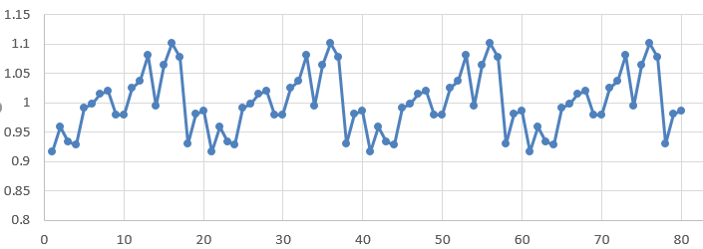

CL: Initially we assumed that cyclic behavior persists every 20 weeks (as per raw data) which was clearly visible using below chart of cyclic.

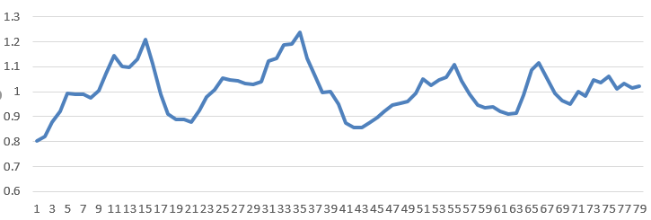

IR: Below chart shows the irregularity at time t.

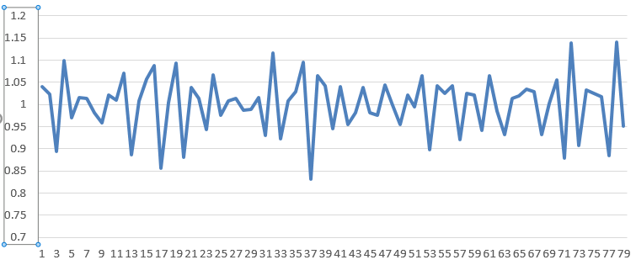

Next step is to forecast the last 12 values in the times series. The y (blue) and predicted y (red) values shown below. The gap has narrowed down at the tail shows the forecasting using decomposition has done a good job in prediction.

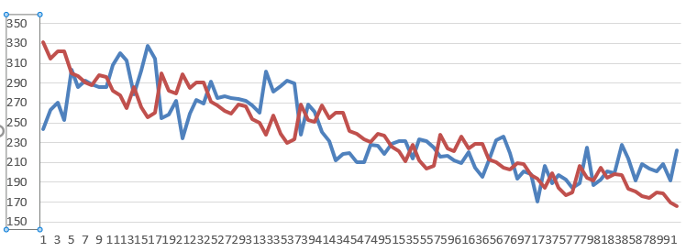

## Time Series Regression

Time Series Regression is based on an analysis of the trend (TR) components of a time series. The strength of this component is estimated as per below:

*yt* = *TRt* + ԑt

Where

*yt* = value of the time series in period t

*TRt* = the trend in time period t

ԑt = the error term in time period t

No Trend: *TRt* = β0

Linear Trend: *TRt* = β0+ β1t

Quadratic Trend: *TRt* = β0+ β1t + β2t2

Based on below we can clearly see that there is an overall linear downward trend for *TRt*:

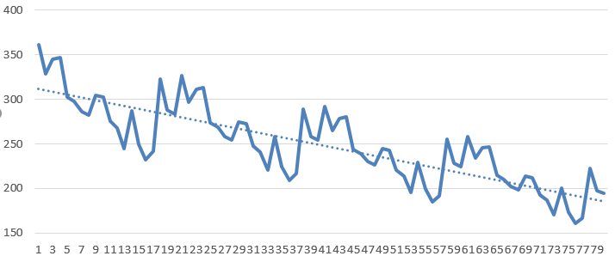

The linear trend model is *TRt* = 313.336 – 1.594t

Please find below the ԑt plot as per *yt* = *TRt* + ԑt:

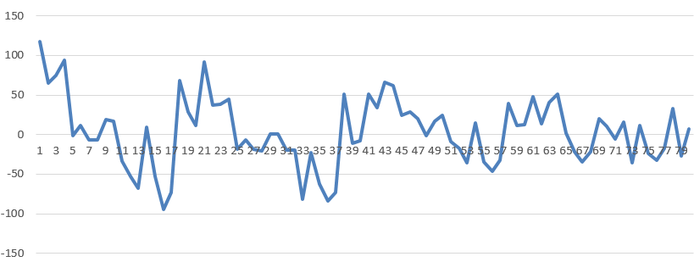

Next step is to forecast the last 12 values in the times series. The y (blue) and predicted y (red) values shown below. The gap has narrowed down at the tail shows the forecasting using decomposition has done a good job in prediction

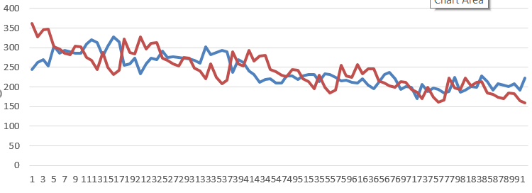

# Model Performance

Below is shown the different method performances and comparison for our Test Data (04 Jan 2009 – 15 Mar 2009)

|  |  |  |  |  |
| --- | --- | --- | --- | --- |
| Model | RMSE | MAE | MAD | RMAD |
| Exponential Smoothing | 17.67 | 13.78 | 9.24 | 3.04 |
| ARIMA |  |  |  |  |
| Decomposition | 27.41 | 23.47 | 11.24 | 3.35 |
| Time Series Regression | 29.01 | 24.92 | 11.05 | 3.32 |

**Fig 4. Error plot for Decision Tree Prediction**

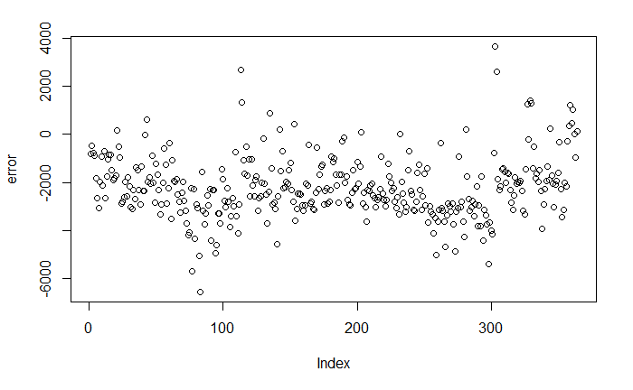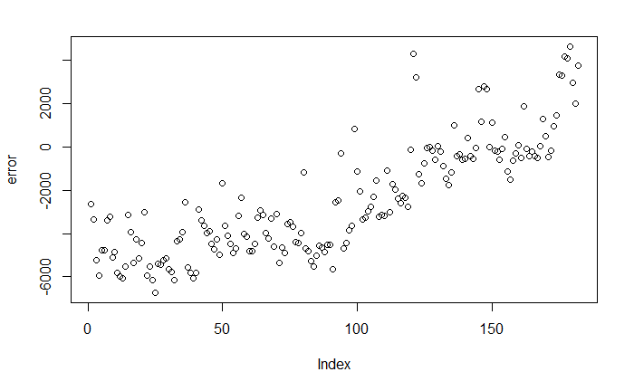

## References

## Q/A

* What is the observations per period? For monthly data, its 12, for quarterly it’s 4. What about weekly and daily, hourly?
* Does logarithmic value take helped?
* Is it a case of Multiplicative or additive case?
* When single mean ADF and trend ADF are similar values, it has seasonality?
* How to detect seasonality from ACF and PACF?