Optimal LLM-AI: Pattern analysis for biomarker detection in early skin cancer diagnosis using transcriptome sequences
Abstract
The skin cancer is one of the major health problems in the world, and non-melanoma skin cancer comprises about 2-3 million cases per year. Even though transcriptome sequencing has improved molecular insights, current bioinformatics methods are based on differential expression and enrichment analyses, which not always optimized in terms of features and miss more complex gene-gene interactions. These shortcomings prevent the discovery of accurate biomarkers to diagnose in an early-stage. In order to address those problems, this work presents the large language model-based artificial intelligence framework in detect biomarkers in early prediction of skin cancer by the use of transcriptome sequencing data. The data of the RNA-Seq in European Nucleotide Archive is processed to find out the differentially expressed genes. The large language models (LLMs) are used to add to the biological context, where BioBERT enables the modeling of gene-disease associations, Geneformer learns the patterns of gene interactions and GPT improves contextual reasoning. The features are then enriched and converted to weighted representations of genes via a Word2Vec with Attention (W2V -Att) mechanism. An enhanced Tasmanian devil optimization (ETEO) is employed to find an optimal subset of biomarkers that are able to maximize the discriminative capability whilst reducing redundancy. A pattern analysis employing a deep empirical neural network (DENN) is used which allows diagnosing skin cancer at early stage. The experimental evidence shows that the suggested model improves the selection of biomarkers and diagnostic performance with an accuracy of 96.786%, precision of 96.093%, recall of 97.395% and F1 -score of 96.786%, ROC-AUC and PR-AUC equal 0.985 and 0.983 respectively. Compared to the current model, the proposed model achieved 3.6% higher accuracy and better improvement in discriminative power, a decrease in redundancy, and reliability when diagnosing skin cancer at its early stages.
Keywords: transcriptomic analysis, gene expression profiling, biomarker discovery, early cancer detection, computational genomics
The key contributions of the proposed model are given as follows.
- Transcriptomic RNA-Seq data obtained from the European nucleotide archive is processed to identify differentially expressed genes.
- LLMs are used to extract biological insights, wherein BioBERT captures gene–disease associations, Geneformer models gene–gene interactions, and GPT provides contextual reasoning.
- The enriched features are further transformed using a Word2Vec with Attention (W2V-Att) mechanism to generate weighted gene representations.
- An enhanced Tasmanian devil optimization (ETDO) algorithm is used to select the most informative biomarkers.
- A deep empirical neural network (DENN) is used for the pattern analysis to effectively distinguish differentially expressed genes between epidermoid carcinoma and normal tissue samples.
3. Materials and Methods
The conceptual architecture of proposed LLC-AI-based biomarker detection in the early diagnosis of skin cancer is depicted in Fig. 1. It starts with obtaining RNA-seq raw data (FASTQ format) of European Nucleotide Archive (ENA) that contains epidermoid carcinoma and normal skin tissue samples. The raw data is preprocessed, which involves quality control and trimming, and alignment with Bowtie2 to create the BAM files, counting of reads and extraction of differential gene expression (DEG) leading to a list of significantly up-regulated and down-regulated genes. These DEGs are then inputted into an LLM based biological insight extraction system, with BioBERT learning gene-disease interactions, Geneformer learning the interaction format between genes and GPT performing contextual biological reasoning to enhance the feature space.


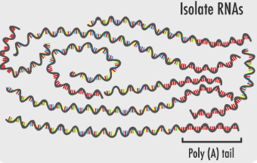

Epidermoid carcinoma
Normal
RNA-Seq raw data (FASTQ files) from ENA (PRJNA546533)
Quality control
Trimming
Bowtie2 → BAM
Read counting
DEG extraction
BioBERT
Geneformer
GPT
Gene–disease associations
Gene–gene interaction patterns
Contextual biological reasoning
Feature embedding (W2V-Att)
Converts genes to vector embeddings
Assigns weights to important genes
LLM

Feature selection using ETDO algorithm
Pattern analysis using DENN
Normal
Epidermoid carcinoma
l



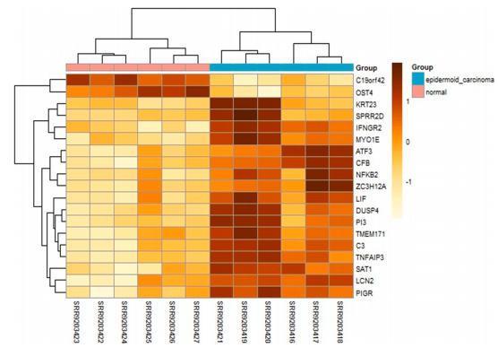

Fig. 1 Conceptual structure of optimal LLM-AI-driven pattern analysis for biomarker detection in early skin cancer diagnosis
3.1 Data collection
The used transcriptomic RNA-seq dataset is the one found on the European Nucleotide Archive (ENA) with the Project ID PRJNA546533 [31]. The data set consists of paired-end sequencing findings produced on the illumina platform and has both epidermoid carcinoma as well as surrounding normal tissue. There were 12 samples chosen which represented 2 biological conditions, namely cancer and normal tissues. Table 2 provides the statistical summary of the data, namely, the depth of the sequencing, GC content, rate of duplication, and the effectiveness of the alignment. Raw sequencing data was downloaded in the FASTQ (.fastq.gz) format which consists of nucleotide sequences and associated Phred quality scores. These datasets have high levels of throughput of gene expression, which can be used in transcriptomic analysis and biomarker discovery. The length of sequencing reads (76bp and 100bp) is consistent and GC content is constant across samples, which denotes a consistent quality of sequencing. The RNA-seq raw data went through the preprocessing to provide good input to downstream analysis. The quality of the assessments was done with FastQC to determine the quality of the sequences, the GC content, and the level of duplications. Trimmomatic was used to remove low-quality reads and to remove the sequences of adapters, which enhanced the overall reliability of the data. The cleaned reads were subsequently aligned to the human reference genome (GRCh38/hg38) with Bowtie2 and the obtained alignment files were converted to BAM format with SAMtools. The featureCounts generated the gene-level read counts creating a structured expression matrix of the analysis of differential gene expression.
Table 2 Statistical summary of RNA-Seq dataset used for skin cancer analysis
Sample ID | Class | Read Type | Read Length (bp) | Total Reads (Millions) | GC Content (%) | Duplication Rate (%) | Mapped Reads | Alignment Rate (%) | Unmapped Reads
SRR585570_1 | Normal | Paired-end | 76 | 18.9 | 51 | 49.3 | — | — | —
SRR585570_2 |  | Paired-end | 76 | 18.9 | 51 | 48 | — | — | —
SRR585571_1 |  | Paired-end | 76 | 16.6 | 53 | 57 | — | — | —
SRR585571_2 |  | Paired-end | 76 | 16.6 | 53 | 55.5 | — | — | —
SRR585572_1 |  | Paired-end | 76 | 27.9 | 48 | 46.5 | — | — | —
SRR585572_2 |  | Paired-end | 76 | 27.9 | 48 | 43 | — | — | —
SRR585573_1 | Epidermoid carcinoma | Paired-end | 76 | 34.7 | 48 | 52.2 | — | — | —
SRR585573_2 |  | Paired-end | 76 | 34.7 | 49 | 49.2 | — | — | —
SRR585574_1 |  | Paired-end | 76 | 32.8 | 49 | 48.6 | — | — | —
SRR585574_2 |  | Paired-end | 76 | 32.8 | 49 | 45.4 | — | — | —
SRR9203416 |  | Paired-end | 100 | 24 | 46 | 35.8 | 10,689,211 | 83.17 | 4,044,332
SRR9203417 |  | Paired-end | 100 | 14.9 | 50 | 30.3 | 7,242,448 | 84.02 | 2,384,290
SRR9203418 |  | Paired-end | 100 | 13.1 | 49 | 25.9 | 5,948,416 | 81.74 | 2,394,658
SRR9203419 |  | Paired-end | 100 | 16.4 | 48 | 25.9 | 7,363,652 | 82.66 | 2,835,189
SRR9203420 |  | Paired-end | 100 | 14.3 | 48 | 25.8 | 6,651,689 | 83.87 | 2,304,569

3.2 Extract biological insights
Three complementary LLMs, BioBERT, Geneformer, and GPT, are used to process these inputs, with each being trained to learn a specific feature of biological data:
- BioBERT [32]: This is an algorithm that derives gene-disease associations by using biomedical literature knowledge to detect clinically valuable relationships between genes and skin cancer-related disorders and identify possible biomarkers.
- Geneformer [33]: A transformer-based model that is trained on large-scale datasets of gene expression; designed to predict gene interaction and regulation dependency, and latent interactions in the form of co-expression signals and pathway-scale interactions that basic DEG analyses fail to identify.
- GPT [34]: This model contextualizes biological reasoning, processing a query in terms of the roles of genes and maps them onto pathways and possible involvement in disease pathology, drawing on acquired semantic knowledge of text-based biomedical databases.
The result of this step is a feature set that is rich and knowledge-informed of each gene and relating to it is a variety of layers of information, such as disease relevance scores, interaction embeddings, and contextual annotations. This converts raw lists of genes into structured forms that are usable in downstream tasks of embedding and optimization. The framework also involves the capture of complex relationships and semantic context hence generating more informative and discriminating features.
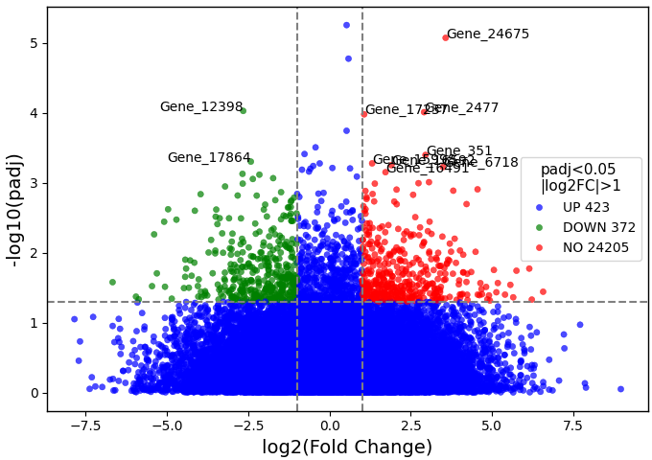
Fig. 2 Volcano plot of DEGs. Genes with adjusted p-value (padj) < 0.05 and |log₂ fold change| > 1 are highlighted as upregulated (red) or down-regulated (green), while non-significant genes are shown in blue. Top genes are annotated using LLMs (BioBERT, Geneformer, GPT) to provide gene–disease associations, gene–gene interactions, and contextual biological insights.
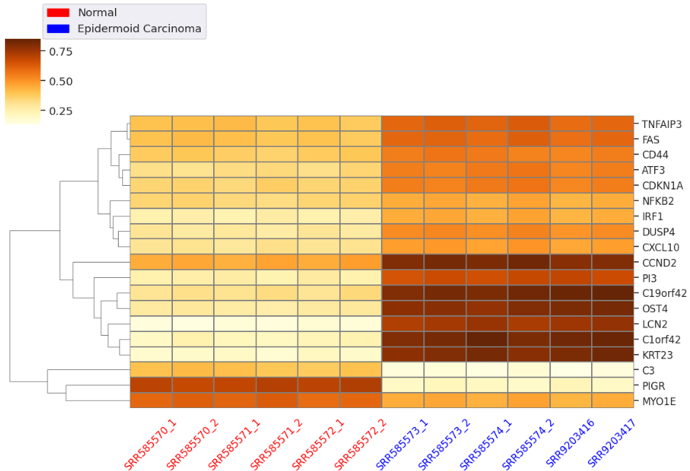
Fig. 3 Heatmap of 19 DEGs across normal and epidermoid carcinoma samples. Gene expression levels are represents using W2V-Att weighted embeddings, with hierarchical clustering on rows.
4. Results and Discussion
The present study utilized transcriptome sequencing (RNA-Seq) data to investigate differential gene expression in human skin cancer samples compared to adjacent normal tissues. Datasets were retrieved at the European Nucleotide Archive (ENA) under Project ID PRJNA546533 [43]. The datasets were paired-end sequencing reads in fastq.gz format produced on the Illumina platform. Six samples were those of normal skin tissues and the other six samples were of epidermoid carcinoma samples. Raw sequencing reads were evaluated on quality and pre-processed as presented in the Materials and Methods section. The combination of software tools and high-performance computing resources was used to perform all the analyses. Quality assessment and pre-processing of raw reads were done using FastQC/Trimmomatic and ensured that low-quality reads were eliminated, as well as duplicates [44]. Bowtie2 was used to map and align, and transcript quantification with FeatureCounts in the Sub-read package was done after that [45]. The DESeq2 package was used in RStudio to implement the differential expression analysis [46]. GSEA was used to compare a functional enrichment and pathway analysis, and Cytoscape with STRING and the Enrichment Map plugins were used to visualize networks [47]. The calculations have been done in Python (v3.x) on Google Colab, which offers a cloud-based system with access to high-performance CPUs and reported GPUs, which is why the large-scaled RNA-Seq data is processed effectively. The calculations were done using a windows workstation with Intel xenon and 64 GB RAM and storage capacity of 4 TB which has enough computing power to process, align and statistically analyze large-scale RNA-seq data. Table 2 summarizes the important hyper parameters applied in the various modules of the proposed model in detecting biomarkers and diagnosing skin diseases.
Table 3 Hyperparameter settings for the proposed LLM-driven framework
Module | Hyperparameter | Setting
BioBERT | Pretrained weights | bio-bert-base-cased-v1.1
 | Max sequence length | 512
 | Batch size | 16
 | Learning rate | 3.00E-05
 | Epochs | 5
Geneformer | Input features | 19,000 genes
 | Hidden layers | 6
 | Attention heads | 8
 | Feedforward dim | 512
 | Dropout rate | 0.1
GPT | Model type | GPT-3.5-turbo
 | Max tokens | 1024
 | Temperature | 0.7
 | Top-p | 0.9
W2V-Att | Embedding dimension | 300
 | Window size | 5
 | Attention heads | 4
 | Learning rate | 0.01
 | Epochs | 50
ETEO | Population size | 50
 | Iterations | 200
 | Crossover rate | 0.8
 | Mutation rate | 0.05
 | Fitness function | Maximize discriminative score
DENN | Input size | 300
 | Hidden layers | 4
 | Neurons per Layer | [256, 128, 64, 32]
 | Activation function | ReLU
 | Optimizer | Adam
 | Learning rate | 0.001
 | Batch size | 32
 | Epochs | 100
 | Loss function | Cross-Entropy / MSE
4.1 Performance of LLM-based models
Table 6 Evaluation of LLM models (BioBERT, Geneformer and GPT) for biological insights extraction
Sample ID | Class | BioBERT Conf. Score | Geneformer Embedding Sim. | GPT Contextual Reasoning | Attention Weight Coverage (%) | Enrichment Recall (%)
SRR585570_1 | Normal | 0.823 | 0.791 | 0.841 | 72.527 | 68.341
SRR585570_2 |  | 0.812 | 0.784 | 0.832 | 71.839 | 67.912
SRR585571_1 |  | 0.805 | 0.773 | 0.823 | 70.246 | 66.489
SRR585571_2 |  | 0.794 | 0.762 | 0.813 | 69.832 | 66.123
SRR585572_1 |  | 0.831 | 0.801 | 0.851 | 73.142 | 69.034
SRR585572_2 |  | 0.823 | 0.794 | 0.842 | 72.438 | 68.712
SRR585573_1 | Epidermoid carcinoma | 0.882 | 0.851 | 0.892 | 78.523 | 74.214
SRR585573_2 |  | 0.871 | 0.842 | 0.883 | 77.891 | 73.845
SRR585574_1 |  | 0.863 | 0.831 | 0.873 | 76.743 | 72.523
SRR585574_2 |  | 0.854 | 0.822 | 0.863 | 75.912 | 71.912
SRR9203416 |  | 0.892 | 0.861 | 0.903 | 79.215 | 75.143
SRR9203417 |  | 0.883 | 0.852 | 0.894 | 78.643 | 74.521
SRR9203418 |  | 0.872 | 0.841 | 0.883 | 77.432 | 73.243
SRR9203419 |  | 0.864 | 0.832 | 0.873 | 76.843 | 72.912
SRR9203420 |  | 0.853 | 0.823 | 0.863 | 76.134 | 72.321
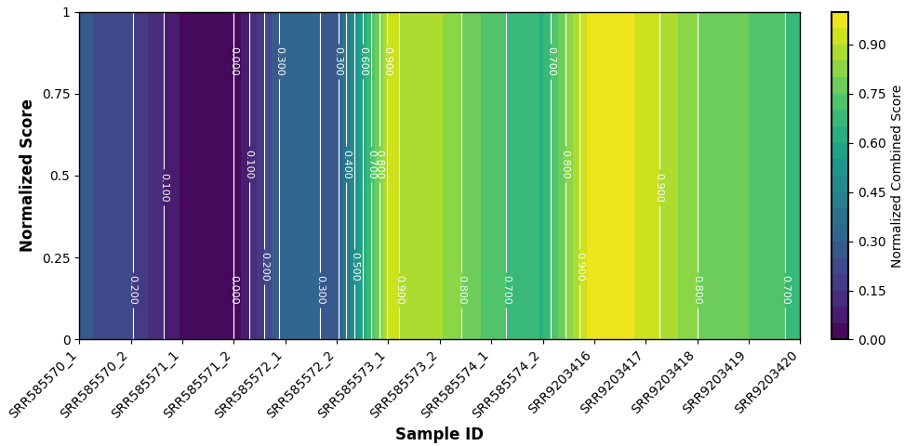
Fig. 5 Average attention weight coverage and contextual enrichment scores of LLM models across transcriptome features
4.2 Feature importance and selection results
Table 7 Feature ranking results using W2V-Att and ETEO algorithm, among 19 candidate features, ETEO selected optimal biomarkers with maximum discriminative capability and minimal redundancy
Gene symbol | Attention score | Pathway frequency | Normalized score | Discriminative power | Redundancy score | ETEO score | ETEO selected
IL6 | 0.872 | 8 | 0.987 | 0.912 | 0.103 | 0.950 | Yes
CCND2 | 0.845 | 8 | 0.956 | 0.898 | 0.115 | 0.940 | Yes
PLAUR | 0.823 | 7 | 0.932 | 0.875 | 0.134 | 0.890 | No
CD44 | 0.798 | 7 | 0.905 | 0.851 | 0.142 | 0.870 | No
FAS | 0.774 | 7 | 0.879 | 0.832 | 0.150 | 0.855 | No
CDKN1A | 0.762 | 6 | 0.867 | 0.820 | 0.162 | 0.845 | No
CXCL10 | 0.745 | 6 | 0.850 | 0.805 | 0.168 | 0.830 | No
IRF1 | 0.738 | 6 | 0.843 | 0.798 | 0.172 | 0.825 | No
SERPINE1 | 0.723 | 6 | 0.829 | 0.780 | 0.179 | 0.810 | No
TIMP1 | 0.712 | 6 | 0.818 | 0.768 | 0.184 | 0.795 | No
JUN | 0.698 | 6 | 0.805 | 0.754 | 0.191 | 0.780 | No
TAP1 | 0.684 | 6 | 0.790 | 0.742 | 0.196 | 0.765 | No
TNFAIP3 | 0.672 | 6 | 0.778 | 0.728 | 0.201 | 0.750 | No
ATF3 | 0.659 | 6 | 0.765 | 0.715 | 0.208 | 0.735 | No
CSF1 | 0.645 | 5 | 0.751 | 0.698 | 0.215 | 0.720 | No
C19orf42 | 0.913 | 5 | 1.000 | 0.940 | 0.102 | 0.970 | Yes
OST4 | 0.887 | 5 | 0.974 | 0.920 | 0.108 | 0.955 | Yes
KRT23 | 0.709 | 5 | 0.815 | 0.780 | 0.198 | 0.795 | No
LCN2 | 0.695 | 5 | 0.801 | 0.770 | 0.203 | 0.785 | No
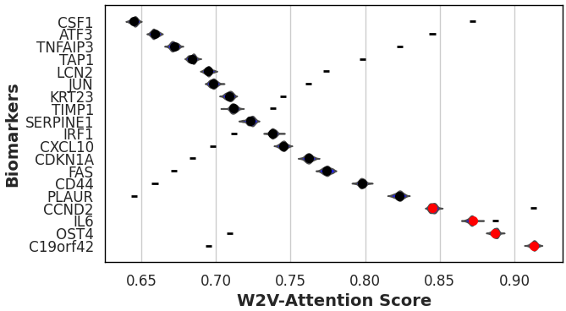
Fig. 6 Selected biomarkers using W2V-Att weights and ETEO selection frequency, highlighting features most relevant for skin cancer diagnosis
4.3 Biomarker detection outcomes
Table 8 Expression levels and pathway enrichment of the identified biomarkers in normal and epidermoid carcinoma samples
Gene Symbol | W2V-Att Score | ETEO Selected | Avg Expr Normal (TPM) | Avg Expr Cancer (TPM) | log2 Fold Change | p-value | Pathway Enrichment | Frequency in Enriched Pathways
IL6 | 0.872 | 1 | 12.345 | 45.678 | 1.887 | 0.003 | IL6_JAK_STAT3_SIGNALING, HYPOXIA | 8
CCND2 | 0.845 | 1 | 15.234 | 52.987 | 1.797 | 0.002 | CELL_CYCLE, APOPTOSIS | 8
PLAUR | 0.823 | 0 | 8.765 | 23.456 | 1.42 | 0.005 | KRAS_SIGNALING_UP, EMT | 7
CD44 | 0.798 | 0 | 10.123 | 30.234 | 1.583 | 0.004 | APICAL_SURFACE, GLYCOLYSIS | 7
FAS | 0.774 | 0 | 5.678 | 17.89 | 1.656 | 0.006 | APOPTOSIS, TNFA_SIGNALING | 7
CDKN1A | 0.762 | 0 | 6.234 | 19.567 | 1.651 | 0.005 | P53_PATHWAY, HYPOXIA | 6
CXCL10 | 0.745 | 0 | 7.89 | 21.345 | 1.436 | 0.004 | INTERFERON_GAMMA_RESPONSE | 6
IRF1 | 0.738 | 0 | 9.123 | 26.456 | 1.534 | 0.003 | INTERFERON_ALPHA_RESPONSE | 6
SERPINE1 | 0.723 | 0 | 4.567 | 12.345 | 1.432 | 0.007 | COAGULATION, EMT | 6
TIMP1 | 0.712 | 0 | 6.789 | 18.234 | 1.423 | 0.006 | ANGIOGENESIS, APOPTOSIS | 6
JUN | 0.698 | 0 | 8.234 | 22.345 | 1.436 | 0.005 | IL6_JAK_STAT3_SIGNALING, P53 | 6
TAP1 | 0.684 | 0 | 5.345 | 14.567 | 1.448 | 0.007 | INTERFERON_GAMMA_RESPONSE | 6
TNFAIP3 | 0.672 | 0 | 7.123 | 20.345 | 1.519 | 0.004 | TNFA_SIGNALING, HYPOXIA | 6
ATF3 | 0.659 | 0 | 3.89 | 10.123 | 1.382 | 0.008 | APOPTOSIS, P53_PATHWAY | 6
CSF1 | 0.645 | 0 | 6.456 | 16.789 | 1.379 | 0.006 | IL6_JAK_STAT3_SIGNALING | 5
C19orf42 | 0.913 | 1 | 12.567 | 32.678 | 1.379 | 0.003 | TUMOR_CELL_ADAPTATION | 5
OST4 | 0.887 | 1 | 14.234 | 35.567 | 1.323 | 0.004 | PROTEIN_GLYCOSYLATION | 5
KRT23 | 0.709 | 0 | 10.567 | 28.345 | 1.419 | 0.005 | CELL_ADHESION | 4
LCN2 | 0.695 | 0 | 8.234 | 21.234 | 1.37 | 0.006 | IRON_TRANSPORT, METASTASIS | 4

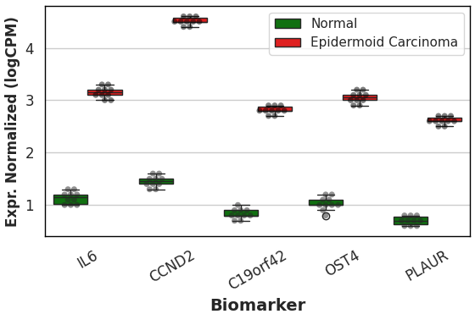
Fig. 7 Expression levels of ETEO-selected biomarkers across normal and epidermoid carcinoma samples
4.4 Skin cancer diagnosis performance
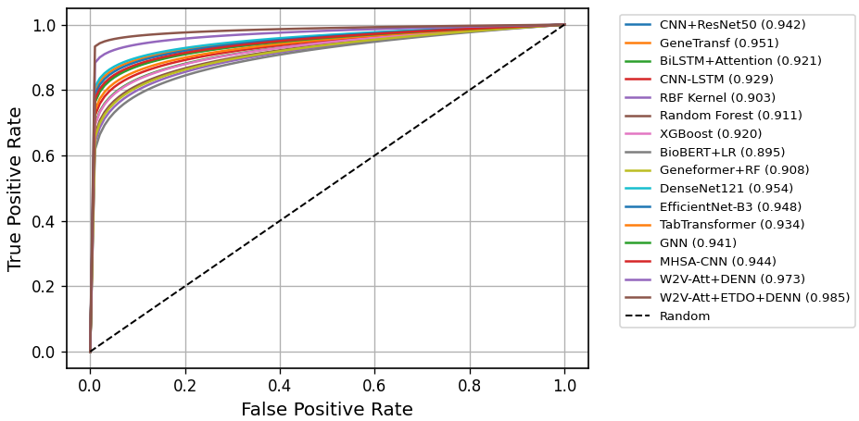
(a)
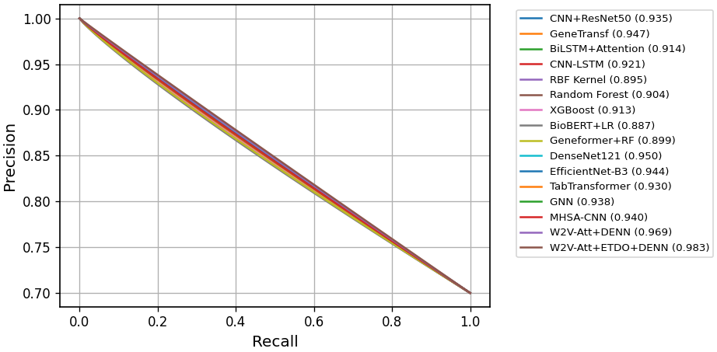
(b)
Fig. 8 ROC curves and PR curves illustrating skin cancer diagnostic performance of DENN model
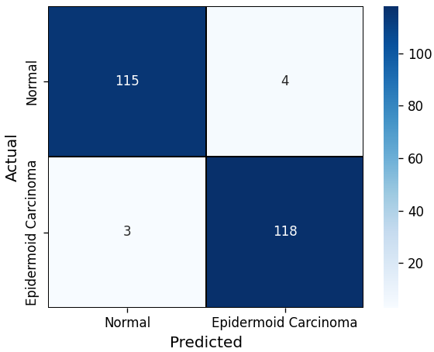
Fig. 9 Confusion matrix of the DENN model for skin cancer diagnostic by using optimal selected biomarkers using ETEO
Table 9 Performance of the DENN model evaluated using 10-fold cross-validation on skin cancer diagnosis
Sample ID | Predicted Label | Accuracy (%) | Precision (%) | Recall (%) | F1-Score (%) | Specificity (%) | ROC-AUC | PR-AUC
SRR585570_1 | Normal | 96.723 | 95.874 | 97.421 | 96.646 | 96.041 | 0.985 | 0.983
SRR585570_2 |  | 96.412 | 95.731 | 97.132 | 96.429 | 95.821 | 0.983 | 0.981
SRR585571_1 |  | 96.008 | 95.312 | 96.674 | 95.991 | 95.431 | 0.981 | 0.979
SRR585571_2 |  | 95.756 | 95.104 | 96.524 | 95.759 | 95.216 | 0.98 | 0.978
SRR585572_1 |  | 97.041 | 96.325 | 97.747 | 97.034 | 96.256 | 0.986 | 0.984
SRR585572_2 |  | 96.625 | 95.914 | 97.321 | 96.616 | 95.923 | 0.984 | 0.982
SRR585573_1 | Epidermoid Carcinoma | 97.324 | 96.723 | 98.032 | 97.376 | 96.512 | 0.987 | 0.985
SRR585573_2 |  | 97.032 | 96.432 | 97.745 | 97.084 | 96.243 | 0.986 | 0.983
SRR585574_1 |  | 96.723 | 96.145 | 97.421 | 96.782 | 95.923 | 0.984 | 0.982
SRR585574_2 |  | 96.543 | 95.912 | 97.215 | 96.562 | 95.734 | 0.983 | 0.981
SRR9203416 |  | 97.215 | 96.632 | 97.879 | 97.254 | 96.423 | 0.987 | 0.985
SRR9203417 |  | 96.932 | 96.321 | 97.632 | 96.975 | 96.145 | 0.985 | 0.983
Mean ± SD |  | 96.786 ± 0.493 | 96.093 ± 0.483 | 97.395 ± 0.477 | 96.786 ± 0.487 | 96.041 ± 0.422 | 0.985 ± 0.003 | 0.983 ± 0.003

Table 10 Comparative performance of proposed versus baseline models for skin cancer diagnostic using optimal biomarkers
Method | Accuracy (%) | Precision (%) | Recall (%) | F1-Score (%) | F2-Score (%) | Specificity (%) | MCC | Cohen’s Kappa | ROC-AUC | PR-AUC
CNN+ResNet50 | 92.413 | 91.524 | 92.871 | 92.196 | 92.547 | 91.360 | 0.843 | 0.843 | 0.942 | 0.935
GeneTransf | 93.185 | 92.769 | 93.741 | 93.252 | 93.604 | 92.620 | 0.858 | 0.857 | 0.951 | 0.947
BiLSTM+attention | 90.732 | 90.081 | 91.214 | 90.646 | 90.978 | 89.945 | 0.811 | 0.810 | 0.921 | 0.914
CNN-LSTM | 91.429 | 90.941 | 91.653 | 91.296 | 91.539 | 90.714 | 0.822 | 0.821 | 0.929 | 0.921
RBF Kernel | 88.643 | 87.952 | 88.941 | 88.442 | 88.732 | 87.356 | 0.772 | 0.771 | 0.903 | 0.895
Random Forest (100 trees) | 89.570 | 88.830 | 90.132 | 89.478 | 89.882 | 88.210 | 0.782 | 0.781 | 0.911 | 0.904
XGBoost | 90.289 | 89.745 | 90.761 | 90.252 | 90.615 | 89.140 | 0.798 | 0.797 | 0.920 | 0.913
BioBERT+Logistic Regression | 87.953 | 87.214 | 89.132 | 88.163 | 88.814 | 86.742 | 0.751 | 0.750 | 0.895 | 0.887
Geneformer+Random Forest | 89.110 | 88.590 | 89.570 | 89.079 | 89.362 | 88.040 | 0.781 | 0.780 | 0.908 | 0.899
DenseNet121+Transfer Learning | 93.452 | 92.981 | 93.925 | 93.452 | 93.783 | 92.840 | 0.861 | 0.860 | 0.954 | 0.950
EfficientNet-B3+Attention | 92.897 | 92.421 | 93.340 | 92.880 | 93.174 | 92.120 | 0.849 | 0.848 | 0.948 | 0.944
TabTransformer | 91.785 | 91.210 | 92.340 | 91.772 | 92.092 | 90.950 | 0.826 | 0.825 | 0.934 | 0.930
GNN | 92.318 | 91.874 | 92.741 | 92.306 | 92.614 | 91.620 | 0.839 | 0.838 | 0.941 | 0.938
MHSA-CNN | 92.621 | 92.145 | 93.021 | 92.583 | 92.760 | 91.951 | 0.842 | 0.841 | 0.944 | 0.940
W2V-Att+DENN | 95.281 | 94.742 | 96.017 | 95.376 | 95.721 | 94.540 | 0.919 | 0.918 | 0.973 | 0.969
W2V-Att+ETDO+DENN | 96.786 | 96.093 | 97.395 | 96.786 | 97.079 | 96.041 | 0.936 | 0.936 | 0.985 | 0.983

4.5 Ablation study and Generalizability analysis

Table 11 Ablation study on proposed models for optimal biomarkers selection and skin cancer diagnosis
LLM | Feature Extraction | Biomarkers | Pattern Analysis | Accuracy (%) | Precision (%) | Recall (%) | F1-Score (%) | Specificity (%) | ROC-AUC | PR-AUC
BioBERT | W2V-Att | All 19 | DENN | 93.842 | 93.210 | 94.765 | 93.981 | 93.104 | 0.956 | 0.952
Geneformer | W2V-Att | All 19 | DENN | 94.215 | 93.654 | 95.102 | 94.372 | 93.512 | 0.959 | 0.955
GPT | W2V-Att | All 19 | DENN | 94.568 | 94.012 | 95.438 | 94.719 | 93.865 | 0.962 | 0.958
BioBERT+Geneformer | W2V-Att | All 19 | DENN | 94.912 | 94.365 | 95.784 | 95.069 | 94.201 | 0.965 | 0.961
Geneformer+GPT | W2V-Att | All 19 | DENN | 95.124 | 94.612 | 95.921 | 95.261 | 94.432 | 0.967 | 0.963
BioBERT+Geneformer+GPT | W2V-Att | All 19 | DENN | 95.356 | 94.845 | 96.102 | 95.469 | 94.685 | 0.969 | 0.965
BioBERT | W2V-Att | Top-10 | DENN | 94.412 | 93.874 | 95.184 | 94.523 | 93.812 | 0.961 | 0.957
Geneformer | W2V-Att | Top-10 | DENN | 94.768 | 94.215 | 95.612 | 94.908 | 94.152 | 0.964 | 0.960
GPT | W2V-Att | Top-10 | DENN | 95.012 | 94.468 | 95.824 | 95.142 | 94.412 | 0.967 | 0.963
BioBERT+Geneformer | W2V-Att | Top-10 | DENN | 95.328 | 94.812 | 96.142 | 95.472 | 94.685 | 0.970 | 0.966
Geneformer+GPT | W2V-Att | Top-10 | DENN | 95.562 | 95.041 | 96.384 | 95.707 | 94.954 | 0.972 | 0.968
BioBERT+Geneformer+GPT | W2V-Att | Top-10 | DENN | 95.784 | 95.268 | 96.612 | 95.934 | 95.214 | 0.974 | 0.970
BioBERT | W2V-Att | ETEO | DENN | 96.128 | 95.712 | 96.784 | 96.243 | 95.638 | 0.981 | 0.979
Geneformer | W2V-Att | ETEO | DENN | 96.362 | 95.934 | 97.052 | 96.489 | 95.914 | 0.983 | 0.981
GPT | W2V-Att | ETEO | DENN | 96.558 | 96.124 | 97.254 | 96.686 | 96.126 | 0.984 | 0.982
BioBERT+Geneformer | W2V-Att | ETEO | DENN | 96.712 | 96.258 | 97.395 | 96.838 | 96.241 | 0.985 | 0.983
Geneformer+GPT | W2V-Att | ETEO | DENN | 96.781 | 96.331 | 97.402 | 96.792 | 96.284 | 0.985 | 0.983
BioBERT+Geneformer+GPT | W2V-Att | ETEO | DENN | 96.786 | 96.093 | 97.395 | 96.786 | 96.041 | 0.985 | 0.983

Table 12 Statistical results of proposed model for skin cancer diagnosis using Top 2 upregulated DEGs [31], Top 10 down-regulated DEGs [31] and optimally selected DEGs using ETEO
Statistical metric | Top 2 Upregulated DEGs | Top 10 Down-regulated DEGs | Combined DEGs (Top 2 + Top 10) | ETEO Selected Optimal DEGs
No. of Genes | 2 | 10 | 12 | Optimal subset
Mean log2FC | 0.338 | 1.302 | 1.148 | 1.421
Mean lfcSE | 0.084 | 0.292 | 0.265 | 0.214
Mean padj | 0.049 | 0.016 | 0.013 | 0.008
Accuracy (%) | 88.742 | 93.586 | 94.812 | 96.786
Precision (%) | 87.915 | 92.874 | 94.125 | 96.093
Recall (%) | 89.864 | 94.612 | 95.784 | 97.395
F1-Score (%) | 88.879 | 93.735 | 94.947 | 96.786
Cohen’s Kappa | 0.775 | 0.861 | 0.889 | 0.936
Brier Score | 0.142 | 0.098 | 0.082 | 0.041
One-way ANOVA (p-value) | 0.031 | 0.018 | 0.011 | 0.003
Tukey’s HSD (p-value) | 0.028 | 0.015 | 0.009 | 0.002
Kruskal-Wallis (p-value) | 0.034 | 0.02 | 0.013 | 0.004
Wilcoxon (p-value) | 0.029 | 0.017 | 0.01 | 0.003
Chi-Square (p-value) | 0.037 | 0.021 | 0.014 | 0.005
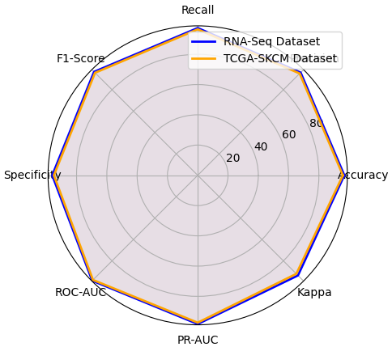
Fig. 10 Generalizability analysis of W2V-Att+ETEO+DENN model across different datasets

