VIPUL PATIL
─── Senior Data Engineer ───
+91-96012-91584 | contactvipulgpatil@gmail.com | linkedin.com/in/vipul-patil-a95349159 | Ahmedabad, India

PROFESSIONAL SUMMARY

Senior Data Engineer with 6+ years of progressive experience architecting enterprise-grade cloud data platforms across healthcare, finance, and retail domains. Expert in building production-ready, high-availability pipelines using Snowflake, Databricks, Apache Airflow, and dbt — with deep specialization in Medallion/Lakehouse architecture, dimensional modeling, and large-scale ELT optimization at 50M+ daily record volumes. Certified SnowPro Core & Architect. Proven track record delivering measurable engineering impact: 40% pipeline efficiency gains, 70% reduction in ETL failures, and 35% cloud cost savings. Known for translating complex business requirements into scalable, fault-tolerant data systems and leading high-performing engineering teams.

CORE TECHNICAL SKILLS

Cloud | AWS (S3, Lambda, Glue, IAM, API Gateway) · Azure (ADF, ADLS Gen2, Databricks, Key Vault, Blob Storage)
Data Warehouse | Snowflake (Architecture, Clustering, Virtual Warehouses, Snowpipe, Performance Tuning) · Azure SQL · SQL Server
Lakehouse | Apache Spark · PySpark · Databricks (Delta Lake, Unity Catalog, Auto Loader, DLT, Workflows) · Medallion Architecture
Transformation | dbt (Incremental Models, Snapshots, Tests, Macros) · Spark SQL · T-SQL · SSIS · Star/Snowflake Schema · SCD Type 1 & 2
Orchestration | Apache Airflow (DAGs, SLAs, Alerting) · Databricks Workflows · Azure Data Factory · Metadata-driven Pipelines
Programming | Python · PySpark · SQL · Shell Scripting · Power Automate · Workflow Automation
BI & Reporting | Power BI · Tableau · SSRS · SSAS · Crystal Reports
Practices | ETL/ELT Design · Data Quality Frameworks · CI/CD for Data · Agile/Scrum · Data Governance

WORK EXPERIENCE
Senior Data Engineer · KenexAI | Jan 2025 – Present

- Architected a cloud-native Lakehouse platform on Azure Databricks & Snowflake, enabling AI/ML-ready data consumption across 5+ business domains and processing 50M+ records daily.
- Engineered Medallion Architecture (Bronze → Silver → Gold) with PySpark and Delta Lake MERGE operations, achieving sub-2-hour SLA adherence and full audit lineage.
- Built a modular dbt ELT framework with 150+ automated tests across staging, intermediate, and mart layers — reducing pipeline data errors by 45% and accelerating feature delivery by 3×.
- Optimized Snowflake virtual warehouse configurations and clustering key strategies, cutting cloud compute spend by 35% while improving query performance by 60%.
- Designed Apache Airflow DAG orchestration with dynamic task generation, SLA alerting, and auto-retry logic across 20+ production pipelines — achieving 99.8% uptime.
- Integrated ADLS Gen2, AWS S3, and Snowpipe for automated multi-format ingestion (CSV, JSON, Parquet), reducing ingestion latency from hours to under 15 minutes.
- Delivered Gold-layer feature tables supporting 3 active production ML models, collaborating directly with data scientists on schema design and refresh SLAs.
- Mentored 3 junior engineers, drove dbt/Airflow best practice standards, and led bi-weekly architecture reviews across the data engineering org.

Senior Data Engineer · Altera Digital Health | Feb 2024 – Jan 2025

- Spearheaded data platform modernization for 10+ healthcare clients — migrating SSIS legacy workflows to Snowflake + ADF architecture, handling 20M+ daily records with 99.9% reliability.
- Architected dbt transformation layer with star-schema dimensional models (SCD Type 2) for clinical, operational, and financial analytics, cutting report build time by 55%.
- Engineered parameterized ADF pipelines ingesting data from 8+ heterogeneous EHR source systems with built-in error quarantine, schema validation, and HIPAA compliance.
- Reduced ETL pipeline failure rate by 70% by implementing proactive error handling, Airflow SLA alerting, and automated pipeline health monitoring dashboards.
- Improved overall pipeline throughput by 40% through Python automation, SSIS optimization, and intelligent SQL Job scheduling strategies.
- Led a team of 4 engineers — conducting code reviews, defining data governance standards, and driving engineering best practices across the healthcare data org.
- Awarded Top Quarterly Performer for the 4th consecutive year (2024) for engineering excellence, delivery speed, and measurable client impact.

Data Engineer · Altera Digital Health | Aug 2021 – Feb 2024

- Engineered end-to-end ETL pipelines using SSIS and Azure Data Factory integrating 6+ healthcare source systems (EHR, labs, claims) into SQL Server and Snowflake.
- Designed star-schema fact and dimension tables with SCD Type 2 patient history tracking, supporting 15+ production analytics reports across clinical and financial domains.
- Automated data movement between ADF, SQL Server, and Snowflake, reducing manual processing effort by 60% and eliminating recurring ingestion failures.
- Implemented Python-based validation, reconciliation, and monitoring pipelines, saving 4 hours/day of analyst overhead and catching 95% of upstream data issues early.
- Delivered incremental load strategies and SQL index tuning that improved pipeline execution speed by 50% and reduced query response times across high-volume tables.
- Onboarded 3 new enterprise healthcare clients with zero-downtime ETL migrations using phased cutover strategies and custom transformation mapping frameworks.

Associate Data Engineer · Altera Digital Health | Oct 2019 – Aug 2021

- Built SSIS ETL pipelines ingesting structured healthcare data from EHR systems and clinical labs, supporting production data warehouse loads with 99% SLA adherence.
- Automated recurring data workflows using SQL Jobs and SSIS packages, reducing manual reporting effort by 35% and improving pipeline scheduling consistency.
- Engineered SQL stored procedures, optimized views, and index strategies — reducing application query execution time by 40% on high-volume healthcare datasets.
- Delivered high-priority ETL solutions for top-tier providers across multiple Agile sprints with zero missed deadlines throughout the full 2-year tenure.

Junior Data Engineer · Exxat Systems | Jun 2018 – Oct 2019

- Developed SQL pipelines and data extracts for healthcare SaaS modules (STEPS, CCS), supporting clinical placement and performance analytics for enterprise clients.
- Automated data import validation using SQL scripts, reducing ingestion errors by 25% and improving downstream data consistency across 10+ source feeds.
- Performed data profiling on source datasets, identified anomalies, and collaborated with senior engineers to implement upstream validation rules in ETL flows.

KEY ACHIEVEMENTS

1 | Cut cloud compute costs by 35% through Snowflake warehouse right-sizing, clustering key tuning, and query optimization across 12 production schemas.

2 | Reduced ETL pipeline failure rate by 70% by engineering SLA alerting, auto-retry workflows, and error quarantine logic across ADF and SSIS systems.

3 | Improved pipeline throughput by 40% through Airflow DAG restructuring, Python automation, and intelligent SQL Job scheduling strategies.

4 | Achieved 99.8% pipeline uptime across 20+ Airflow DAGs through robust retry mechanisms, dead-letter queuing, and real-time health dashboards.

5 | Accelerated dbt model delivery by 3× by introducing modular ELT patterns with 150+ automated tests, reusable macros, and incremental materialization.

6 | Migrated legacy ADF orchestration to Databricks Workflows, cutting average job execution time by 50% and enabling full pipeline observability.

7 | Awarded Top Quarterly Performer in 2021, 2022, 2023, and 2024 — 4 consecutive years — for engineering delivery, innovation, and cross-functional leadership.

CERTIFICATIONS  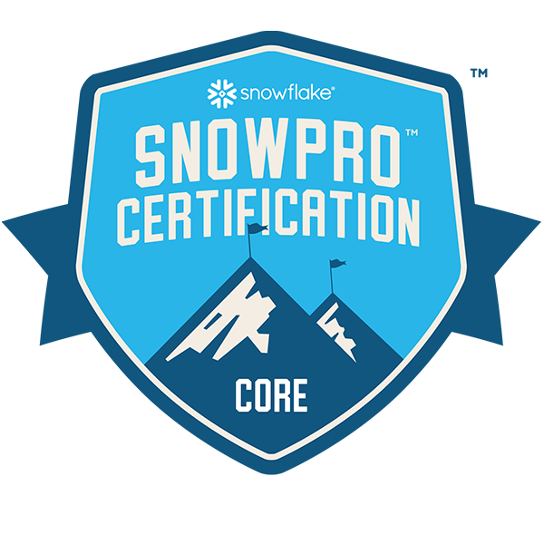 SnowPro Core Certification Snowflake · Mar 2025 – Mar 2027   SnowPro Advanced: Architect Snowflake · Mar 2025 – Mar 2027  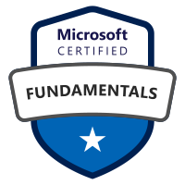 Microsoft Azure Fundamentals (AZ-900) Microsoft Certified · 2023  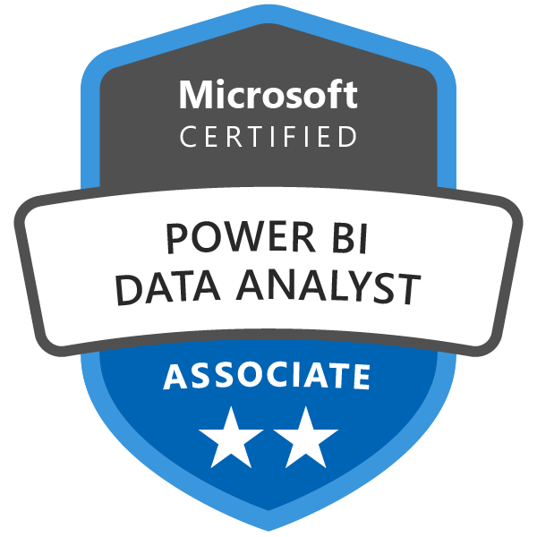 PL-300: Power BI Data Analyst Microsoft Certified · 2022   Microsoft Certified Solutions Associate (MCSA) Microsoft Certified · 2020 |  | EDUCATION  Bachelor of Engineering  Gujarat Technological University  2015 – 2018  Diploma in Electronics & Communication  Gujarat Technological University  2011 – 2014

