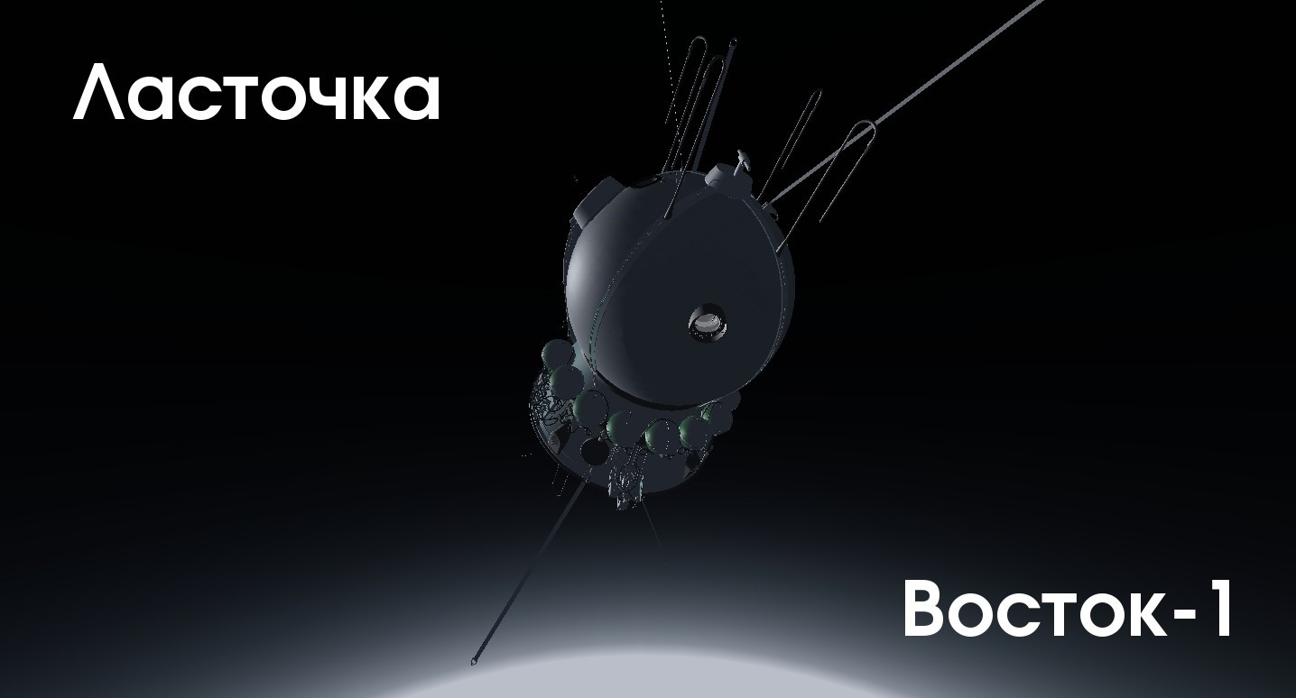
Important note
The meaning of the Vostok‑1 project is not to reproduce Yuri Gagarin's historical flight in every detail, but to give you a general vision of the technical features of piloted spaceflight as a whole.
That flight was fully automated. You would hardly be interested in watching a mediocre imitation of it for an hour and a half. It would be much more interesting if you took most of the control yourself — from liftoff to landing.
Modern cosmonauts can land Soyuz spacecraft by hand during deorbit, with 4g overloads. In principle, this flight could have been like that. But simply, not many people are ready to trust a human that much when other variants are available.
The project turned out a little bit more complex than initially expected. Many things are still to come. But it is already possible to fly around the Earth and return safely.
Wish you a good flight.
With respect and sympathy,
Victor Slavutinsky, vitosnet@mail.ru

Cabin view
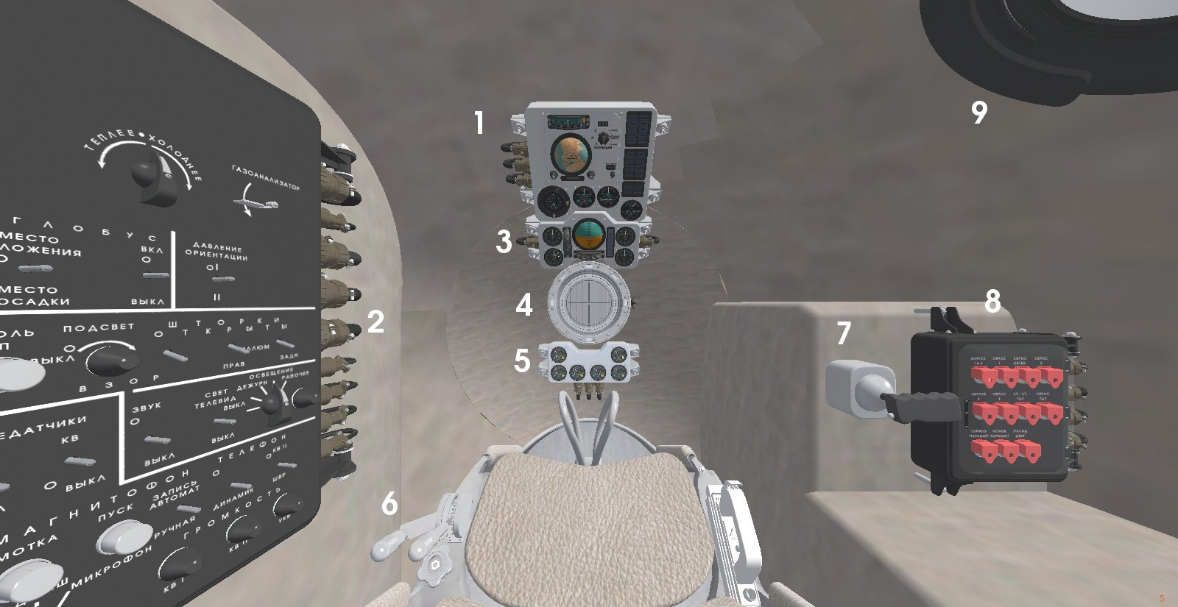
- Main panel
- Left control panel
- Panel of orientation, position and speed indication
In real Vostok-1, a TV camera was in place of it and transmitted information about the cosmonaut's condition to Earth.
- “Vzor” optical orientator
- First three stages control panel
Absented in real Vostok-1.
- Thrust control handle
It seems it has other functions in real Vostok-1.
- Orientation control handle
- Right control panel
Absented in real Vostok-1.
- Right window

Main panel
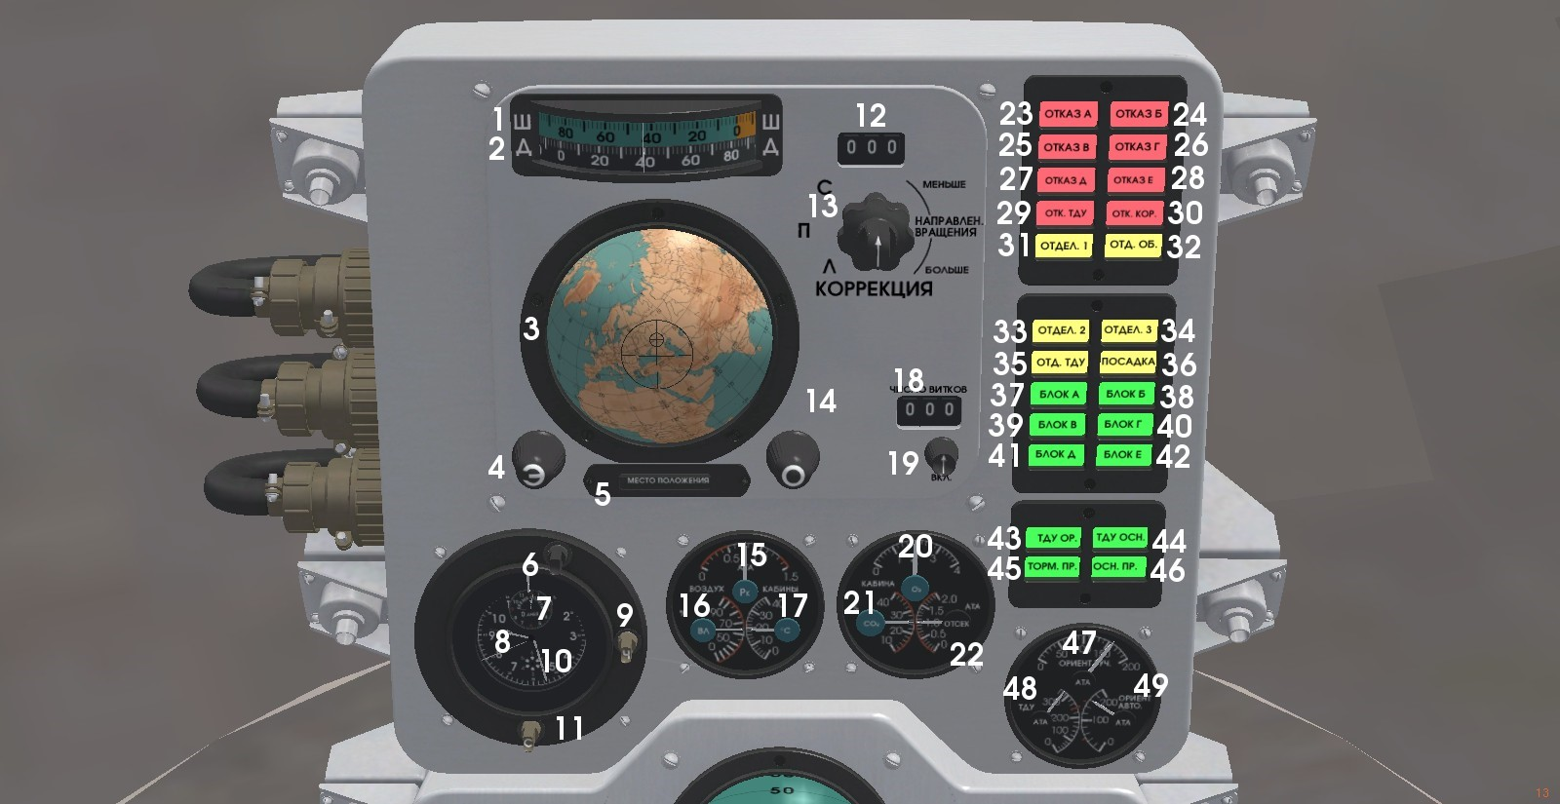
- Latitude indicator
- Longitude indicator
- “Globus” position indicator
Direction from big cross to small cross shows where top of spacecraft is directed to.
- Adjustment vernier
To be honest, have no information what it adjust. Will be happy if someone tells me about that.
- “Globus” mode indicator
Globus have two modes what can be switched by left control panel or by pressing “g” key. First mode shows approximate position of craft. Second mode shows approximate landing position on base of spacecraft speeds data. Calculated position now is not exact much due to technical reasons, but it's correct enough to at least for landing on continent instead of water.
- Duration of flight indicator adjustment gear
In unpressed state adjust minutes, in pressed hours of flight time.
- Duration of flight indicator
- Clock
In real Vostok-1 shows Moscow time.
- Clock adjustment gear
In unpressed state adjust seconds, in pressed minutes.
10. Daytime indicator
In orbital flight night and day in sum have only one and half of the hour in duration. It's easy to disorientate yourself in time. Indicator allows to understand what part of orbital daytime is now.
11. Daytime indicator adjustment gear
In unpressed state adjust needle only, in pressed adjust needle and central scale relatively to outer scale.
12. Adjustment number of position data indicator
Positions that are shown by indicators are computing results. Onboard computer accounts it on base of gyros and acceleration sensors states. So it's approximate and can drift. To normalizing of it cosmonaut can use data what is translated from Earth on communicating sessions and what is accounted in Control Center on base of spaceship observation and location. At now indicators show real exact information all the time but shift and adjustment will be realized soon.
13. Position data adjustment vernier
Central switch gives a mode, outer vernier adjust data.
14. Adjustment vernier
Same with 4 paragraph.
15. Cabin air pressure indicator
Not available currently, will be realized in case of depressurization case implementation.
16. Cabin air humidity indicator
Offline at now, maybe will be turned on in time.
17. Cabin air temperature indicator
Heating on sun and cooling in shadow will be implemented for sure.
18. Circuits counter indicator
Will be implemented.
19. Circuits counter indicator adjustment vernier
- Cabin air oxygen percent indicator
Will be implemented with oxygen control. Too much of oxygen can cause fire, too small part can lead to blackout of cosmonaut.
- Cabin air carbon dioxide percent indicator
- Cabin air pressure indicator

- Block A malfunction lamp
In real Vostok-1 lamps have different purposes. In imitation it's used for simple function/malfunction indication.
Rocket stages is:
Blocks A, B, C, D: blocks of first stage clockwise by forward block.
E: Second stage.
F: Third stage.
TDU: brake engine stage. Spacecraft.
Most probable reason of first and second stages block malfunctioning is growing of g force beyond 4g. Most part of stages mass is oxidizer and fuel, so on end of stage functioning it have significantly less mass then on beginning. But engine thrust is same, so acceleration and g force grows considerably. Check g force indicator at sages functioning finish and reduce thrust to failure avoid.
24. Block B malfunction lamp
Other probable reason of first stage blocks malfunctioning is aerodynamic pressure overload. Force, what air flow press surface of carrier with, inverse depends of altitude and straight of pressure. If that force will grow beyond limit of five tons per square meter then carrier could be damaged. Check dynamic pressure indicator and reduce thrust as needed to keep force smaller.
25. Block C malfunction lamp
26. Block D malfunction lamp
27. Block E malfunction lamp
Check g force and thrust on end of second stage functioning to avoid second stage failure.
28. Block F malfunction lamp
Block F is intended for high altitudes using only. Attempt to ignite or use it at altitudes up to 50km would lead to malfunctioning or even exploding of it, at least in imitation.
29. TDU malfunction lamp
Same with 28 paragraph.
30. Spacecraft malfunction lamp
Probable reasons of spacecraft malfunction is cabin pressure atmosphere conditions going beyond limits or malfunctioning of main parachute system what demands of emergency ejection. Both will be implemented in time.
31. First stage functioning time completion warning lamp
Switched on when fuel and oxygen weights of first stage is less than 10% of initial state. Warnings of necessity of thrust reducing and then separating of first stage.
32. Fairings functioning time completion warning lamp
Fairings can be separated only in vacuum on altitudes beyond 50km, otherwise TDU block will be damaged by airflow. On the other hand, fairings mass is more than half of tonne, so the sooner it get away the better. If lamp is on then separate first stage fast.
33. Second stage functioning time completion warning lamp
Same with 31 paragraph.
34. Third stage functioning time completion warning lamp
35. TDU stage functioning time completion warning lamp
36. Deorbit warning lamp
Shifted on after TDU separation and stays on until landing.
37. Block A engine functioning lamp
38. Block B engine functioning lamp
39. Block C engine functioning lamp
40. Block D engine functioning lamp
41. Block E engine functioning lamp
42. Block F engine functioning lamp
43. TDU orientation engines functioning lamp
44. TDU main engine functioning lamp
45. Brake parachute functioning lamp
46. Main parachute functioning lamp
47. TDU handled orientation system balloons pressure indicator
Check orientation system pressure in orbital flight, use short impulses for control. After nitrogen expending orientation could be started after main TDU engine ignition only what would mean loss of some fuel part without positive effect. There is no much fuel for main engine, deorbit is questionable in that case.
48. TDU main engine balloons pressure indicator
Instead of real Vostok-1, TDU main engine can be used many times for orbit correction. But fuel reserves very limited still, so check remain. Se for correction only pressure down to red line and reserve other part for deorbit.
49. TDU automated orientation system balloons pressure indicator
TDU of real Vostok-1 have, in addition to handled orientation system, two automated orientations systems to guarantee right orientation on deorbit burn. In imitation that systems is unrealized yet, but it will be added in short time.

Left control panel
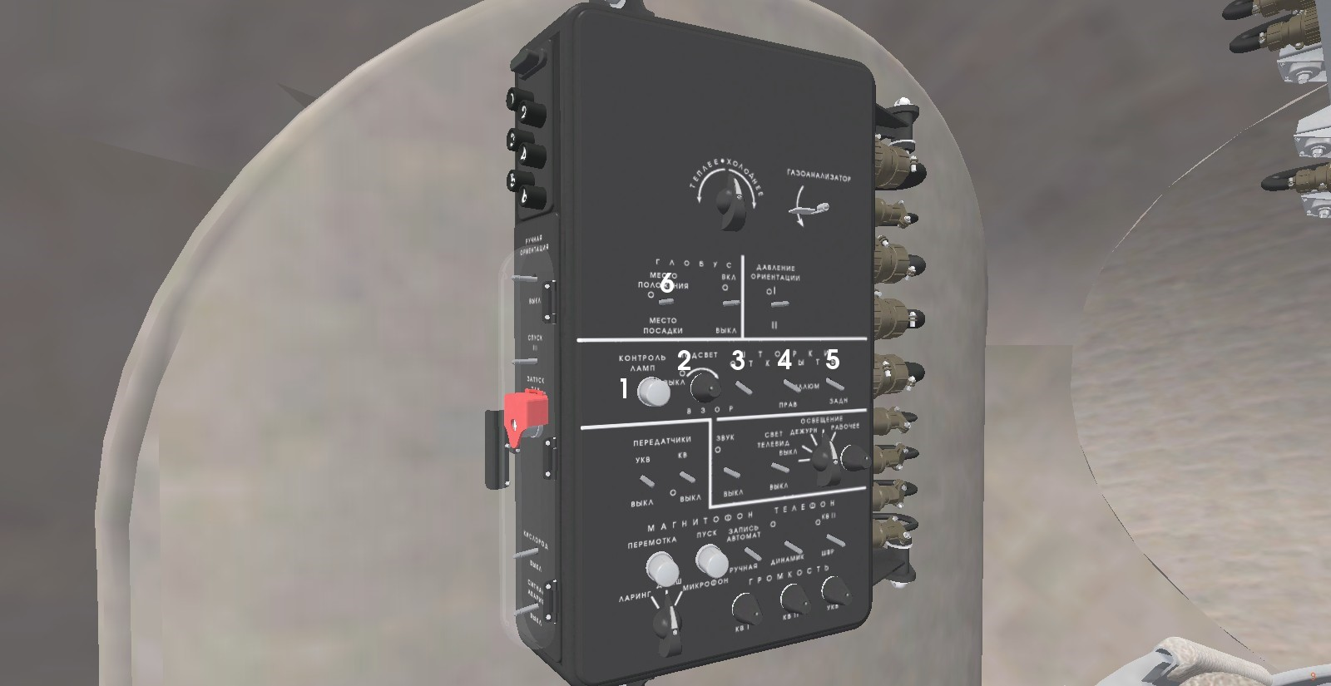
- “Vzor” and panels lamps control button
Currently most part of left panel functions is switched off.
- “Vzor” lightning adjust vernier
- “Vzor” shutters switch
- Right window shutters switch
- Back window shutters switch
- “Globus” modes switch

Panel of orientation, position and speed indication
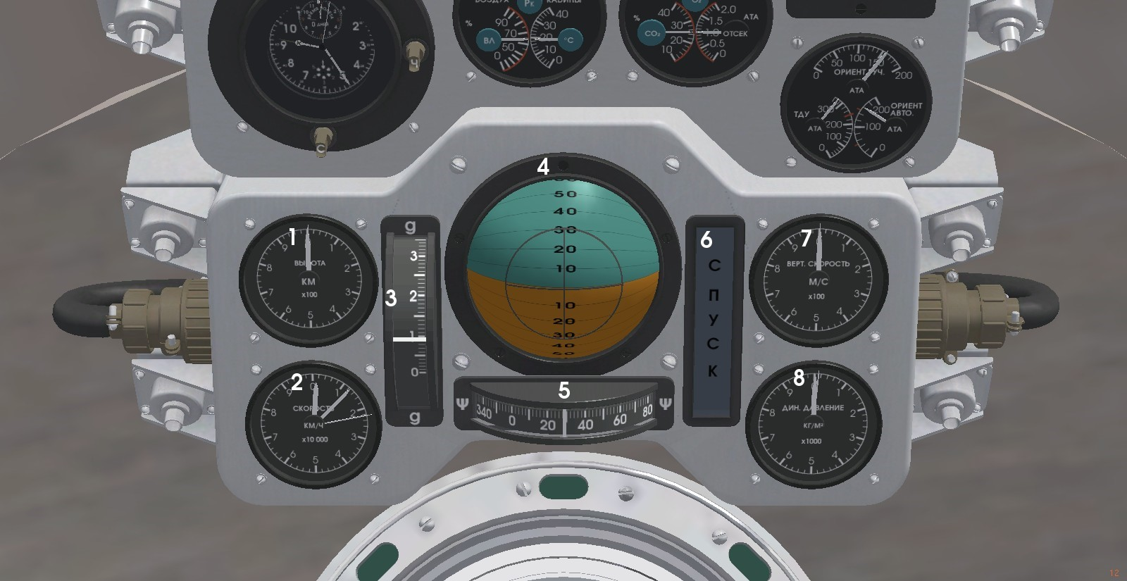
- Altitude indicator
Shows altitude over sea level. Have three needles, x100 means what “hours” needle shows hundreds of kilometers, “minutes” shows tens, ”seconds” show kilometers.
- Horizontal speed indicator
Х10 000 kilometers/hour. Notice what it shows speed about 1000km/h while rocket is stays on the ground. It's Earth rotation speed what's added. Because Earth is rotated from west to east flight gotta be conducted in opposite direction. Otherwise it's subtracted instead of added and amount of fuel could become too small for orbital speed reaching.
- G force indicator
Normal accelerations for rising on orbit is up to 4g, for deorbit is up to 10g. If g force goes beyond first limit then thirst and second stages can malfunction what would mean premature ending on flight and emergency landing. On third stage malfunction or going on orbit errors suborbital flight with overloads to 15g is possible. On too rough deorbit and g forces beyond 15g simulator will count flight as failed.
- Artificial horizon
Note what horizon shows view what's correspond to view from “Vzor” visor. In horizontal flight vertical angle of horizon is 90 degrees and whole view is green or orange.
- Compass
Normal direction of rocket on start of going to orbit is 65 degrees.
- Descent indicator
Lamp is on when descent occurs.
- Absolute vertical speed indicator
«Hours» needle shows hundreds of meters per second so thin needle is meters per second. Shows only absolute values, it's needed to check descent indicator to know direction of vertical speed.
- Dynamical pressure indicator
Shows force with airflow press surface of carrier with. Check pressure and reduce thrust to keep it below five tonnes on one square meter limit.

“Vzor” optical orientator
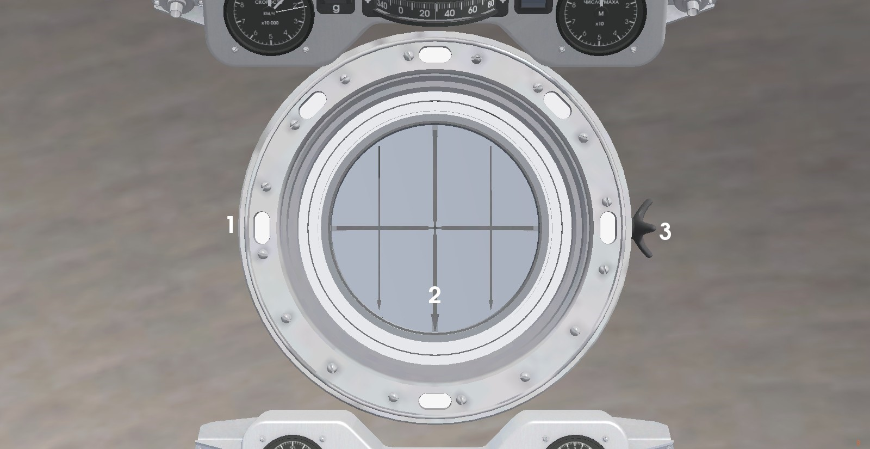
- Rotation direction indicator
- Optical orientator
In case of automatic orientation system malfunction visual orientation for deorbit burn is possible. Orientate spacecraft manually to put reflection of underling Earth surface in center of “Vzor” round mittor. Running of Earth surface must go from sharp end of arrows to blunt end. In that position TDU engine nozzle is directed into direction of orbit and deorbit burn can go correctly.
- Shutters closing handle
In real Vostok-1 Sun is shining so bright what cause short period of blindness if Sun itself seeing in “Vzor” or window. In imitation that effect can be out of reach but shutters is realized, for growth and for beauty.

First three stages control panel
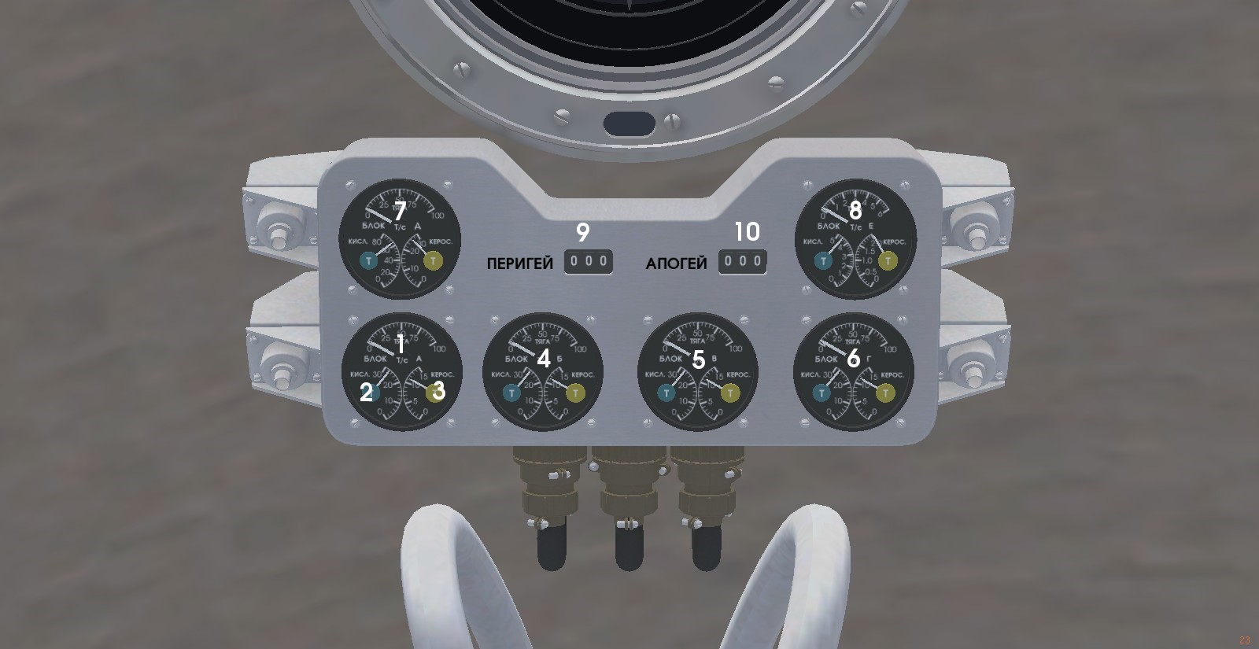
- Block A thrust indicator
In tonnes per seconds. On begin of liftoff weight of block, approximately sum of oxidizer and fuel weight is 40tns, thrust of maximum throttle is 83tns/sec, so block itself gives 2g acceleration and g force is 3g.
- Block A oxidizer weight indicator
In tonnes.
- Block A fuel weight indicator
Same with paragraph 2.
- Block B thrust and weights indicator
- Block C thrust and weights indicator
- Block D thrust and weights indicator
- Block E thrust and weights indicator, second stage
- Block F thrust and weights indicator, third stage
- Perigee altitude indicator
Altitude of orbit lowest point. Note that perigee rising goes very fast on end of climbing to orbit.
10. Apogee altitude indicator
Altitude of orbit highest point. On the end of climbing to orbit, when path is almost horizontal, approximately equals craft position altitude.

Thrust control handle
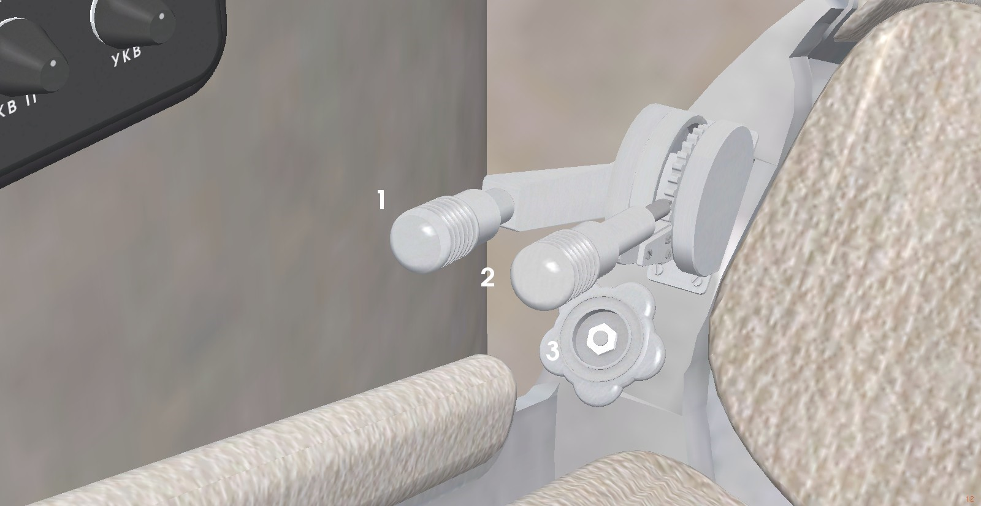
- Handle lock
Switched by mouse click or r button. Vibrations can lead handle to shift so lock it in moments when constant throttle is needed.
- Throttle control handle
Controlled by mouse clicking on ends of base or PgUp/PgDown buttons.
- Valve
Must be for emergency oxygen feed. Will be happy if someone enlighten about function of it.

Orientation control handle and right control panel
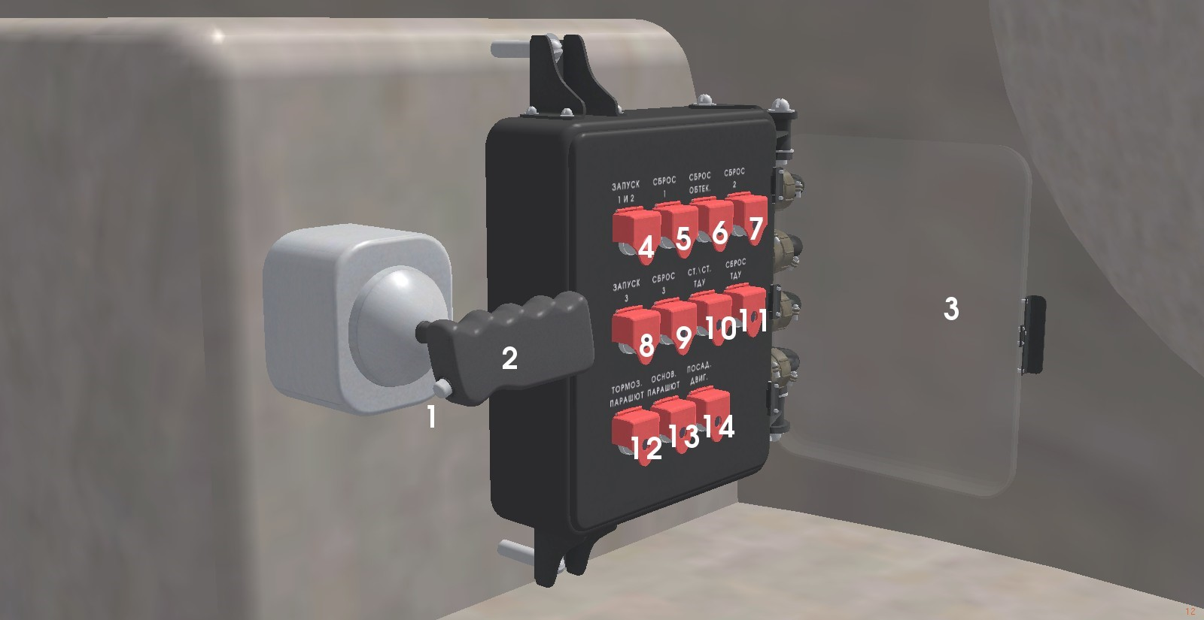
- Control handle control button
Switched on by c button pressing. On going to orbit and first three stages activity phase pressing on it stabilizes and holds carrier in angles what if has on moment of pressing. On orbital TDU activity phase pressing activates a control that would not work otherwise, it's made for fuel preservation. Shift handle a bit by needed axis then press button for short period of time to start rotation. Move handle to zero position after that and press and hold button on moment of needed angle reaching to stop rotation.
- Orientation control handle
Have three axes. Moving up and down controls pitch, left and right controls roll and clockwise and anticlockwise controls yaw. If You have no joystick then keyboard with NumLock switched on is preferable for control. Then keys 8 and 2 controls pitch, 4 and 6 controls roll and 0 and right Enter controls yaw. 5 key sets handle to zero on all angles. If handle is in zero position on some of axes then stabilization computer holds angle on that axis, automatically on first three stages phase of flight and on button pressing in TDU activity phase. Have in mind what carrier initially stands, so rotation in plane what is parallel to Earth surface is controlled by roll, while in horizontal flight it controlled by yaw. Note what control surfaces and engines turns can parry alpha angles up to 10deg only so too fast turn on atmosphere phase of light can lead to uncontrollable spin.
- Safety right control panel door
Opened and closed by mouse click.
- First and second stages ignition button
Panel lights up buttons what could be used next in normal flight procedure. Engine startup procedure is absented already, so unlock throttle handle and put throttle to maximum right after ignition for liftoff.
- First stage separation button
Engines of first three stages can be ignited only once so it can be switched off only in stage separation procedure.
- Fairings separation button
- Second stage separation button
- Third stage ignition button
- Third stage separation button
10. TDU main engine ignition/stop button.
Instead of real Vostok-1, main TDU engine can be ignited and switched off many times to provide orbit correction. But amount of fuel is still real, for one and half minutes of maximum thrust only. On excess correction using lasting amount can become too small for returning.
11. TDU separation button
12. Brake parachute deploying button
In real Vostok-1 instead of brake cute orientation and pulling chute is used.
13. Main parachute deploying button
14. Safety landing sensor extraction button
Safety landing engine was planned but absented in real Vostok-1. It was used first time in Voskhod-1 first three seat spacecraft.

Right window
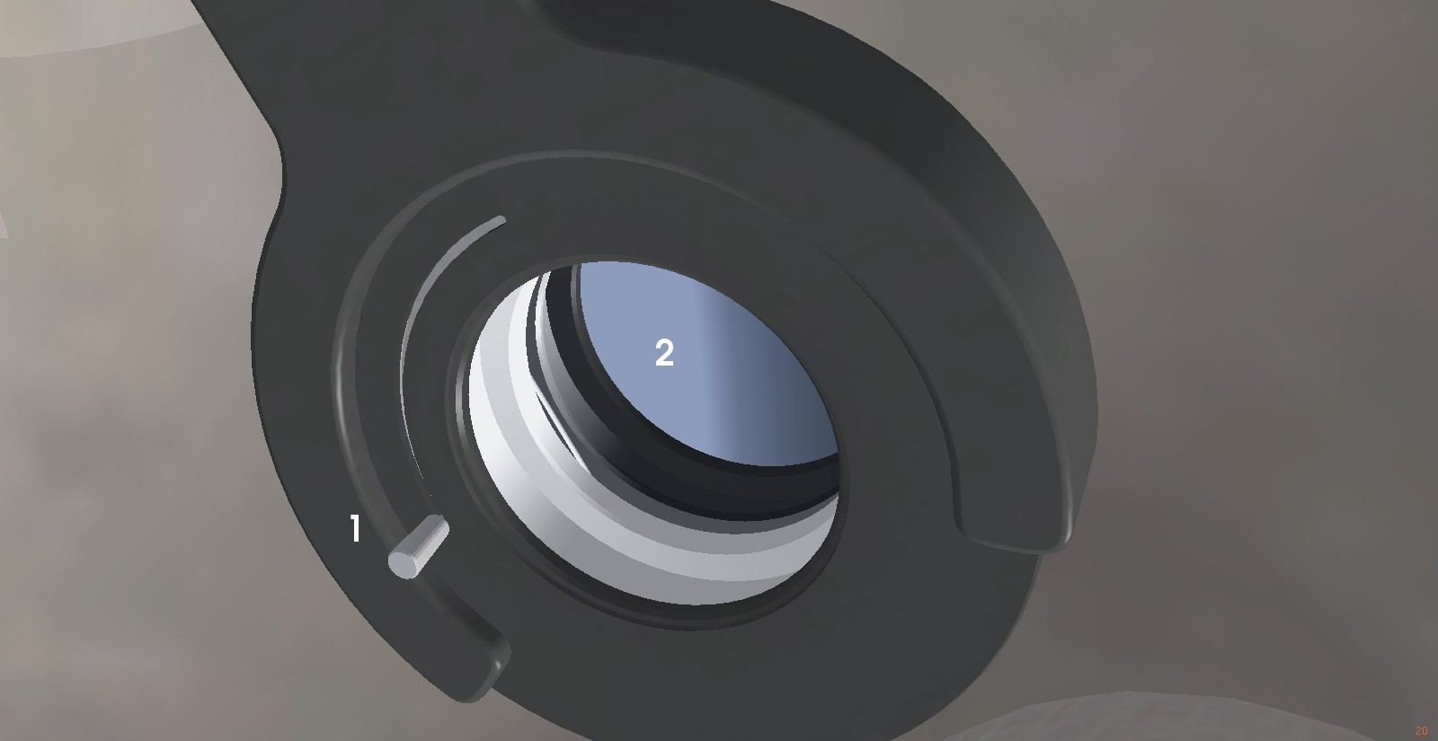
- Shutters closing handle
Shutters can be opened and closed by mouse click.
- Earth in window

Orbital speeds for different altitudes
Altitude,km | Speed,km/h
120 | 28211
140 | 28168
160 | 28124
180 | 28081
200 | 28039
220 | 27996
240 | 27954
260 | 27911
280 | 27869
300 | 27828
320 | 27786
Orbital speed is 7.9km/sec only right above Earth surface. Because it depends of distance to Earth center in inverse then it bit smaller on bigger altitudes. If You will get in horizontal flight bigger speed and switch engine off after that then spacecraft will go on other orbit as if was tied to it with spring or rubber band, rush it with speed, and, because where is hardly some braking in vacuum, will oscillate around it, it called “eccentricity” scientifically. Keep that in mind and reach orbital speed as exact as possible.

Main keyboard shortcuts
Shortcut | Action
R | Lock/Unlock thRottle handle
С | Control handle button
O | Open/Close cOntrol panel
S | Ignite first and Second stages
F | Drop Fairings
Shift-F | Drop First stage
Shift-S | Drop Second stage
H | Ignite tHird stage
Shift-H | Drop tHird stage
U | Ignite/Stop tdU engine
Shift-U | Drop tdU
B | Extract Brake parachute
M | Extract Main parachute
L | Extract Landing engine sensor

Liftoff and ascent to orbit
- Unlock throttle handle
- Open right panel and ignite first two stages.
- Maximize throttle.
- On 100m altitude reach begin rotation by compass to north-east direction, 55 degrees.
- On end of turning stabilize carrier and put nose down on 30 degrees by pitch.
- Look on dynamic pressure indicator from time to time and reduce thrust to keep pressure below 5 tons/square meter limit.
- Restore thrust with pressure dropping.
- Continue ascent with pitch angle growing by small amounts continuing for 500m/sec vertical speed stabilizing.
- Correct yaw angle on need.
10. Check g force indicator and control throttle to preserve g force 4g limit exceeding.
11. Separate fairings on 50km altitude exceeding.
12. On exhaust of first stage fuel separate it and return throttle to maximum.
13. On 130km altitude reaching increase pitch angle to reduce vertical speed to values beyond 100m/sec and become zero at 160km altitude.
14. Check g force indicator and reduce thrust to keep g force in 4g limit.
15. On exhaust of second stage fuel separate it.
16. Check what control handle control button is unpressed.
17. Ignite third stage and maximize throttle.
18. Control angle to reach zero vertical speed on altitude of 160km approximately.
19. Reduce throttle to minimum at an appropriate speed and hold zero vertical speed by pitch angle control.
20. On reaching a perigee above 150km separate third stage.
21. On need ignite TDU on lower thrust and correct orbit parameters. Watch for fuel amount to keep rest of it beyond red line on indicator to guarantee correct deorbit burn later.

Deorbit and landing
- Orientate spacecraft in plane what parallel to Earth surface below and turn it to make main engine nozzle looks into flight direction. Use “Vzor” and orientation panel to make it correctly.
- Switch “Globus” to “МЕСТО ПОСАДКИ” (landing site) position indication mode.
- Ignite main TDU engine and put thrust on maximum.
- Check horizontal speed indicator. Speed gotta start to reduce.
- On reaching needed landing site position on “Globus” or reaching zero perigee altitude stop TDU engine. To fastest deorbit use all TDU main engine fuel.
- Separate TDU stage.
- Extract brake parachute on 7km altitude.
- Extract main parachute on 2.5km altitude.
- Extract soft landing sensor on vertical speed reducing to 10m/sec.
- Wish a safe landing for you.

