Federator.ai Kubernetes Deployment Utilization Helper Utility

This utility collects Kubernetes cluster resource data and Federator.ai recommendations for the Kubernetes cluster and uses an Excel spreadsheet to summarize the resource data. The spreadsheet displays the CPU/memory resource requests, limits, and the utilization compared to those requests and limits for all deployments/statefulsets within the cluster. Users can use this resource request, limit, and utilization data to identify deployments/statefulsets that may be over-provisioned or under-provisioned.

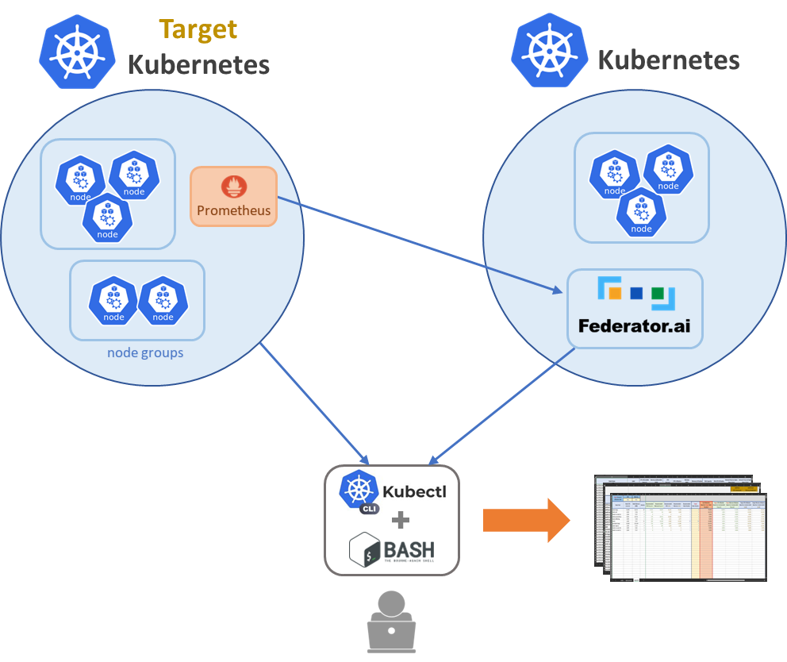
deployment_utilization_20240216.xlmm
k8s-resource-collect.sh

Utility
- deployment_utilization_20240216.xlsm – Excel spreadsheet displays the CPU/memory resource requests, limits, and the utilization.
- k8s-resource-collect.sh – Linux bash script for collecting Kubernetes cluster resource data and Federator.ai recommendations for the Kubernetes cluster.
Example:

k8s-resource-collect.sh --host=127.0.0.1:31012 --username=admin –password=xxxxx --cluster=h3-61 –resource=controller

Where “host” is the hostname or URL of Federator.ai, “username”/”password” are the username and password for logging in Federator.ai, and “cluster” is the cluster name of the managed target cluster configured in Federator.ai. “resource” is to tell the script to collect controller (deployments/statefulsets) data.

Federator.ai Kubernetes Node/Controller Resource Collector v1.1.4

k8s-resource-collect.sh [options]

Mandatory options:
-h, --host='' Federator.ai API host(ip:port) (DEFAULT: '127.0.0.1:31012')
-u, --username='' Federator.ai API user name (DEFAULT: 'admin')
-p, --password='' Federator.ai API password (or read from 'F8AI_API_PASSWORD')
-c, --cluster='' Target Kubernetes cluster name
Optional options:
-k, --kubeconfig='' Kubeconfig file full path (DEFAULT: )
-x, --context='' Kubeconfig context name (DEFAULT: '')
-g, --granularity='' Resource recommendation granularity (DEFAULT: '21600')
-d, --directory='' Local path where .csv files will be saved (DEFAULT: '.')
-r, --resource='both' Generate Node('node') and/or Controller('controller') .csv (DEFAULT: 'both')
-l, --logfile='' Full path of the log file (DEFAULT: './k8s-resource-collect.log')
-a, --federatorai='yes' Whether to use Federator.ai recommendations (DEFAULT: 'yes')
-t, --pastperiod='' Past period in days for getting the maximum usage (DEFAULT: '28')
-n, --namespaces='' List of namespaces separated by comma, override controllers' recommendations

Examples:
k8s-resource-collect.sh --host=127.0.0.1:31012 --username=admin --password=xxxx --cluster=h3-61 –resource=controller

Requirements
- Microsoft Windows 10 and above
- Microsoft Excel 2016 and above, Windows version
- Linux host with kubectl configured for the Kubernetes cluster

Steps
The “k8s-resource-collect.sh” script helps users to collect resource (Node and Controller) data and save the data to “deployment-raw.csv” file. The “deployment_utilization_20240216.xlsm” spreadsheet is configured to load the resource data from the CSV file automatically when the spreadsheet is opened.
- Upload the “k8s-resource-collect.sh” script to the Linux host with kubectl configured for the target Kubernetes cluster.
- Run the script with the required options, “--host”, “--password”, “--cluster”, and “—resource”. By default, the CSV files (deployment-raw.csv) will be saved in the directory where the script is located.
~# bash ./k8s-resource-collect.sh --host=172.31.3.61:31012 --cluster=prom334 --password=xxxxxxxx –resource=controller
Federator.ai Kubernetes Node/Controller Resource Collector v1.1.4

Kubernetes cluster: prom334(172.31.3.34)

(It may take a few minutes to complete...)

Start collecting Controller resource data:
.....................................................
Successfully created Controller .csv: './deployment-raw.csv'. ~#
~# ls -l *.csv
-rw-r--r--. 1 root root 4324 Feb 8 18:38 deployment-raw.csv
- Create a new folder, “C:\Data”, on your Windows desktop, copy the spreadsheet to the folder, and download the two CSV files to the same folder.
Microsoft Windows [Version 10.0.22621.1194]
(c) Microsoft Corporation. All rights reserved.

C:\>cd c:\Data

c:\Data>dir
Volume in drive C is Windows
Volume Serial Number is BEFF-E40B

Directory of c:\Data

02/08/2023 10:36 PM <DIR> .
02/08/2023 06:38 PM 4,324 deployment-raw.csv
02/08/2023 05:33 PM 349,394 deployment_utilization_20230816.xlsx
2 File(s) 353,718 bytes
1 Dir(s) 396,065,189,888 bytes free

c:\Data>
- Open the “C:\Data\deployment_utilization_20240216.xlsx” spreadsheet. The “deployment” sheet will be refreshed with the collected data.

Note:
Due to the Excel limitation, spreadsheets can only be configured to automatically load CSV files from a fixed location. By default, this spreadsheet is set up to load the two CSV files from the “C:\Data” folder.
If you want to change the location of the CSV file, the configuration is in
- “Excel Data Queries & Connections”.
- Double-click the “deployment-raw” in the “Queries & Connections” panel.
- Click “Source” in the “Query Settings” panel.
- Change the absolute path in “File.Contents()”
- Close & Load

