# Federator.ai Kubernetes Node Utilization Helper Utility

This utility collects Kubernetes cluster resource data and Federator.ai recommendations for the Kubernetes cluster and uses an Excel spreadsheet to summarize the resource data. By adjusting the “Target Resource Utilization Goal” and “Target Node Number” in the spreadsheet, users can estimate the number of nodes that are needed to meet the target resource utilization goals and the cost reduction with the estimated node number.

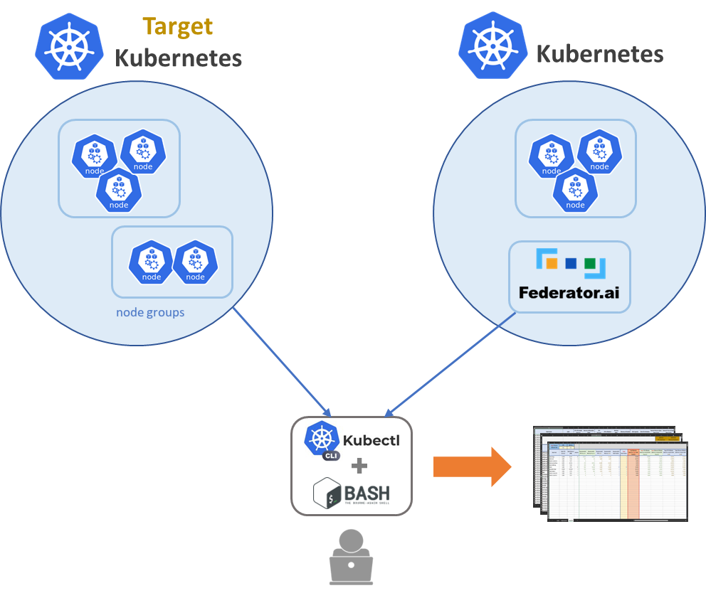

k8s-resource-collect.sh

node_utilization_20231117.xlsm

## Utility

* **node_utilization_20231117.xlsm** – Excel spreadsheet for estimating the number of Kubernetes nodes that are needed to meet the target resource utilization goals.
* **k8s-resource-collect.sh** – Linux bash script for collecting Kubernetes cluster resource data and Federator.ai recommendations for the Kubernetes cluster.  
  Example:

k8s-resource-collect.sh --host=127.0.0.1:31012 --username=admin –password=xxxxx --cluster=h3-61

Where “host” is the hostname or URL of Federator.ai, “username”/”password” are the username and password for logging in Federator.ai, and “cluster” is the cluster name of the managed target cluster configured in Federator.ai.

Federator.ai Kubernetes Node/Controller Resource Collector v1.1.4

k8s-resource-collect.sh [options]

Mandatory options:

-h, --host='' Federator.ai API host(ip:port) (DEFAULT: '127.0.0.1:31012')

-u, --username='' Federator.ai API user name (DEFAULT: 'admin')

-p, --password='' Federator.ai API password (or read from 'F8AI_API_PASSWORD')

-c, --cluster='' Target Kubernetes cluster name

Optional options:

-x, --context='' Kubeconfig context name (DEFAULT: '')

-g, --granularity='' Resource recommendation granularity (DEFAULT: '21600')

-d, --directory='' Local path where .csv files will be saved (DEFAULT: '.')

-r, --resource='both' Generate Node('node') and/or Controller('controller') .csv (DEFAULT: 'both')

-l, --logfile='' Full path of the log file (DEFAULT: './k8s-resource-collect.log')

-a, --federatorai='yes' Whether to use Federator.ai recommendations (DEFAULT: 'yes')

-t, --pastperiod='' Past period in days for getting the maximum usage (DEFAULT: '28')

Examples:

k8s-resource-collect.sh --host=127.0.0.1:31012 --username=admin --password=xxxx --cluster=h3-61

## Requirements

* Microsoft Windows 10 and above
* Microsoft Excel 2016 and above, Windows version
* Linux host with **kubectl** configured for the Kubernetes cluster

## Steps

The “k8s-resource-collect.sh” script helps users to collect resource (Node and Controller) data and save the data to two CSV files, “node-raw.csv” and “deployment-raw.csv”. The “node_utilization_20231117.xlsm“ spreadsheet is configured to load the resource data from the two CSV files automatically when the spreadsheet is opened.

1. Upload the “k8s-resource-collect.sh” script to the Linux host with **kubectl** configured for the target Kubernetes cluster.
2. Run the script with the required options, “--host”, “--password”, and “--cluster”. By default, two CSV files (deployment-raw.csv and node-raw.csv) will be saved in the directory where the script is located.

~# bash ./k8s-resource-collect.sh --host=172.31.3.61:31012 --cluster=prom334 --password=xxxxxxxx

Federator.ai Kubernetes Node/Controller Resource Collector v1.0.1

Kubernetes cluster: prom334(172.31.3.34)

Start collecting Controller resource data.

Successfully created Controller .csv: './deployment-raw.csv'.

Start collecting Node resource data.

(It may take a few minutes to complete...)

Successfully created Node .csv: './node-raw.csv'.

~#

~# ls -l *.csv

-rw-r--r--. 1 root root 4324 Feb 8 18:38 deployment-raw.csv

-rw-r--r--. 1 root root 263 Feb 8 18:39 node-raw.csv

1. Create a new folder, “**C:\Data**”, on your Windows desktop, copy the spreadsheet to the folder, and download the two CSV files to the same folder.

Microsoft Windows [Version 10.0.22621.1194]

(c) Microsoft Corporation. All rights reserved.

C:\>cd c:\Data

c:\Data>dir

Volume in drive C is Windows

Volume Serial Number is BEFF-E40B

Directory of c:\Data

02/08/2023 10:36 PM <DIR> .

02/08/2023 06:38 PM 4,324 deployment-raw.csv

02/08/2023 05:33 PM 349,394 node_utilization_20231117.xlsx

02/08/2023 06:39 PM 263 node-raw.csv

3 File(s) 353,981 bytes

1 Dir(s) 396,065,189,888 bytes free

c:\Data>

1. Open the “C:\Data\node_utilization_20231117.xlsx” spreadsheet. The “node”, “deployment”, and “capacity” sheets will be refreshed with the collected data.
2. Alter “Target Resource Utilization Goal” and “Target Node Number” in the “capacity” sheet to get the Target CPU/Memory Utilization matching your CPU/Memory utilization goals.

Note:

Due to the Excel limitation, spreadsheets can only be configured to automatically load CSV files from a fixed location. By default, this spreadsheet is set up to load the two CSV files from the “C:\Data” folder.

If you want to change the location of the two CSV files, the configuration is in

1. “Excel 🡪 Data 🡪 Queries & Connections”.
2. Double-click the “node-raw” in the “Queries & Connections” panel.
3. Click “Source” in the “Query Settings” panel.
4. Change the absolute path in “File.Contents()”
5. Close & Load

Make the same change for another CSV file.

