**Transformer**

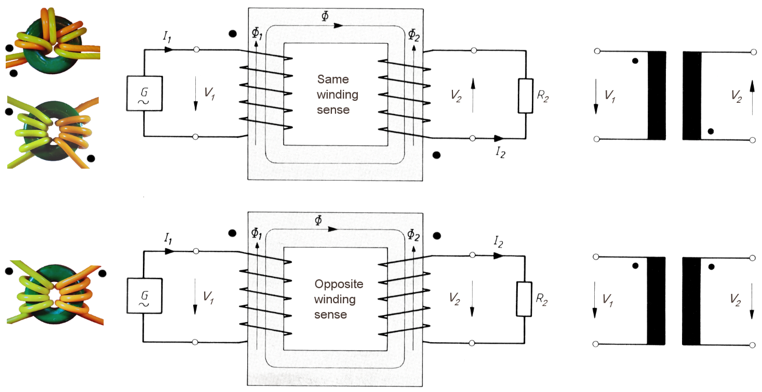

**Dot convention for the winding sense**

When a current enters the dot, then it circles around the total flux Φ in the same sense. It follows that at the dots, the voltages are of the same polarity.

**Transformer equations**

The net flux is always Φ = Φ1 + Φ2 (with a load attached the load-generated Φ2 is canceled by Φ1):

Because of the conservation of energy, it follows:

$$V_{1}I_{1}=V_{2}I_{2} → \frac{I_{1}}{I_{2}}=\frac{N_{2}}{N_{1}}$$

The input impedance is calculated like:

$$R_{1}=\frac{V_{1}}{I_{1}}=\frac{V_{2}{N_{1}}/{N_{2}}}{I_{2}{N_{2}}/{N_{1}}}=\frac{V_{2}}{I_{2}}{\left(\frac{N_{1}}{N_{2}}\right)}^{2}={\left(\frac{N_{1}}{N_{2}}\right)}^{2}R_{2}$$