Activity 1: reconstructing the past

|  |  |
| --- | --- |
| VCE key knowledge | * Interdependencies between species as represented by food webs, including impact of changes to keystone species |
| VCE key science skills | * Access secondary data, including data sourced through the internet that would otherwise be difficult to source as raw or primary data |
| Learning outcomes | * Construct food webs and food pyramids as ways to represent relationships in an ecosystem * Describe how energy flows through an ecosystem and is represented by trophic levels * Identify and describe a range symbiotic and predatory relationships between species |
| Duration | 90-120 minutes |

Students are introduced to the arid zone by constructing a food web and pyramid to represent the pre-European ecosystem. Students learn that ecosystems can be represented in different ways, and that there are different kinds of relationships between species, including a variety of symbiotic relationships and predation. Using a food pyramid model as well as a food web model illustrates the approximate ratios of species in different trophic levels.

A lot of the key content is covered in this lesson, and the amount of time needed will depend on student prior familiarity with these concepts.

Students will encounter a lot of key terms in this activity and should ensure they have clear definitions written in their notes. These terms are highlighted in bold where they are introduced in the activity and should be defined at that point. Although there are a lot in this activity, many will probably be familiar to students.

* **Ecosystem**: *a community of living organisms in conjunction with the non-living components of their environment, interacting in a system*
* **Arid**: *a region that is characterized by a severe lack of water, hindering the growth of plant and animal life*
* **Biotic**: *a living component of an ecosystem*
* **Abiotic**: *a non-living component of an ecosystem (such as water, air, minerals, temperature, sunlight)*
* **Food web**: *a representation of feeding relationships within a community*
* **Producers:** *species that make their own food and do not depend on another organism for nutrition (like most plants)*
* **Consumers:** *species that consume other organisms for nutrition and energy needs. There are usually several levels of consumers from primary consumers that eat producers (herbivores), through to predators that eat other animals (carnivores)*
* **Decomposers:** *species of fungi and bacteria that turn organic waste like dead plants into nutrients in the soil that can be used again by producers*
* **Trophic levels:** *a series of levels in food web where each member of the same level has a similar function and the same food relationships to other trophic levels*
* **Niche:** *The specific place of a particular organism in an ecological community. Includes the specific abiotic and biotic factors and relationships to other species*
* **Symbiosis:** *a close long-term interaction between different species*
* **Amensalism:** *an association between two species in which one is inhibited or destroyed and the other is unaffected, such as cattle trampling on grass.*
* **Commensalism:** *an association between two species in which one receives a benefit from the other, while the other is unaffected, such as birds that feed on insects that are tuned up by grazing animals.*
* **Mutualism:** *an association between two different species where both species benefit from the association, such as the relationship between cows and the bacteria in their gut. The cows benefit from the bacteria that break down the cellulose which the cow is unable to do, while the bacteria have a place to live and a steady food supply.*
* **Parasitism:** *an association between two different species where one benefits at the expense of another, such as head lice or tape worms.*
* **Predation:** *a biological interaction where one species consumes another to obtain nutrients and energy, such as deer grazing on grass.*

# Step 1: introduction

Explain to students that the Australian landscape has changed dramatically over time, especially since the arrival of Europeans. In these lessons students will explore some of these changes in the **arid** zone. To understand how things have changed, we will first look at the past, before Europeans arrived.

Show students this map of the arid zone (link: <http://www.abc.net.au/news/2015-07-15/map-of-australia/6621270>) and explain that we will be exploring the **ecosystems** that can be found in this area, and how these have changed over time.

[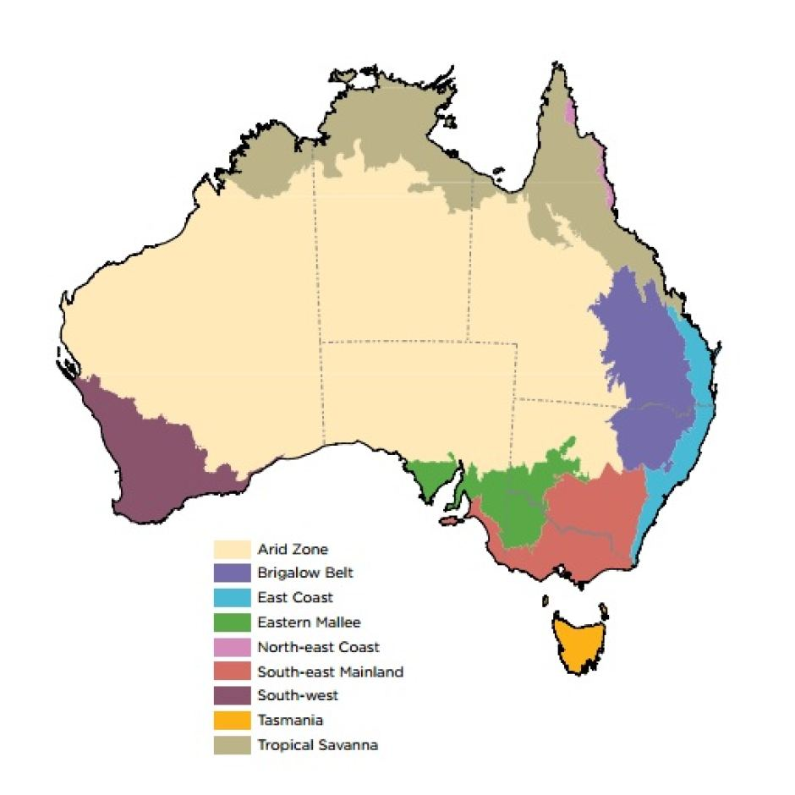](https://www.google.com.au/url?sa=i&rct=j&q=&esrc=s&source=images&cd=&cad=rja&uact=8&ved=0ahUKEwjTtJK4rrvRAhWBKJQKHWSjBUgQjRwIBw&url=http://www.abc.net.au/news/2015-07-15/map-of-australia/6621270&bvm=bv.143423383,d.dGc&psig=AFQjCNFu_hwsdj44b70oN8zY3ZM7EVquHw&ust=1484267669852408)

Each species lives in a specific **niche** in the ecosystem, and all living things are connected to each other and to the non-living aspects of the landscape. These are the **biotic** and **abiotic** factors. Explain that this connectedness is what ecology is all about, and in this unit we will learn about the ecology of the arid zone and the work that ecologists are doing there.

Show this 4-minute video to introduce students to the arid zone.

<http://www.abc.net.au/catalyst/stories/3251977.htm>

# Step 2: food webs refresher

To understand the impact of European colonisation, the first task is to reconstruct the past by understanding what the ecosystem was like back then.

Explain what a **food web** is by projecting the image on the whiteboard and explaining the role of **producers**, **consumers** and **decomposers**, and the idea that energy moves through the **trophic levels**.

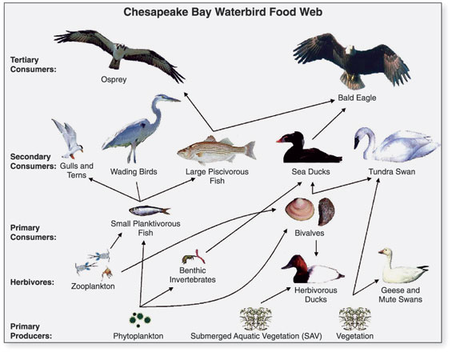

Public domain image via Wikipedia

**Teacher explanation:** *a food web is one way that we can represent the relationships between all the living things in an ecosystem. Energy and matter move through the ecosystem, and the food web shows us the possible paths that the energy and matter might take. Food chains represent just one path, whereas a food web shows many different paths that energy and matter can take. So at the bottom of the food web we have producers, these are usually plants and don’t depend on another species to get energy and nutrients, because they get these from the soil and the sun. Then there are the animals that eat plants, the herbivores. These are called primary consumers, because they eat the producers and the energy and matter move through the system as shown by the arrows in the food web. Next there are secondary consumers that eat those herbivores, such as a snake that eats a mouse. The food web represents the energy and matter as they move from the mouse to the snake. Above this, tertiary consumers are usually larger predators like an eagle that eats the snake. Finally, there are the decomposers like fungi and bacteria that feed on organic matter like dead plants. These decomposers complete the cycle by turning the organic matter into nutrients in the soil, to be used again by the producers. These different levels of producer, consumers and decomposers are called trophic levels.*

# Step 3: reconstructing the food web

Students use the ‘species cards’ to make a food web representing the ecosystem in the arid zone as it would have looked pre-European by cutting out species cards and sticking them on paper with arrows drawn between species. It is important to emphasise that these are just a few species to represent the food web, there is in fact a huge diversity of species, particularly pre-European.

It should look something like this:

Dingo

Bird

Lizard

Bettong

Mistletoe

Grass

Mulga

Fungi

Ask students to indicate producers, consumers and decomposers.

**Extension option:** ask students to research other species that are missing from this food web.

Next, show students how the trophic levels in a food web can also be represented as a pyramid and ask them to draw their food webs as a pyramid. The advantage of this representation is that it gives an idea of the ratios of the species in different trophic levels (or more accurately the relative amounts of biomass at each trophic level).

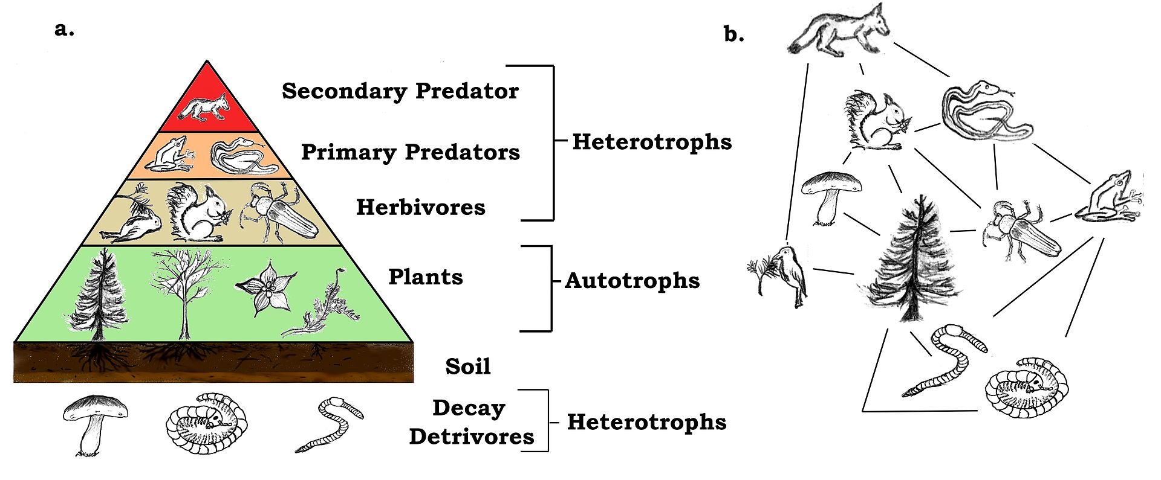

Thompsma via Wikipedia CC BY 3.0

# Step 4: helping each other

Explain that within an ecosystem, there are lots of complex relationships between species.

Watch this 5-minute video on symbiosis <https://www.youtube.com/watch?v=zSmL2F1t81Q>

[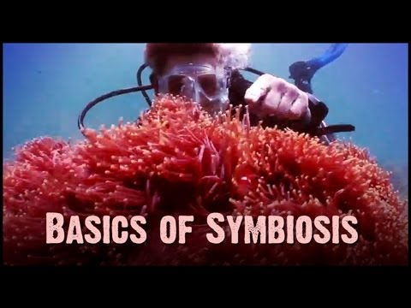](https://www.youtube.com/watch?v=zSmL2F1t81Q)

After watching, students define **symbiosis**, **commensalism, mutualism, parasitism** and **amensalism** in their notes.

**Teacher explanation:** *the term ‘amensalism’ was not included in the video and will need to be defined by the teacher. It is a less common term than the others, and refers to a relationship where one species inflicts harm on another species even though there is no benefit. An example would be where cattle trample grass. Commensalism, mutualism, parasitism and amensalism are all types of symbiotic relationships.*

Students identify symbiotic relationships within the food webs they have constructed.

**Teacher explanation:** *mistletoe-bird = mutualism; mulga tree-mistletoe = parasitic; bettong-ectomycorrhizal = mutualism; ectomycorrhizal-tree = mutualism; tree-grass = amensalism because the tree blocks sunlight damaging grass, but tree doesn’t gain anything. Bettongs-shingleback = commensalism.*

# Step 5: eating each other

Watch this 10-minute video on predation <https://www.youtube.com/watch?v=mFDiiSqGB7M>

[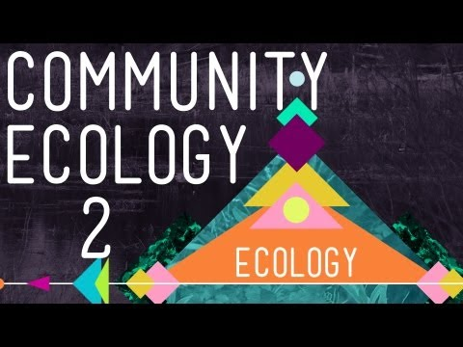](https://www.youtube.com/watch?v=mFDiiSqGB7M)

After watching, students define **predation** in their books.

**Teacher explanation:** *Students should note that parasitism was included in the first video as a form of symbiosis, yet it was also included in the second video on predation. This reflects slightly different definitions of terms. The broadest definition of symbiosis includes all relationships between tightly associated species, including parasitism. The broadest definition of predation includes all cases where one organism obtains nutrients and energy from another organism, even if it doesn’t consume that organism entirely. Therefore, parasitism can be considered a form of symbiosis and a form of predation.*

Students identify predation relationships within food webs they have constructed.

**Teacher explanation:** *dingo-bettong = predation*; *lizards also prey on insects; bettongs and other primary consumers eat grasses and seeds which can be considered predation.* During grazing the ‘prey’. Nevertheless the term predation can be used when referring to grazing.