Activity 2: Where did all the mammals go?

|  |  |
| --- | --- |
| VCE key knowledge | * The distribution, density and size of a population of a particular species within an ecosystem and the impacts of factors including available resources, predation, competition, disease, chance environmental events, births, deaths and migration |
| Learning outcomes | * The introduction of rabbits and foxes, and the removal of the dingo, have been responsible for the extinction or near-extinction of almost all small mammal species in Australia * Indigenous peoples actively managed the landscape |
| Duration | 30 minutes (60 with extension) |

Students learn the story of the introduction of rabbits and foxes and the devastating impact this had on the ecosystem, particularly on mammals.

Students will encounter one key term in this activity and should ensure they have a clear definition written in their notes. This term is highlighted in bold where it is introduced in the activity and should be defined at that point.

* **Invasive species**: *a species that is not native to a specific location and tends to spread to the degree that causes damage to the ecosystem.*

# Step 1: Indigenous management

Show the ‘through our eyes’ video where an Indigenous man talks about managing the land before Europeans arrived and mentions some of the ecological changes that resulted from European arrival.

<https://www.youtube.com/watch?v=-FcJezLo5Xs>

[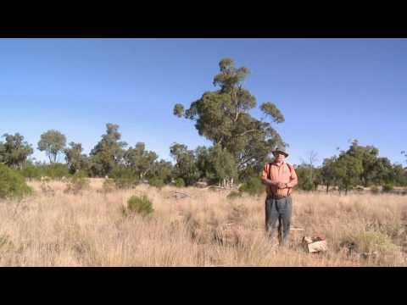](https://www.youtube.com/watch?v=-FcJezLo5Xs)

After watching, draw attention to the fact that the landscape has been modified by people for tens of thousands of years, but that the arrival of Europeans resulted in rapid and dramatic changes.

# Step 2: rabbits

Explain that we will be looking at only a few of the impacts that European contact has had in the arid zone. The first is rabbits. Rabbits are an invasive species. Watch this film on rabbit introduction <https://www.youtube.com/watch?v=cDVV9aUhZg4&app=desktop>

# Step 3: foxes (and cats)

Foxes and cats are also invasive species that have had a devastating impact on the ecosystem.

Students read this article <http://www.bbc.com/news/science-environment-31359188>

# Extension option: cool burning

This extension explores Indigenous land management in more detail and illustrates the surprising extent to which landscapes and ecosystems were modified before European colonisation.

Show video <http://www.abc.net.au/landline/content/2013/s3767527.htm>

Guided class discussion question: how do European ideas of nature contrast with Aboriginal views of nature?

**Teacher explanation:** *a number of observations can be made from watching this film. Europeans tend to view nature as something separate from humans. Nature is there to be exploited through farming, a process of ordering and structuring the natural world so that it becomes a tame and safe place. To counter these domesticated spaces, Europeans have long sought to maintain areas of ‘wild’ nature in reserves both for the conservation of species and for recreation. These areas of wild nature should be free from human impact, reflecting the deeply-held ideas that humans are not part of nature. Aboriginal Australians, like many Indigenous peoples around the world, do not view people as fundamentally separate from nature. Rather, they tend to view themselves as part of the landscape and part of the natural world around them. From this perspective, it makes no sense to separate the landscape into wild and tame areas. The historian in the film, Bill Gammage, shows how Aboriginal Australians managed the land extensively and were an integral part of the landscape encountered by early Europeans. This was (and still is) missed by Europeans because they didn’t encounter the orderly farmed areas familiar to them and so assumed the landscape was not managed at all, and also because of how they viewed Aboriginal peoples as incapable of sophisticated land management.*