Addressing the crisis at Arid Recovery

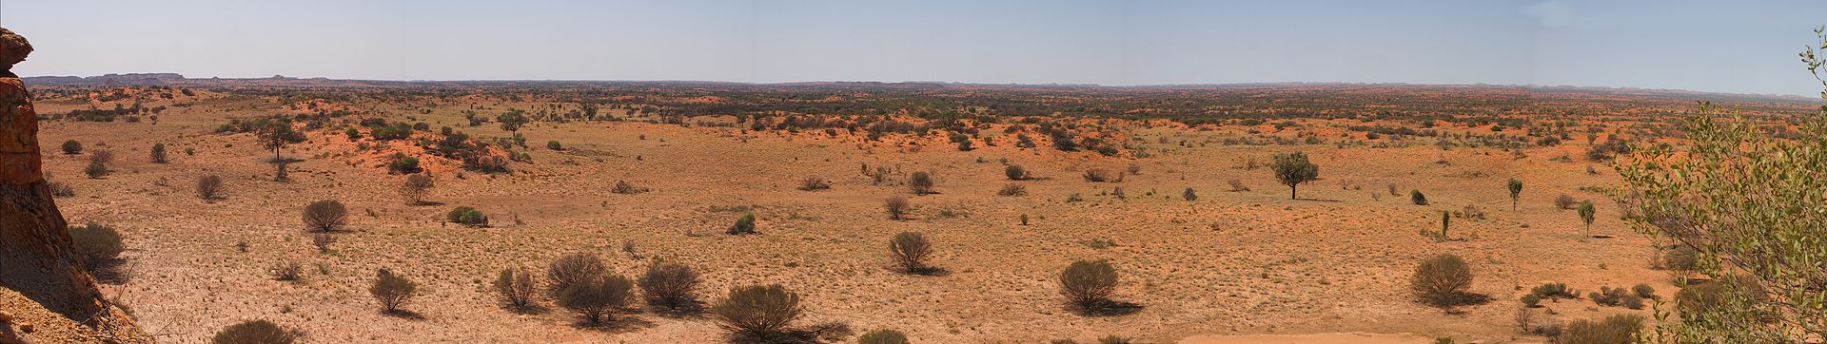

Mark Marathon via Wikipedia CC BY-SA 3.0

After watching the short video on Arid Recovery, answer the questions below. Go to the Arid Recovery website at <aridrecovery.org.au> to help you.

1. Where is Arid Recovery located?
2. What is its main aim?
3. How does it achieve this aim?
4. Click on ‘Conservation’ on the banner and read ‘untamed beauty’. Write one thing that surprises you.
5. Name 3 small mammals that have been reintroduced into the reserve (hint: see timeline)

Arid Recovery took advantage of a key moment in the story of invasive species: the release of Rabbit Calicivirus Disease (RCD). Watch this short video from CSIRO in 1999 which explains the release of RCD. While you watch, think about what factors are mentioned that impact populations of rabbits. <https://www.youtube.com/watch?v=wXT2C_QWMBk>

[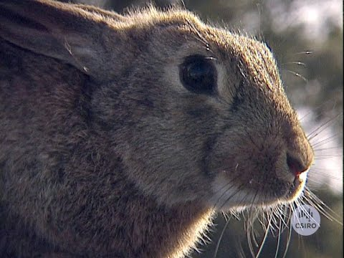](https://www.youtube.com/watch?v=wXT2C_QWMBk)

1. Write two factors that impact on the density of a population that were mentioned in the video in relation to rabbits.
2. What was the major problem as rabbit populations crashed?
3. Using the data in the table below, draw a graph (on separate graph paper) to show the decline in rabbit numbers

|  |  |
| --- | --- |
| Date | Approximate rabbit numbers per square kilometer |
| 1989 | 100 |
| 1990 | 500 |
| 1991 | 60 |
| 1992 | 70 |
| 1993 | 100 |
| 1994 | 240 |
| 1995 | 90 |
| 1996 | 10 |
| 1997 | 0 |
| 1998 | 0 |
| 1999 | 5 |
| 2000 | 5 |

1. Mark on the graph when Arid Recovery began
2. Add fox numbers from the table below to your graph. Because the scale of fox numbers is different from rabbits, you will need to add another axis to your graph on the other side.

|  |  |
| --- | --- |
| Date | Approximate fox numbers per square kilometer |
| 1989 | 2.5 |
| 1990 | 2.4 |
| 1991 | 1.5 |
| 1992 | 0.3 |
| 1993 | 1.4 |
| 1994 | 0.3 |
| 1995 | 0.6 |
| 1996 | 0.3 |
| 1997 | 0 |
| 1998 | 0 |
| 1999 | 0 |
| 2000 | 0 |

1. What was the key factor that impacted the size and density of the population of foxes in the arid zone, shown on the graph?
2. What was the key factor that impacted the size and density of the rabbit population in the arid zone, shown on the graph?