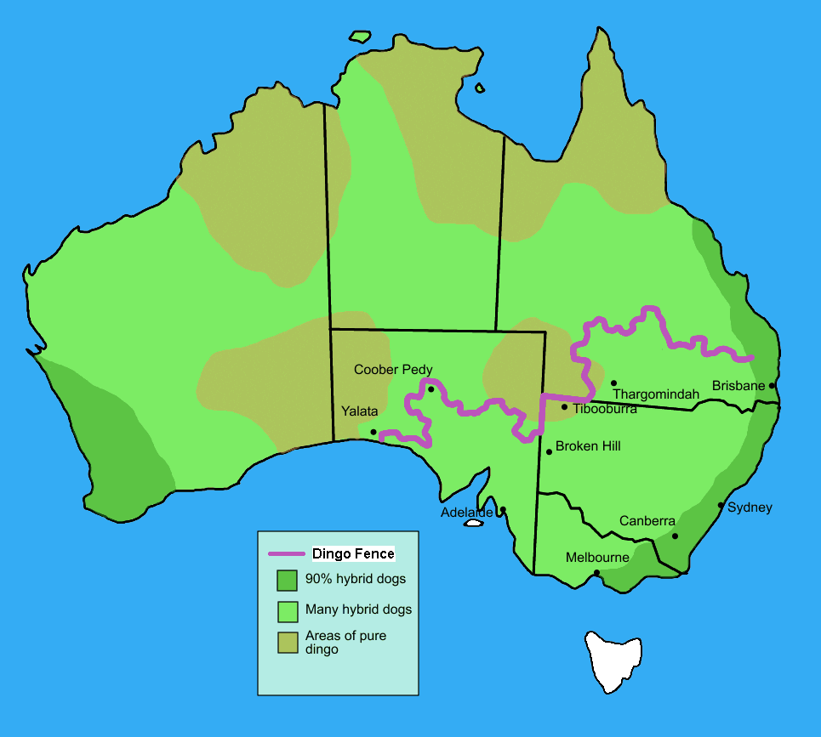Dingoes at the top

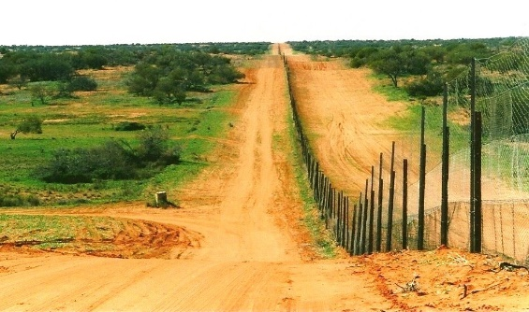Dingoes are thought to have been introduced to Australia around 4000 years ago as semi-domesticated dogs. Dingoes were troublesome for European farmers because they killed livestock and so, beginning in the 1880s, a ‘dingo fence’ was built, and dingoes were removed from large parts of Australia. Today, dingoes are absent or rare from the areas inside the dingo fence, including Victoria and New South Wales, and common in much of the rest of Australia.

Remember that the arid zone today is home to large numbers of rabbits and foxes, with a few dingoes in some areas and small populations of native mammals.

Ecologists at Arid Recovery wondered what impact dingoes might have on the ecosystem. They have investigated this question in a number of different ways.

1. In one study, ecologists Mike Letnic and Freya Koch compared the density of different species in one area of the arid zone where the dingo fence separates the ecosystem. On one side there are no dingoes, while on the other side dingoes are present.

Given what you know about apex predators, what do you think might happen to the following species in the **presence** of dingoes? Explain your reasoning.

|  |
| --- |
| Red kangaroo: |
| Rabbit: |
| Native mouse: |
| Fox: |

1. Below are the results of this study. The numbers in the table are ‘mean abundance’ based on sightings per kilometer.

|  |  |  |
| --- | --- | --- |
| Species | No dingoes | Dingoes |
| Dingo | 0.00 | 0.05 |
| Fox | 0.20 | 0.00 |
| Red kangaroo | 0.51 | 0.00 |
| Rabbit | 0.42 | 1.55 |
| Dusky hopping mouse (native) | 0.00 | 0.10 |

Which animals **increase** in the **absence** of dingoes?

Which animals **decrease** in the **absence** of dingoes?

1. Are these the results you were expecting? If you got any wrong, try to explain why these results were obtained.

|  |
| --- |
| Red kangaroo: |
| Rabbit: |
| Native mouse: |
| Fox: |

1. Why might you be cautious when interpreting this data?
2. If this data is correct, then removal of the dingo is an example of a trophic cascade and the ‘mesopredator release’ theory. Explain how.
3. Ecologists working at Arid Recovery wanted to test this idea further. The following is an excerpt from an article in a scientific journal written by these ecologists.

*Recent evidence suggests that Australia’s top-order predator, the dingo, may suppress the introduced cat and red fox. We tested this relationship by reintroducing 7 foxes and 6 feral cats into a 37 km2 fenced paddock in arid South Australia inhabited by a male and female dingo. GPS datalogger collars recorded locations of all experimental animals every 2 hours. Interactions between species, mortality rates, and postmortems were used to determine the mechanisms of any suppression. Dingoes killed all 7 foxes within 17 days of their introduction and no pre-death interactions were recorded. All 6 feral cats died between 20 and 103 days after release and dingoes were implicated in the deaths of at least 3 cats.*

Does this support the theory of mesopredator release in the case of dingoes and foxes?

Feral cats are another invasive species that wreak havoc in the ecosystem. Does this study support the theory of mesopredator release in the case of dingoes and cats?

1. This study was conducted in the fenced reserve at Arid Recovery. What might the limitations of this study be?
2. Do you think we can describe dingoes as a ‘keystone species’? Why?