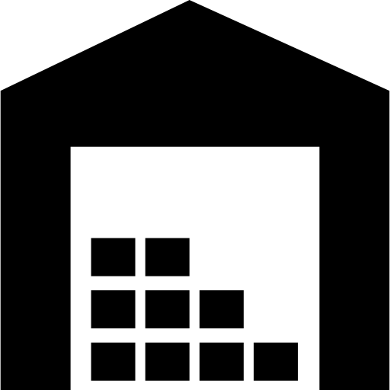

**Oswal Industrial**

**Complex - 1**