Flexbox

The biggest difference between Bootstrap 3 and Bootstrap 4 & 5 is that Bootstrap 5 now uses flexbox, instead of floats, to handle the layout.

To create a flexbox container and to transform direct children into flex items, use the d-flex class:

Example

<div class="d-flex p-3 bg-secondary text-white">  
  <div class="p-2 bg-info">Flex item 1</div>  
  <div class="p-2 bg-warning">Flex item 2</div>  
  <div class="p-2 bg-primary">Flex item 3</div>  
</div>



### To create an inline flexbox container, use the d-inline-flex class: Example

<div class="d-inline-flex p-3 bg-secondary text-white">  
  <div class="p-2 bg-info">Flex item 1</div>  
  <div class="p-2 bg-warning">Flex item 2</div>  
  <div class="p-2 bg-primary">Flex item 3</div>  
</div>



## Horizontal Direction

Use .flex-row to display the flex items horizontally (side by side). This is default.

**Tip:** Use .flex-row-reverse to right-align the horizontal direction:

### Example

<div class="d-flex flex-row bg-secondary">  
  <div class="p-2 bg-info">Flex item 1</div>  
  <div class="p-2 bg-warning">Flex item 2</div>  
  <div class="p-2 bg-primary">Flex item 3</div>  
</div>  
  
<div class="d-flex flex-row-reverse bg-secondary">  
  <div class="p-2 bg-info">Flex item 1</div>  
  <div class="p-2 bg-warning">Flex item 2</div>  
  <div class="p-2 bg-primary">Flex item 3</div>  
</div>

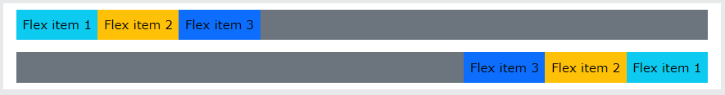

## Vertical Direction

Use .flex-column to display the flex items vertically (on top of each other), or .flex-column-reverse to reverse the vertical direction:

### Example

<div class="d-flex flex-column">  
  <div class="p-2 bg-info">Flex item 1</div>  
  <div class="p-2 bg-warning">Flex item 2</div>  
  <div class="p-2 bg-primary">Flex item 3</div>  
</div>  
  
<div class="d-flex flex-column-reverse">  
  <div class="p-2 bg-info">Flex item 1</div>  
  <div class="p-2 bg-warning">Flex item 2</div>  
  <div class="p-2 bg-primary">Flex item 3</div>  
</div>

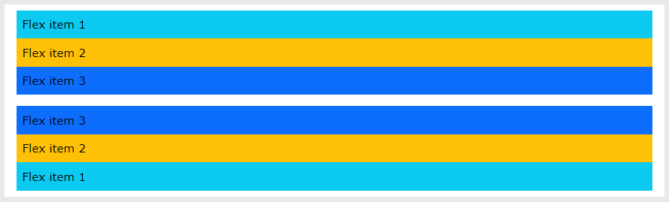

## Justify Content

Use the .justify-content-* classes to change the alignment of flex items. Valid classes are start (default), end, center, between or around:

### Example

<div class="d-flex justify-content-start">...</div>  
<div class="d-flex justify-content-end">...</div>  
<div class="d-flex justify-content-center">...</div>  
<div class="d-flex justify-content-between">...</div>  
<div class="d-flex justify-content-around">...</div>

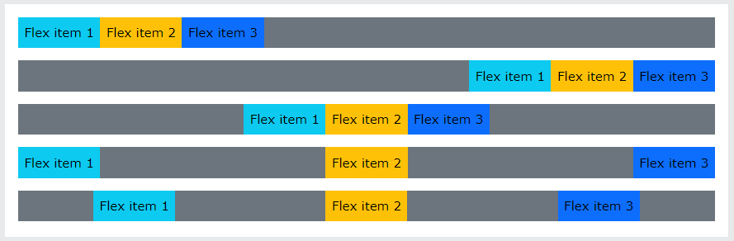

To know [Clickhere](https://www.w3schools.com/bootstrap5/bootstrap_flex.php)

References

https://www.w3schools.com/bootstrap5/bootstrap_flex.php