Bootstrap 5 Text/Typography

## **Bootstrap 5 Default Settings**

Bootstrap 5 uses a default font-size of 1rem (16px by default), and its line-height is 1.5.

In addition, all <p> elements have margin-top: 0 and margin-bottom: 1rem (16px by default).

## **<h1> - <h6>**

Bootstrap 5 styles HTML headings (<h1> to <h6>)  with a bolder font-weight and a responsive font-size.

Example

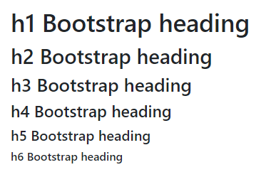

You can also use .h1 to .h6 classes on other elements to make them behave as headings if you want:

### **Example**

<p class="h1">h1 Bootstrap heading</p>  
<p class="h2">h2 Bootstrap heading</p>  
<p class="h3">h3 Bootstrap heading</p>  
<p class="h4">h4 Bootstrap heading</p>  
<p class="h5">h5 Bootstrap heading</p>  
<p class="h6">h6 Bootstrap heading</p>

## **Display Headings**

Display headings are used to stand out more than normal headings (larger font-size and lighter font-weight), and there are six classes to choose from: .display-1 to .display-6:

### **Example**

# Display 1

# Display 2

# Display 3

# Display 4

# Display 5

# Display 6

[Try it Yourself »](https://www.w3schools.com/bootstrap5/tryit.asp?filename=trybs_txt_display&stacked=h)

## **<small>**

In Bootstrap 5 the HTML <small> element (and the .small class) is used to create a smaller, secondary text in any heading:

### **Example**

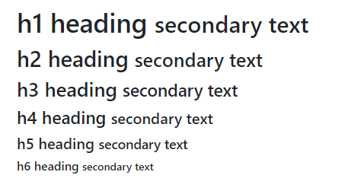

To known [clickhere](https://www.w3schools.com/bootstrap5/bootstrap_typography.php)

Refernces

https://www.w3schools.com/bootstrap5/bootstrap_typography.php