Bootstrap 5 is the newest version of [Bootstrap](https://www.w3schools.com/bootstrap/default.asp), which is the most popular HTML, CSS, and JavaScript framework for creating responsive, mobile-first websites.

Bootstrap 5 is completely free to download and use!

What is Bootstrap?

* Bootstrap is a free front-end framework for faster and easier web development
* Bootstrap includes HTML and CSS based design templates for typography, forms, buttons, tables, navigation, modals, image carousels and many other, as well as optional JavaScript plugins
* Bootstrap also gives you the ability to easily create responsive designs

**What is Responsive Web Design?**  
  
Responsive web design is about creating web sites which automatically adjust themselves to look good on all devices, from small phones to large desktops.

### **Bootstrap 5 Example**

<div class="container-fluid p-5 bg-primary text-white text-center">  
  <h1>My First Bootstrap Page</h1>  
  <p>Resize this responsive page to see the effect!</p>  
</div>  
  
<div class="container mt-5">  
  <div class="row">  
    <div class="col-sm-4">  
      <h3>Column 1</h3>  
      <p>Lorem ipsum dolor sit amet, consectetur adipisicing elit...</p>  
      <p>Ut enim ad minim veniam, quis nostrud exercitation ullamco laboris...</p>  
    </div>  
    <div class="col-sm-4">  
      <h3>Column 2</h3>  
      <p>Lorem ipsum dolor sit amet, consectetur adipisicing elit...</p>  
      <p>Ut enim ad minim veniam, quis nostrud exercitation ullamco laboris...</p>  
    </div>  
    <div class="col-sm-4">  
      <h3>Column 3</h3>  
      <p>Lorem ipsum dolor sit amet, consectetur adipisicing elit...</p>  
      <p>Ut enim ad minim veniam, quis nostrud exercitation ullamco laboris...</p>  
    </div>  
  </div>  
</div>

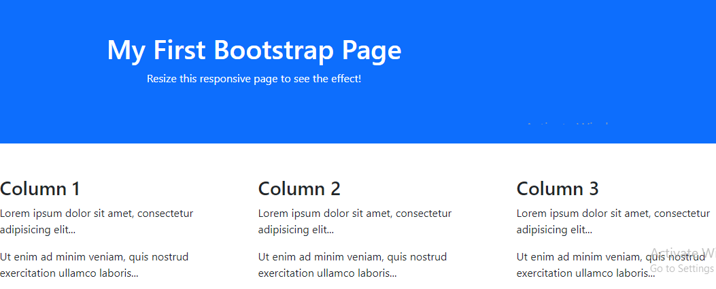

## Bootstrap Versions

Bootstrap 5 (released 2021) is the newest version of [Bootstrap](https://www.w3schools.com/bootstrap/default.asp) (released 2013); with new components, faster stylesheet and more responsiveness.

Bootstrap 5 supports the latest, stable releases of all major browsers and platforms. However, Internet Explorer 11 and down is not supported.

The main differences between Bootstrap 5 and Bootstrap 3 & 4, is that Bootstrap 5 has switched to vanilla JavaScript instead of jQuery.

**Note:** [Bootstrap 3](https://www.w3schools.com/bootstrap/default.asp) and [Bootstrap 4](https://www.w3schools.com/bootstrap4/default.asp) is still supported by the team for critical bugfixes and documentation changes, and it is perfectly safe to continue to use them. However, new features will NOT be added to them.

Why Use Bootstrap?

Advantages of Bootstrap:

* **Easy to use:** Anybody with just basic knowledge of HTML and CSS can start using Bootstrap
* **Responsive features:** Bootstrap's responsive CSS adjusts to phones, tablets, and desktops
* **Mobile-first approach:** In Bootstrap, mobile-first styles are part of the core framework
* **Browser compatibility:** Bootstrap 5 is compatible with all modern browsers (Chrome, Firefox, Edge, Safari, and Opera). **Note** that if you need support for IE11 and down, you must use either BS4 or BS3.

Where to Get Bootstrap 5?

There are two ways to start using Bootstrap 5 on your own web site.

You can:

* Include Bootstrap 5 from a CDN
* Download Bootstrap 5 from getbootstrap.com

Bootstrap 5 CDN

If you don't want to download and host Bootstrap 5 yourself, you can include it from a CDN (Content Delivery Network).

jsDelivr provides CDN support for Bootstrap's CSS and JavaScript:

### **MaxCDN:**

<!-- Latest compiled and minified CSS -->  
<link href="https://cdn.jsdelivr.net/npm/bootstrap@5.1.3/dist/css/bootstrap.min.css" rel="stylesheet">  
  
<!-- Latest compiled JavaScript -->  
<script src="https://cdn.jsdelivr.net/npm/bootstrap@5.1.3/dist/js/bootstrap.bundle.min.js"></script>

**One advantage of using the Bootstrap 5 CDN:**  
Many users already have downloaded Bootstrap 5 from jsDelivr when visiting another site. As a result, it will be loaded from cache when they visit your site, which leads to faster loading time. Also, most CDN's will make sure that once a user requests a file from it, it will be served from the server closest to them, which also leads to faster loading time.  
  
**JavaScript?**  
Bootstrap 5 use JavaScript for different components (like modals, tooltips, popovers etc). However, if you just use the CSS part of Bootstrap, you don't need them.

## Downloading Bootstrap 5

If you want to download and host Bootstrap 5 yourself, go to <https://getbootstrap.com/>, and follow the instructions there.

References

https://www.w3schools.com/bootstrap5/bootstrap_get_started.php