## HTML **Contents** ## What is HTML? - HTML stands for Hyper Text Markup Language - HTML is the standard markup language for creating Web pages - HTML describes the structure of a Web page - HTML consists of a series of elements - HTML elements tell the browser how to display the content - HTML elements label pieces of content such as "this is a heading", "this is a paragraph", "this is a link", etc. ## What is an HTML Element? - An HTML element is defined by a start tag, some content, and an end tag. **Example:** \ Content goes here... \ \My First Heading\ \My first paragraph.\ 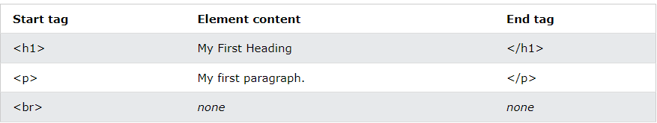 **Note:** Some HTML elements have no content (like the \ element). These elements are called empty elements. Empty elements do not have an end tag! ## Web Browsers The purpose of a web browser (Chrome, Edge, Firefox, Safari) is to read HTML documents and display them correctly. A browser does not display the HTML tags, but uses them to determine how to display the document: 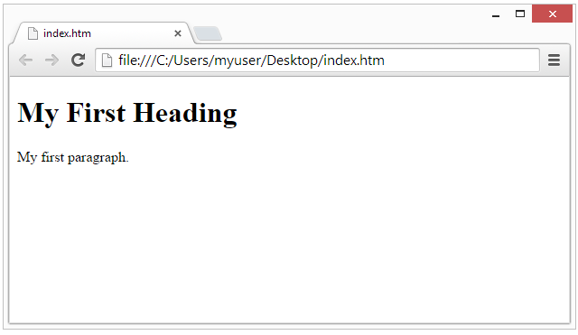 ## HTML Page Structure Below is a visualization of an HTML page structure: 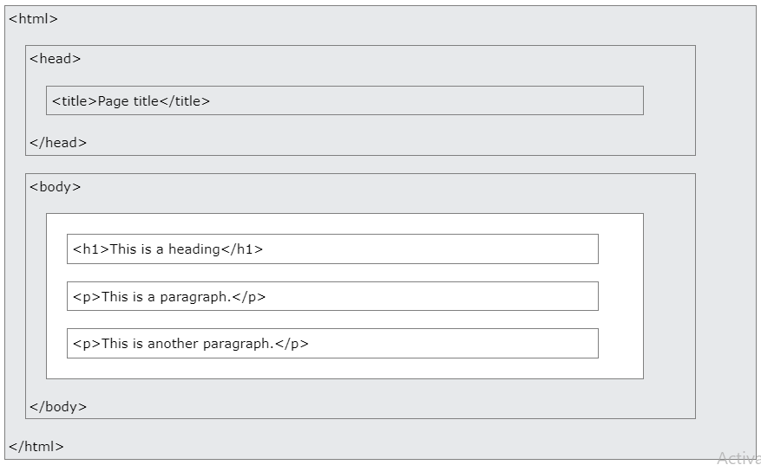 **Note:** The content inside the \ section (the white area above) will be displayed in a browser. The content inside the \ element will be shown in the browser's title bar or in the page's tab. # HTML Editors A simple text editor is need to learn HTML. ## Learn HTML Using Notepad or TextEdit - Web pages can be created and modified by using professional HTML editors. - However, for learning HTML we recommend a simple text editor like Notepad (PC) or TextEdit (Mac). - A simple text editor is a good way to learn HTML. - Follow the steps below to create your first web page with Notepad or TextEdit. ## Step 1: Open Notepad (PC) **Windows 8 or later:** Open the **Start Screen** (the window symbol at the bottom left on your screen). Type **Notepad**. **Windows 7 or earlier:** Open **Start** \> **Programs \>** **Accessories \>** **Notepad** ## Step 2: Write Some HTML Write the following HTML code into Notepad. 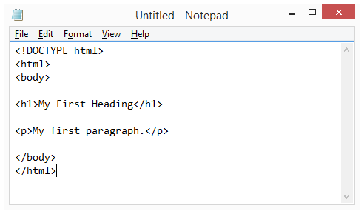 ## Step 3: Save the HTML Page - Save the file on your computer. - Select **File \> Save as** in the Notepad menu. - Name the file **"index.htm"** and set the encoding to **UTF-8** (which is the preferred encoding for HTML files). 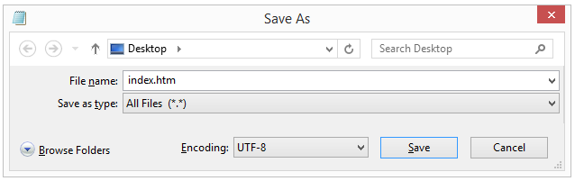 **Tip:** You can use either .htm or .html as file extension. There is no difference, it is up to you. ## Step 4: View the HTML Page in Your Browser Open the saved HTML file in your favorite browser (double click on the file, or right-click - and choose "Open with"). The result will look much like this: 