JavaScript Introduction

JavaScript is the world's most popular programming language.

JavaScript is the programming language of the Web.

JavaScript is easy to learn.

## **Why Study JavaScript?**

JavaScript is one of the **3 languages** all web developers **must** learn:

   1. [**HTML**](https://www.w3schools.com/html/default.asp) to define the content of web pages

   2. [**CSS**](https://www.w3schools.com/css/default.asp) to specify the layout of web pages

   3. **JavaScript** to program the behavior of web pages

## **The <script> Tag**

In HTML, JavaScript code is inserted between <script> and </script> tags.

## **JavaScript in <head> or <body>**

You can place any number of scripts in an HTML document.

Scripts can be placed in the <body>, or in the <head> section of an HTML page, or in both.

Placing scripts at the bottom of the <body> element improves the display speed, because script interpretation slows down the display.

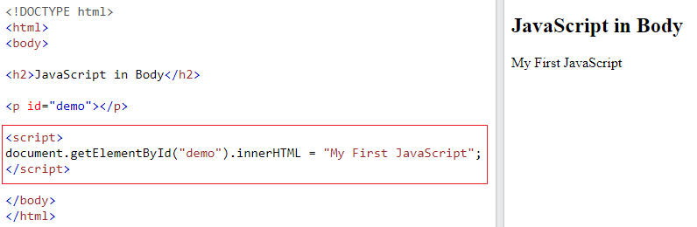

## **External JavaScript**

Scripts can also be placed in external files:

### **External file: myScript.js**

function myFunction() {  
  document.getElementById("demo").innerHTML = "Paragraph changed.";  
}

External scripts are practical when the same code is used in many different web pages.

JavaScript files have the file extension **.js**.

To use an external script, put the name of the script file in the src (source) attribute of a <script> tag:

### **Example**

<script src="myScript.js"></script>

You can place an external script reference in <head> or <body> as you like.

The script will behave as if it was located exactly where the <script> tag is located.

External scripts cannot contain <script> tags.

## **External JavaScript Advantages**

Placing scripts in external files has some advantages:

* It separates HTML and code
* It makes HTML and JavaScript easier to read and maintain
* Cached JavaScript files can speed up page loads

To add several script files to one page  - use several script tags:

### **Example**

<script src="myScript1.js"></script>  
<script src="myScript2.js"></script>

## **JavaScript Display Possibilities**

JavaScript can "display" data in different ways:

* Writing into an HTML element, using innerHTML.
* Writing into the HTML output using document.write().
* Writing into an alert box, using window.alert().
* Writing into the browser console, using console.log().

## **Using innerHTML**

To access an HTML element, JavaScript can use the document.getElementById(id) method.

The id attribute defines the HTML element. The innerHTML property defines the HTML content:

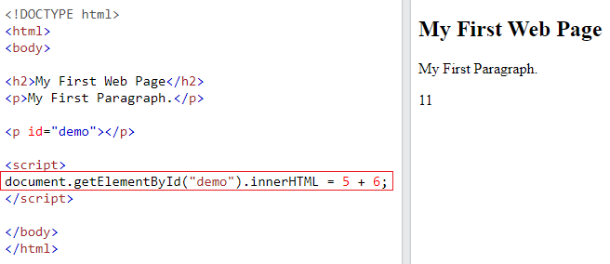

Changing the innerHTML property of an HTML element is a common way to display data in HTML.

## **Using document.write()**

For testing purposes, it is convenient to use document.write():

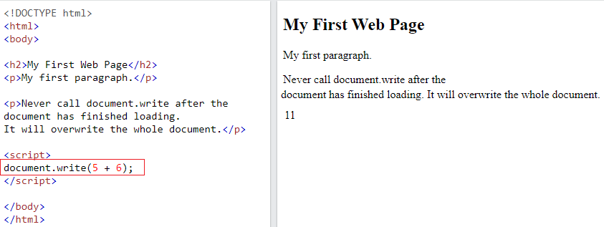

Using document.write() after an HTML document is loaded, will **delete all existing HTML**:

The document.write() method should only be used for testing.

## **Using window.alert()**

You can use an alert box to display data:

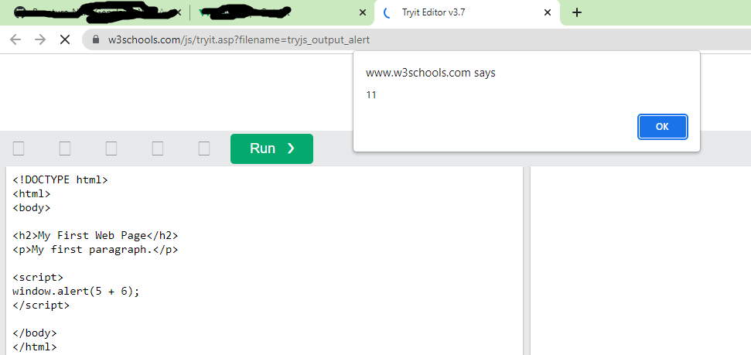

You can skip the window keyword.

In JavaScript, the window object is the global scope object, that means that variables, properties, and methods by default belong to the window object. This also means that specifying the window keyword is optional:

## **Using console.log()**

For debugging purposes, you can call the console.log() method in the browser to display data.

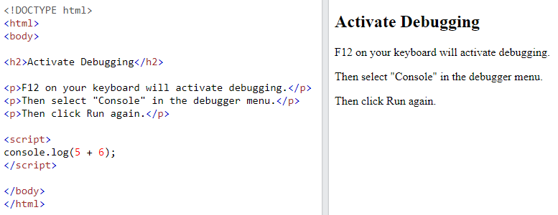

References

<https://www.w3schools.com/js/js_whereto.asp>

https://www.w3schools.com/js/js_output.asp