PostgreSQL GRANT

After [creating a role](https://www.postgresqltutorial.com/postgresql-roles/) with the LOGIN attribute, the role can log in to the PostgreSQL database server. However, it cannot do anything to the database objects like tables, [views](https://www.postgresqltutorial.com/postgresql-views/), [functions](https://www.postgresqltutorial.com/postgresql-create-function/), etc.

For example, the user role cannot [select data from a table](https://www.postgresqltutorial.com/postgresql-tutorial/postgresql-select/) or execute a specific function.

To allow the user role to interact with database objects, you need to grant privileges on the database objects to the user role by using the GRANT statement.

The following shows the simple form of the GRANT statement that grants one or more privileges on a table to a role:

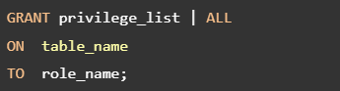

In this syntax:

* First, specify the privilege_list that can be [SELECT](https://www.postgresqltutorial.com/postgresql-tutorial/postgresql-select/), [INSERT](https://www.postgresqltutorial.com/postgresql-tutorial/postgresql-insert/), [UPDATE](https://www.postgresqltutorial.com/postgresql-tutorial/postgresql-update/), [DELETE](https://www.postgresqltutorial.com/postgresql-tutorial/postgresql-delete/), [TRUNCATE](https://www.postgresqltutorial.com/postgresql-tutorial/postgresql-truncate-table/), etc. You use the ALL option to grant all privileges on a table to the role.
* Second, specify the name of the table after the ON keyword.
* Third, specify the name of the role to which you want to grant privileges.

## **PostgreSQL GRANT statement examples**

First, use the postgres user to connect to the PostgreSQL database server using any client tool of your choice.

Second, [create a new user role](https://www.postgresqltutorial.com/postgresql-roles/) called joe that can login to the PostgreSQL database server:

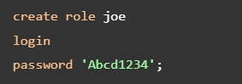

Third, [create a new table](https://www.postgresqltutorial.com/postgresql-tutorial/postgresql-create-table/) called candidates:

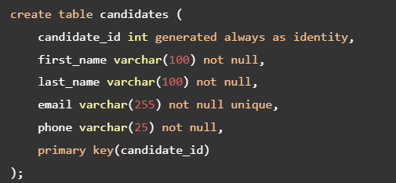

Fourth, use the role joe to log in to the PostgreSQL database server in a separate session.

Fifth, attempt to select data from the candidates table from the joe‘s session:



PostgreSQL issued an error:



To grant the SELECT privilege on the candidates table to the role joe, you execute the following GRANT statement in the postgres‘ session:



Sixth, execute the SELECT statement from the joe‘s session:



PostgreSQL returns an empty result set instead of an error.

Seventh, execute the following [INSERT](https://www.postgresqltutorial.com/postgresql-tutorial/postgresql-insert/)statement:

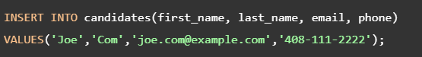

PostgreSQL issued the following error because joe does not have the INSERT privilege on the candidates table:



Eighth, grant INSERT, UPDATE, and DELETE privileges on the candidates table to the role joe:



Ninth, execute the INSERT statement again from the joe‘s session:

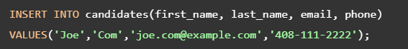

Now, joe can insert data into the candidates table. In addition, it can update or delete data from the table.

## **More PostgreSQL GRANT examples**

Let’s takes some more examples of using the GRANT statement.

### **Grant all privileges on a table to a role**

The following statement grants all privileges on the candidates table to the role joe:



### **Grant all privileges on all tables in a schema to a role**

The following statement grants all privileges on all tables in the public schema of the dvdrental sample database to the role joe:

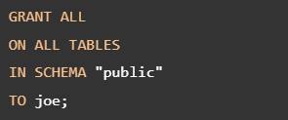

### **Grant SELECT on all tables**

Sometimes, you want to create a readonly role that can only select data from all tables in a specified schema.

In order to do that, you can grant SELECT privilege on all tables in the public schema like this:

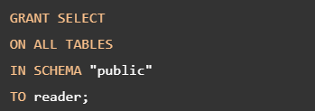

So far, you have learned how to grant privileges on tables. To grant privileges on other objects, check it out[the GRANT statement syntax](https://www.postgresql.org/docs/current/sql-grant.html).

# PostgreSQL REVOKE

The REVOKE statement revokes previously [granted privileges](https://www.postgresqltutorial.com/postgresql-administration/postgresql-grant/) on database objects from a [role](https://www.postgresqltutorial.com/postgresql-roles/).

The following shows the syntax of the REVOKE statement that revokes privileges on one or more tables from a role:

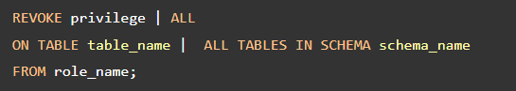

In this syntax:

* First, specify the one or more privileges that you want to revoke. You use the ALL option to revoke all privileges.
* Second, specify the name of the table after the ON keyword. You use the ALL TABLES to revoke specified privileges from all tables in a schema.
* Third, specify the name of the role from which you want to revoke privileges.

## **PostgreSQL REVOKE statement example**

Let’s take an example of using the REVOKE statement.

### **Step 1. Create a role and grant privileges**

First, use the postgres user to log in to the dvdrental [sample database](https://www.postgresqltutorial.com/postgresql-sample-database/):



Second, [create a new role](https://www.postgresqltutorial.com/postgresql-roles/) called jim with the LOGIN and PASSWORD attributes:

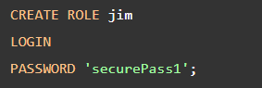

Third, grant all privileges on the film table to the role jim:



Finally, grant the SELECT privilege on the actor table to the role jim:



### **Step 2. Revoke privileges from a role**

To revoke the SELECT privilege on the actor table from the role jim, you use the following statement:

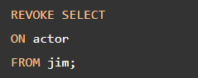

To revoke all privileges on the film table from the role jim, you use REVOKE statement with the ALL option like this:



## **Revoking privileges on other database objects**

To revoke privileges from other database objects such as [sequences](https://www.postgresqltutorial.com/postgresql-tutorial/postgresql-sequences/), [functions](https://www.postgresqltutorial.com/postgresql-functions/), [stored procedures](https://www.postgresqltutorial.com/postgresql-create-procedure/), [schemas](https://www.postgresqltutorial.com/postgresql-schema/), [databases](https://www.postgresqltutorial.com/postgresql-create-database/), check it out [the REVOKE statement](https://www.postgresql.org/docs/current/sql-revoke.html).

Refernces

<https://www.postgresqltutorial.com/postgresql-administration/postgresql-grant/>

https://www.postgresqltutorial.com/postgresql-administration/postgresql-revoke/